AUTOMATA LAB
TASK 04
INFINITE LOOP
DETECTION
Computability Theory • Turing Machines • Practical Static Analysis

ACADEMIC DETAILS | INFORMATION
Course | 21CSC301T — Formal Language and Automata
Programme | B.Tech. Artificial Intelligence and Machine Learning
Department / Semester | AIML / V
Academic Year | 2026–2027
Faculty Handling | Dr. C. Gunasundari (AP)
Assessment | Task 4
SDG Alignment | SDG 9 — Industry, Innovation and Infrastructure
Student | Harshit Parmar
Registration Number | RA2411026050026

SUBMISSION DEADLINE: 06 NOVEMBER 2026

Abstract
An infinite loop is a program execution that continues indefinitely without reaching a designated termination state. Detecting such behaviour is important in software reliability, resource management, embedded systems, and service availability. The central theoretical result is that no algorithm can decide, for every arbitrary program and input, whether execution will eventually halt. This is the Halting Problem. This report formulates the problem, explains undecidability and recognizability, and proposes an engineering workaround based on restricted static analysis, bounded execution, finite-state cycle detection, testing, and timeouts. A Python AST prototype and interactive dashboard demonstrate useful restricted cases without claiming to solve the general undecidable problem.

1. Problem Understanding

1.1 Real-world problem
Consider a software service that processes a request inside a loop. If the loop condition never becomes false and no reachable exit is executed, the request may consume CPU time indefinitely. Consequences include blocked threads, delayed responses, battery drain, missed real-time deadlines, and denial of service.

1.2 Computational formulation
Let P be a program and x an input. The decision problem is HALT = { ⟨P, x⟩ | program P eventually halts on input x }. The question is whether a total algorithm exists that always returns the correct answer for every valid program-input pair.

1.3 Assumptions
- Programs have finite descriptions.
- Execution follows a well-defined operational semantics.
- Halting means reaching a designated terminal configuration.
- The general result concerns unrestricted computational programs.
- The prototype operates on a limited subset of Python loop patterns.

2. Formal Model: Turing Machine
A deterministic Turing machine is represented by M = (Q, Σ, Γ, δ, q₀, q_accept, q_reject), where Q is a finite state set, Σ is the input alphabet, Γ is the tape alphabet, δ is the transition function, q₀ is the initial state, and q_accept/q_reject are halting states.
A configuration records the current state, tape contents, and head position. A computation is C₀ ⊢ C₁ ⊢ C₂ ⊢ … . The machine halts if it reaches a designated halting state; otherwise, it may continue forever.

2.1 Mapping software to computability
Software concept | Computability concept
Program source and input | TM description and input string
Program execution state | TM configuration
One instruction step | One transition
Return / exit | Halting configuration
Infinite execution | Infinite transition sequence
Loop detector | Proposed decision procedure for halting

3. Why General Exact Detection Is Undecidable
Assume a perfect decider H(P,x) exists. It always halts and answers YES if P halts on x, and NO otherwise. Construct D(P) to do the opposite of H(P,P): if H predicts that P halts on itself, D loops forever; otherwise, D halts immediately.
Now execute D on its own description, D(D). If H(D,D) predicts halting, the construction makes D(D) loop. If it predicts non-halting, the construction makes D(D) halt. Both possibilities contradict the assumed correctness of H. Therefore, no total algorithm can decide the Halting Problem for all arbitrary program-input pairs.

4. Decidability and Recognizability
A language is decidable if a Turing machine halts on every input and correctly accepts members and rejects non-members. A language is recognizable if a Turing machine accepts every member, but on a non-member it may reject or run forever.
The Halting language is recognizable: simulate P(x) and accept if it halts. If it never halts, the simulation continues forever. Its complement is not recognizable in the unrestricted setting. Thus there is no recognizer that always confirms every non-halting instance.

5. Worked Examples

Example A — constant-true loop
while True:\n print("still running")

The condition is always true. If no reachable break, exception, or external termination mechanism exits the loop, it does not terminate under the assumed execution model. A syntax-based tool can flag this pattern.

Example B — unchanged condition variable
i = 0\nwhile i < 5:\n print(i)

The body does not modify i. Since i starts at zero and remains zero, i < 5 remains true. This is a restricted case where simple data-flow reasoning can establish the behaviour.

Example C — counter is updated
i = 0\nwhile i < 5:\n print(i)\n i += 1

The variable increases on each iteration. Under ordinary integer semantics, the condition eventually becomes false. The prototype should not flag this pattern.

Example D — syntactic break
while True:\n if ready():\n break\n wait()

A break is syntactically present, but whether it is reached depends on ready() and program state. Merely finding break is not a proof of termination.

6. Proposed Restricted-Case Engineering Solution

6.1 Static AST analysis
- Flag while True or while 1 when no break targeting that loop is found syntactically.
- Flag a simple loop when a variable used in its condition is not assigned in the loop body.
- Report syntax errors separately.
- If no rule fires, report no supported pattern found—not that the program halts.
These rules are intentionally conservative and incomplete. They do not solve arbitrary aliasing, function calls, exceptions, concurrency, indirect state changes, or complex control flow.

6.2 Bounded deterministic finite-state monitor
For a deterministic finite-state transition system with a finite state space, store every visited state. If a terminal state is reached, report termination. If a state repeats, deterministic behaviour guarantees that the same future sequence repeats; report a cycle. If the step limit is reached first, report step limit reached—not infinite loop.

7. Prototype Architecture
Component | Input | Method | Output
Python parser | Source code | ast.parse | Syntax tree / syntax error
Static rule engine | AST | Pattern and assignment checks | Risk findings
Finite-state monitor | Initial state + transition | Visited-state set | Terminated / cycle / limit
Dashboard | User-entered snippet | Demonstration rules | Visual explanation
Unit tests | Known examples | Assertions | Validation evidence

7.1 Result interpretation
Status | Meaning
HIGH_RISK_PATTERN | Constant-true loop without visible exit found
POTENTIAL_RISK | Condition variable may remain unchanged
REVIEW | Visible break exists, but reachability is unproved
NO_PATTERN_FOUND | No supported pattern found; termination is not proved
INVALID_SYNTAX | Input could not be parsed as Python

8. Validation Plan and Test Cases
The project includes unit tests for constant-true loops, unchanged condition variables, counter updates, invalid Python syntax, repeated states in a finite-state transition system, and terminal-state detection.
python -m unittest discover -s tests -v

Attach a screenshot of the actual test output after running the tests on the your machine.

9. Practical Implications for Software/System Design
- Static analysis and code review before deployment.
- Unit, integration, and property-based testing.
- Execution timeouts and watchdog timers.
- CPU, memory, and request quotas.
- Cancellation and cooperative interruption.
- Telemetry and alerts for unusually long-running tasks.
- Finite-state verification where the state space can be bounded.
Timeouts do not prove that a program would never halt; they establish an operational limit for a particular run. Testing can find bugs but cannot exhaustively cover every possible input of an unrestricted program.

10. SDG 9 Alignment
Reliable software infrastructure supports resilient systems and innovation. Detecting selected infinite-loop patterns, monitoring execution time, and applying resource limits can improve service availability and operational reliability. The project demonstrates Level 2 Design Alignment by translating a theoretical limitation into a practical, bounded engineering workflow.

11. Limitations and Future Enhancements
- The AST rules cover only simple patterns.
- The browser dashboard is an explanatory demonstration; the Python AST analyzer is the project implementation.
- The analyzer does not prove termination or non-termination for arbitrary programs.
- Future work could add control-flow graphs, richer data-flow analysis, configurable timeouts, and a sandboxed runner for controlled toy programs.

12. Conclusion
The Halting Problem establishes a fundamental boundary: universal exact infinite-loop detection for arbitrary programs is undecidable. This does not make practical loop analysis useless. By narrowing the scope, a tool can identify selected suspicious patterns, detect cycles in finite deterministic models, and combine static checks with testing and runtime safeguards. The prototype illustrates how computability theory informs responsible software engineering.

13. Individual Contribution Statement
This report is prepared as an individual submission. The supplied assessment sheet labels Task 4 as team work; confirm with the faculty that individual submission is permitted.
Student | Registration number | Individual contribution
Harshit Parmar | RA2411026050026 | Independently completed problem formulation, formal model, computability analysis, prototype implementation, testing, documentation, and presentation preparation.

14. Presentation Evidence Checklist
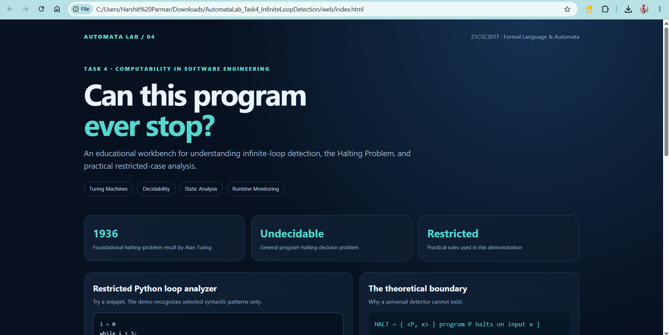
Screenshot of dashboard opened in browser

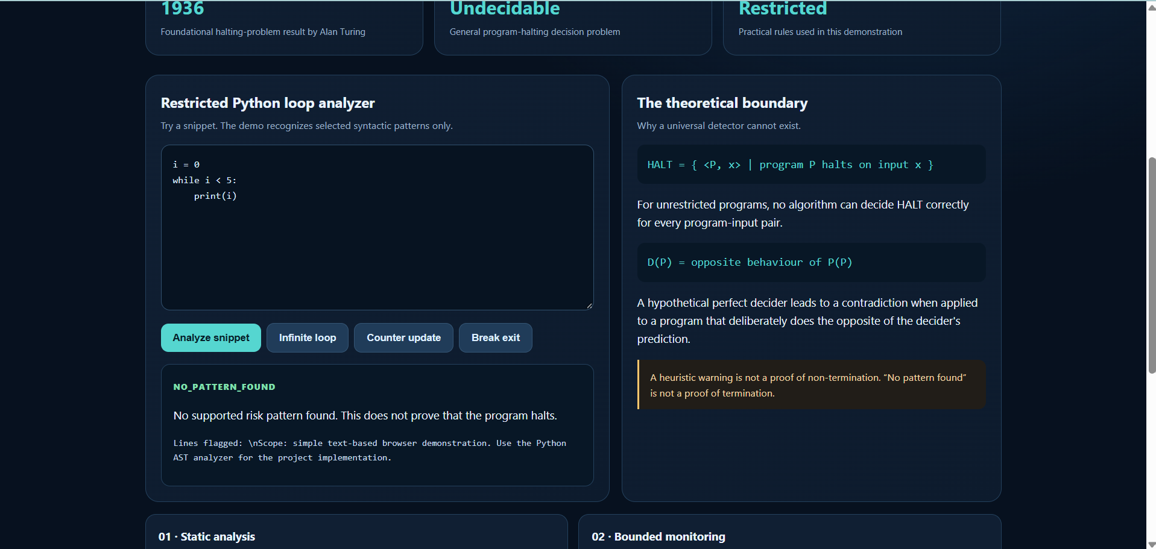
Screenshot showing counter-update example

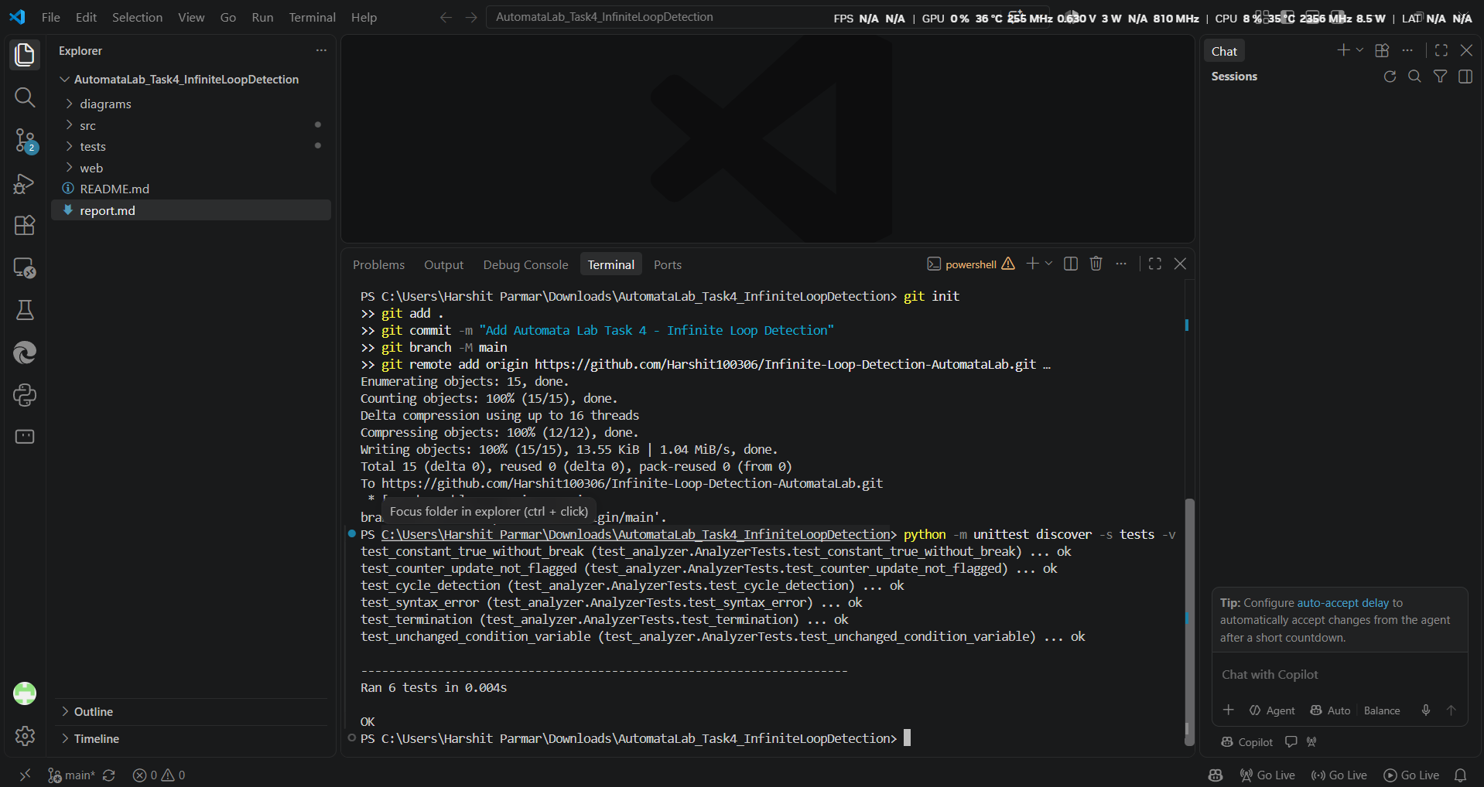
Screenshot of Python unit tests passing

GitHub repository URL
https://github.com/Harshit100306/Infinite-Loop-Detection-AutomataLab

References
A. M. Turing, “On Computable Numbers, with an Application to the Entscheidungsproblem,” Proceedings of the London Mathematical Society, 1936.

M. Sipser, Introduction to the Theory of Computation, 3rd ed., Cengage Learning, 2012.

J. E. Hopcroft, R. Motwani, and J. D. Ullman, Introduction to Automata Theory, Languages, and Computation, 3rd ed., Pearson, 2006.

Python Software Foundation, “ast — Abstract Syntax Trees,” Python documentation, https://docs.python.org/3/library/ast.html.

