Project Name: **Marketplace**

Introduction:

Marketplace is a project based out of Ethereum smart contract. it runs on the blockchain, and allows people to purchase them on the website using cryptocurrency.

Whenever someone purchase the item , they become the owner because the application is powered by a smart contract on the blockchain which manages the marketplace, it tracks who owns the items for sale and it transfer the ownership of the items automatically

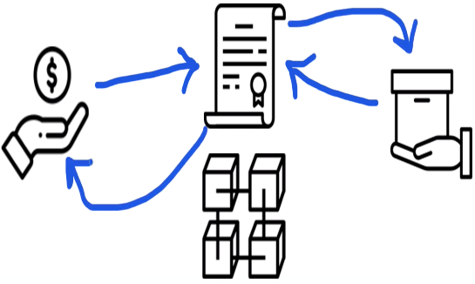

**Problem Definition:**

Nowadays the biggest problem in retail sector is the inability to track the product authenticity, origination of product, availability etc. Conventionally UPC codes are used to keep the track of product data but still unable to provide much information about the supplier authentic etc, here is the solution of it where in this project, due to its peer-to-peer network user will be able to exchange information directly with the supplier of product

**Hardware/Software Specification and requirement:**

* Remix IDE
* Ethereum
* Web3.js
* Solidity Smart contract
* Ganache
* Node.JS
* Truffle framework
* Metamask Ethereum Wallet
* Hardware used (16GB RAM, intel CORE i7 processor, NVidia GEFORCE GTX 4GB GPU +internal graphic processing unit)