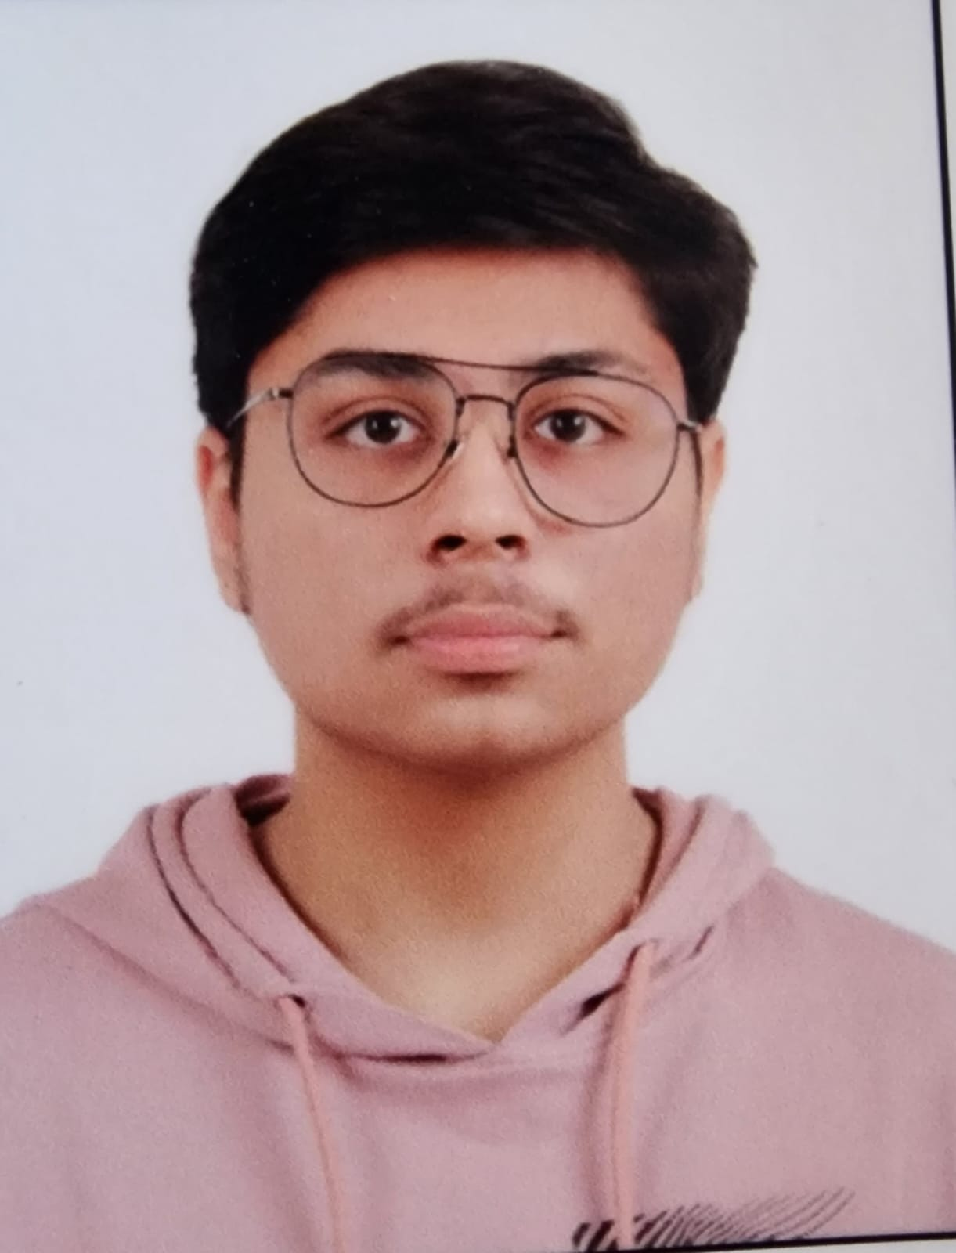
AARAV SAINI
INFORMATION TECHNOLOGY AND ENGINEERING
📍 Sector 86, Faridabad, Haryana
📧 aaravsainii09@gmail.com | 📞 +91 8851757870
🔗 LinkedIn: Aarav Saini

PROFILE
I am a dedicated B.Tech student with a deep passion for coding and technology. From a young age, I have been fascinated by how software shapes the world, and this curiosity has driven me to constantly learn, build, and innovate. My goal is to achieve excellence in life by combining technical expertise with a strong personal drive for growth and success. I possess natural leadership abilities and have successfully led teams in both academic and extracurricular projects, fostering collaboration and productivity. I believe in building strong, meaningful relationships with my peers and colleagues, and I take pride in maintaining a positive and professional attitude in corporate and team environments. My growth mindset pushes me to continuously improve myself—technically, personally, and professionally. I am confident in my ability to contribute effectively to any organization and look forward to creating a meaningful impact through my skills, vision, and dedication to excellence.

EDUCATION
Maharaja Agrasen Institute of Technology | GGSIPU, Delhi
Bachelor of Technology – INFORMATION TECHNOLOGY AND ENGINEERING
2024 – Present | CGPA: 7.76
J.N. International School, Delhi
Senior Secondary (Class 12th) | 2023 – 2024
Percentage: 90%

TECHNICAL SKILLS
- Basic Computer Knowledge (MS Word, PowerPoint)
- Programming: Python (basic), C programming (basic)
- Editing Software: Basic knowledge of DaVinci Resolve

SOFT SKILLS & INTERESTS
- Languages: Fluent in English and Hindi
- Interests: Reading, Debates, Sports, Connecting with new people

PROJECTS & EVENTS
Tech Events
Strong leadership and team management skills developed through active participation in tech fests and group assignments. Known for excellent communication and smooth collaboration with team members during high-pressure events.
Sports Enthusiast
Played badminton competitively during school and regularly represented my class in inter-house tournaments, consistently performing well and showing strong sportsmanship.

ACHIEVEMENTS
- 1st Prize – Intra Lawn Tennis Tournament (School Level)
- Recognized for maintaining discipline and academic excellence throughout school life

