**SYNOPSIS REPORT**

**ON**

**Implementing Compression Algorithm and Secure Transmission over UDP Protocol**

**Submitted by:**

|  |  |  |
| --- | --- | --- |
| Name | SAP ID | Roll No |
| Harsh Narain Mathur | 500069098 | R100218020 |
| Harshit Chauhan | 500069534 | R100218021 |
| Pranay Mahajan | 500068668 | R100218037 |

# *Under the guidance of*

**Mr.Ankit Vishnoi**

Assistant Professor

Department of Systematics

School Of Computer Science

upes-new-logo

# School of Computer Science and Engineering

**University of Petroleum & Energy Studies, Dehradun**

**Aug-Dec 2020**

**Project Proposal Approval Form (2020)**

|  |  |  |
| --- | --- | --- |
| 1 |  |  |
|  |  |

**Minor**

**Synopsis Report (2020)**

**Project Title:**

Implementing Compression Algorithm and Secure Transmission over UDP Protocol

**1. Abstract:**

Over the last few decades there has been a tremendous increase in the amount of digital data produced and transmitted, representing text, images, video, sound, computer programs, etc. With this trend expected to continue, it makes sense to pursue research on compression algorithms.

Compression algorithms reduce the repetition of data without actual loss of data.

The algorithm proposed here deals with compression of text files using word compression techniques by first Huffman coding the input file channel encoding the source coded file and transmitting over UDP protocol.

With its fast-compressed feature, Word Based Compression Algorithm is a great solution, especially for transmission of data that is large and it helps in compression without the loss of data.

It helps in reduction of both compression ratio that is defined as the ratio between the uncompressed size and compressed size and transmission time of data over a channel.

**2. Introduction:**

With the advancement of technology, the amount of data produced has been enormously increasing but the storage being provided is not sufficient to meet the increasing demands. With the help of Word-Based compression algorithm, we can efficiently compress text files for better storage. This can not only be used to reduce storage space requirement but also reduce input/output load.

Data compression is a technique by which the same amount of data is transmitted by using a smaller number of bits. It is the process of modifying, encoding or converting the bits structure of data in such a way that it consumes less space on disk. The compression works in the following way first the message is compressed using encoding algorithm and then it is decompressed using decoding algorithms to get the desired data.

One of the most important algorithm to implement compression is that of huffman encoding and it is used for lossless compression of data. In this it uses variable length encoding where length codes are assigned on the basis of frequency of characters. The character which has the maximum frequency is allotted smallest code and character which has least occurrence gets the highest code.

We compress the file and send it to the receiver the desired file and it is all done with the help of maximum frequency is allotted smallest code and character which has least occurrence gets the highest code.

**3. Literature Review:**

**3.1. Data compression and decompression using Huffman Encoding**

Huffman encoding is used for lossless compression of data. Huffman, uses variable length encoding where length codes are assigned to characters on the basis of frequency of occurrence of character. The character which has the maximum frequency is allotted with smallest bit code and character which has least occurrence gets the highest bit code.

**3.2. Socket programming**

Socket programming is a way of connecting two nodes on a network to communicate with each other. In this the compressed file generated through huffman is transferred to the desired receiver with the help of socket programming. In socket programming the node which accepts request is server and the node that sends request is client.

**4. Problem Statement:**

This project presents a proposal to make connection between client and server using socket programming and compress the large size of text file into small size without any loss of data.

**5. Objective:-**

1. To establish a connection between CLIENT and SERVER using socket programming.

2. To implement compression algorithm to compress the text file.

3. To implement de-compression algorithm to de-compress the text file.

4. To calculate the compression ratio, and space saving percentage.

**6. Methodology:**

* Firstly connection between the client and server is established using socket programming. The server opens up a port number to which client will connect for transmission of text file.
* When the connection is established the sample text file is transferred from client to server.
* Server encrypts the received text file and then scans the entire file and stores the contents in the buffer .
* The encrypted file is then transmitted to the client which decrypts the content and is further transmitted to encoder .
* The frequency count of each character is calculated and store it in a table in ascending order.
* To compress the file prepare the Huffman tree and generate the Huffman code for each character.
* Then the compressed file is passed to the decoder which reads the Huffman encoded file with one binary digit at a time to retrieve the original text.
* After the complete decompression ,decompressed file(original contents of file) is generated which can be accessed by the client

**7. PERT Chart:**

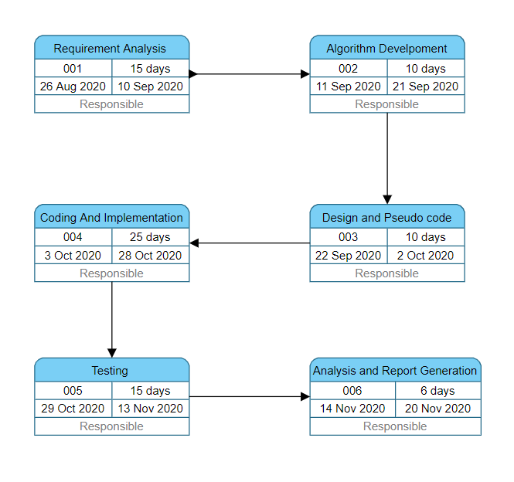

**8. System Requirements:-**

* **Hardware Requirements-**
* Computer System : Two –(32- or-64-bit) Core i5 or higher
* Processor : Dual Core or Higher
* RAM : 512 MB or Higher
* Disk Space : 512 MB

* **Software Requirements-**
* Operating System : Windows 10/8/7 (32- or 64-bit) / Linux
* Software : Text Editor
* Compiler : GCC

**9. References:**

**[1] <https://www.edureka.co/blog/socket-programming-in-java/>**

**[2] <https://www.techiedelight.com/huffman-coding/>**

**[3]** [**https://medium.com/stantmob/data-compression-with-huffman-coding-ad7bcb07c5d5**](https://medium.com/stantmob/data-compression-with-huffman-coding-ad7bcb07c5d5)

**Approved By**

**Mr. Ankit Vishnoi Dr. Monit Kapoor**

**Project Guide Head of Department**