INFO 6205

Ranking System Algorithm Project Report

1. *RANKING SYSTEM:*

* Ranking system algorithm is the process of comparing given data set based on various factors and deciding the most expected outcome for certain event under given circumstances. Conclusion is made depending upon finding probabilities considering certain factors with past data and predicting future events. For an example, with the amount of information available on the web, finding what you need would be nearly impossible without some help sorting through it. Google ranking systems are designed to do just that: sort through hundreds of billions of webpages in our Search index to find the most relevant, useful results in a fraction of a second, and present them in a way that helps you find what you’re looking for.

1. *DATA STRUCTURED USED:*

* Data structure used here is HashMap and that’s due to following reasons:
  + According to the dataset and required data to be stored for analysis and calculations, HashMap provides the best implementation where we can store key as combination of winning team and opponent team and values in the form of match results considering factors like win/loss, average and RPO.

Declaration: HashMap<String, Object>

Where, Key = String = Concatenated String of winning team and opponent’s name

Value = Object = Statistical data of series between teams

Ex – If series has been played between India and Australia then Key will be India-Australia

and value will be statistical data of series between them

* + HashMap provides time complexity of O(1) for both put and get operations, making it efficient data structure when such operations happen frequently. Ultimately, it provides best efficient solution in terms of time.

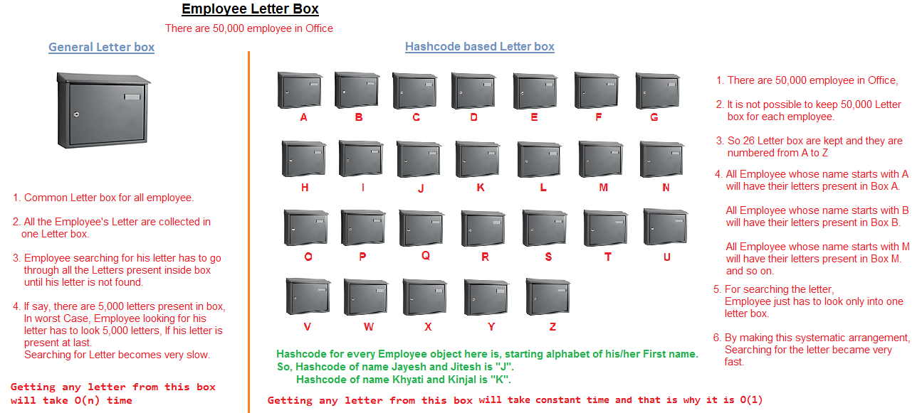

1. *DISCRETE VS CONTINUOUS DATASET*

* **Discrete Data:** Data that can only take certain values.

For example: the number of students in a class (you can't have half a student).

* **Continuous Data:** Data that can take any value (within a range).

Example - People's heights could be any value (within the range of human heights), not just certain fixed heights.

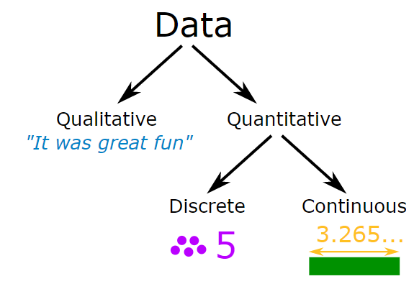

1. *DATASET INTRODUCTION*

* Dataset indicates the number of teams and statistics for teams’ matches with remaining teams
* Dataset provides below information
* Dataset has total 81 records for statistics of matched played between teams over last 3 years
* Data consider following parameters with its nature of data
* Each team played series of how many matches with remaining teams – Discrete data
* Matches won out of total matches - Discrete data
* Average during the series – Continuous data
* RPO during the series - Continuous data

1. Win/Loss statistics for each team

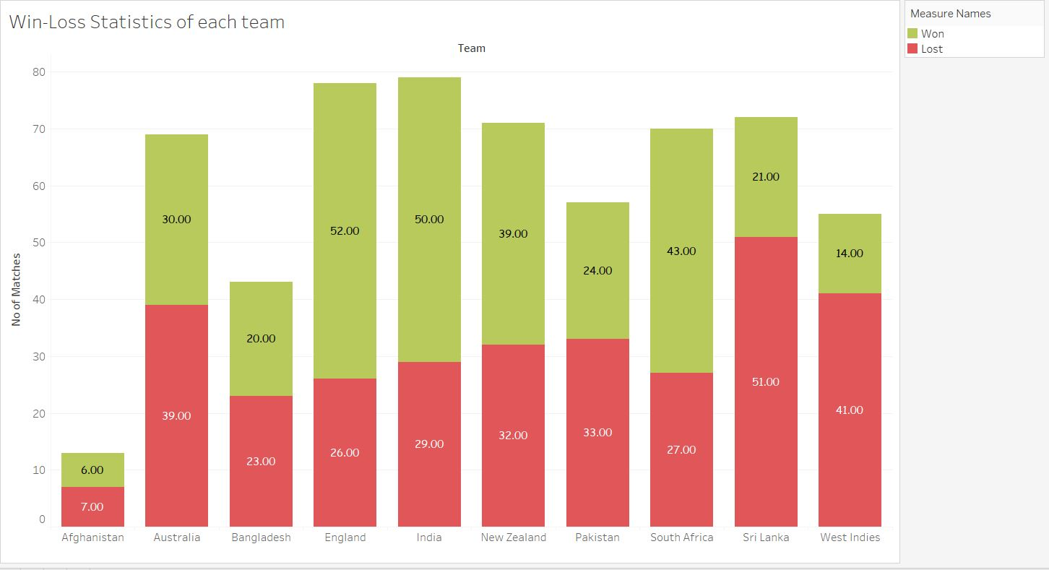

1. Mean of the *Average* of each team

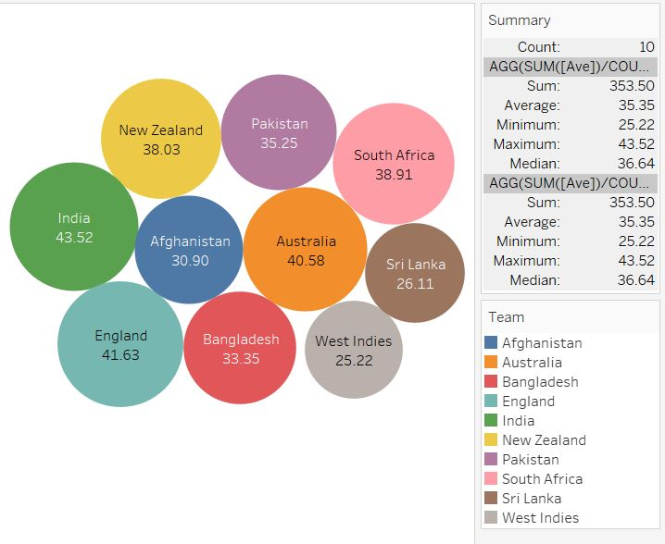

1. Mean of *RPO* of each team

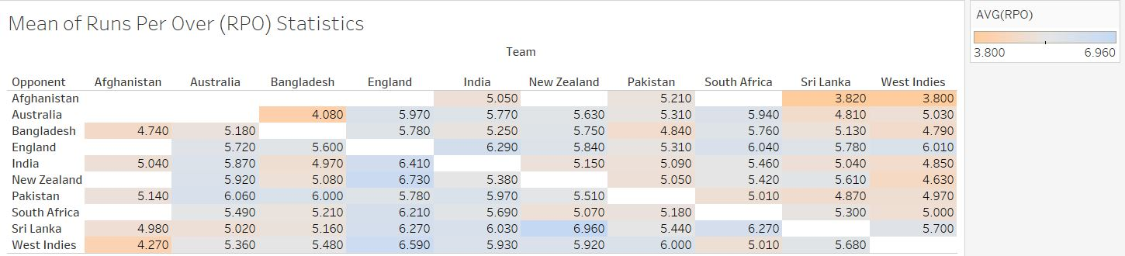

1. *PROGRAM AND ALGORITHM FLOW:*

