1)Screenshot of the report view page which appears when power desktop starts.

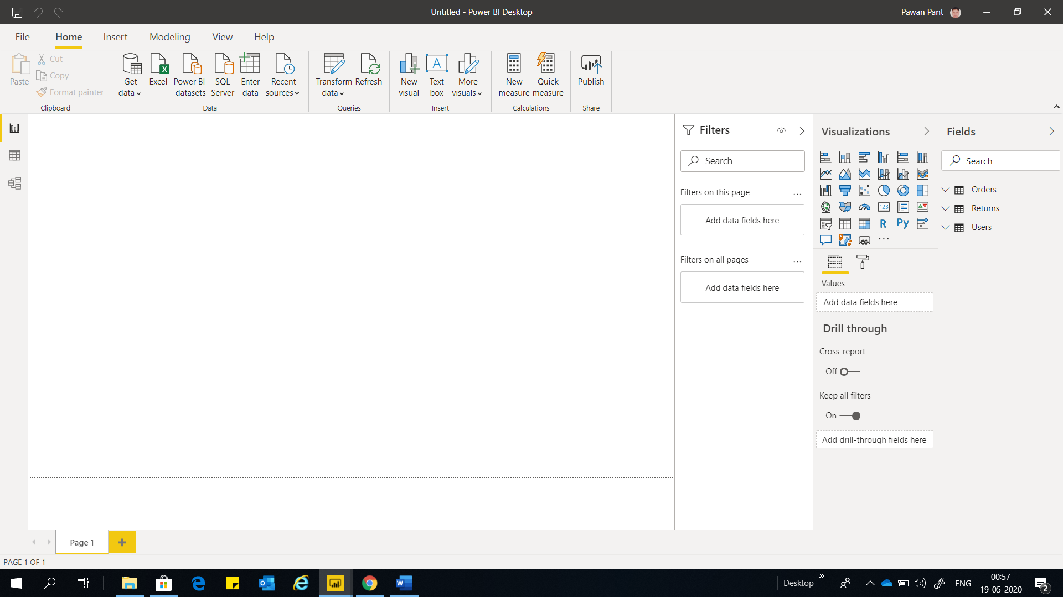

2***) All the required screenshots***

**Report view:**

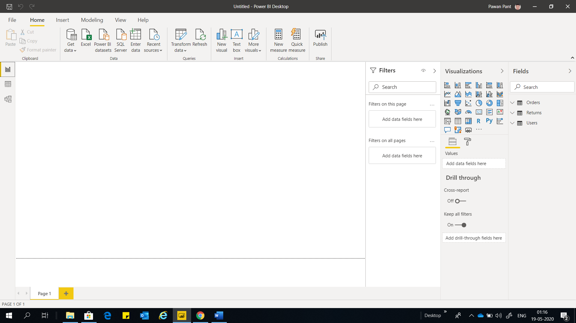

Data View

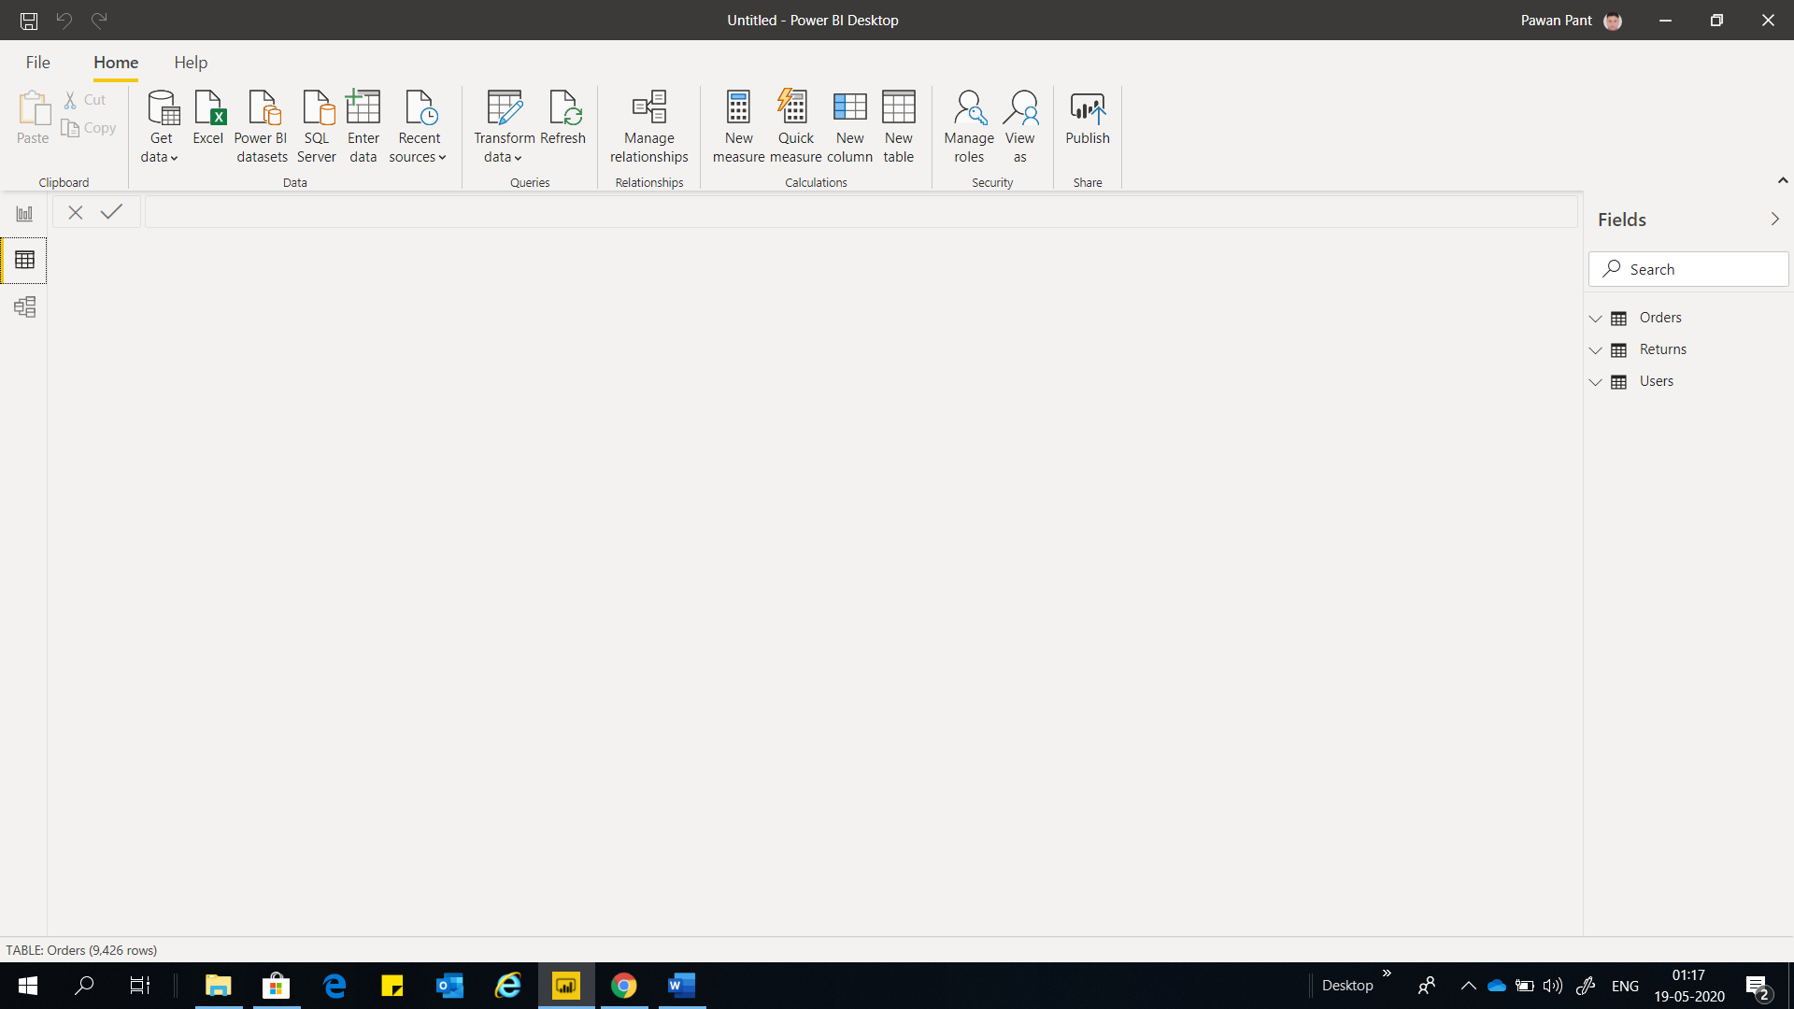

Model view

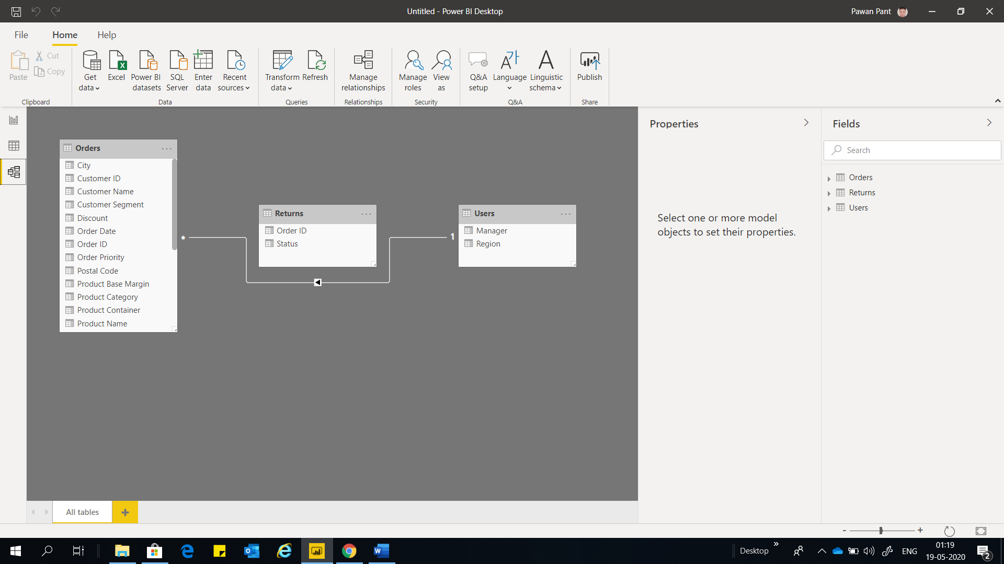

Power Query Editor

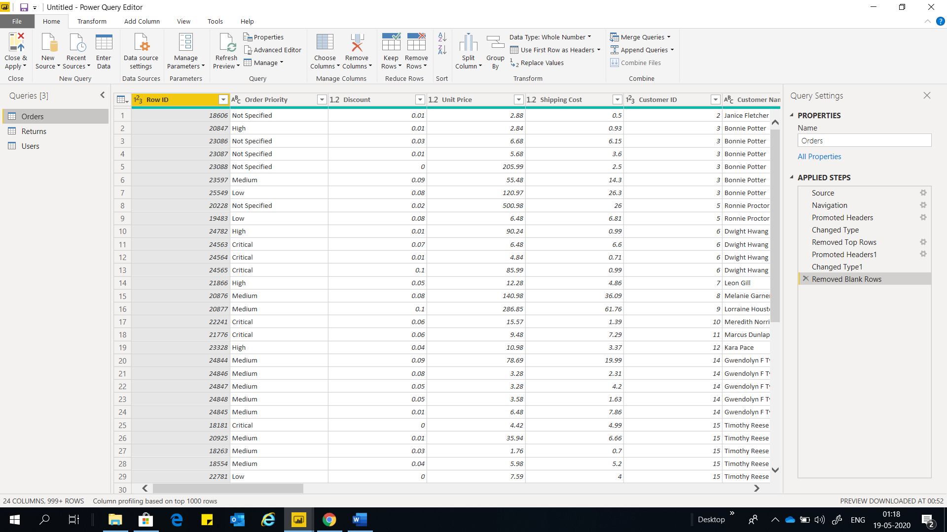

Advance Editor

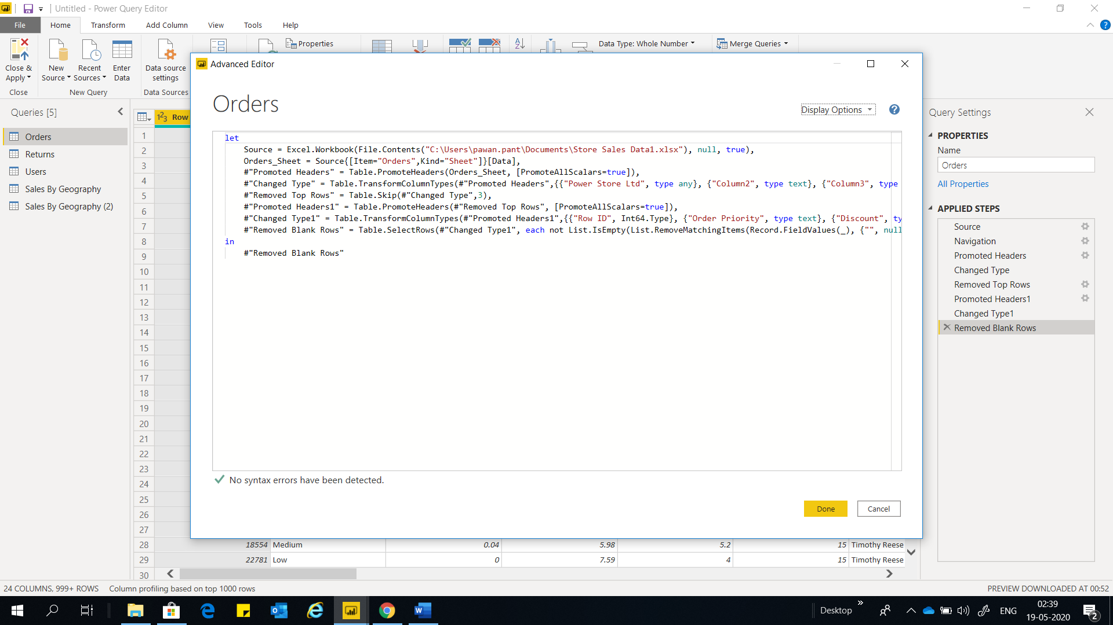

**Power BI Desktop*:***

It is the free application we install in our local computer that lets us to connect, transform, visualize our data through charts and graphs that provide relation between various parameters.

**Power BI pro:**

Power BI pro is the application which is charged to the organization according to the users and time. It is quick easy to use self-service analytics for users requiring collaboration, dashboard sharing ad- hoc analysis and report publishing. It has more advanced features than Power BI Desktop. The features are listed as:

Self-service and modern BI in the cloud

Collaboration, publishing, sharing and ad-hoc analysis

Fully managed by Microsoft

Price: $9.99 per month per user

**Power BI Premium**:

Power BI Premium is also chargeable. It has more advanced features than Power BI Pro. An add on to power bi premium is for projects requiring large scale data demanding performance and the ability to distribute content without requiring per user licensing. The features are listed below:

Enterprise BI, big data analytics cloud and on-premises reporting

Advanced administration and deployment controls

Dedicated cloud compute and storage resources

Price: $4995 monthly price per dedicated cloud compute and storage resource with annual subscription.