Important Problems

1. Sequence with maximum consecutive elements
2. Check is valid Preorder
3. Pair of Sum in O(N) time and O(H) space
4. Remove Nodes with only 1 child
5. LL random pointers
6. Binary Search - > Find median of row sorted array

DE Shaw
1. Maximum sum square submatrix of size k
2. Minimum size subarray sorting which array becomes sorted
3. Minimum Platforms GFG https://practice.geeksforgeeks.org/problems/minimum-platforms/0

Microsoft
1. Spiral Order matrix print and build
2. Max Distance interview bit
3. Median of 2 sorted arrays(write in paper and keep)

TO DO (MUST DO AT ANY COST):
1. Nth lexicographical permutation find
2. KMP

DE Shaw PPT:
1. Firm Overview – Global Investment and Tech dev firm
front middle and back office.
High tech usage
Arcesium pure tech
Startup type culture
Core Principles -
Hire extraordinary
High Road
Unusually ambitious goal
Focus on firm
Analysis and communication
Work life balance
Finance admin and tech divisions

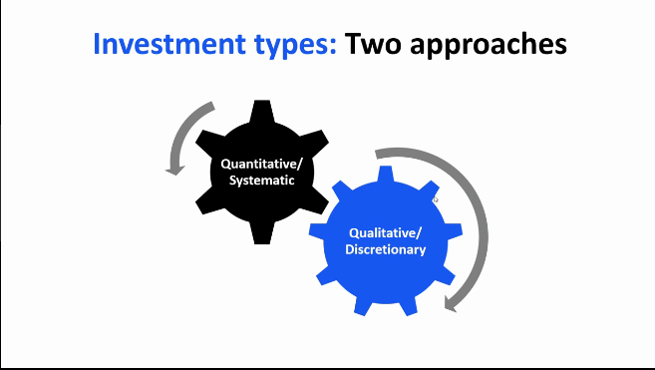
front office
quality and test engineering
systems

HAMARA Front tech office
-

