**Experiment - 1**

**(Installation of Spark)**

**Requirements:**

* HomeBrew
* Scala
* Java
* Apache Spark
* Xcode-select

**Steps for installing spark are as follows:**

* Installing HomeBrew in mac from the following link **/usr/bin/ruby -e “$(curl -fsSL** [**https://raw.githubusercontent.com/Homebrew/install/master/install**](https://raw.githubusercontent.com/Homebrew/install/master/install)**)”.**
* Installing xcode-select from the following command: “xcode-select -install”.
* Installing Java by downloading Java SE11 from link: “<https://www.oracle.com/technetwork/java/javase/downloads/jdk11-downloads-5066655.html>”, and installing it.
* Installing Scala and python as “brew install Scala” and “brew install python” respectively.

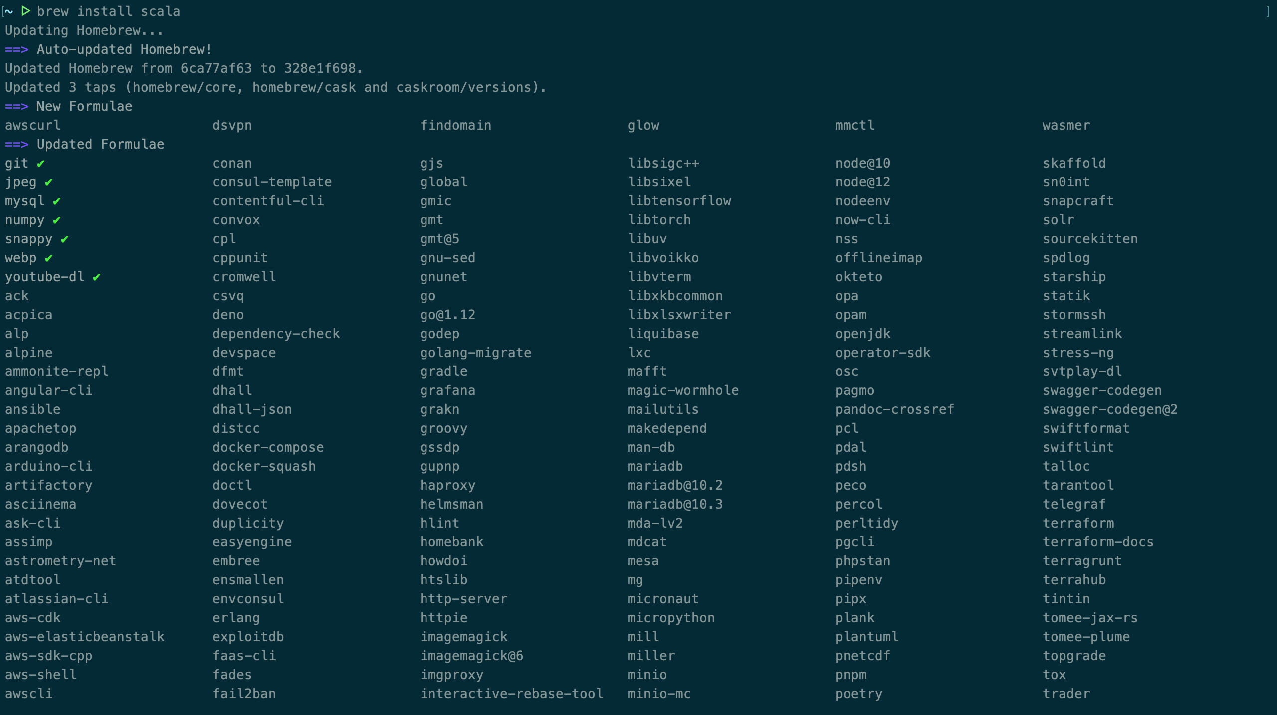

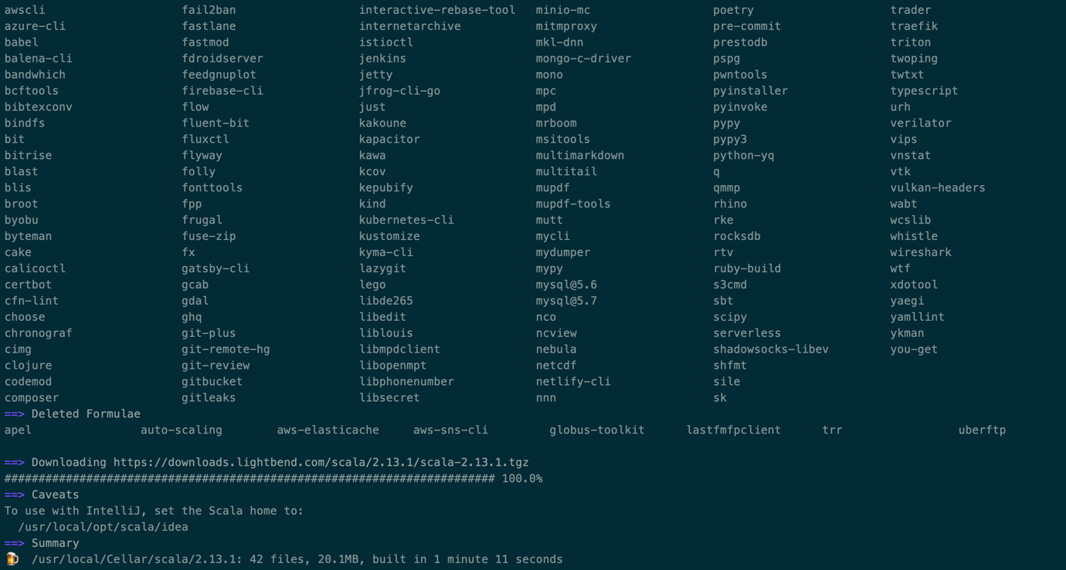

* Install Apache Spark by running “brew install apache-spark”.
* Verify the installation by running “spark-shell” in the terminal.

