**Experiment – 2**

**(Using Scala)**

Scala Work:

* Creating dataset by running “val data = 1 to 50000” in terminal.

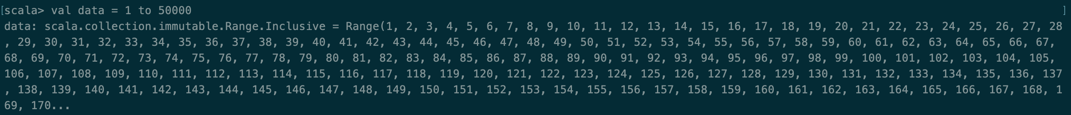

* Sampling by “val SparkSample = sc.parallelize(data, 30)”.



* Filtering the data by “SparkSample.filter(_ <10).collect())”.



**Experiment – 3**

**(Using Python)**

Python Work:

* Creating a text file by “file = open(“Harshit_Hobbies.txt”, “w”)”.



* Adding data into it by running “file.write(“Games”)”.

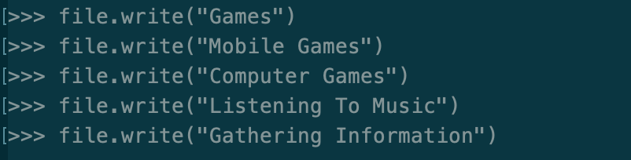

* Setting the textfile path by “textfile = sc.textFile(“Users/HarshitDawar/Downloads/Harshit_Hobbies.txt”)”



* Counting the elements by “textfile.count()”.

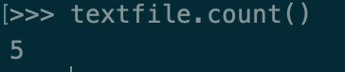

* Printing the first element by “textfile.first()”.

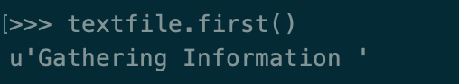

* Printing the occurences of a particular word by “line = textfile.filter(lambda line: “Games” in line)”.

