1. Which are the top three variables in your model which contribute most towards the probability of a lead getting converted?

**i. The number of Total Visits to the website.**

**ii. The Total Time Spent on the Website.**

**iii. The presence of Lead Origin through Lead Add Form.**

1. What are the top 3 categorical/dummy variables in the model which should be focused the most on in order to increase the probability of lead conversion?

**i. The occurrence of Lead Origin via Lead Add Form.**

**ii. Engagement in the Last Activity involving a Phone Conversation.**

**iii. Lead Sourcing specifically from the Welingak Website.**

1. X Education has a period of 2 months every year during which they hire some interns. The sales team, in particular, has around 10 interns allotted to them. So during this phase, they wish to make the lead conversion more aggressive. So they want almost all of the potential leads (i.e. the customers who have been predicted as 1 by the model) to be converted and hence, want to make phone calls to as much of such people as possible. Suggest a good strategy they should employ at this stage.

**In order to address this question effectively, it's essential to consider the sensitivity and specificity plot. In our scenario, sensitivity refers to the accuracy of predicting actual conversions among all conversions. As the company employs more interns, we aim to set a lower cutoff threshold. This adjustment enables our model to capture nearly all potential leads. However, a consequence of lowering the threshold is an increase in misclassification of non-conversions as conversions.**

**Despite this drawback, the decision to decrease the cutoff threshold represents a strategic tradeoff. With a larger workforce available, we can manage the higher volume of misclassified non-conversions. Therefore, the benefits of capturing a greater number of leads outweigh the cost of dealing with false positives.**

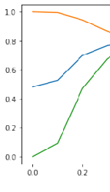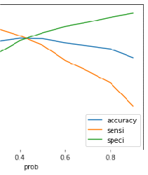

1. Similarly, at times, the company reaches its target for a quarter before the deadline. During this time, the company wants the sales team to focus on some new work as well. So during this time, the company’s aim is to not make phone calls unless it’s extremely necessary, i.e. they want to minimize the rate of useless phone calls. Suggest a strategy they should employ at this stage.

# Considering our operational constraints with fewer personnel available to make calls to potential customers, prioritizing accuracy in our predictions becomes paramount. Specifically, we aim to maximize our specificity, which refers to accurately predicting non-conversions out of the total number of actual non-conversions.

# To achieve this, we should select a cutoff point on the specificity plot that is significantly higher. By doing so, we optimize our model to correctly identify the majority of non-conversions, minimizing the risk of wasting resources on contacting leads that are unlikely to convert. This strategic approach ensures that our limited manpower is utilized efficiently and effectively, maximizing the return on our efforts.