**Demo**

**Blockchain server initiation and compiling smart contracts**

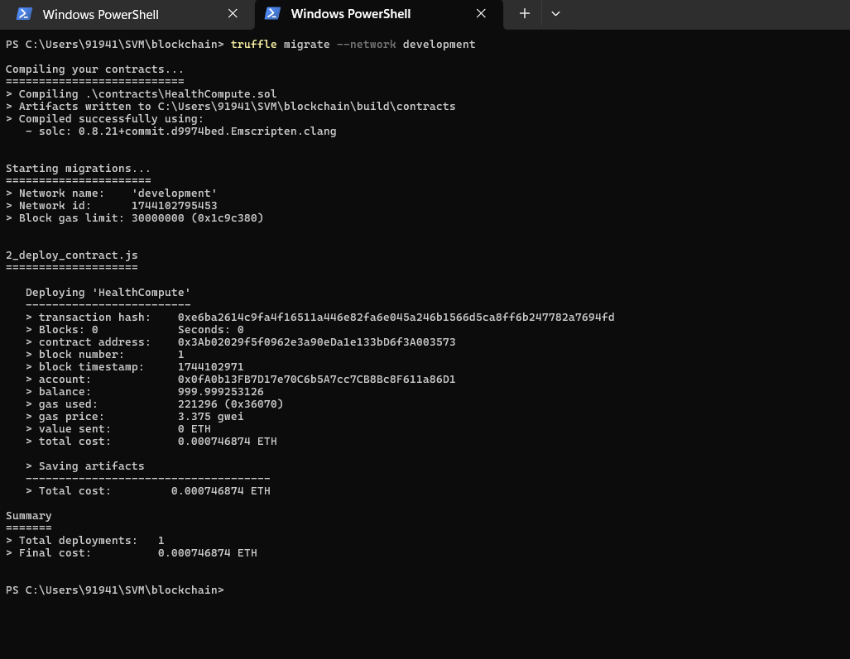

**Client sending medical records (encrypted)**

**

**Server processing**

**Result Hashing at blockchain server**

**Client gets result and verification of hashes(result+data)**

**Model Accuracy**

