ARTIFICIAL INTELLIGENCE PROJECT

UCS411
Self Driving Car
Using Reinforcement Learning

Submitted By:
Kirtan Kumar Borana (102317230)
Harshit Madaan (102317234)
Yati Bhansali (102317249)

Submitted To:
Ms. Mrinalini Kakroo


Computer Science and Engineering Department
Thapar Institute of Engineering and Technology
(Deemed to be University), Patiala, Punjab, India
Jan-June 2025

Acknowledgement

I would like to express my sincere gratitude to all those who supported and guided me throughout the course of this project.
First and foremost, I would like to thank Ms. Mrilani, under whose valuable guidance and encouragement, I was able to successfully complete this project on Autonomous Driving Using Deep Q-Learning in CARLA. I also extend my heartfelt thanks to the CARLA Simulator Open-Source Community for providing a rich platform that enabled the simulation of real-world driving scenarios. I am grateful to my peers and colleagues for their constructive feedback and support throughout this journey. Lastly, I thank my family and friends for their constant encouragement and motivation. Their contributions have been invaluable, and this project would not have been possible without their support.

Index

S.No. | Title | Page No.
1. | Abstract | 4
2. | Introduction | 5
3. | Problem Statement | 6
4. | Objectives | 7
5. | Tools Used | 8
6. | Algorithms | 9
7. | Methodology | 13
8. | Result | 18
9. | Conclusion | 20
10. | References | 21

Abstract

In recent years, autonomous vehicles have emerged as a transformative innovation aimed at enhancing road safety, improving traffic efficiency, and reducing human error. This project presents a simulation-based approach to training a self-driving agent using Deep Q-Learning (DQN) within the CARLA simulator environment. The agent is equipped with a front-facing RGB camera, capturing real-time visual inputs to make driving decisions.

Leveraging a convolutional neural network (CNN) model based on the Xception architecture, the agent learns optimal driving strategies by interacting with the environment, receiving rewards for efficient and collision-free navigation. A carefully designed reward function incentivizes safe, high-speed driving while penalizing collisions and inefficient behavior.

Through repeated episodes, the agent improves its driving policy by balancing exploration and exploitation. The CARLA simulator provides a safe, realistic, and customizable environment to rigorously train and evaluate the performance of the autonomous system without real-world risks. This project highlights the potential of combining reinforcement learning with vision-based perception for scalable, robust self-driving solutions and lays a foundation for future advancements in autonomous driving research.

Introduction

- Autonomous vehicles and their goals:
Autonomous vehicles are developed with the objective of significantly reducing the number of road accidents by eliminating human error, which is a major cause of traffic incidents. Additionally, they aim to improve the overall flow of traffic by optimizing driving behavior and supporting 24/7 mobility without the limitations of human fatigue, distractions, or reaction times.
- Limitations of traditional rule-based systems:
Traditional rule-based driving systems are often rigid and lack the adaptability needed to operate effectively in dynamic and unpredictable real-world environments. They are unable to learn from new experiences or improve over time, making them unsuitable for handling complex driving situations where flexibility and adaptation are crucial.
- Overview of CARLA Simulator:
CARLA is an open-source simulation platform specifically designed for autonomous driving research. It provides highly realistic maps, diverse environmental conditions, and accurate sensor models such as cameras, LiDARs, and radars. By offering a safe and controlled environment, CARLA allows researchers to test and train AI agents without the risks associated with real-world experiments.
- Approach of the Project:
In this project, we utilize Reinforcement Learning (RL) methods in combination with a front-facing camera within the CARLA simulator. The agent learns to drive by interpreting visual input from the camera and receiving feedback based on its actions, gradually improving its ability to navigate complex driving environments through continuous interaction and learning.
- Project Motivation and Purpose:
We selected this project to gain deeper insights into how AI systems make decisions in complex, real-world-like scenarios. It also allows us to develop a scalable, simulation-based solution for autonomous driving, which can later be adapted and extended for use in real-world applications, contributing to the advancement of intelligent transportation technologies.

Problem Statement

The pursuit of fully autonomous vehicles poses significant challenges, particularly in dynamic, uncertain, and highly variable environments where traditional rule-based control systems often prove inadequate. Rule-based approaches, constrained by predefined logic and lacking the ability to learn from new experiences, are ill-suited for complex real-time tasks such as lane keeping, obstacle avoidance, and adaptive navigation. To overcome these limitations, this project proposes the development of a reinforcement learning-based control system for an autonomous vehicle within a simulated environment. By leveraging a reward-driven learning paradigm, the agent is trained through continuous interaction with its environment, improving its performance over time via trial-and-error feedback mechanisms. This methodology enables the agent to autonomously develop robust, adaptable strategies for navigation without reliance on hard-coded rules, offering a scalable solution for real-world autonomous driving applications and advancing the field of intelligent transportation systems.

Objectives

- Simulate a Realistic Driving Environment:
Create a virtual environment using the CARLA simulator that replicates real-world road conditions, including lane markings, obstacles, and varied traffic scenarios. This will allow the self-driving agent to interact with dynamic environments and test its capabilities in realistic settings.
- Implement Reinforcement Learning for Perception and Control Tasks:
Use reinforcement learning techniques to train the self-driving car to perform key tasks like lane detection and obstacle avoidance based on visual input. The agent will learn optimal driving strategies by interacting with its environment and receiving feedback.
- Define Effective State, Action, and Reward Structures:
Develop an appropriate state space (e.g., vehicle’s position, speed), action space (e.g., steering, acceleration), and a reward function that encourages safe and efficient driving behaviors. The reward system will help the agent focus on safe navigation while avoiding obstacles and staying within lane boundaries.
- Train the Agent for Lane Keeping and Obstacle Avoidance:
Allow the reinforcement learning agent to learn and refine its lane-keeping and obstacle-avoidance strategies through continuous interaction with the simulated environment. The agent will improve its decision-making capabilities over time through trial and error.
- Evaluate the Agent’s Performance:
Assess the agent’s ability to navigate different driving scenarios by measuring metrics such as lane adherence, collision rates, and obstacle avoidance. The evaluation will help determine the effectiveness of the agent’s learned behaviors in real-world-like conditions.

Tools Used

Tools | Purpose | Description
CARLA Simulator | Simulation Environment | Open-source simulator used to create realistic driving scenarios for training.
Python | Programming Language | Used for scripting, algorithm development, and integrating various components.
NumPy | Data Processing | Handles numerical operations and efficient array manipulation.
TensorBoard | Visualization and Monitoring | Monitors training performance and visualizes key learning metrics.
Keras | Deep Learning Framework | High-level neural networks API built on TensorFlow; used for building, training, and evaluating deep learning models, particularly for reinforcement learning tasks.
OpenCV | Computer Vision | Used for image processing tasks such as lane detection and obstacle recognition.
tqdm | Progress Visualization | Used for displaying progress bars during training episodes.
math | Mathematical Operations | Provides mathematical functions (e.g., trigonometry for camera positioning).
glob & sys | System Utilities | Used for dynamically importing CARLA Python API and handling system paths.

Algorithms Used

1. Deep Q-Learning (DQN)
- Deep Q-Learning extends classical Q-Learning by using a deep neural network (CNN) instead of a simple Q-table.
- The input to the network is a raw image captured by the car's front-facing camera.
- The output is a set of Q-values—one for each possible discrete action (e.g., turn left, go straight, turn right).
- The agent selects actions to maximize cumulative rewards over time.

How it works:
- At each time step, the agent observes the state (camera image).
- It predicts Q-values for all possible actions.
- It selects an action either randomly (exploration) or based on the highest Q-value (exploitation).
- It performs the action in the environment, receives a reward, and observes the next state.
- The network is trained to minimize the difference between predicted and actual Q-values using Mean Squared Error (MSE) loss.
Thus, over many episodes, the agent learns optimal driving behavior by continuously improving its policy based on feedback from the environment.

2. Experience Replay (Replay Buffer)
- Problem without Replay: Consecutive experiences are highly correlated, making training unstable.
- Solution: Store experiences (state, action, reward, next_state, done) in a replay memory buffer (deque).
- During training, random mini-batches are sampled from this buffer to train the model.

Benefits:
- Breaks temporal correlation between samples.
- Improves learning efficiency and stabilizes updates.
- Allows the model to learn from past mistakes and successes, not just the latest move.

3. Target Network
- Problem without Target Network:
During training, the Q-values being predicted keep changing, making learning highly unstable.
- Solution:
Maintain a separate target network, which is a delayed copy of the main model.
- Every few steps, the target network’s weights are updated to match the main network.

Benefits:
- Stabilizes learning by fixing the target during mini-batch updates.
- Helps avoid feedback loops where the model is chasing its own moving targets.

4. Epsilon-Greedy Exploration Strategy
- Exploration vs Exploitation:
  - Exploration: Trying new actions randomly to discover better strategies.
  - Exploitation: Using known best actions to maximize reward.
- The agent follows an epsilon-greedy policy:
  - With probability ε: Pick a random action (exploration).
  - With probability 1 - ε: Pick the action with highest Q-value (exploitation).

Epsilon Decay:
- Starts with high ε (more exploration).
- Gradually decays ε to encourage more exploitation as the agent learns.

5. Bellman Equation for Q-Value Update
- DQN updates its Q-value predictions based on the Bellman equation:
- Where:
  - Q(s,a) = Predicted value of taking action aaa in state sss.
  - γ = Discount factor (importance of future rewards).
  - reward = Immediate reward received.
  - Max ⁡Q(next_state,a′) = Maximum predicted Q-value for next state.

How it's used:
- After every action, the model updates its predictions to reflect not just immediate reward, but also the expected future rewards.
In code:
The Bellman update is applied inside the training function when adjusting the target Q-values.

How the Algorithm Evaluates Performance
The agent's performance is evaluated based on total cumulative rewards per episode. Key performance indicators:
- High rewards indicate smooth, safe, and efficient driving.
- Low or negative rewards imply crashes, slow driving, or failure to navigate properly.
- Over time, improvements are tracked by plotting:
  - Average rewards
  - Minimum and maximum rewards
  - Success rates
Rewards structure:
Event | Reward
Driving fast (>50 km/h) | +1
Driving slowly (<50 km/h) | -1
Collision | -200
Performance monitoring is automated using a custom TensorBoard logger that logs stats at regular intervals.
Methodology

How CARLA Simulator Works
- CARLA (Car Learning to Act) is a highly realistic open-source driving simulator developed specifically for autonomous vehicle research.
- It provides:
  - Detailed urban and suburban maps (roads, traffic, pedestrians, buildings).
  - Fully controllable vehicles and extensive APIs for custom driving tasks.
  - Sensors such as RGB cameras, collision sensors, LIDAR, semantic segmentation.
- Sensor Setup in This Project:
  - A front-facing RGB camera captures images at 640×480 resolution.
  - A collision sensor detects crashes against obstacles.
- CARLA allows safe training of AI agents in complex scenarios without real-world risks like property damage or human injury.

How DQN is Integrated with CARLA
- The agent receives visual input from the camera sensor mounted on the simulated car.
- Images are preprocessed (reshaped and normalized) before being input into a Convolutional Neural Network (CNN).

- The CNN predicts Q-values corresponding to three discrete driving actions:
  - Go Straight
  - Turn Left
  - Turn Right
- The agent selects actions based on an epsilon-greedy strategy:
  - Either explore (random action) or exploit (highest predicted Q-value action).
- The selected action is executed in CARLA via steering and throttle commands.
- After executing an action, the agent:
  - Receives a reward based on speed and collision status.
  - Observes the next frame (next state).
  - Stores the experience for training.
Thus, the CARLA environment provides real-world-like feedback to the agent’s decisions, enabling continuous learning and performance improvement.

Step-by-Step Working of the System
Step | Description
Step 1 | Initialize the CARLA server, world, and blueprint library. Connect client to CARLA.
Step 2 | Spawn the vehicle at a random location in the map.
Step 3 | Attach sensors: Front RGB camera and Collision Sensor to the vehicle.
Step 4 | Start the episode: capture the first camera frame as the initial state.
Step 5 | Preprocess the frame (reshape, normalize pixel values).
Step 6 | Predict Q-values using the deep neural network (CNN model).
Step 7 | Choose an action: either explore (random) or exploit (best Q-value) based on ε-greedy policy.
Step 8 | Apply the selected action in CARLA using vehicle control commands (steer + throttle).
Step 9 | After executing action: capture the next camera frame (new state) and receive a reward.
Step 10 | Store the (state, action, reward, next_state, done) tuple in replay memory.
Step 11 | Sample random mini-batches from replay memory after enough experiences.
Step 12 | Train the DQN model using Bellman update rule on mini-batches.
Step 13 | Periodically update the Target Network to stabilize training.
Step 14 | If a collision occurs or time limit ends, terminate the episode.
Step 15 | Reduce ε (epsilon) slightly to favor exploitation in future episodes.
Step 16 | Restart a new episode: respawn vehicle and repeat Steps 4–16.
Step 17 | Monitor performance using average rewards and loss values via TensorBoard.
Step 18 | Save trained models periodically if performance thresholds are met.

Core Mechanisms Supporting the Methodology
- Experience Replay:
Stores all past experiences in a replay buffer to break correlations and allow learning from diverse situations.

- Target Network:
A secondary network that updates slowly to make Q-learning stable and prevent oscillations during training.
- Epsilon Decay:
Starts with a high exploration rate (ε=1), gradually reduces it over episodes to allow more exploitation once learning progresses.
- Bellman Equation:
The fundamental mathematical principle guiding how Q-values are updated based on future reward estimations.

Reward Structure Design
Rewards are carefully designed to shape the agent's driving behavior:
Behavior | Reward
Speed > 50 km/h | +1
Speed < 50 km/h (too slow) | -1
Collision detected | -200
Thus, the agent is encouraged to drive smoothly and efficiently while avoiding crashes.

Performance Evaluation
- The system evaluates the agent's learning progress using:
  - Average Reward per Episode: Measures how well the agent is driving.
  - Collision Rate: How often the agent crashes.
  - Episode Duration: How long the agent survives before failing.

- TensorBoard Visualizations:
  - Tracks reward trends.
  - Monitors epsilon decay.
  - Observes training loss curves.
Successful training is observed when:
- Average rewards consistently increase.
- Collision events decrease.
- The agent generalizes to new spawn points and environments.

Code
Self Driving Car Code

Conclusion
This project effectively demonstrated the use of Deep Q-Learning (DQN) to train a self-driving car within the CARLA simulator, showcasing the potential of reinforcement learning (RL) in autonomous vehicle navigation. By combining a vision-based perception system with DQN, the agent learned to handle complex driving scenarios through continuous interaction with a realistic simulated environment.Key highlights of the project include:
- Stable Learning Framework: The integration of DQN, Experience Replay, and Target Networks ensured stable training. The epsilon-greedy exploration strategy struck a balance between exploration and exploitation, enabling the agent to gradually improve its driving policy.
- Performance Improvement: Over the course of 100 training episodes, the agent showed marked progress—average rewards increased, collisions decreased, and episode durations extended (from 5–6 steps to 8–9 steps), reflecting improved lane adherence and obstacle avoidance.
- Role of Hyperparameters: The epsilon decay rate proved essential in guiding learning efficiency. Initial high values of ε (~1) promoted exploration, while gradual decay led to more stable and consistent behavior. This emphasizes the critical role of hyperparameter tuning, particularly ε and the discount factor γ, in achieving effective convergence.
- Safe and Realistic Simulation: The CARLA simulator provided a high-fidelity and risk-free platform for evaluating autonomous navigation strategies, allowing for realistic experimentation without real-world risks.
- Scalability for Future Work: While the core objectives were met, future enhancements could involve sensor fusion (e.g., LiDAR, radar), more advanced RL algorithms (such as PPO or SAC), and enhanced reward structures to support adaptability across diverse driving conditions.
This project validates reinforcement learning as a viable approach to autonomous driving, particularly in simulated environments. It highlights the importance of well-designed training strategies and hyperparameter tuning for effective agent learning. Building on this foundation can help close the gap between simulation and real-world deployment, contributing to the advancement of intelligent, safe, and efficient transportation systems.
In summary, the project not only met its technical goals but also provided valuable insights into RL-based autonomous driving, offering a strong platform for future innovation.
References

[1] CARLA Simulator Official Documentation
https://carla.readthedocs.io/en/latest/
[2] CARLA GitHub Repository
https://github.com/carla-simulator/carla
[3] Deep Reinforcement Learning for Autonomous Driving: A Survey (Research Paper)
https://arxiv.org/abs/2106.12927
[4] Deep Q-Learning Algorithm (DQN) Explained
https://www.deepmind.com/research/publications/playing-atari-with-deep-reinforcement-learning
[5] Reinforcement Learning Specialization – University of Alberta (Coursera)
https://www.coursera.org/specializations/reinforcement-learning
[6] Understanding Evaluation Metrics in RL
https://spinningup.openai.com/en/latest/spinningup/rl_intro3.html
[7] Official OpenAI SpinningUp Documentation (Algorithms like PPO, DQN)
https://spinningup.openai.com/en/latest/

Result

Accuracy Score
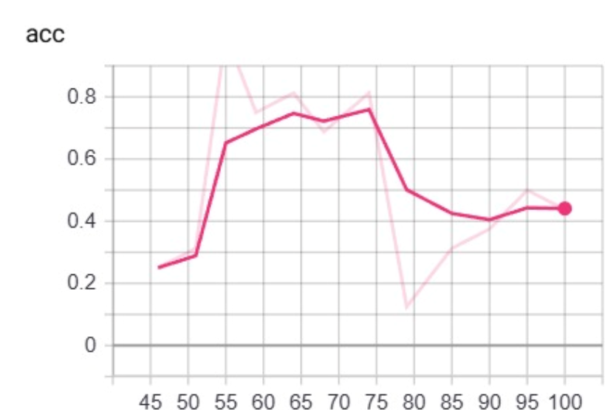
Number of iterations
- This is the epsilon in epsilon-greedy exploration:
•High epsilon → random exploration
•Low epsilon → greedy exploitation
- Here, the agent gradually transitions from exploring to exploiting.

3. Average Reward
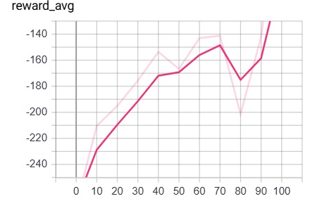
Number of iterations

- This is policy evaluation accuracy, typically measuring how often the selected action matches an ideal or expert policy
- The dip after ~75 episodes might indicate exploration noise or environmental difficulty increasing.
- Accuracy = (Correct Predictions) / (Total Predictions)

2. Epsilon
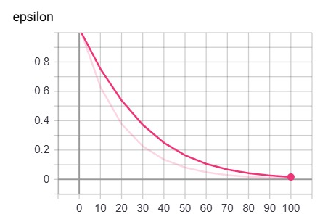
Number of iterations

- Steady increase in average reward over episodes, improving from -240 to ~-140.
- Measures long-term performance of the agent’s actions.
- Rising average reward means the agent is learning to take better actions over time.

4. Reward Maxima
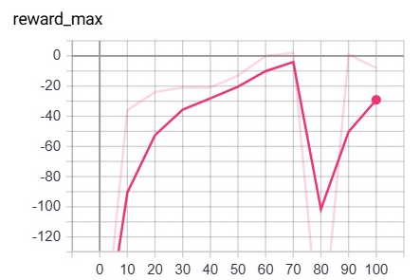
Number of iterations
- Reflects worst-case performance; how badly the agent can perform.
- Rising values indicate that worst-case scenarios are getting less bad.
- Higher (less negative) reward_min → better robustness.
- Wide gap between reward_max and reward_min = inconsistent performance.

6. Episode Duration
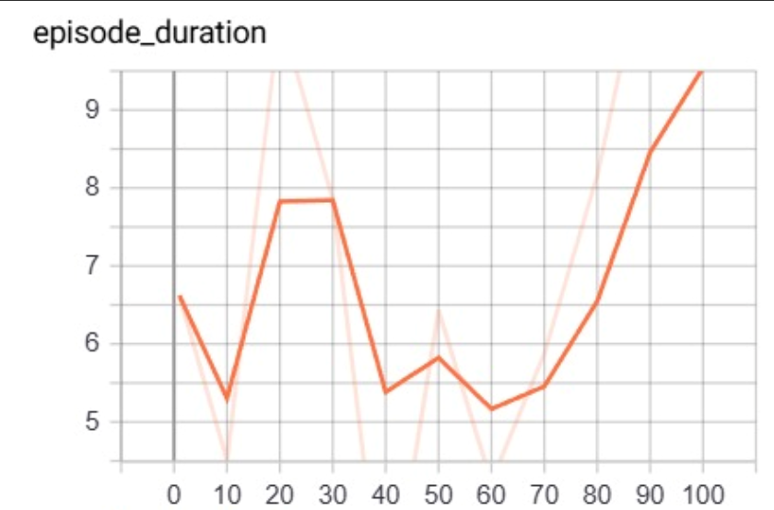

Number of iterations

- Indicates the best-case scenario the agent experienced during training.
- A sharp drop may signal instability or a changing environment.
- Higher max reward → better peak performance.
- Consistent high max values are preferred; large fluctuations = unstable policy.

5. Reward Minima
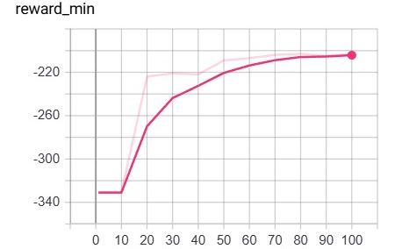

Number of iterations
▪️ 0–40 Episodes:
- Short durations (5–6 steps), unstable behavior.
- Frequent collisions; early exploration phase.
▪️ 40–70 Episodes:
- Some improvement, but inconsistent.
- Starts learning lane-keeping and avoidance.
▪️ 70–100 Episodes:
- Longer durations (8–9+ steps), stable navigation.
- Better decisions, fewer early failure

