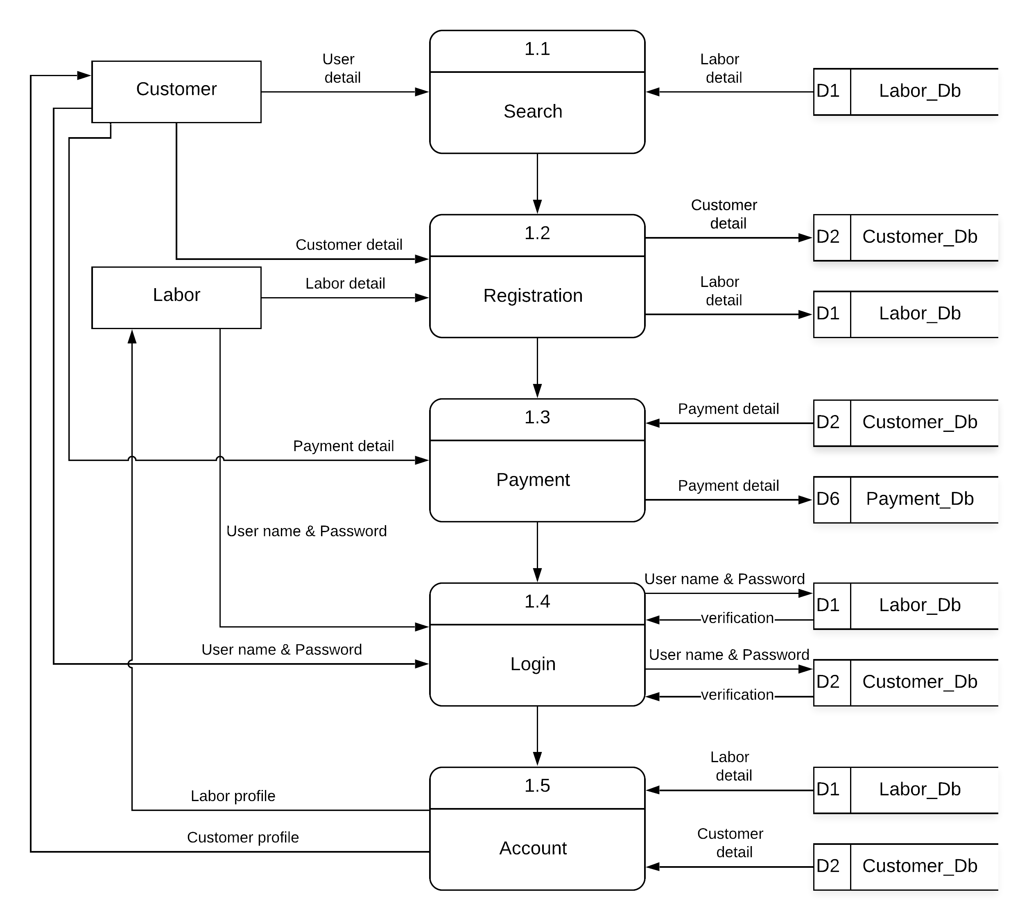
Figure 1 Second Level DFD Diagram

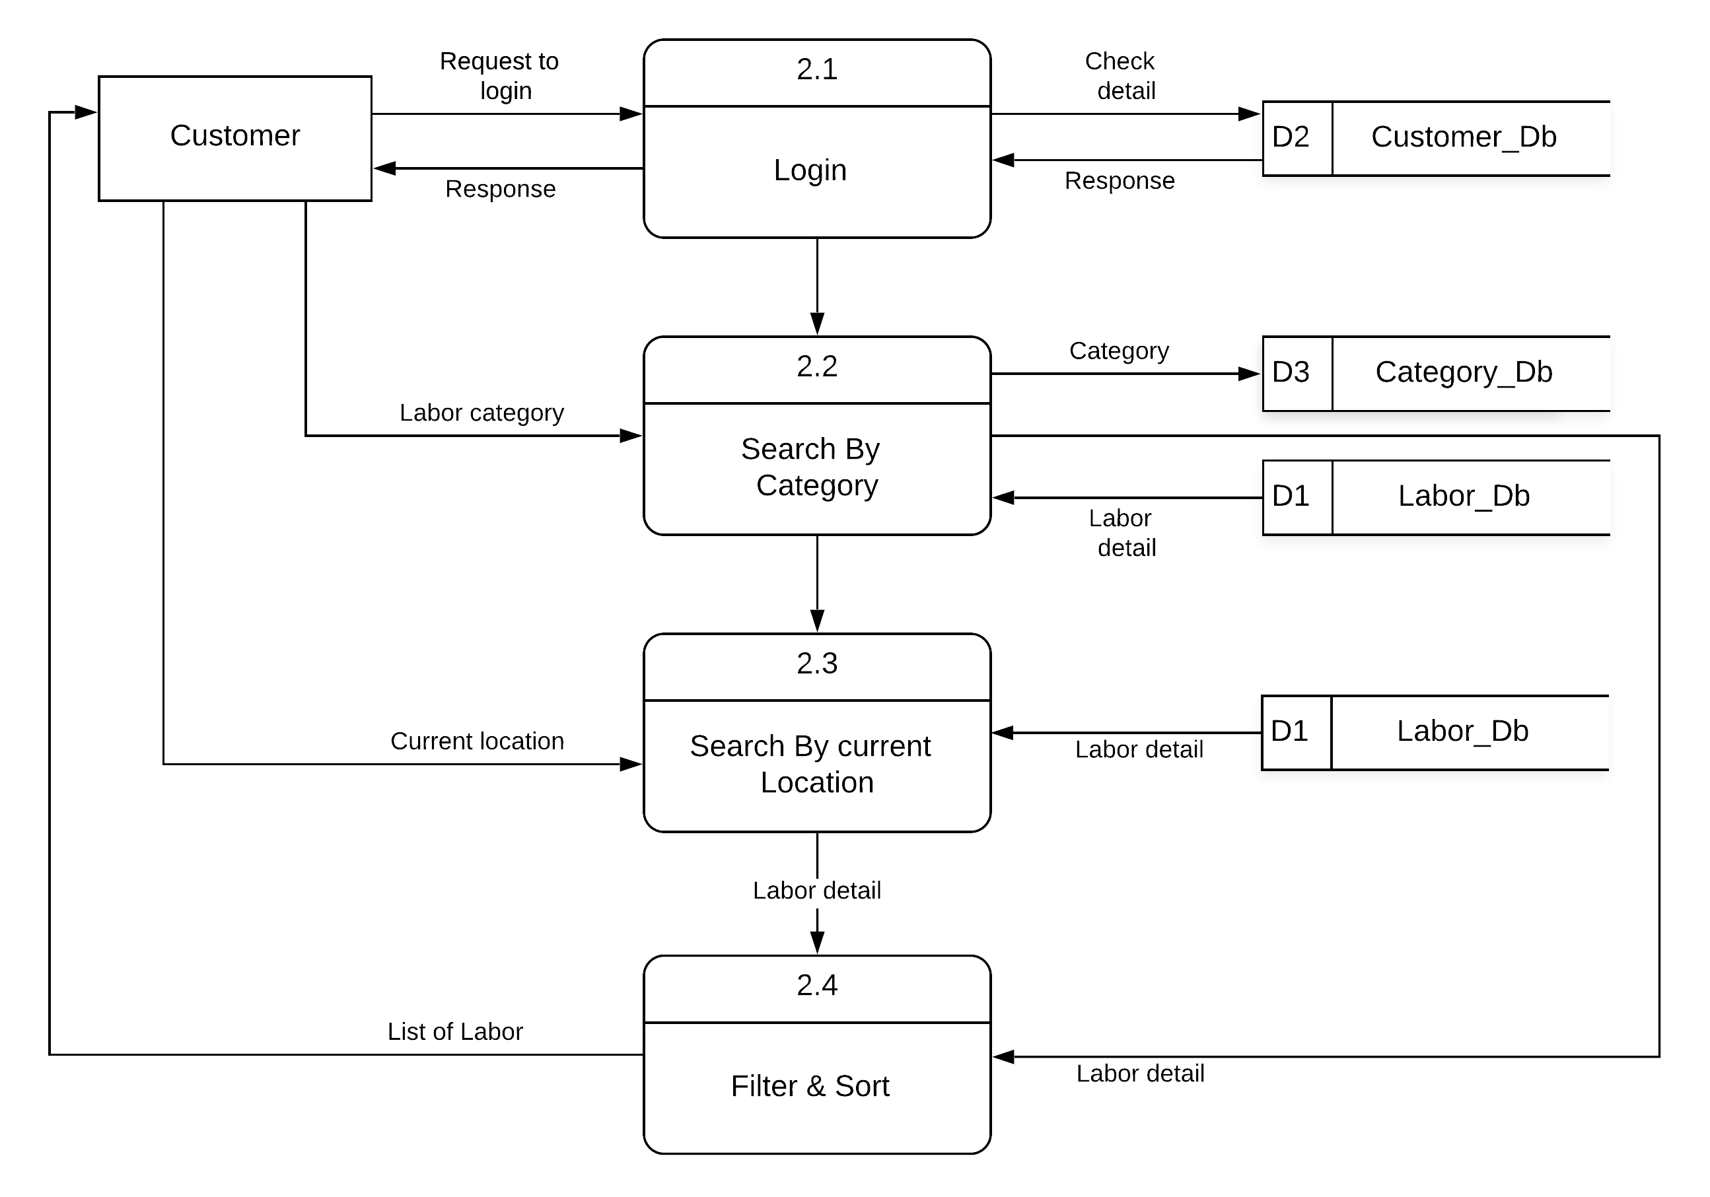
Figure 2 Second Level DFD Diagram

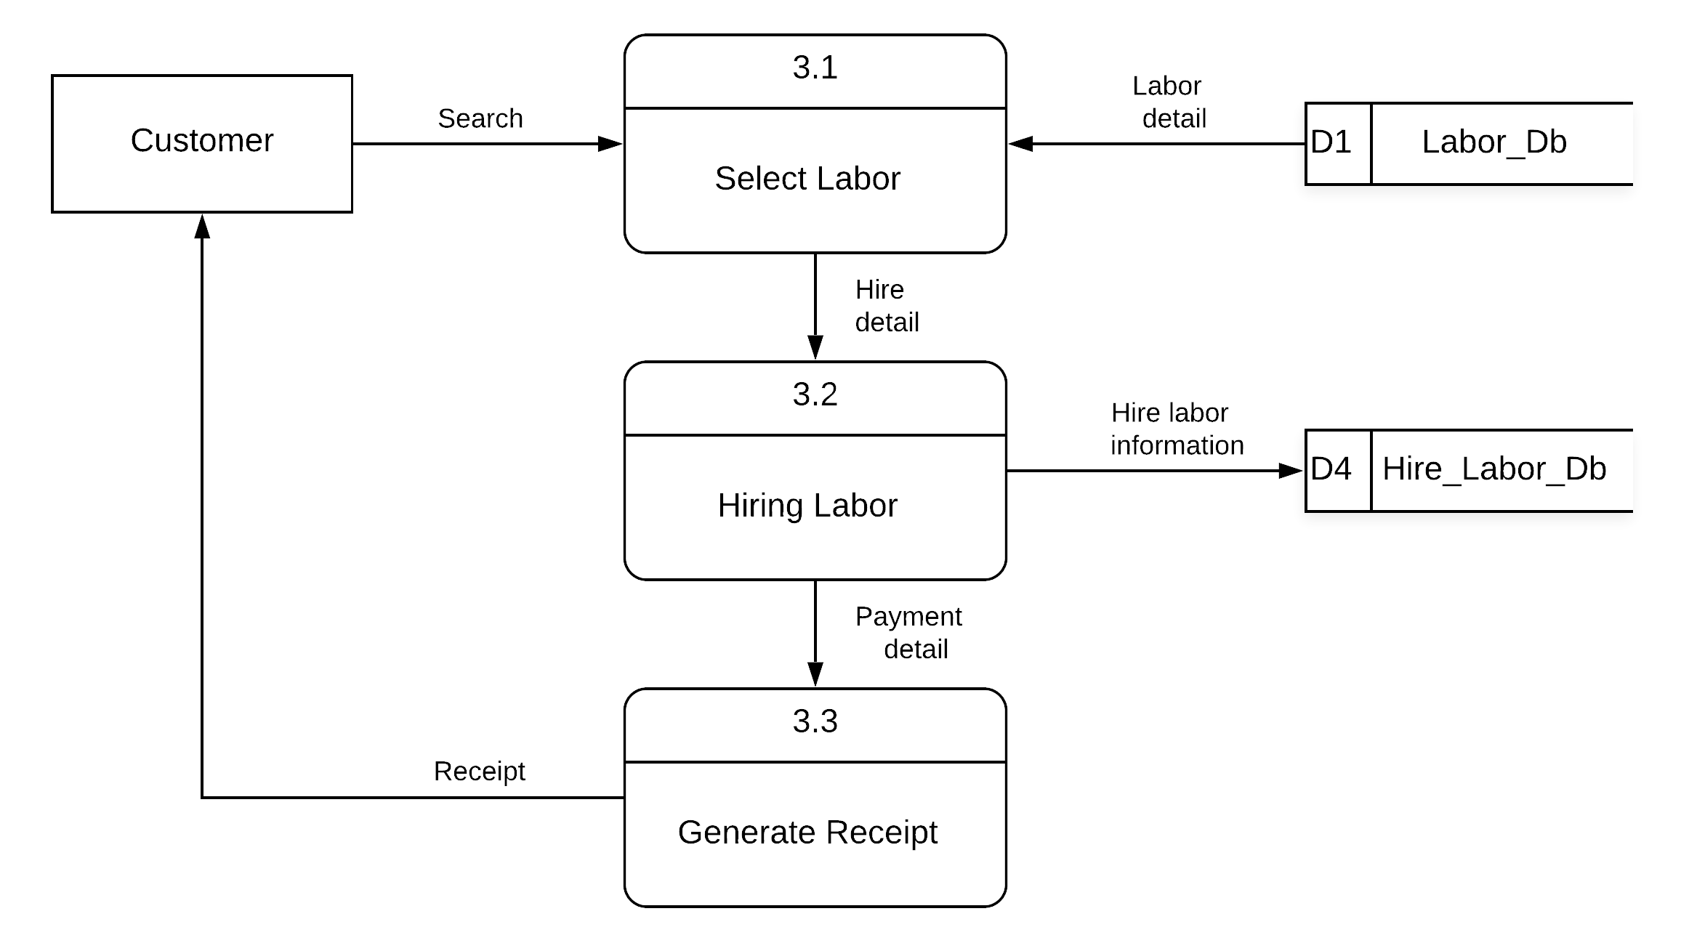
Figure 3 Second Level DFD Diagram

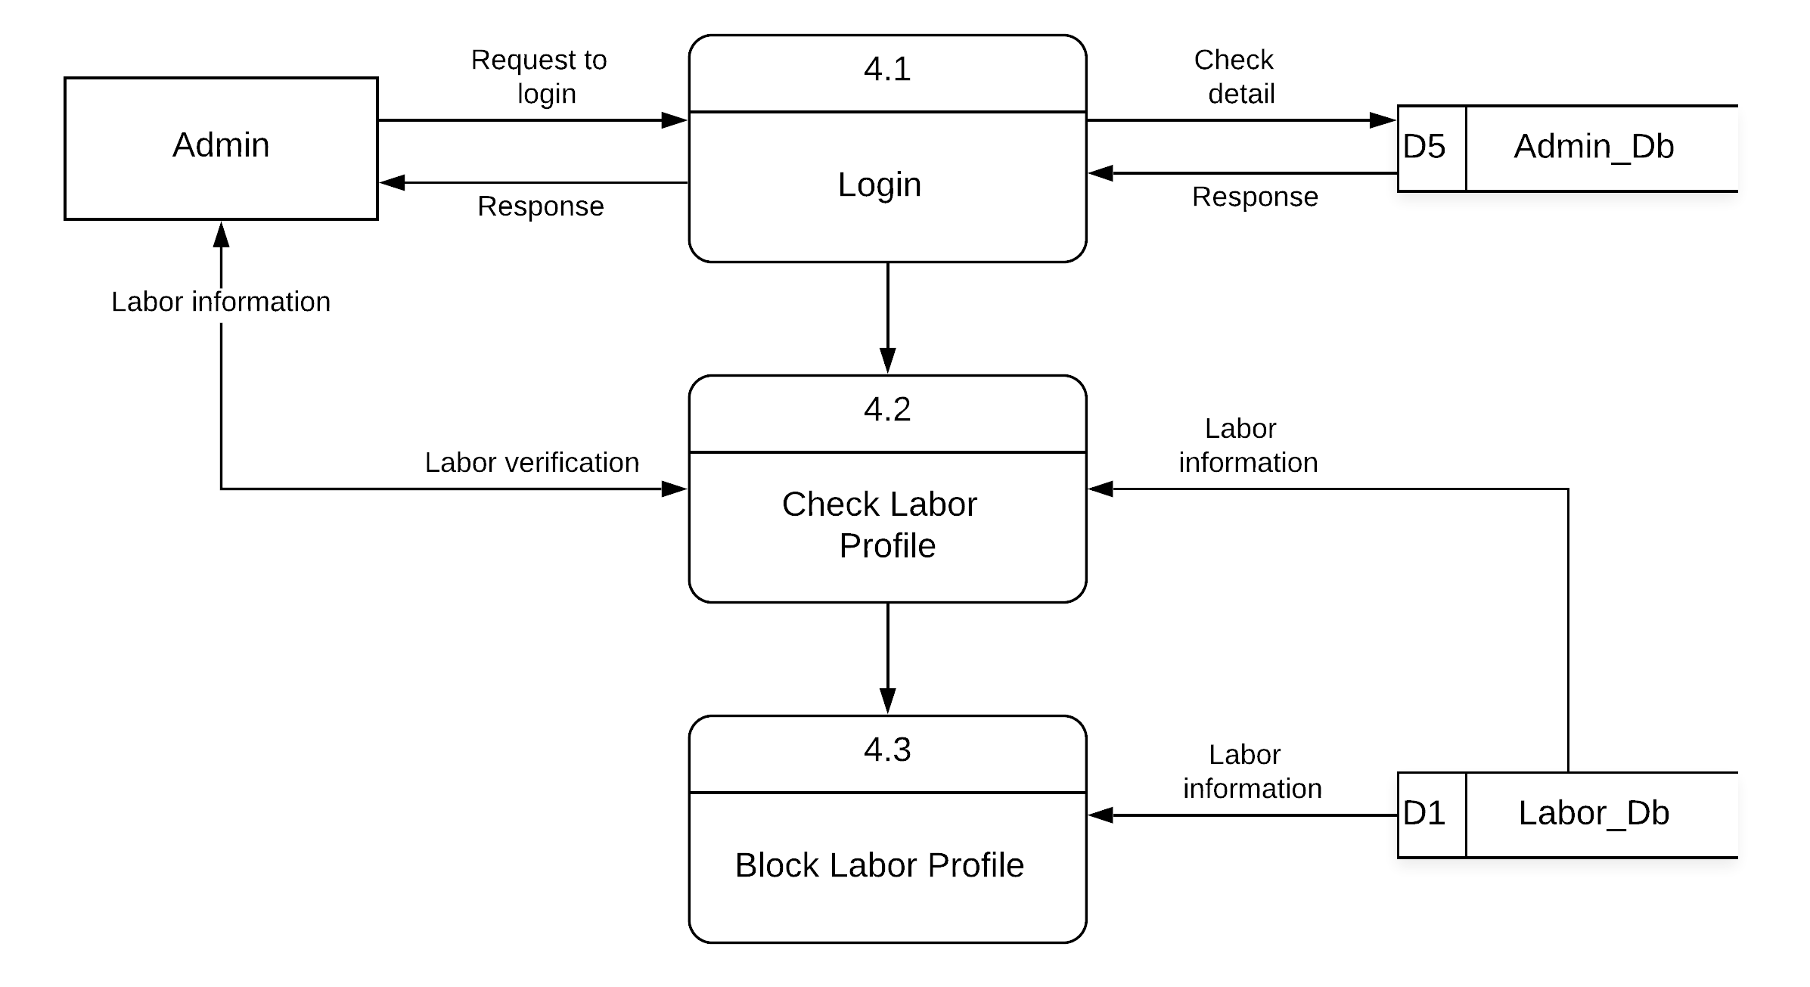
Figure 4 Second Level DFD Diagram
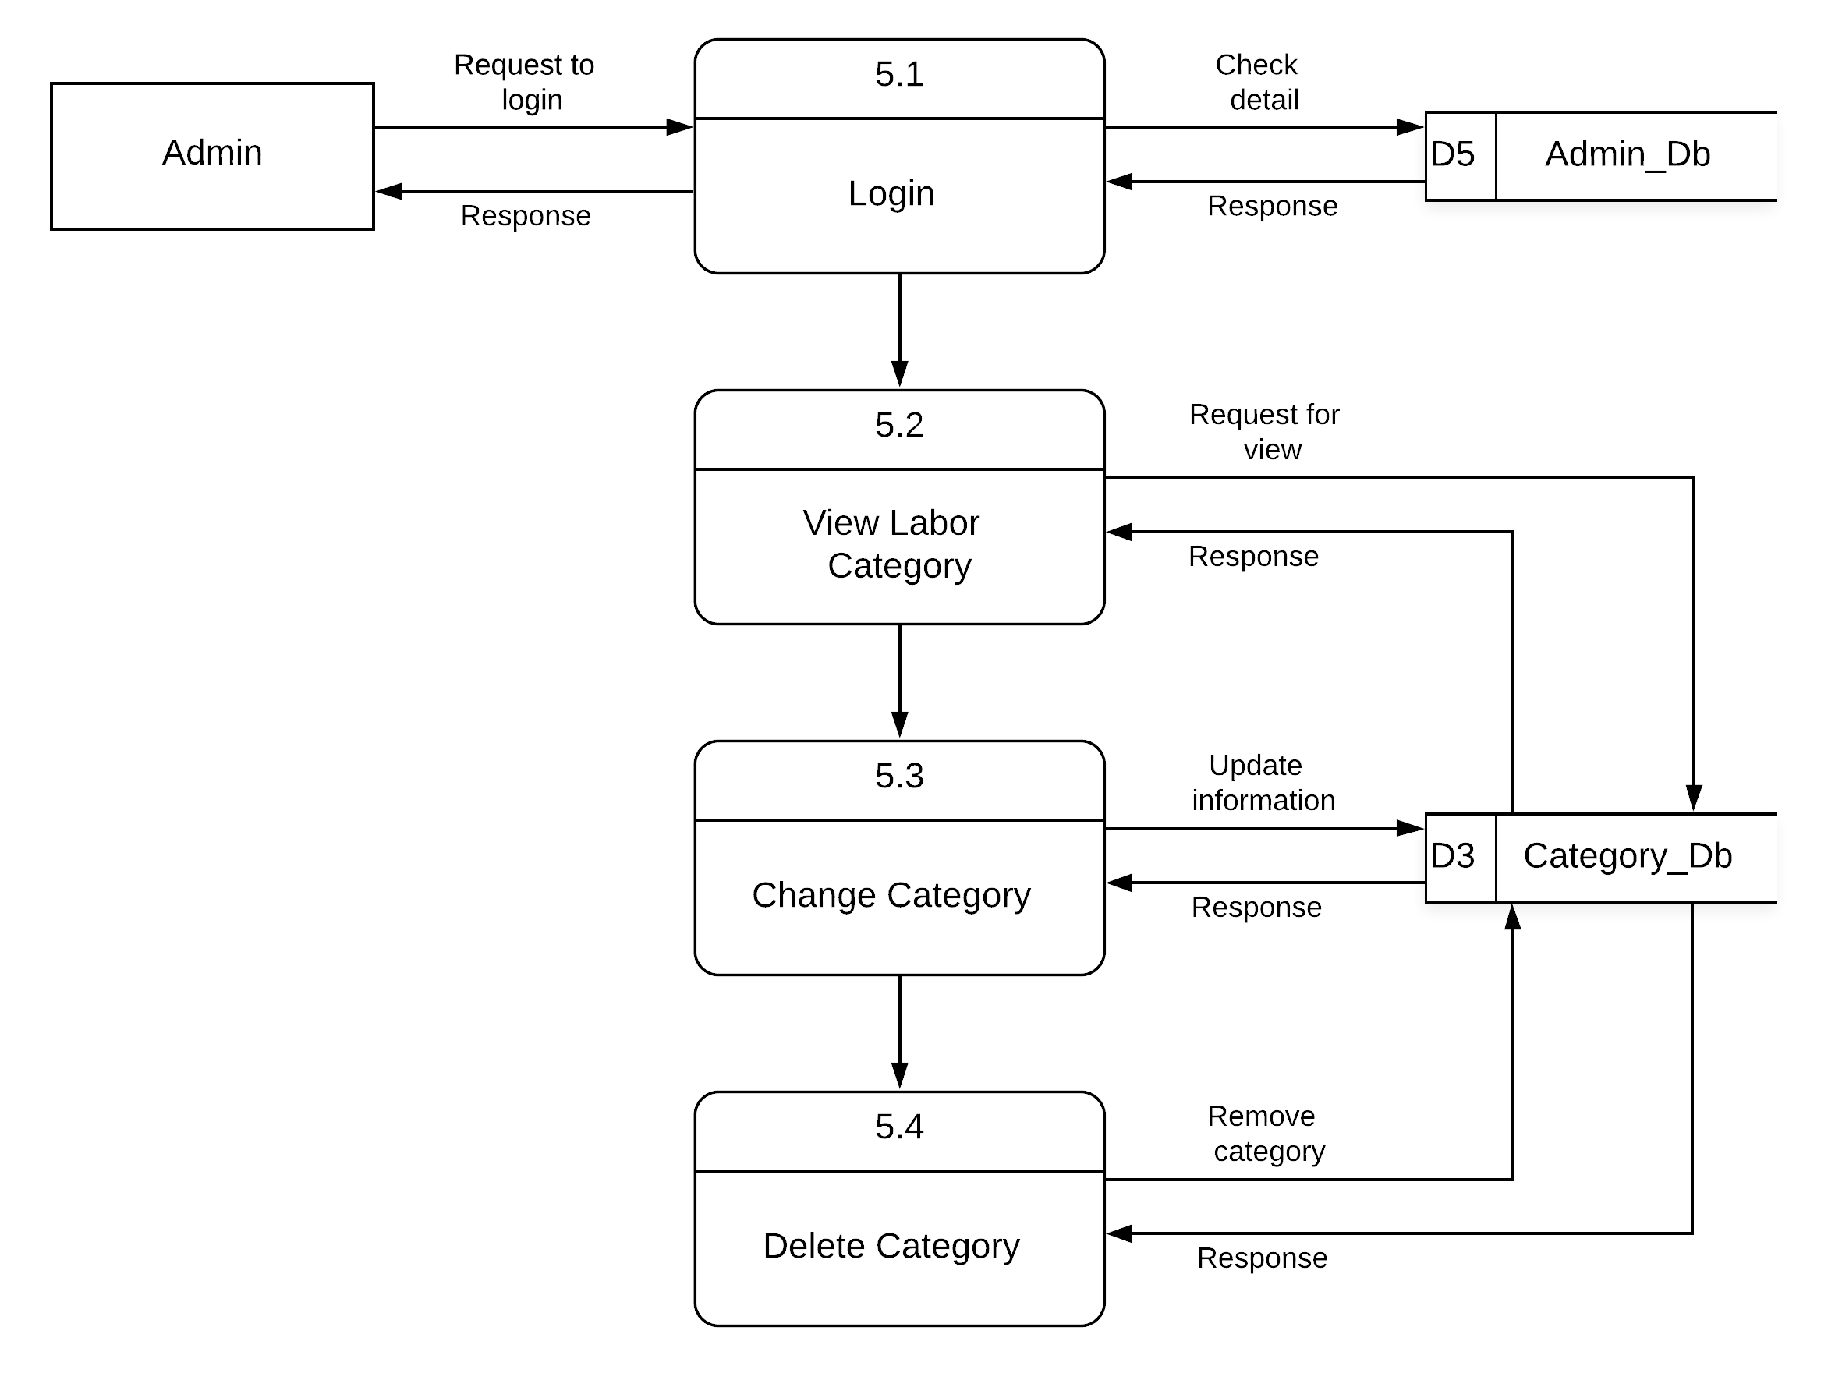
Figure 5 Second Level DFD Diagram

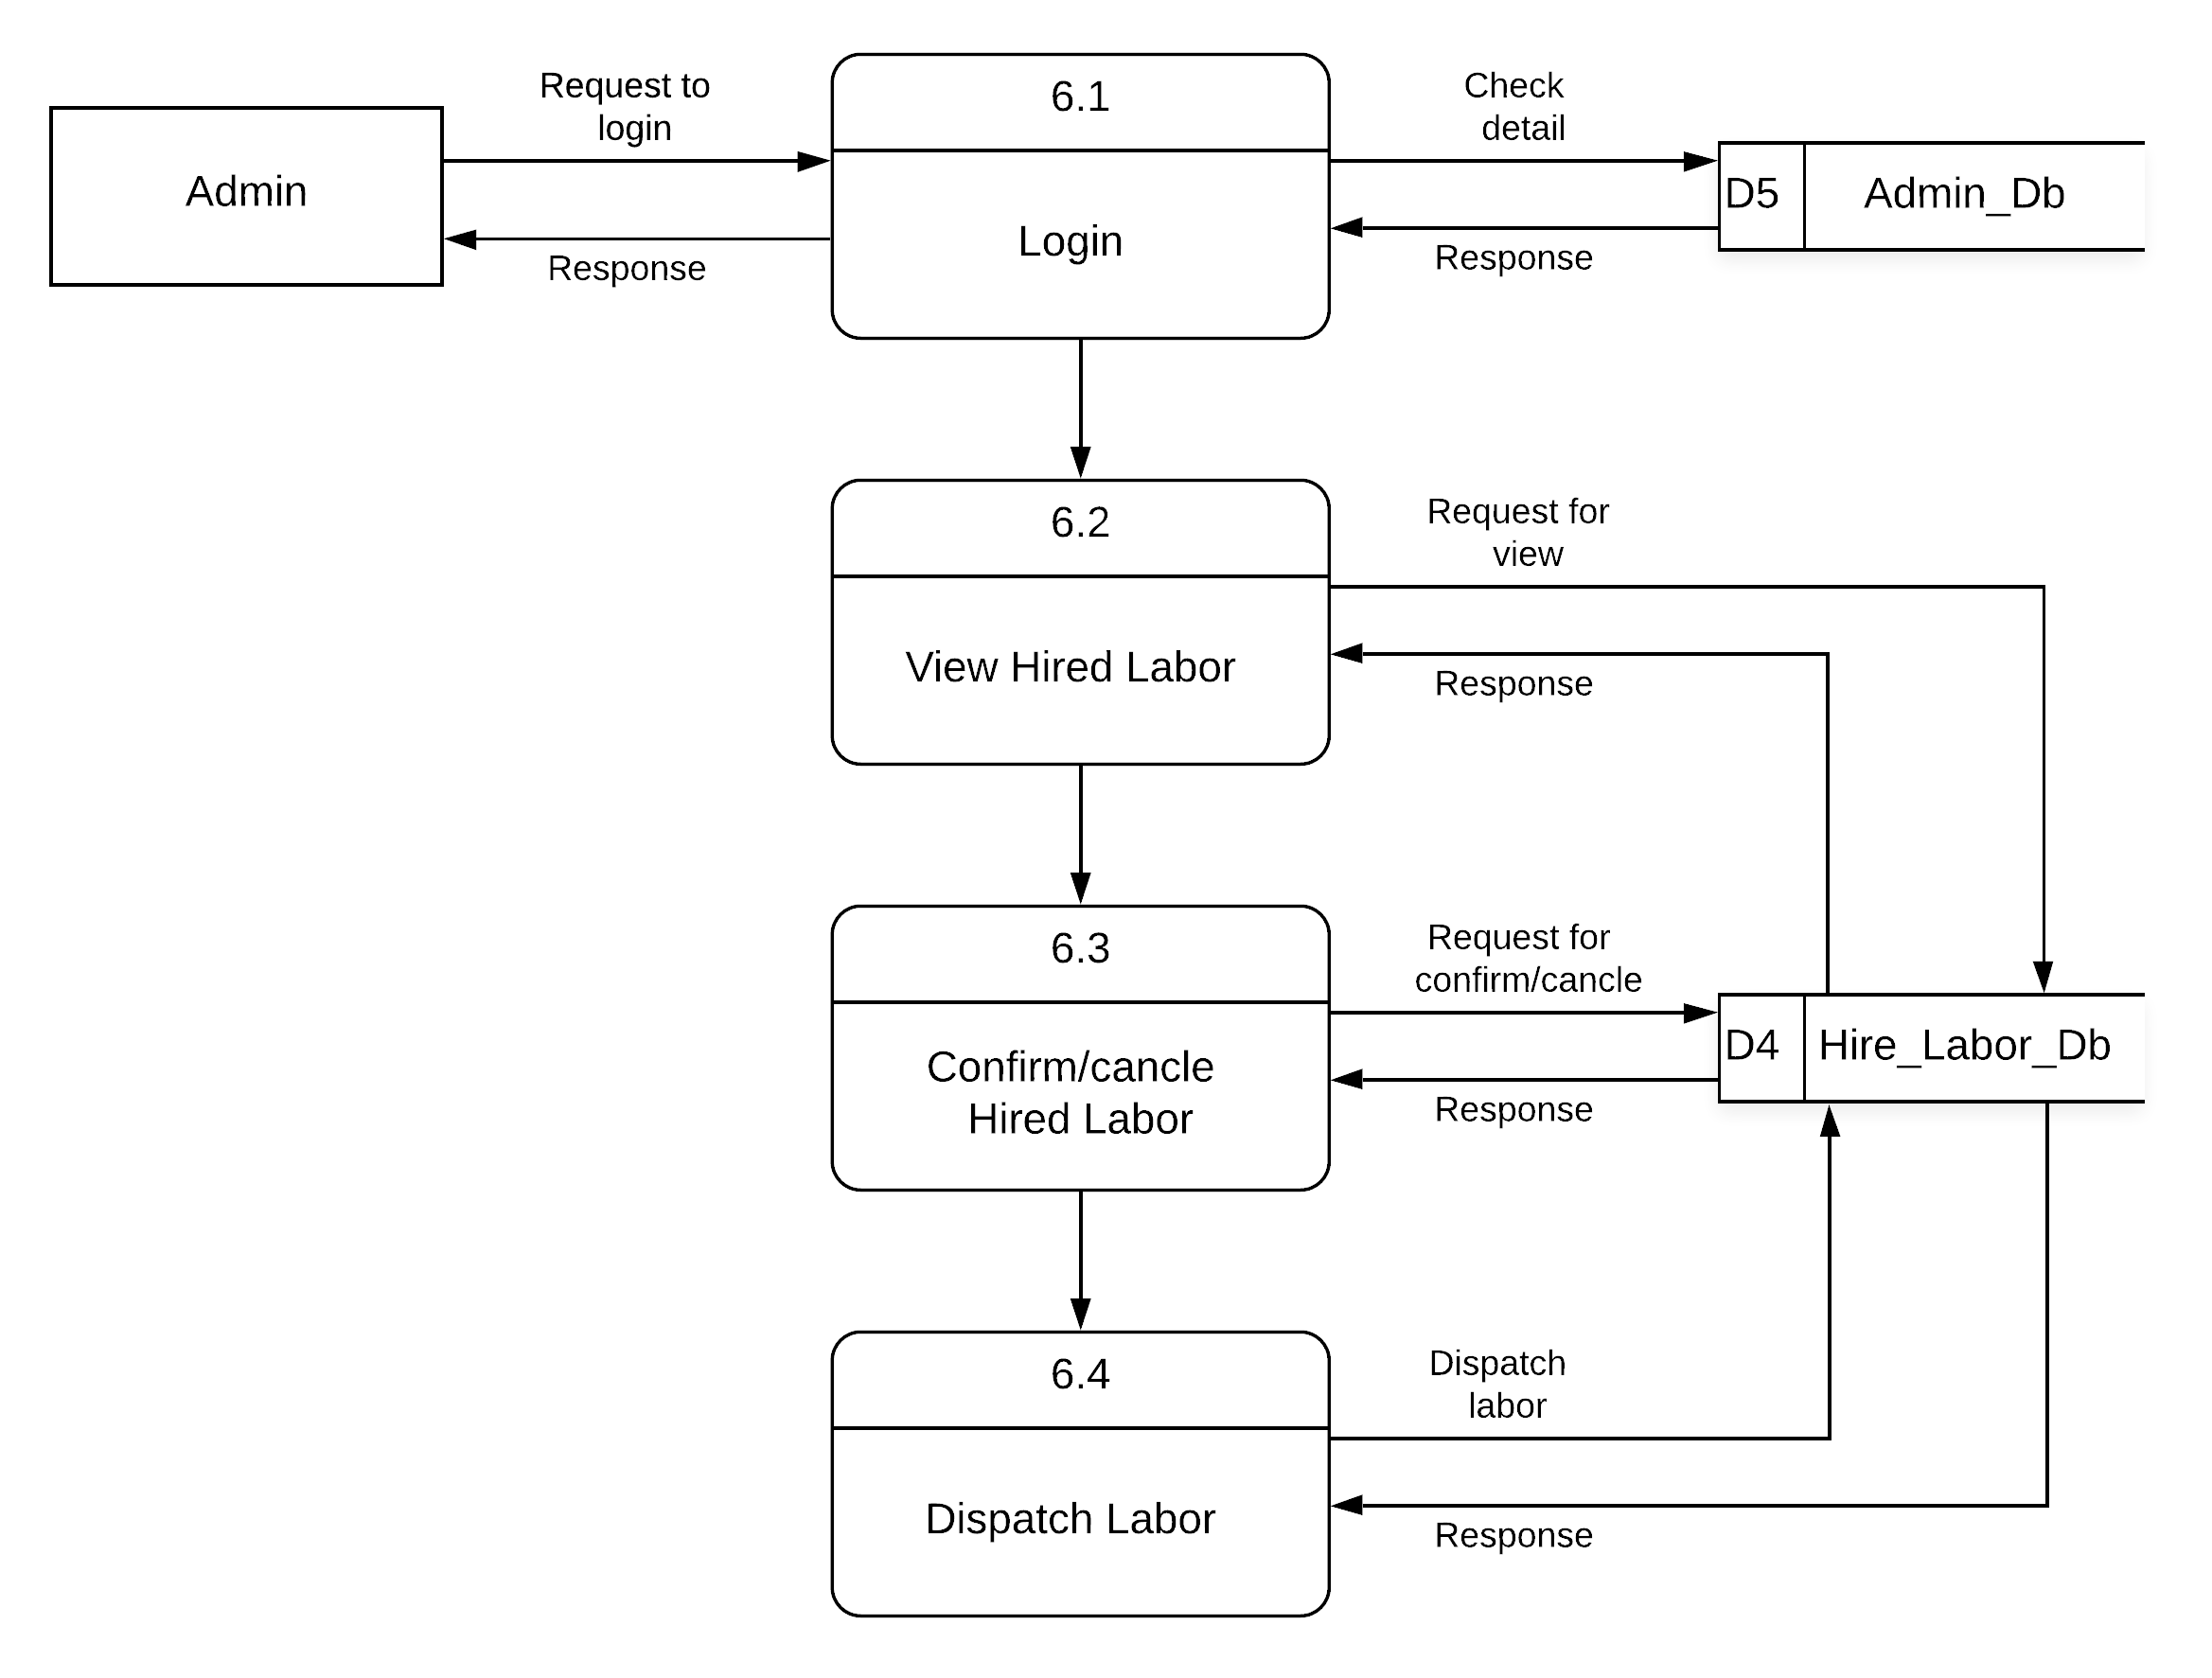
Figure 6 Second Level DFD Diagram

