Name:- Mangukiya Harshit C.

Roll No.:- 51

Exam No.:- 51

System Name:- Contract Labor Source System

Serial No. | Particulars | Page No.
1 | Introduction | 4
1 | 1.1 Scope
1 | 1.2 Objectives
1 | 1.3 Advantages
1 | 1.4 Limitation
2 | General Description | 5
2 | 2.1 Overall Description
2 | 2.2 Feasibility Study
2 | 2.2.1 Technically Feasibility
2 | 2.2.2 Operational Feasibility
2 | 2.2.3 Economical Feasibility
2 | 2.2.4 Resource Feasibility
2 | 2.2.5 Time Schedule Feasibility
2 | 2.3 Functional Requirement
2 | 2.3.1 Module Description
2 | 1. Login/Register
2 | 2. Labor Module
2 | 3. Search Module
2 | 4. Payment Getway Module
2 | 5. Complaint Module
2 | 6. Review Module
2 | 2.3.2 Functions of Various User of The System
2 | 1. Customer
2 | 2. Labor
2 | 3. Admin
2 | 2.4 Non- Functional Requirement
2 | 2.4.1 Security
2 | 2.4.2 Availability
2 | 2.4.3 Maintainability
2 | 2.4.4 Portability
2 | 2.5 Interface Requirements
2 | 2.5.1 GUI
2 | 2.5.2 Software Requirements
2 | 2.5.3 Hardware Requirements
3 | System Analysis and modeling | 10
3 | 3.1 Entity Relationship Diagram | 10
3 | 3.2 Data Flow Diagram | 10
3 | 3.3 Use Case Diagram | 10
3 | 3.4 Database Design | 10

Software Requirements Specifications (SRS) document for Contract Labor Source System website.

1. Introduction:
This SRS is made to briefly describe the requirements of the project of the contract labor source system. This website provides all types of labor information. By using this website, one can find suitable labor for a suitable job. Therefore, one will get more choices of labor as well as this website will generate more job opportunities for the labor.
  - Scope of the system:

Customer:-
- Customer can register.
- Customer can get available labor for particular job.
- Customer can give review and rate the labor.

Labor:-
- Labor can register.
- Labor can set hourly charges according to work.
- Labor can upload work related multiple image, video and related information.

Admin:-
- This system can be easily handled through a single administrator.
- Admin can view all user and labor profile.
- Admin can manage users.

  - objective of the system:

- This system is used to provide the labors detail.
- This system can available for 24 x 7.
- This website provides various labor as your choice because it includes all types of labor in every area.
- Contract labor source system is web based so it can be accessed from anywhere and anytime with basic internet connection.
1.3 Advantages:-

- The viewer can view the all labors information and rating.
- It provides reviews of labor and updated labor information for the viewer.
- The viewer can also view the location of the labor and related information.
- Users can hire any type of labors in a few clicks.

1.4 Limitation:-

- Basic internet connection is a core requirement.
- Users must have to create a profile, as many end-users are illiterate.

2. General description of the system:

  - Overall description:
The contract labor source system is a basic but effective solution to labor work like plumbing, painting, carpentering and many more. it will provide all types of labor services at market-cost.
Using portal customers can search and filter the list of labors to find a suitable person for the job. This will create job opportunities for labor and 24x7 service for users.
Users also can rate and write reviews of the labor along with write complaints against them.
There is also an online payment option for ease of transaction.

  - Feasibility study:

An important outcome of the preliminary investigation is the determination that the system requested is feasible. The feasibility study is carried out to examine the likelihood that the proposed system will be duly developed in the stated cost & period & in turn is useful for organization.
The feasibility of our project has been judged on the basis of time, technology, resources available, behavioral feasibility and cost of development.

2.2.1 Technical Feasibility:

The Project is a complete web based application. The main technologies and tools that are associated with this project.
- HTML
- CSS
- MySQL
- PHP
- Javascript

Each of the technologies is freely available and the technical skills required are
manageable. The Time limitations of product development and the ease of implementing
using these technologies are synchronized.

Initially the web site will be hosted in a free web hosting space, but for later
implementations it will be hosted in a paid web hosting space with a sufficient bandwidth.

From these it’s clear that the project is technically feasible.

2.2.2 Operational Feasibility:

Operational feasibility is dependent on human resources available for the project and involves projecting whether the system will be used if it is developed and implemented.

Operational feasibility is a measure of how well a proposed system solves the problems,
and takes advantage of the opportunities identified during scope definition and how it satisfies
the requirements identified in the requirements analysis phase of system development. If the
user does not understand or able to work on the system further development is of waste.

2.2.3. Economical Feasibility:

As development tools such as sublime text editior, xampp server, SQL database and software are already our own, there isn’t any burden of buying them. The organization doesn’t having the same system, so it is certainly required for them. So here we do not need to invest extra funds to develop the system. Thus, it is economically feasible for the organization.

2.2.4. Resource Feasibility:

It is also an essential part of a feasibility study. It includes questions regarding the time required to complete the project, the type and amount of resources required and dependent factors.

2.2.5. Time Schedule Feasibility:

Projects are initiated with specific deadlines. We need to evaluate whether the deadlines
are mandatory or desirable. Time is the one of the critical factor in the development of any
system but this kind of feasibility is hardly perfect in any system.

We have been asked to complete the project within the working days of the organization
having period of 2 months, approximately. So we have managed to complete the project
before the given deadline. In the project planning section we elaborate our ideas to develop
the system within the given period.

Hence, it is feasible to develop a system in a predetermined time interval.

2.3 Functional Requirements:

2.3.1 Module description:

1. Login/Register:
Labor can register themselves for the system by providing the valid identification documents, after the admin can verify the proof labor can logged in their account and access the portal.

2.Labor Module:
This module is used to display all types of labor profile according to their work.

3. Search module:
Customer search labor according to area and category.Moreover, Customer can filter according charges and review.

4. Payment getway module:
Basic payment getway module.

5. Review module:
Customer can give review easily according to labor work.

2.3.2 Functions of various user of the system:
There will be three users of these system. customer, labor,admin.

1. Customer:

Customer must be able to:
- Login and logout
- View list of available labor
- View the information of the labor.
- View the category wise labor information
- Hire any labor.

2. Labor:
Labor must be able to do:
- Login and logout
- View the details of leader
- Insert/View/delete/Edit their work's videos and images

3. Admin:
Admin must be able to do:
- Login and logout
- Verify labor and register
- Add/delete/Edit Customer and labor account

2.4 Non- Functional Requirements:

2.4.1 Security:
It should be providing password to log on to the system.

2.4.2 Availability:
Any information from customer should be quickly available from any device to the authorized labor.

2.4.3 Maintainability:
The website should be maintainable in such a manner that if any new requirement occurs then it should be easily incorporated in an individual module.

2.4.4 Portability:
The website should be portable on any browsers.

2.5 Interface Requirements:

2.5.1 GUI

- Login page
- Home page
- Labor profile
- About us
- Contect us

2.5.2 Software requirements:

- Sublime text editor.
- Internet connection.
- Web browser.
- Server.

2.5.3 Hardware requirements:

· 512 MB ram.
· 20 GB hard disk.
· Processor 1.3 GHz or higher

Development Description:-

We use xampp server, phpmyadmin for development of this websites.

Front End:Bootstrap, HTML, CSS, Javascript

Back End: MySQL

- MySQL:-

- MySQL provided more security for database.
- MySQL is lightweight database.
- We have to create cascading relationship for maintained the data.
- We have to set the relationship primary key, foreign key and constraints
among tables through database diagram feather provided by MySQL.
- MySQL database is maintained in phpmyadmin through XAMPP server.

3. System Analysis and modeling:
3.1 E-R Diagram:

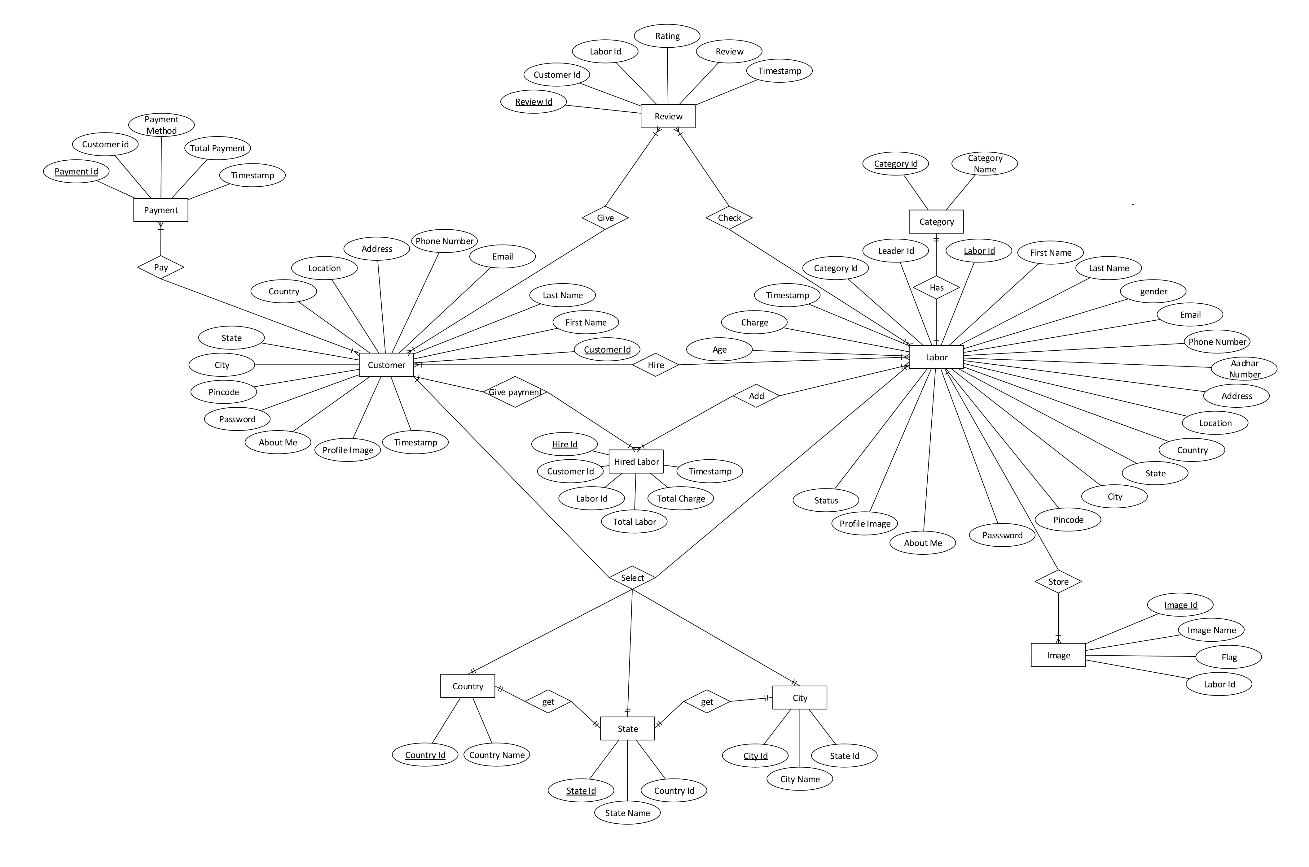
Figure 1 E-R Diagram

3.2 DFD Diagram:

Context Level:

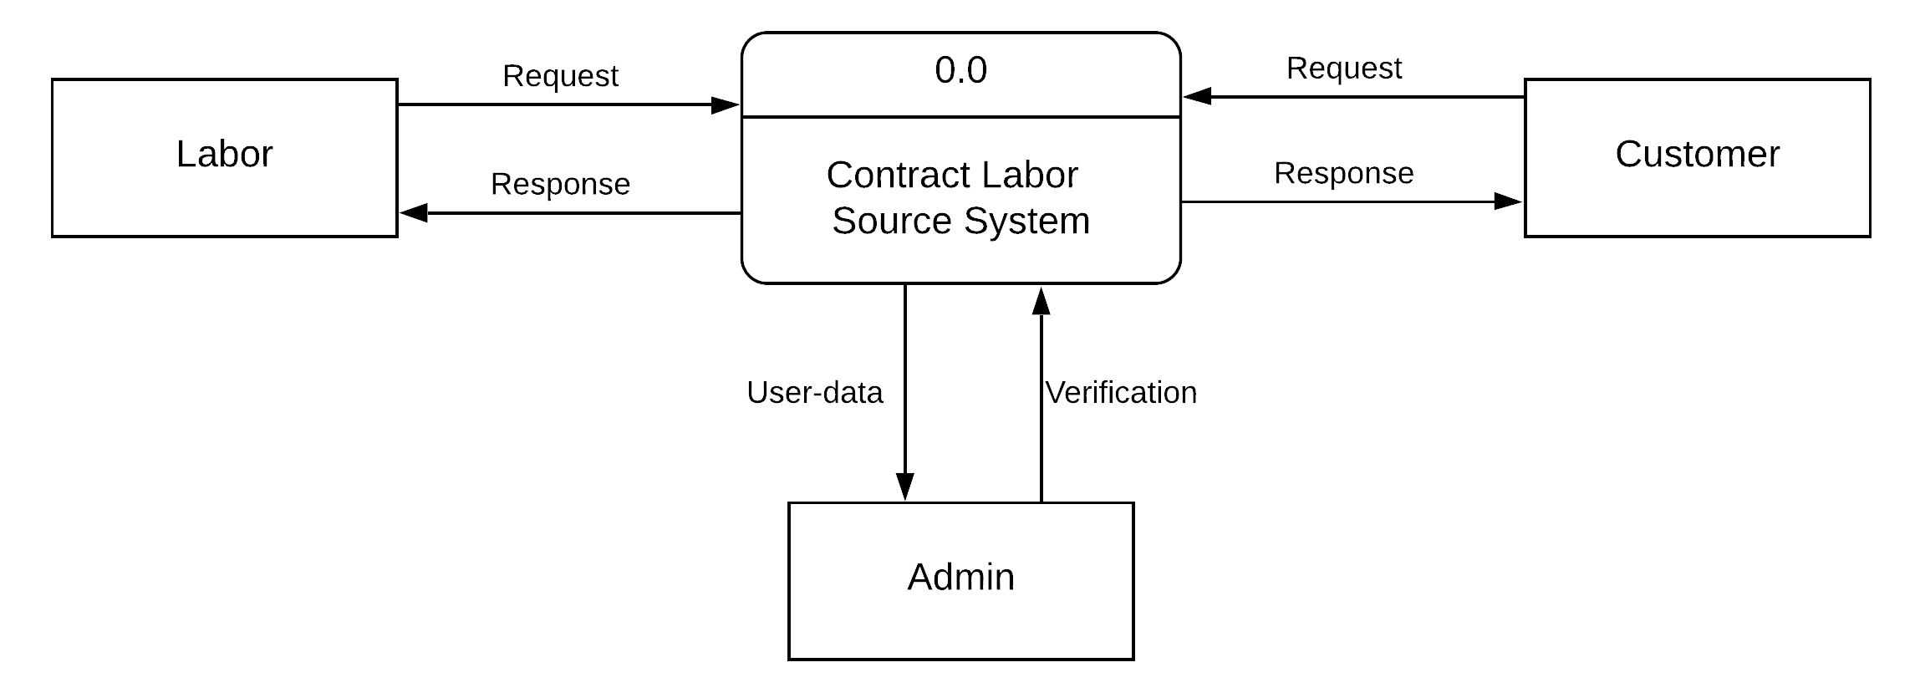
Figure 2 Context Level DFD Diagram

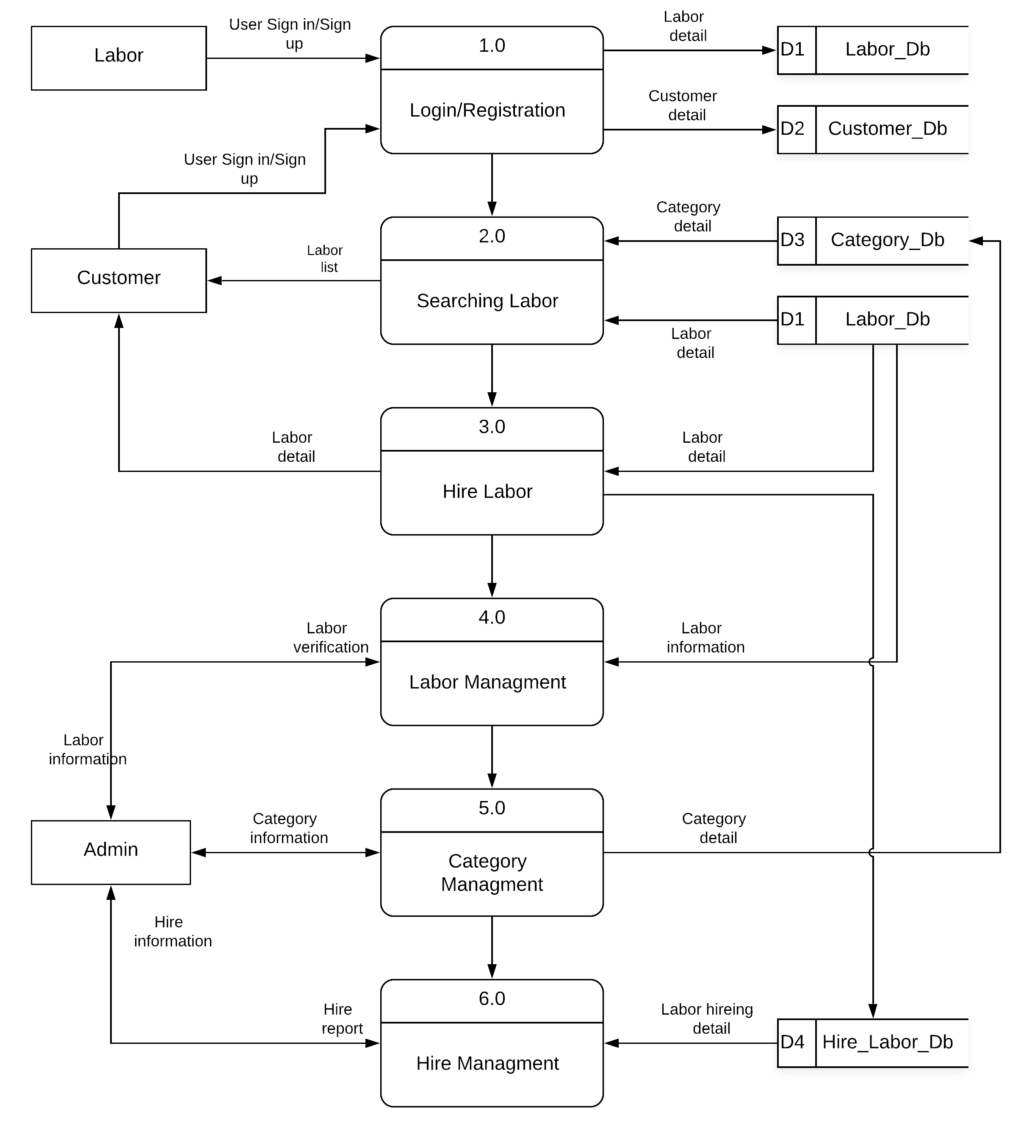
Level 1:
Figure 3 One Level DFD Diagram

Level 2:

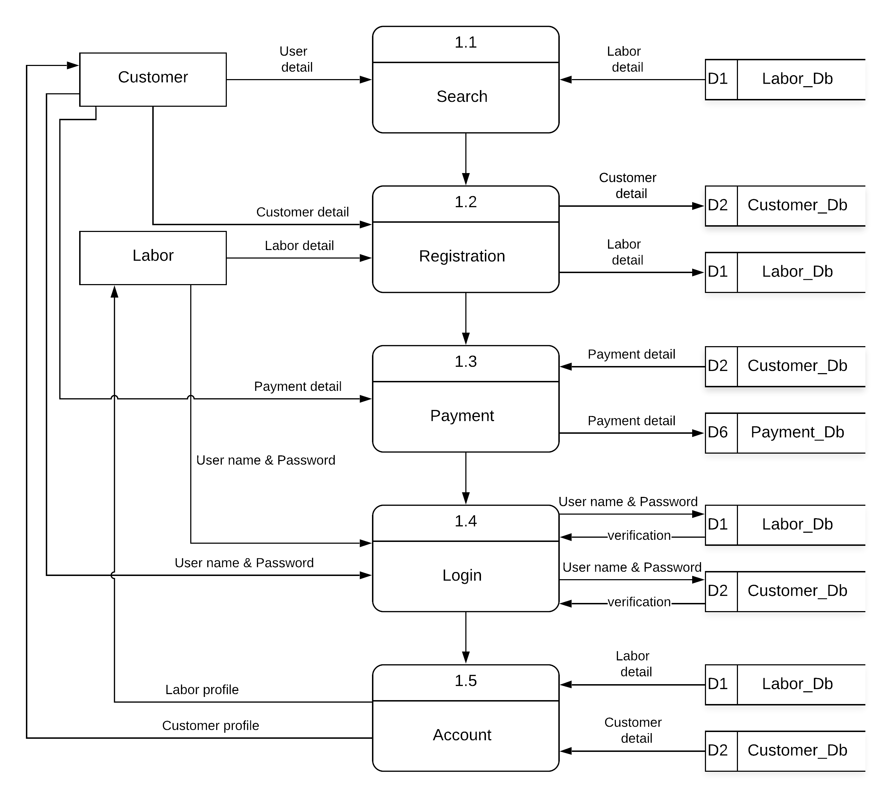
Figure 4 Second Level DFD Diagram
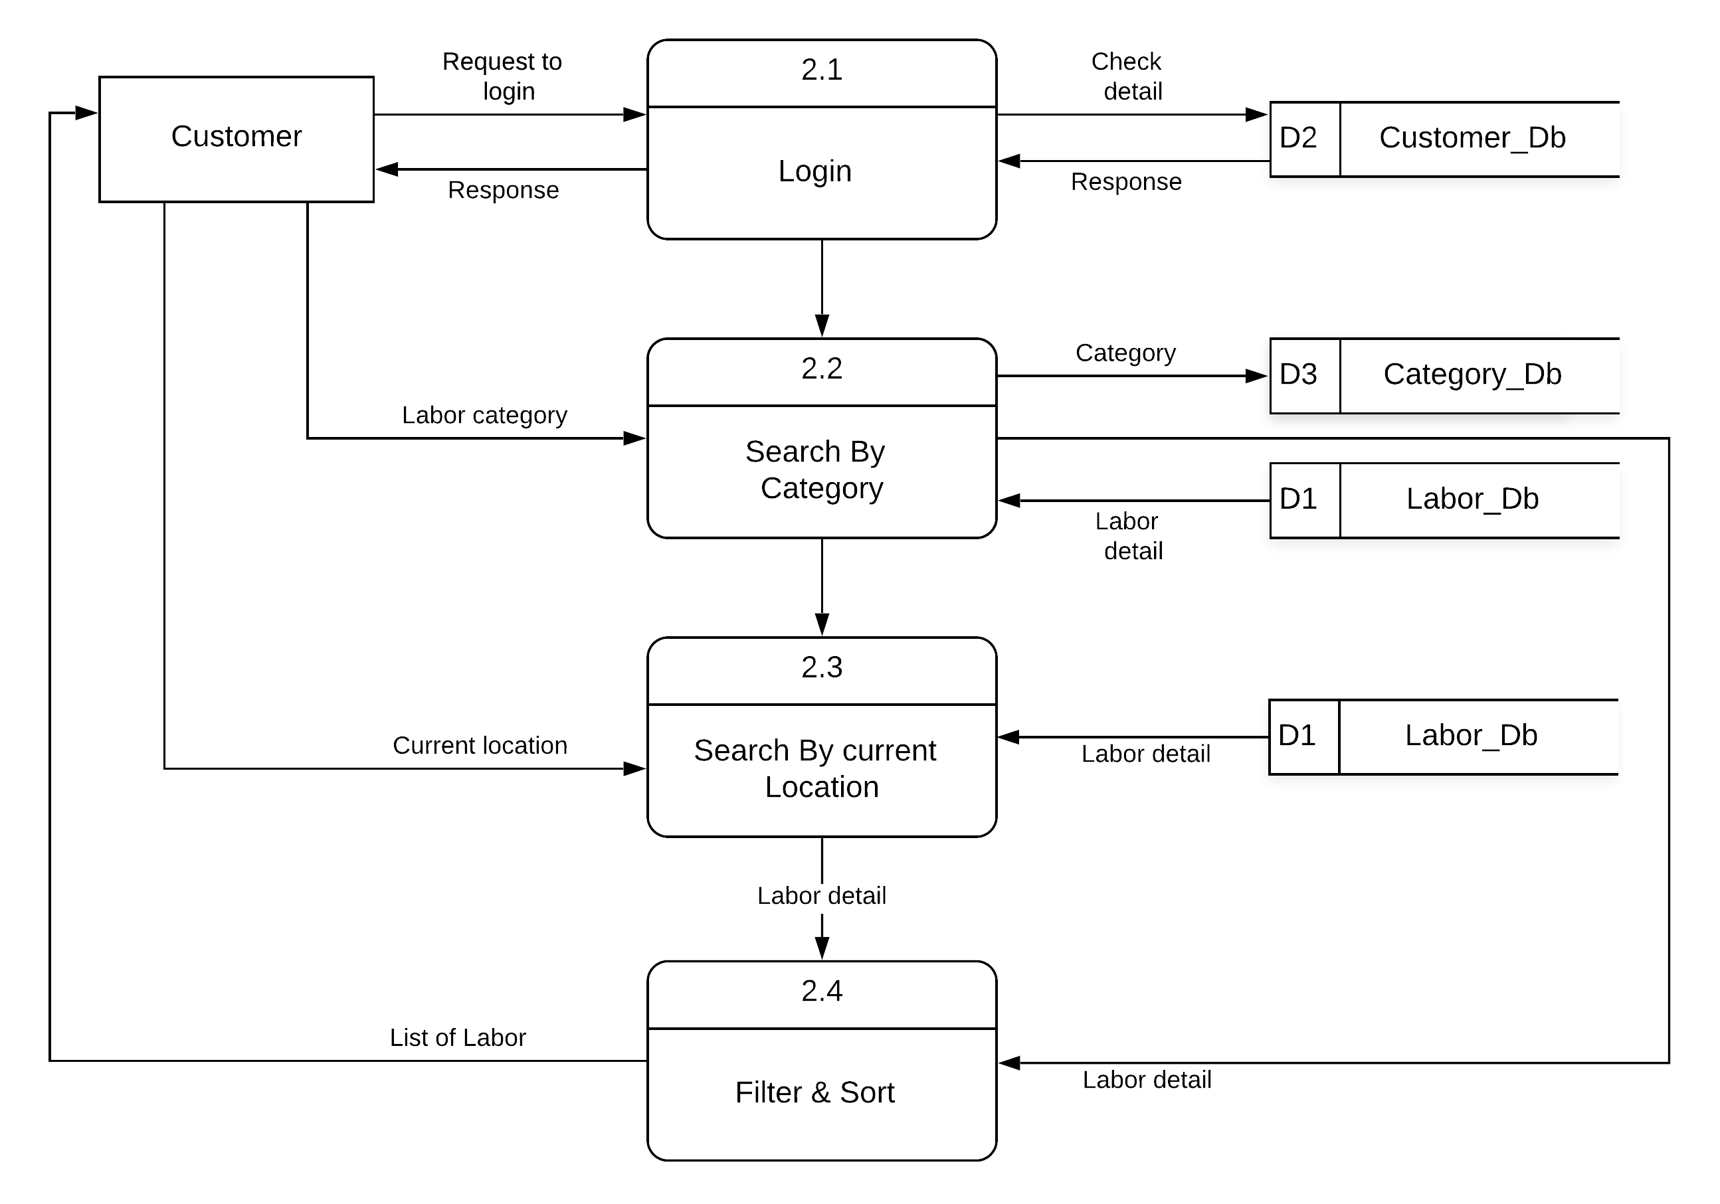
Figure 5 Second Level DFD Diagram
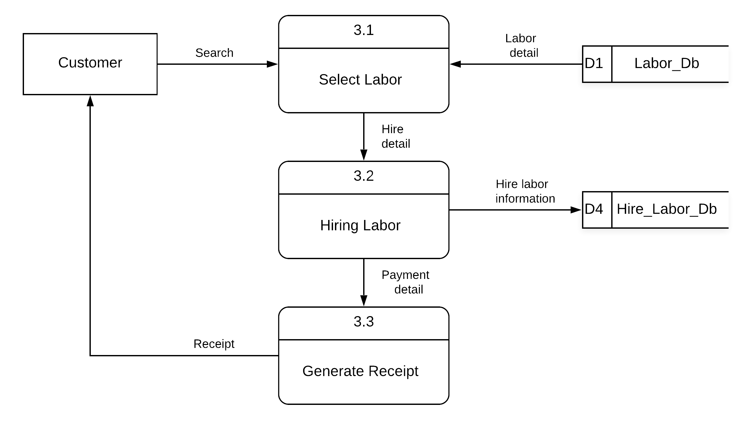
Figure 6 Second Level DFD Diagram
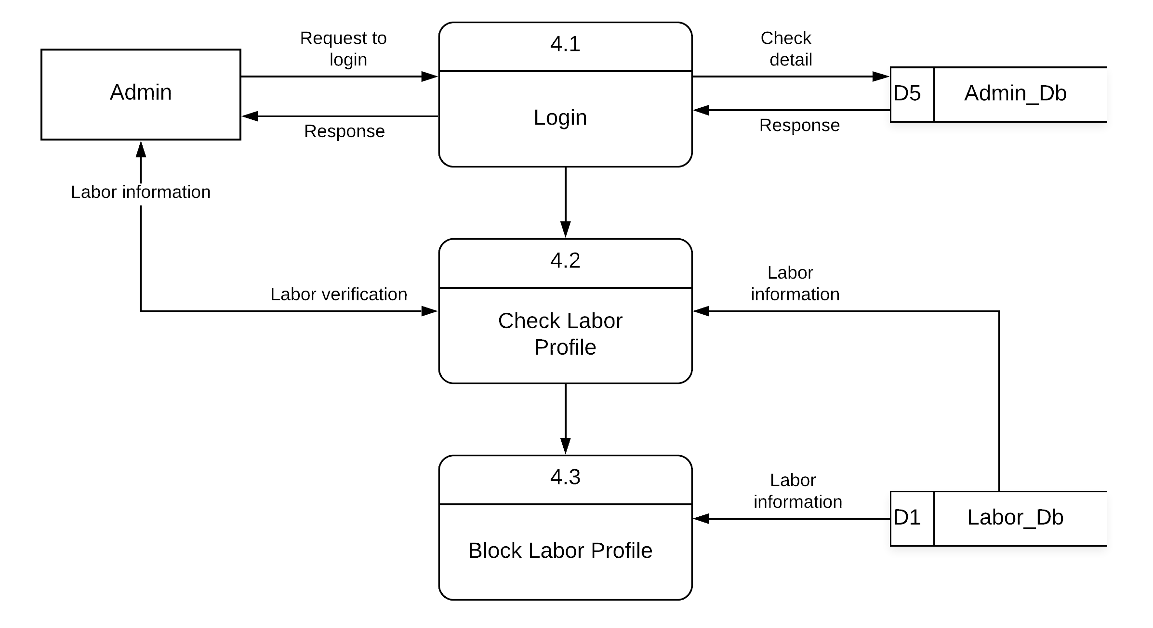

Figure 7 Second Level DFD Diagram

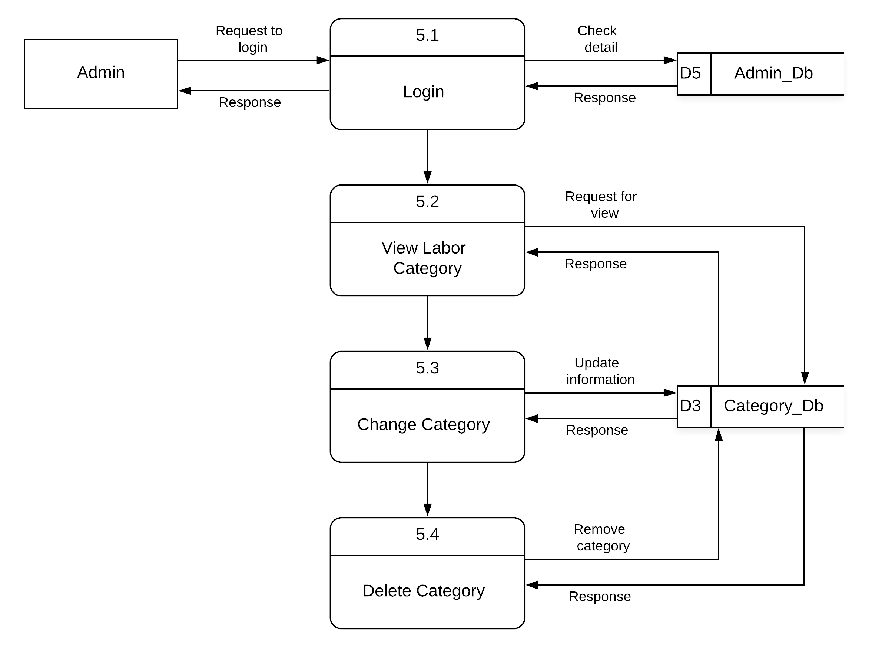
Figure 8 Second Level DFD Diagram
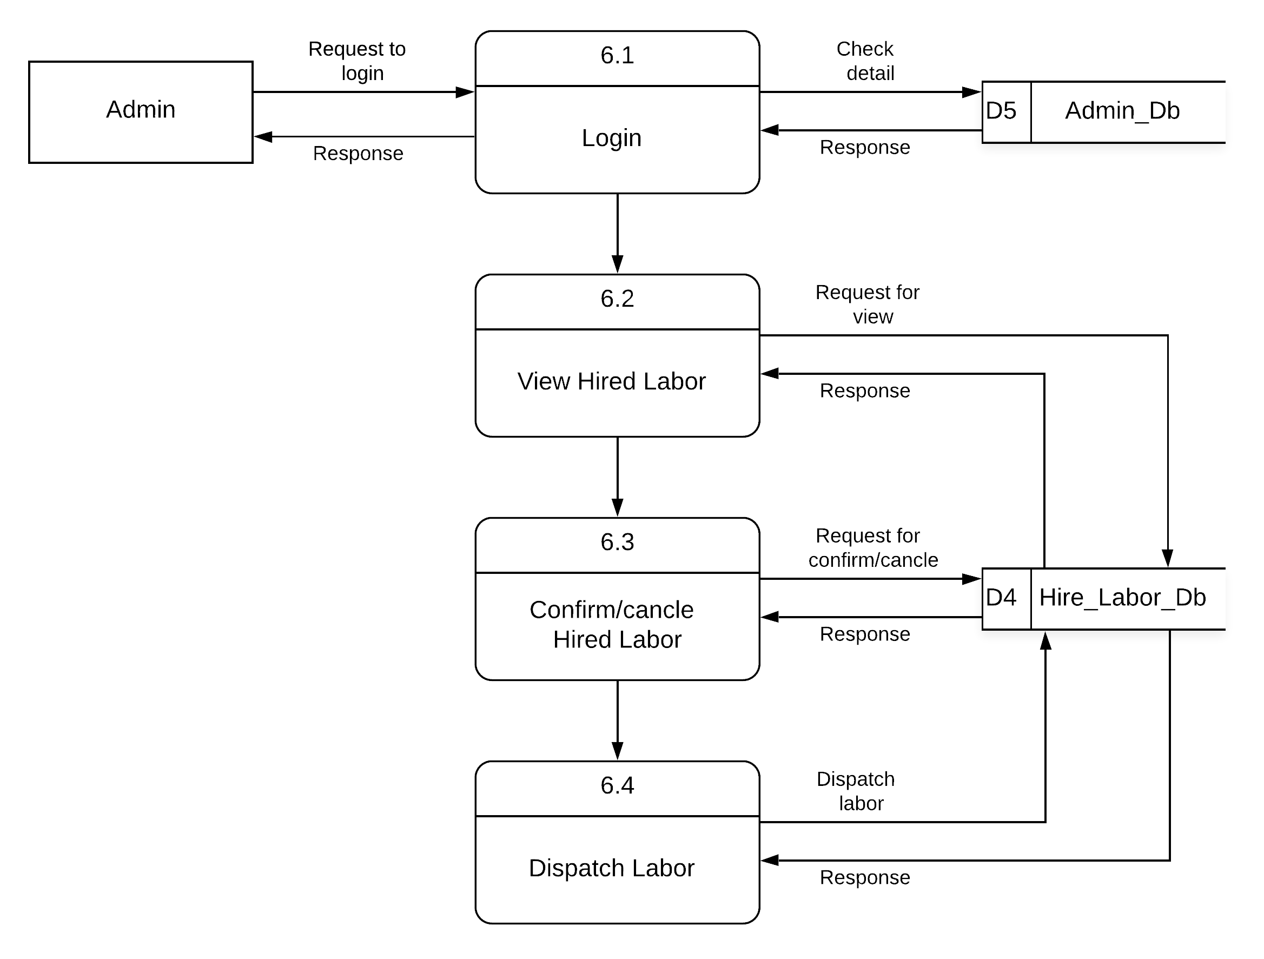
Figure 9 Second Level DFD Diagram

3.4 Use Case Diagram:

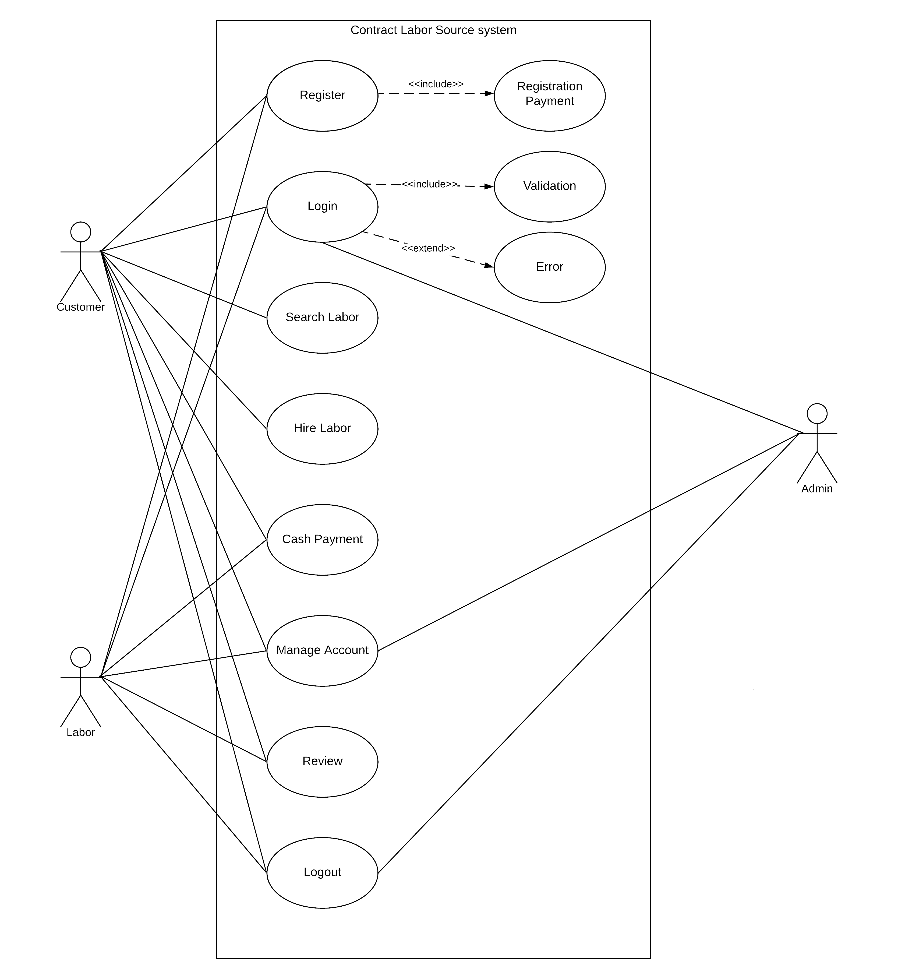

Figure 10 Use Case Diagram

3.5 Database Design:

Database design is the process of producing a detailed data model of a database. This data model contains all the needed logical and physical design choices and physical storage parameters needed to generate a design in a data definition language, which can then be used to create a database.

2.6.1 Table Name:country
Description:id,name
Primary Key:id
Foreign key:

Attribute Name | Type | Size | Constraint | Attribute  Description
id | Integer | 11 | Primary key/Auto  Increment | Enter the Unique country id
name | Varchar | 150 | Not null | country name

2.6.2 Table Name: state
Description:S_id,S_name
Primary Key:S_id
Foreign key: country_id

Attribute Name | Type | Size | Constraint | Attribute  Description
S_id | Integer | 11 | Primary key/Auto  Increment | Enter the Unique state id
S_name | Varchar | 150 | Not null | state name
S_cid | Integer | 11 | Foreign key | References from country

2.6.3 Table Name:city
Description:Ci_id,Ci_name
Primary Key:Ci_id
Foreign key: state_id,country_id

Attribute Name | Type | Size | Constraint | Attribute  Description
Ci_id | Integer | 11 | Primary key/Auto  Increment | Enter the Unique state id
Ci_name | Varchar | 150 | Not null | state name
Ci_sid | Integer | 11 | Foreign key | References from state

2.6.4 Table Name: Customer
Description:C_id,C_firstname,C_lastname,C_email,C_phone,C_address,C_location
,C_pincode,C_password,C_about,C_image,C_date
Primary Key:C_id
Foreign key:C_country,C_state,C_city

Attribute Name | Type | Size | Constraint | Attribute  Description
C_id | Integer | 11 | Primary key/Auto Increment | Enter the Unique customer id
C_firstname | Varchar | 40 | Not null | User firstname
C_lastname | Varchar | 40 | Not null | User lastname
C_email | Varchar | 100 | Not null | User email id
C_phone | Varchar | 10 | Not null | User phone number
C_address | Varchar | 128 | Not null | User address
C_location | Varchar | 200 | Not null | User current  location
C_country | integer | 11 | Foreign key | References from country
C_state | integer | 11 | Foreign key | References from state
C_city | integer | 11 | Foreign key | References from city
C_Pincode | Varchar | 6 | Not null | User pincode
C_password | Varchar | 40 | Not null | User password
C_about | Varchar | 200 | Not null | User about
C_image | Varchar | 200 | Not null | User image
C_date | Datetime |  | Not null | Current datetime

2.6.5 Table Name: Category
Description:Ca_id,Ca_name
Primary Key:C_id
Foreign key:

Attribute Name | Type | Size | Constraint | Attribute  Description
Ca_id | Integer | 11 | Primary key/Auto  Increment | Enter the Unique category id
Ca_name | Varchar | 150 | Not null | Category name

2.6.6 Table Name: Labor
Description:L_id,L_firstname,L_lastname,L_email,L_phone,L_aadharno,
L_address,L_location,L_pincode,L_password,L_about,L_status,L_image,L_video,
L_charge,L_date,L_categoryid,L_leader
Primary Key:L_id
Foreign key: L_categoryid,L_country,L_state,L_city

Attribute Name | Type | Size | Constraint | Attribute  Description
L_id | Integer | 11 | Primary key/Auto Increment | Enter the Unique user id
L_firstname | Varchar | 40 | Not null | User firstname
L_lastname | Varchar | 40 | Not null | User lastname
L_gender | Varchar | 10 | Not null | User gender
L_age | Integer | 11 | Not null | User age
L_email | Varchar | 100 | Not null | User email id
L_phone | Varchar | 10 | Not null | User phone number
L_aadharno | Varchar | 12 | Not null | User aadhar number
L_address | Varchar | 128 | Not null | User address
L_location | Varchar | 200 | Not null | User current  location
L_country | Varchar | 11 | Foreign key | References from country
L_state | integer | 11 | Foreign key | References from state
L_city | integer | 11 | Foreign key | References from city
L_Pincode | Varchar | 6 | Not null | User pincode
L_password | Varchar | 40 | Not null | User password
L_about | Varchar | 200 | Not null | User about
L_image | Varchar | 200 | Not null | User profile image
L_status | Varchar | 20 | Not null | User work's status
L_charge | Integer | 11 | Not null | User charge
L_date | Datetime |  | Not null | Current datetime
L_categoryid | Integer | 11 | Foreign key | References from category
L_Leaderid | Integer | 11 | Not null | Id of leader

2.6.7 Table Name:Hiredlabor
Description:H_id,H_customer_id,H_labor_id,H_laborfname,H_laborlname
,H_total_labor,H_total_charge,H_date
Primary Key:H_id
Foreign key:H_customer_id,H_labor_id

Attribute Name | Type | Size | Constraint | Attribute  Description
H_id | Integer | 11 | Primary key/Auto Increment | Enter the Unique hired labor id
H_customerid | Integer | 11 | Foreign key | References from customer
H_laborid | Integer | 11 | Foreign key | References from labor
H_totallabor | Integer | 11 | Not null | Total number of labor
H_totalcharge | Integer | 11 | Not null | Total charge of all over hired labor
H_date | Datetime |  | Not null | Current datetime

2.6.8 Table Name:Payment
Description:P_id,P_hired_id,P_customer_id,P_custfname,P_custlname,
P_custaddress,P_custpincode,P_payment_method,,P_total_payment,P_date
Primary Key:P_id
Foreign key:P_hired_id,P_customer_id

Attribute Name | Type | Size | Constraint | Attribute  Description
P_id | Integer | 11 | Primary key/Auto Increment | Enter the Unique payment id
P_customer_id | Integer | 11 | Foreign key | References from customer
P_method | Varchar | 128 | Not null | Enter payment method
P_total_payment | Integer | 11 | Not null | Total charge of all over hired labor
P_date | Datetime |  | Not null | Current datetime

2.6.9 Table Name: image
Description:I_id,I_name,I_video
Primary Key:I_id
Foreign key:labor_id

Attribute Name | Type | Size | Constraint | Attribute  Description
I_id | Integer | 11 | Primary key/Auto  Increment | Enter the Unique image id
I_name | Varchar | 200 | Not null | User image name
I_flag | Integer | 11 | Not null | Indentify video and image
labor_id | Integer | 11 | Foreign key | References from labor

2.6.10 Table Name: review
Description:r_id,r_customerid,r_laborid,r_rating,r_review,r_date
Primary Key:r_id
Foreign key:r_customerid,r_laborid

Attribute Name | Type | Size | Constraint | Attribute  Description
r_id | Integer | 11 | Primary key/Auto  Increment | Enter the Unique review id
r_customerid | Integer | 11 | Foreign key | References from customer
r_laborid | Integer | 11 | Foreign key | References from labor
r_rating | Integer | 11 | Not null | Labor rating
r_review | Varchar | 200 | Not null | Labor review
r_date | datetime |  | Not null | Current datetime

