**Experiment No 1**

Name -Harshit Pandey

SAP – 500095944

1. Write brief description of the following Shell commands. Also, attach screenshot after  
running these commands on the terminal.  
whoami, pwd, mkdir, cd, ls, ls -l, ls -a, ls -c, ls -m, ls -p, ls -r, ls -f, clear, rmdir, touch, cat, less, more, sort, rm, cp, mv, wc, head, tail, history.

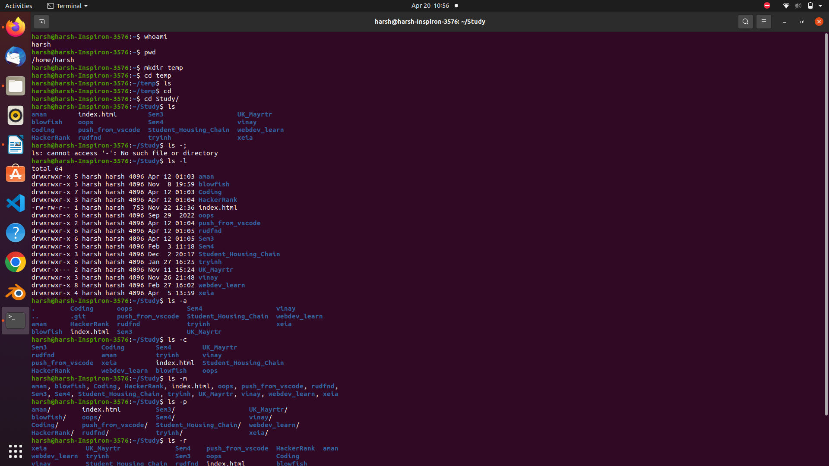

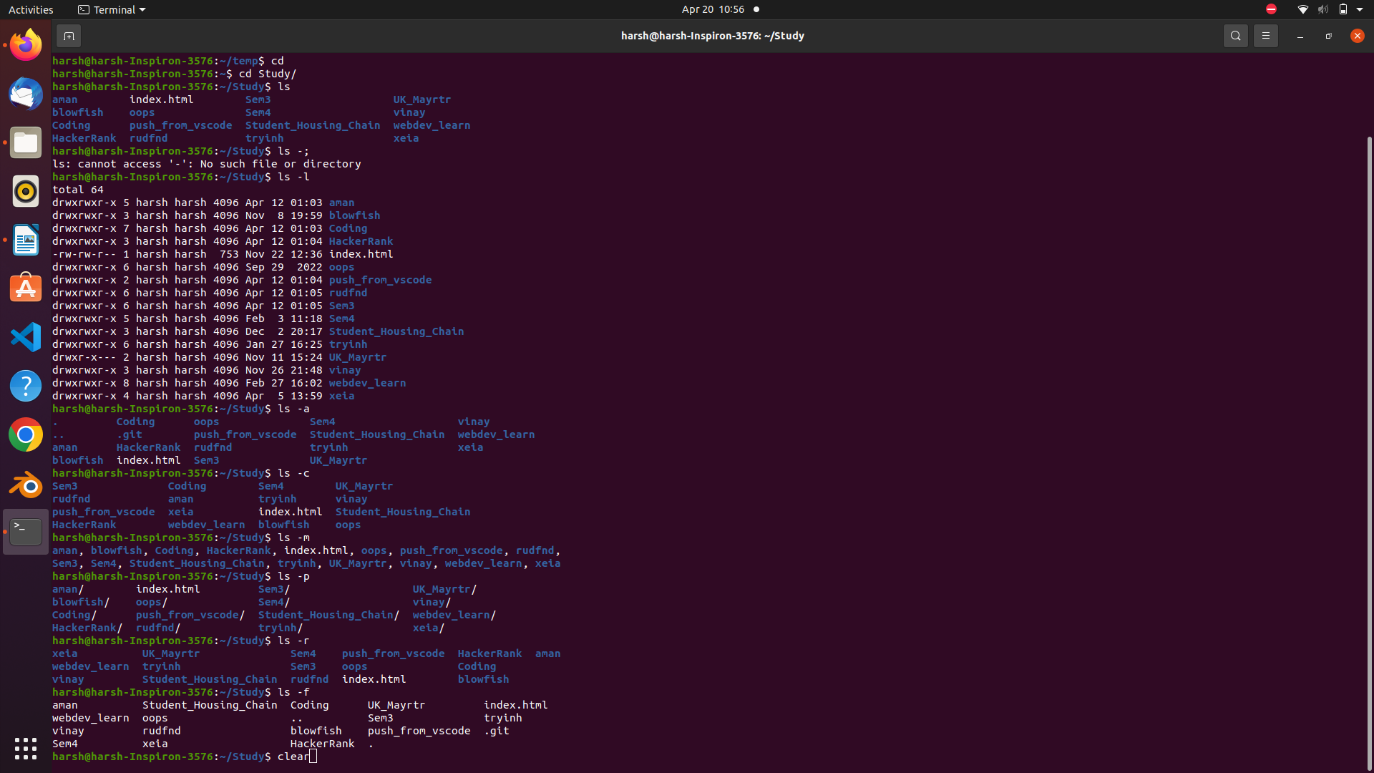

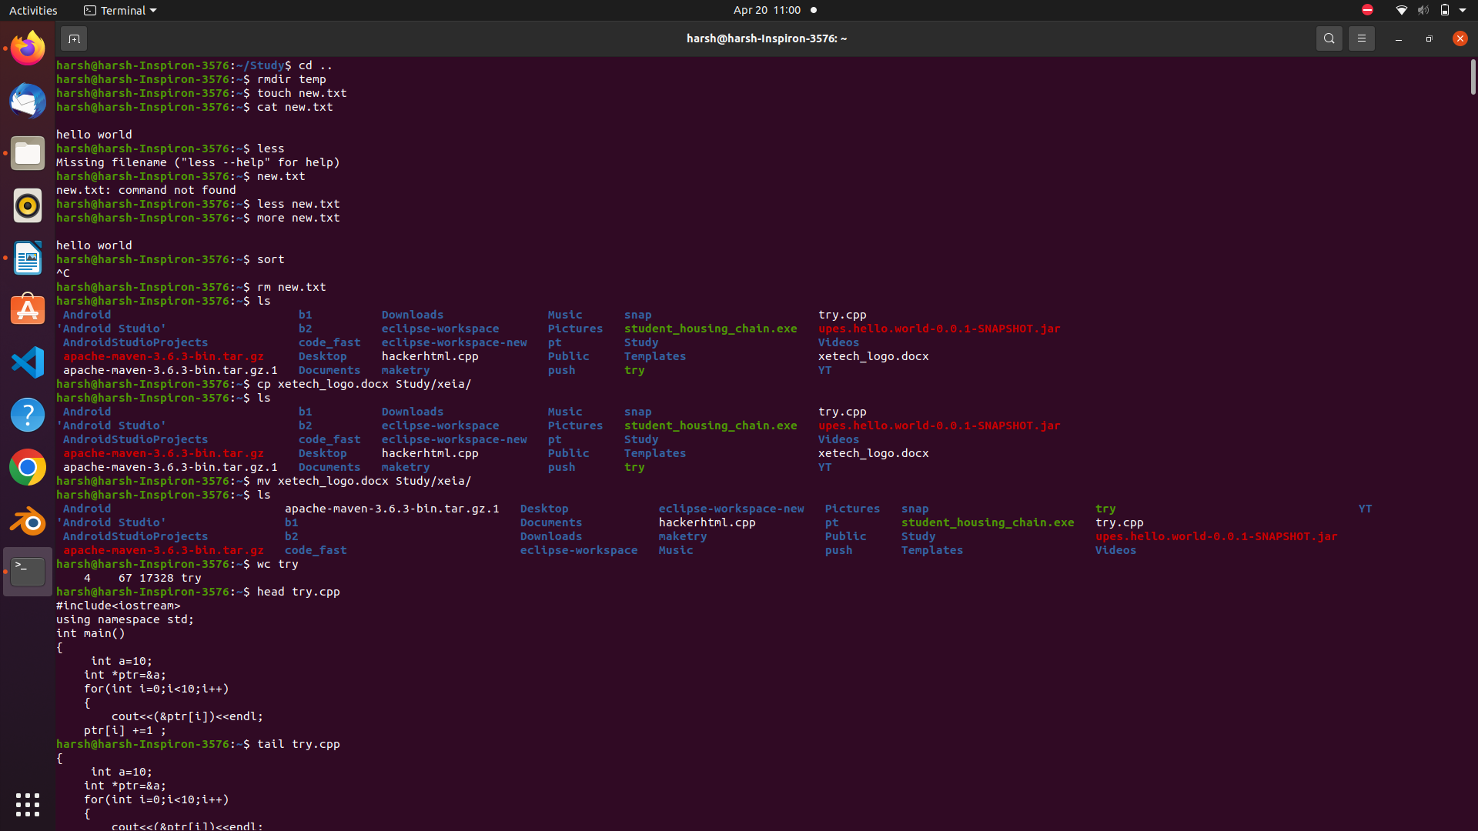

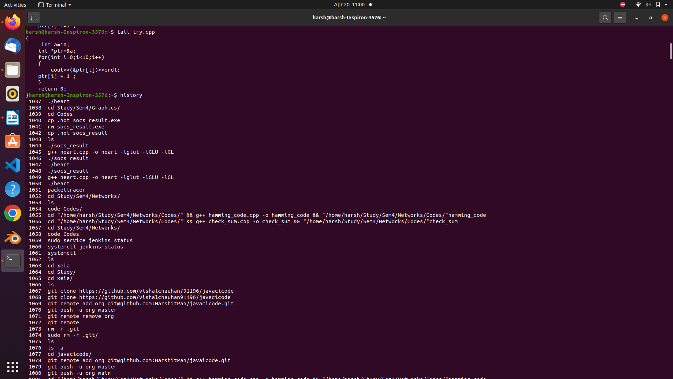

2. Write in details about the grep command. Also, using grep do the following:  
i) find all the patterns that start with “ep” in a given file.  
ii) Print those lines of a given text file which do not contain the word “hi”.  
iii) Explain the usage of options -i, -A, -B, -C in grep command with examples.

Answer -: Grep is a useful command to search for matching patterns in a file. grep is short for "global regular expression print". If you are a system admin who needs to scrape through log files or a developer trying to find certain occurrences in the code file, then grep is a powerful command to use.

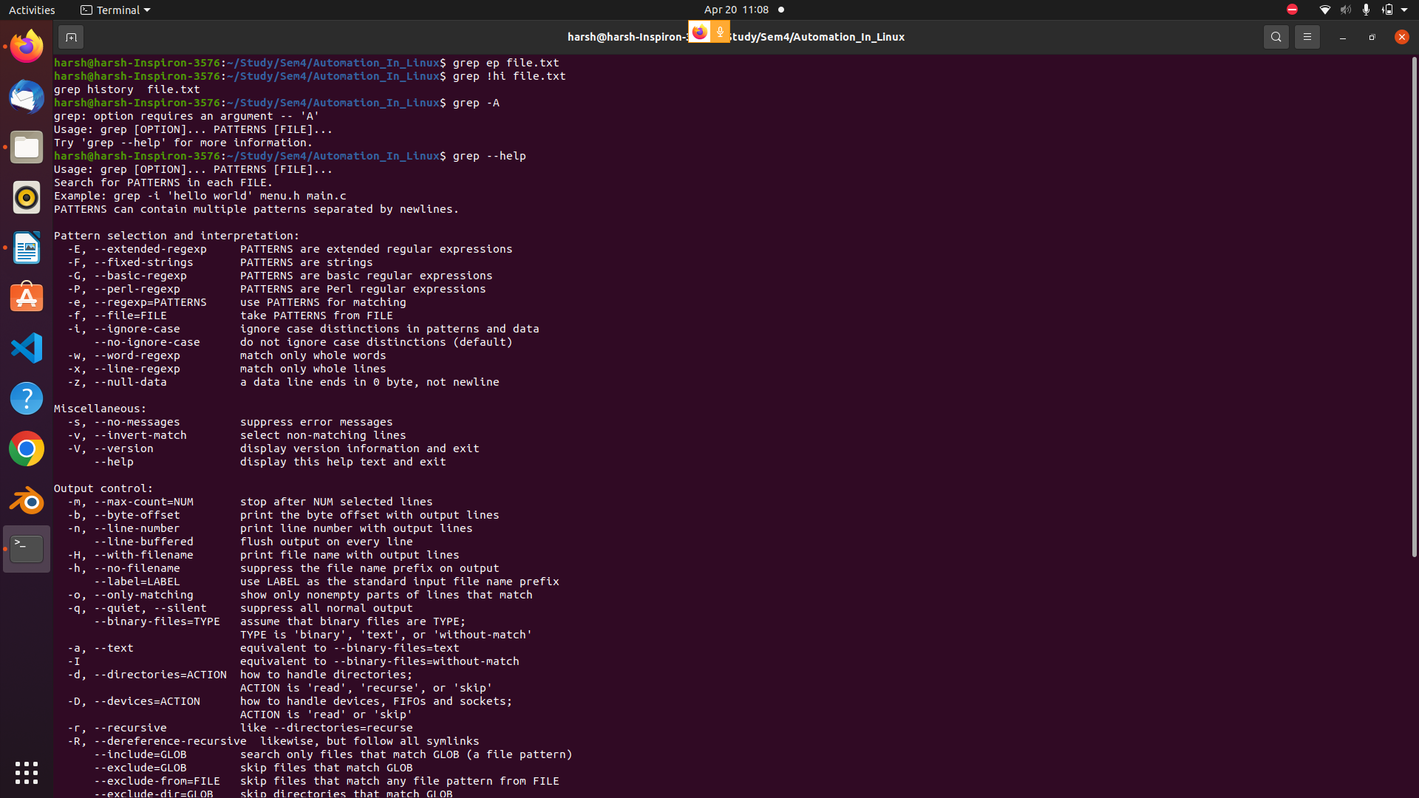

-i → ignore case distinctions in patterns and data

-A → print NUM lines of trailing context

-B → print NUM lines of leading context

-C → print NUM lines of output context