**SOFTWARE ENGINEERING AND PROJECT MANAGEMENT**

**DOCUMENTATION**

For

**Student Housing Chain Management System**

**Submitted to: Mrs. Shelly Garg**

**Submitted By**

|  |  |  |
| --- | --- | --- |
| **Specialization** | **SAP ID** | **Name** |
| DevOps(Hons.) | 500095944 | Harshit Pandey |
| DevOps(Hons.) | 500094582 | Nikhil Singh |



Department of Cybernetics

School Of Computer Science

UNIVERSITY OF PETROLEUM & ENERGY STUDIES,

DEHRADUN- 248007 Uttarakhand



**School of Computer Science**

University of Petroleum & Energy Studies, Dehradun

**Project Documentation**

Content

1. Abstract ………………………………………………………..

2. Introduction ……………………………………………………

3. Problem Statement …………………………………………….

4. Objective ………………………………………………………

5. Requirements…………………………………………………..

6. Methodology………………………………………………….

7. Future Goals…………………………………………………..

8. Data Set……………………………………………………….

9. Use Case Diagram……………………………………………..

10. Data Flow Diagram……………………………………………..

11. Prototype……..………………………………………………...

**Project Title: Student Housing Chain**

1. **Abstract**

Student Housing Chain is a chain of hostels under an organization such that the organization can work more proficiently. In this project, the owner of the company can access details of all hostels under its control and all the students staying in those hostels. The admin can create a new Hostel Code for a new hostel, and the hostel manager can access all the students' data and alter it. This project will be in CLI (Command line interface) mode and will not have any type of GUI (Graphical User Interface). The project will contain, a login page that can be accessed using Hostel Code and is connected to the menu interface. The Admin can log in through a login id pre-defined and can access many other options unique to him.

1. **Introduction**

In today’s world, education is the best weapon to win either battle in or out of the field. To acquire it students have to go to faraway places from their hometowns. The student requires a place to stay during their stay at that place. Many places are built to provide staying facilities to these students. Hostels are one of them with the most facilities that are provided. The hostels provide a staying facility, food facility, washing facility, and many more to the students. Some organizations open their hostel facilities in various parts of the world and some deal with an existing hostel to come under their firm. The education sector is increasing exponentially every day and the same for the student accommodations department which provides housing facilities to non-local students. The department is flourishing and the data coming with it. The Student Housing Chain is a plan for creating a Data Managing Software which helps the organization to store, delete and view that data in a better way with different users having their rights. A hostel manager can access the data of all the students and alter it and the admin or the organization, on the other hand, can access the same data for every hostel that is under them. This way a better hierarchy is established for the management. This Project contains a basic model for altering the dataset belonging to an organization.

1. **Problem Statement**

In Today’s World, with everything being digitized and data becoming the main focus of every field, there is a need to access it in a way that can be feasible, optimized, and easily accessible to the authorized person or group of persons. Data plays a major role in any project. In the student housing department, as the number of students increasing every year, the need to maintain the data is also increasing.

Some of the problems which arise in this field are-:

* No proper application to manage the data.
* In Student Housing Sector i.e. Hostels and their databases are very much distributed.
* Unavailability of a common point to join all hostel’s data.

1. **Objectives**

The Student Housing Chain is an application that is used in the Housing Sector for Students. The objective which is to be fulfilled by this project are -:

* To manage all the data in a proper manner which can be accessed easily.
* To make the data centralized so that all the distributed data are banded together in a single place.
* To form a hierarchy between Admin and Hostel Manager for accessing the data.

1. **Requirements**

For this project, some basic requirements are -:

* **Java Development Kit (JDK)** – The project will be written in Java so we require JDK to compile the code.
* **Java Run-Time Environment (JRE)** – As the project is in Java, The JRE is required to execute the file to start the CLI project.
* **Code Editor** – To write the code we require a Source Code Editor. The Editor which will be used in this project is VS Code.
* **MySQL-Server** – The database which will contain the data entered will be managed by the MySQL server.

Data required,

* Authentication Table – for storing Hostel Code and Password.
* Hostel Details – To store all the hostels comes under the organization and their basic information.
* Different Tables for Different Hostels to store student data.
* **MySQL Connector Jar** – MySQL connector jar is a tool used to connect a java source code to a MySQL server and establish a connection between the two to transfer the data from databases to the source code and to transfer queries from source code to MySQL.

1. **Methodology**

The project is a basic command line project with a CLI Interface. In this project, a user – Hostel Manager, or Organization can access the data as per their requirements and can alter it.

The first page which will be shown is the Login Page. It contains two input statements which are Hostel_Code and Password. When both Hostel_Code and Password are inputted, through the MySQL Connector Jar in the code, the database assigned is accessed and it is checked if there are any ID and Pass in the Authentication Table with the same details (case sensitive).

* If the Hostel_Code is not present in the database it will show a Hostel Not Present statement.
* If the Hostel_Code is present but the Password is not the same as that of Hostel_Code in the database, then an Invalid Password is printed.
* If both Hostel_Code and Password are the same as that of the database, it will send the user to the menu page.
* There are two menu pages, if in Hostel_Code, the admin Id which is already defined in the database as admin is inputted, then the user will be transferred to Admin Menu Page.
* Any other Hostel_Code will directly send the user to the Hostel Manager Menu Page.
* **In Admin Menu, there are 6 options**

1. **Add New Hostel** -: If the choice is 1, then the code will go to a function where we execute a query to insert the details of the new hostel. If the Hostel_Code is already present then due to Hostel_Code being a primary key an exception will be thrown otherwise it will be inserted in the table successfully.
2. **Remove New Hostel** -: If the choice is 2, then a function will run where we first fetch the data of the Hostel_Code inputted by the user. If the Result-Set returned is empty then there Hostel_Code invalid will be printed otherwise a new query is executed to delete the row with inputted Hostel_Code.
3. **Change Password** -: If the choice is 3, then a query is executed in the Authentication table. The password is updated with the inputted one where Code/ID is the same as that admin.
4. **Student Details** – If the choice is 4, then a list of all the available hostel_code will be printed and the admin can input any one of them to go to the menu page for that hostel and can see or alter data of all the students in that particular hostel.
5. **View All Hostel Details** – if the choice is 5, then all hostel details datasets will be printed which is fetched from the hostel details database.
6. **Exit** – if the choice is 6, then the program is terminated.

* **In Manager Menu, there are 6 options**

1. **Add New Student Details** – A function in which a query is executed where a new record of students with all its details is inserted in the table of the hostel in the database with an automatically created student_id. If there is some invalid data, the process is terminated with a specific error message.
2. **Remove Existing Details** – A function that removes data from the hostel table using student_id.
3. **Change Password** – A function that helps to change the password of the lined user. An update query is executed to overwrite the data in the Authentication Table where hostel_code is the same as the linked user.
4. **See Details of all students** – A function that will show all the details of all the students living in the hostel connected with the lined hostel_code.
5. **Update Total Seats** – A function that creates a query to update values in the hostel details table and update the remaining seats and total seats if the updated seats are greater than occupied seats i.e. total seats – remaining seats.
6. **Exit/Back** - A function that will execute the program if the lined id is hostel_code with the Exit option. If the lined user is an admin then a back option will be shown which will transfer it from the hostel section to the admin section.
7. **Future Goals**

* **In Admin Menu**

1. An option where an admin can see all the student details in all hostels.
2. An option that can help the admin to sort all the hostels in a way in which he can see all hostels in descending order of most occupied hostels or the cities with the most occupied hostels.
3. The admin can increase the facilities in a particular hostel.

* **In Manager Menu**

1. An option that will show the list of all students who have not paid the fees with the remaining amount.
2. An option that will show all the students staying in a specific room or specific floor.
3. **Data Set**

The Data Set used here is a collection of details of students as per their hostel where they are residing and details of all the hostels which come under the organization. In this project, we are providing each hostel with a unique code that is stored with the password generated by the admin of the organization.

The data regarding all the hostels are stored together and the data of the students residing in that hostel can be accessed with those Hostel Codes.

The Data Set contains three types of data here,

1. ***Id Authentication*** – This data is the collection of all the Hostel Codes with their Password. It also contains the admin code with its password. This data can only be altered by the admin of the organization and everyone other than the admin i.e. Hostel Managers can’t access it in any way. This data is accessed by two functions of the application. Firstly, the Login Function and Secondly, the Admin Menu.
2. ***Hostel Details*** – This data stores the details of all the hostels which come under the organization. This function can only be accessed by the admin of the organization. The Hostel Manager can view details of their hostels only, with the help of a few functions provided to them. The data in this table can be altered by admin only. Partial Alteration is allowed for the Hostel Manager.
3. ***Set of Student Details*** – This is not particular data but a data set of all the students belonging to the organization as per their residence hostel. This data set is a subset of the major data set of the Student Housing Chain. For each hostel that comes under the company, there is a table with the name as that of the Hostel Code for that hostel and this table store details of all the students who reside in that hostel. There is no particular number for these tables as the admin can increase or decrease their number as per the requirement.

* If a hostel is added to the organization, then its Hostel Code with its Password is stored in Id Authentication. The rest of the details will be stored in Hostel Details with Hostel Code as its unique key in both tables. (Note – Unique Key refers to the data which will be unique for all the data of same the type in the same scope.) At the same time, a new table is created with the name as that of the new Hostel Code added by the admin. This table is made in such a way that it can store data of all the students who will be residing in that hostel. The new table created will be empty and the data inside it will be stored by the Hostel Manager of that Hostel using the Hostel Code and Password created previously.
* If a hostel is removed from the organization, then the data of that Hostel Code will be deleted from Id Authentication and Hostel Details. At the same time, the whole table which stores the data of the student will be dropped from the Data Set.

1. **Use Case Diagram**

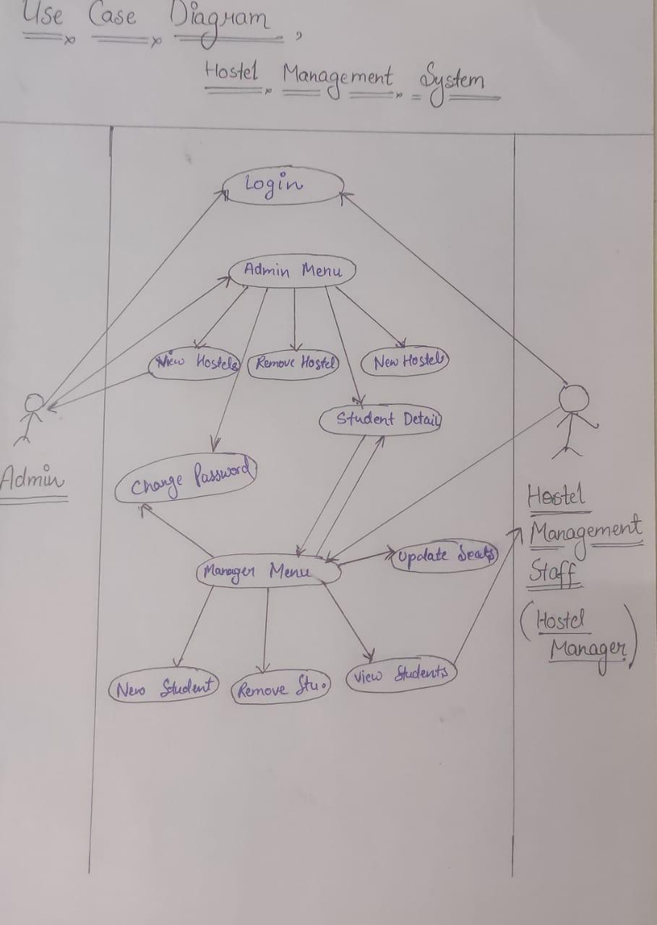

* + - Student Housing Chain

1. **Data Flow Diagram**

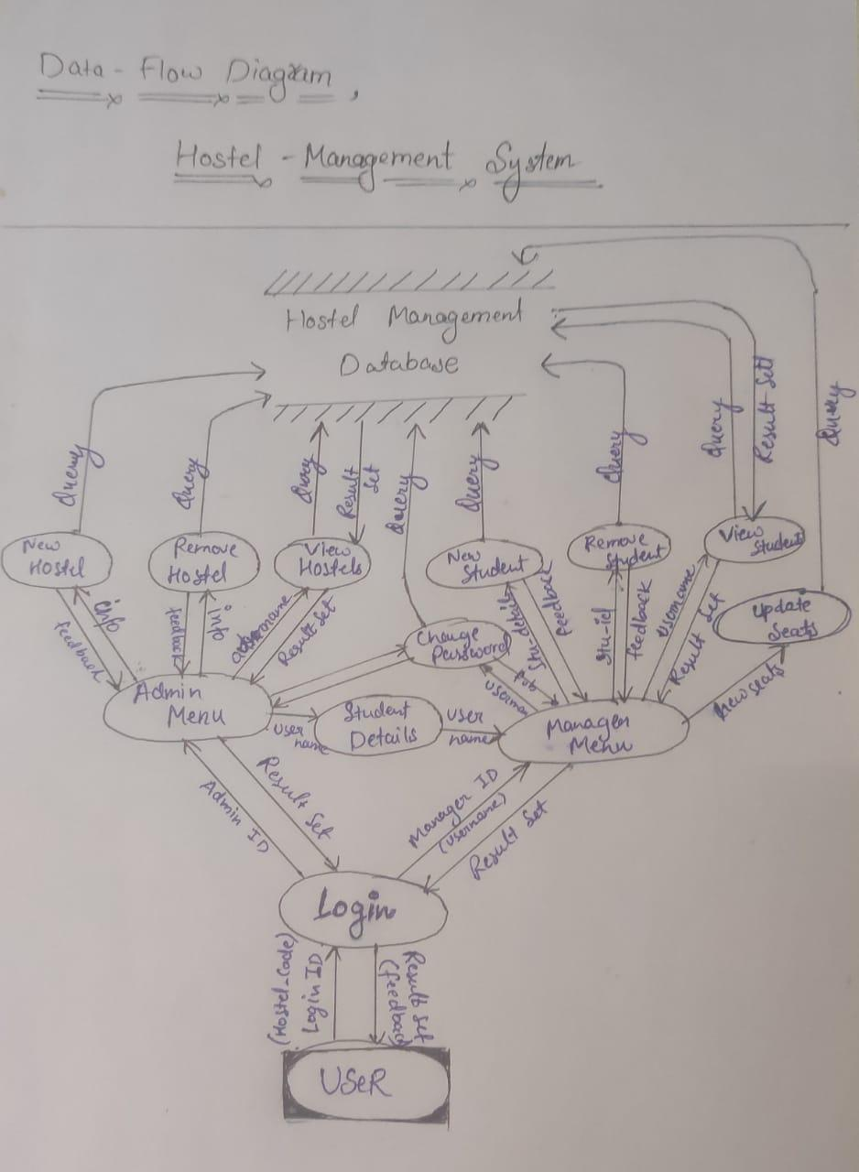

* + - **Student Housing Chain**

1. **Prototype**

Here is a prototype that contains the basic blueprint of how the project will look like. The prototype only contains specific data fields which will be increased in the future.

Source Code -[**https://github.com/HarshitPan/Student_Housing_Chain_CLI**](https://github.com/HarshitPan/Student_Housing_Chain_CLI)

**Manager Section,**

* **Login Page**

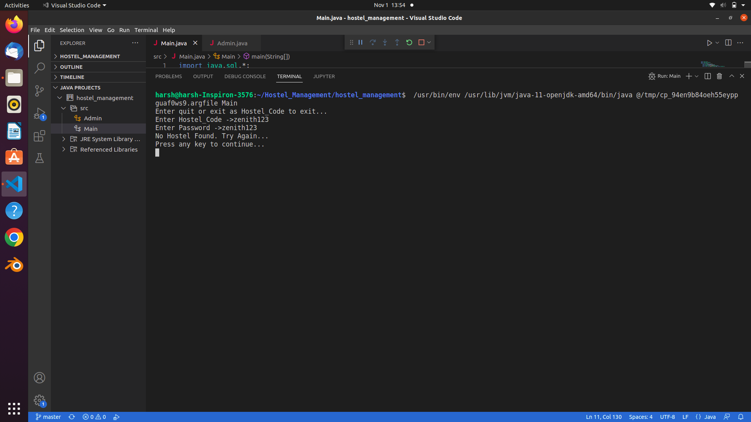

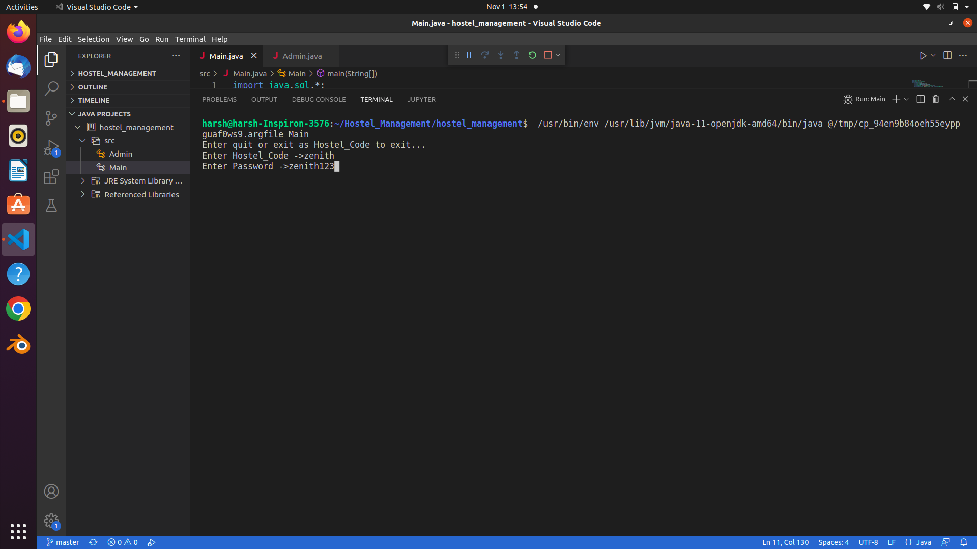

* **Menu**

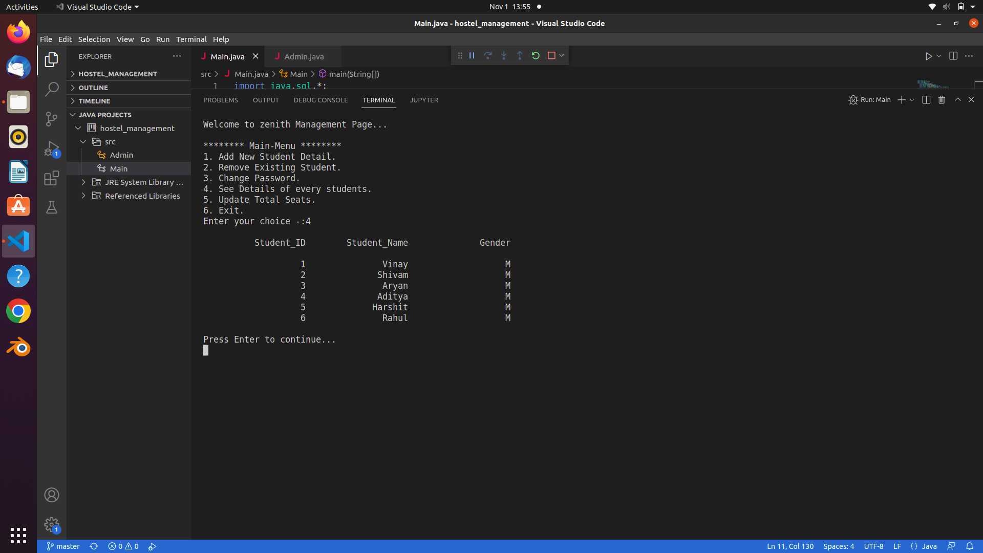

1. **Adding or Removing a new Student**

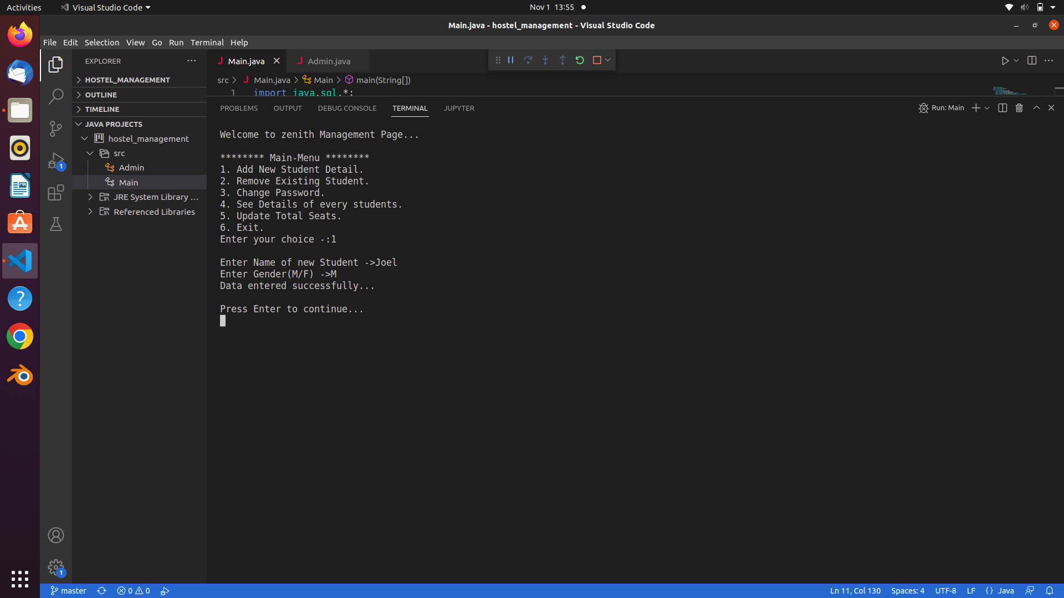

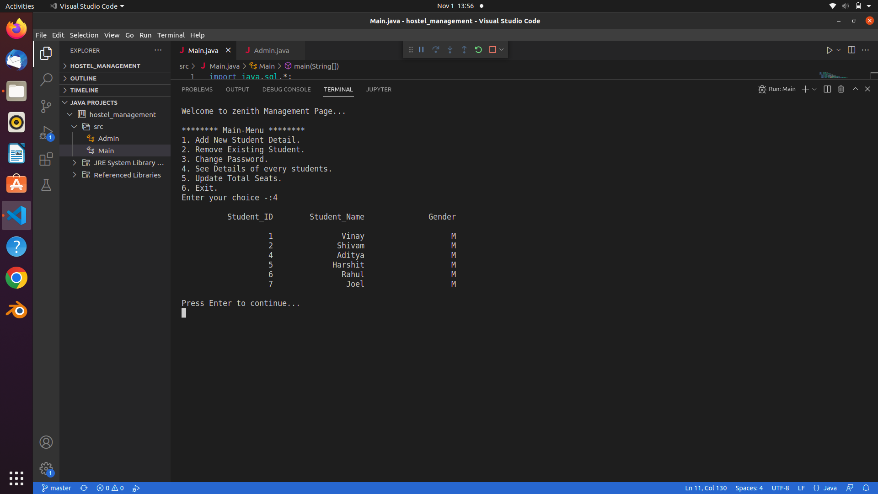

1. **Changing Password**

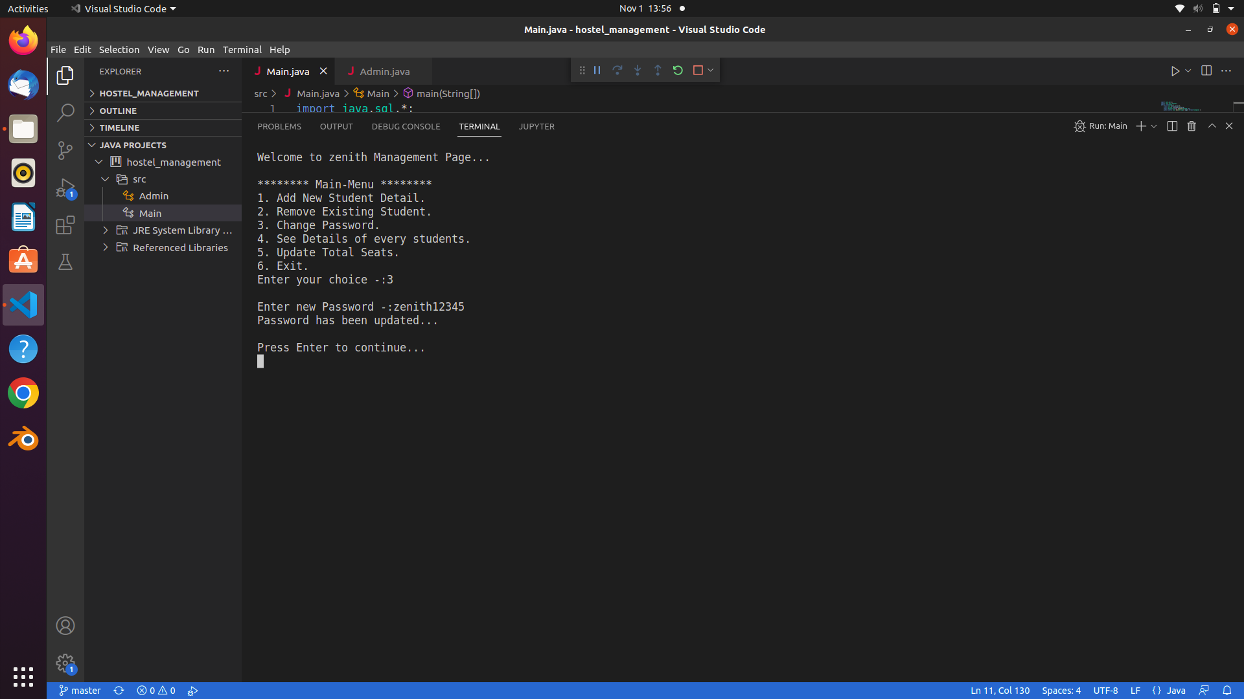

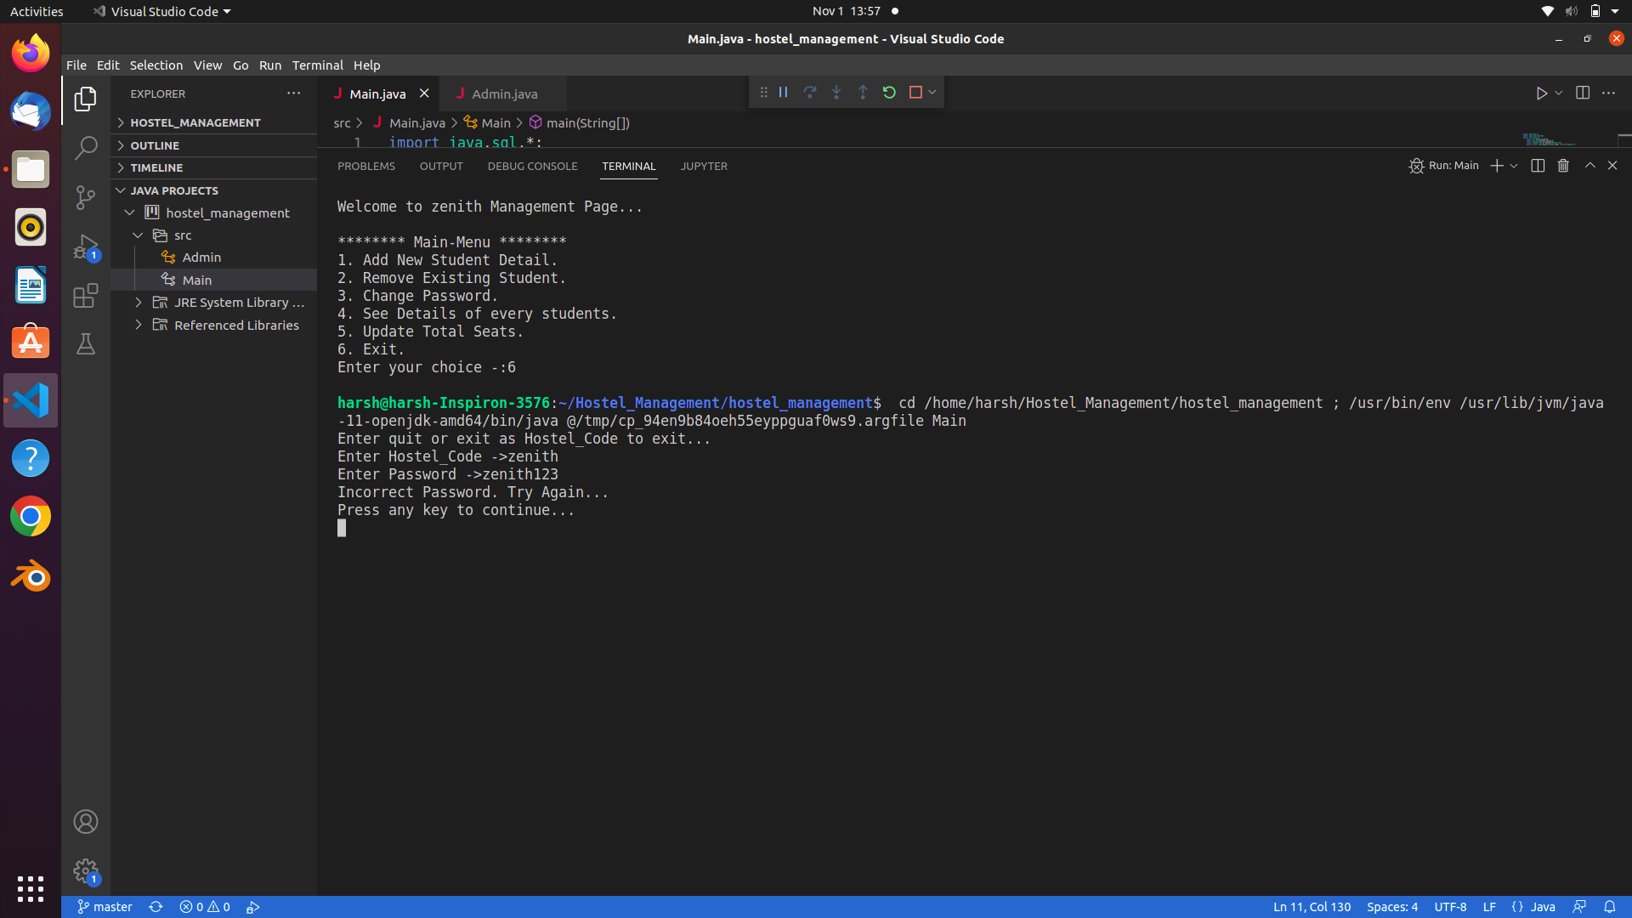

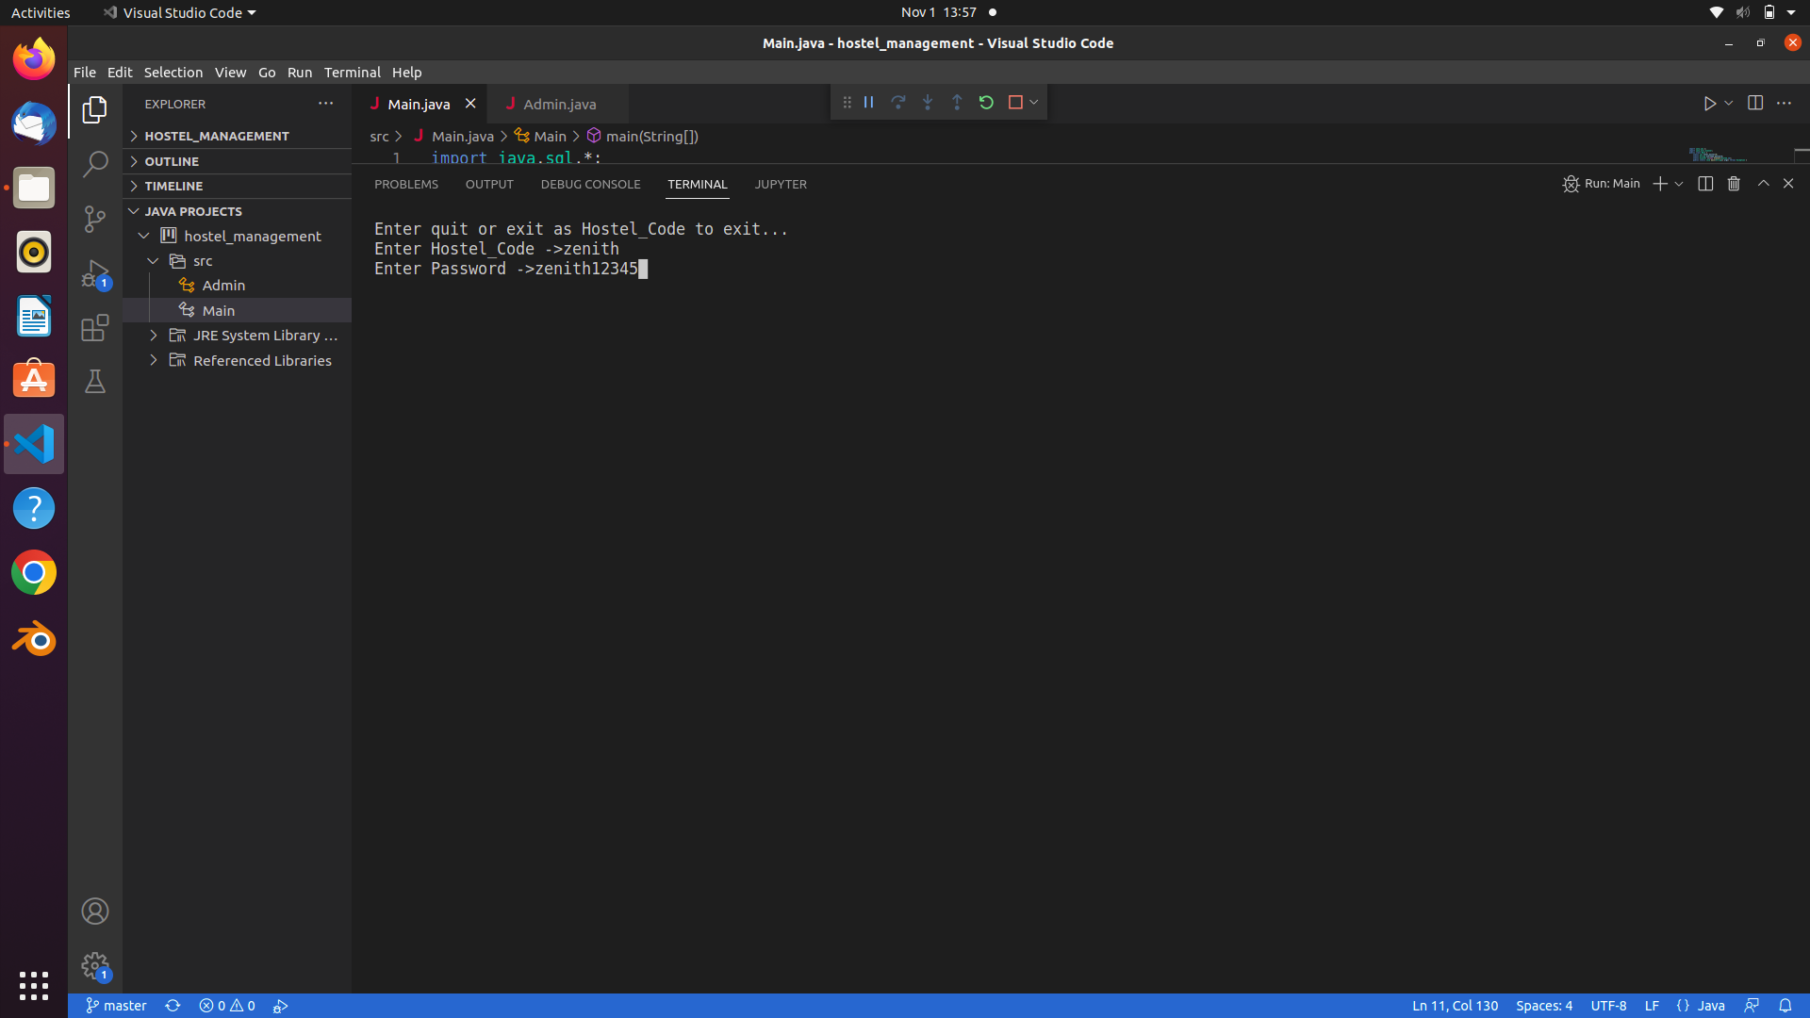

1. **See Details**



1. **Update Seats**

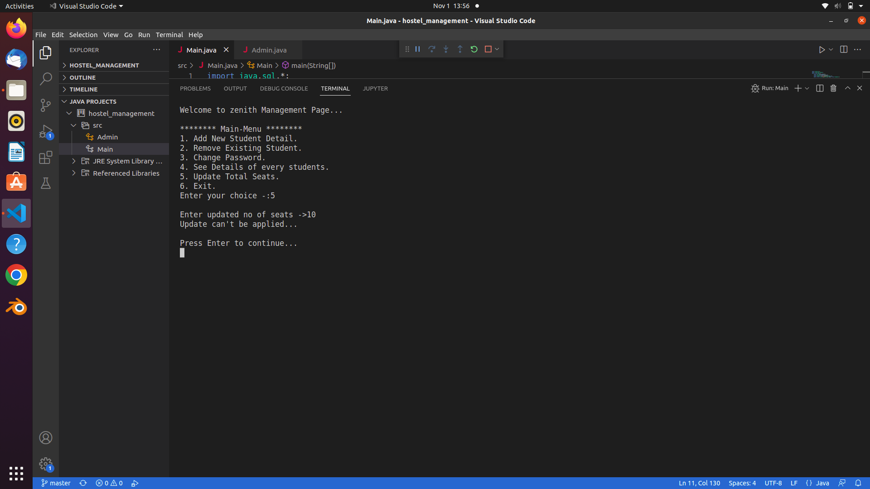

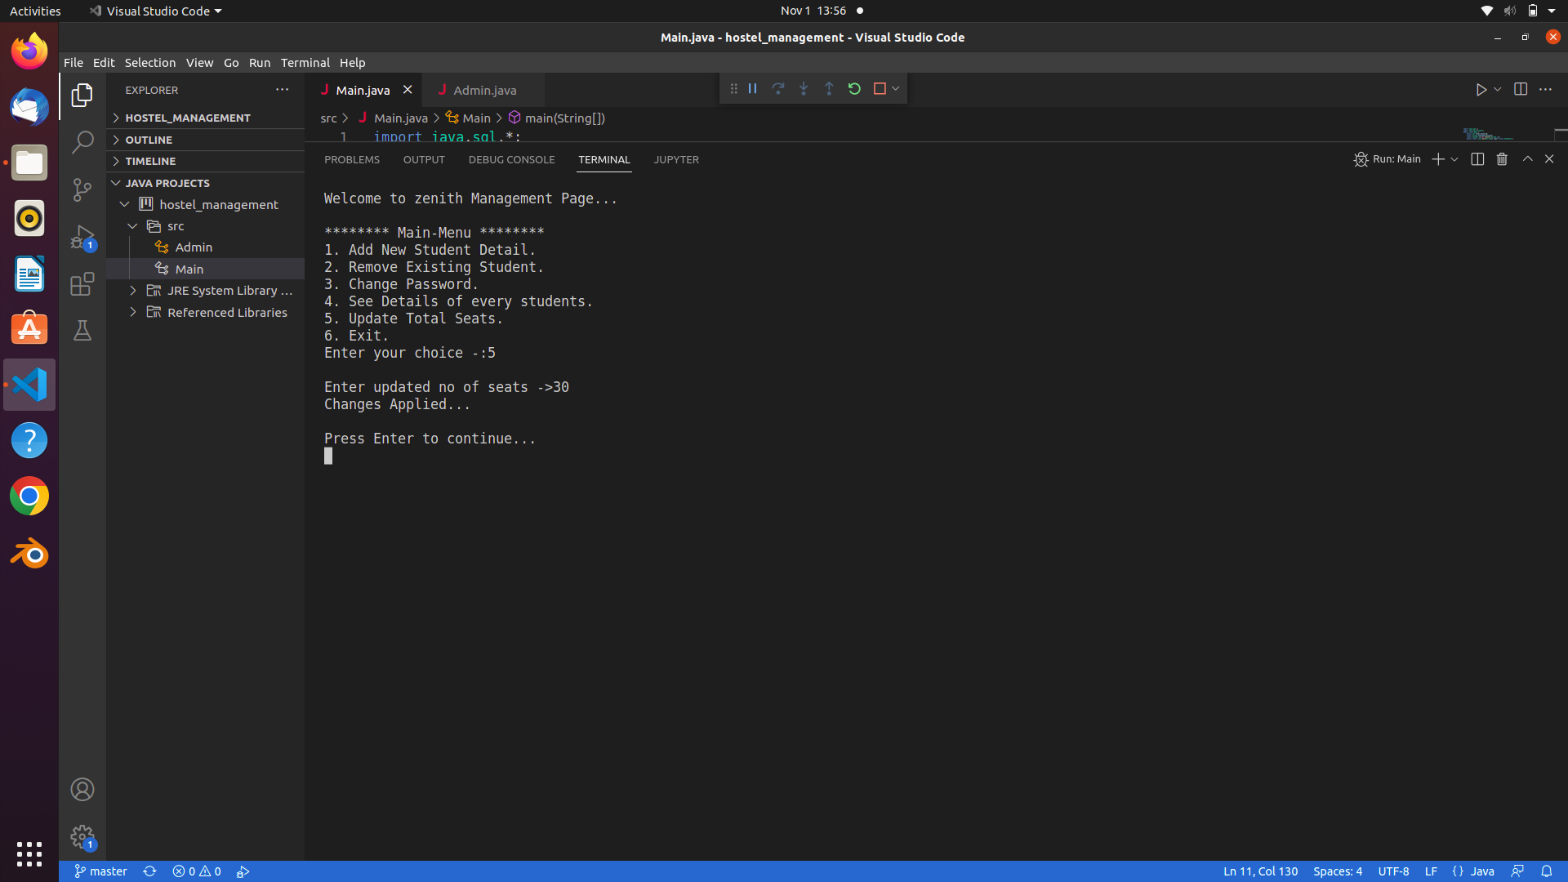

1. **Invalid Choices**

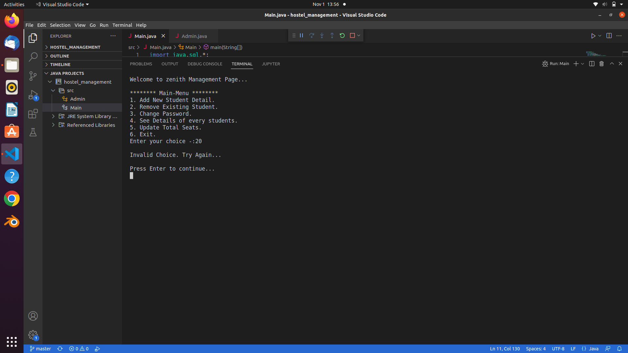

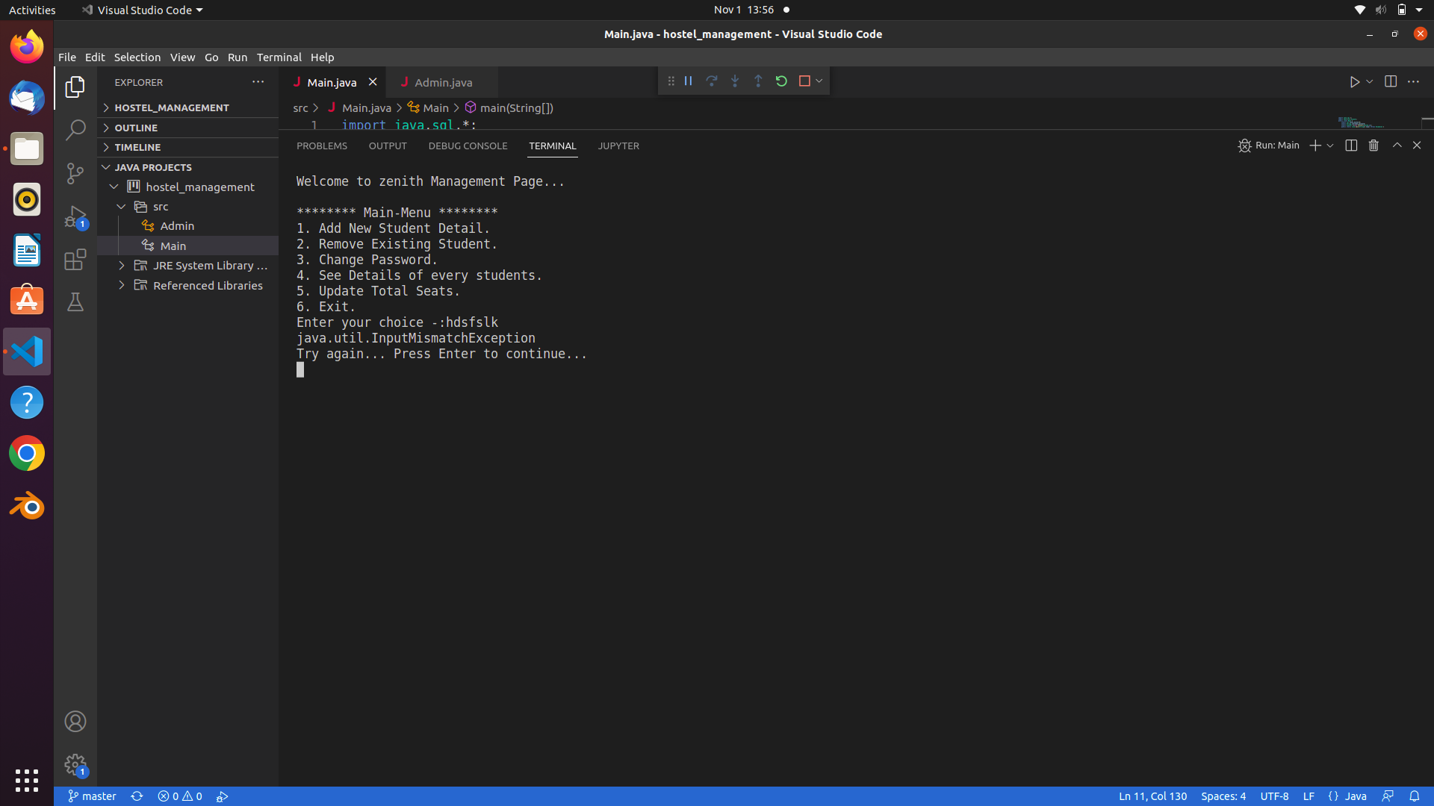

* **Admin Section**
* **Login Page**

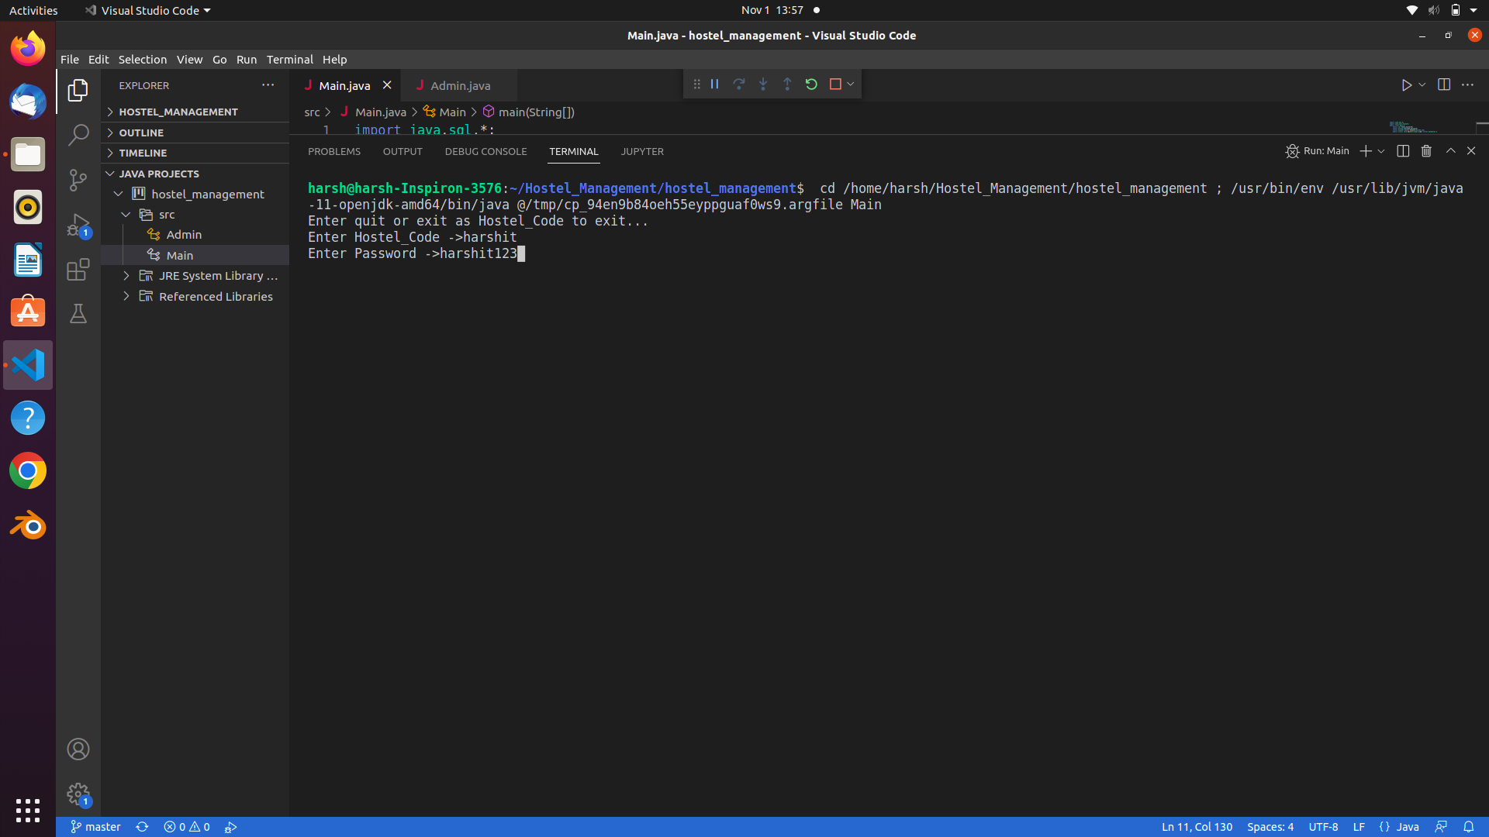

* **Menu**

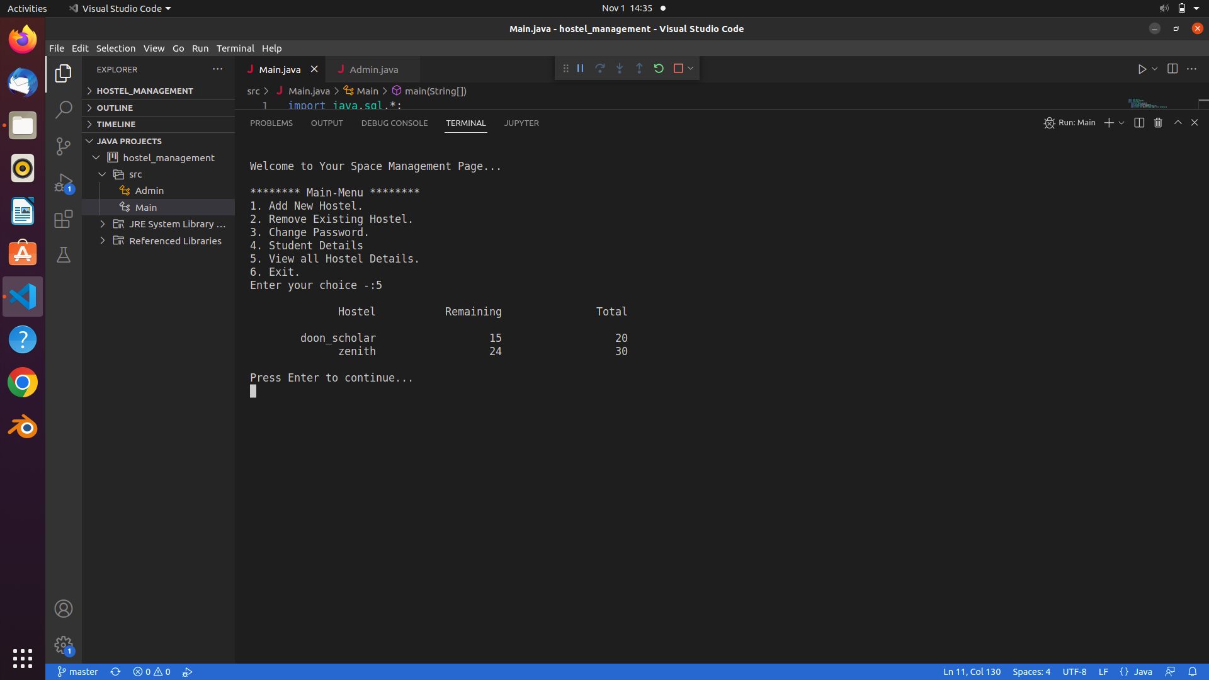

1. **Adding New Hostel**

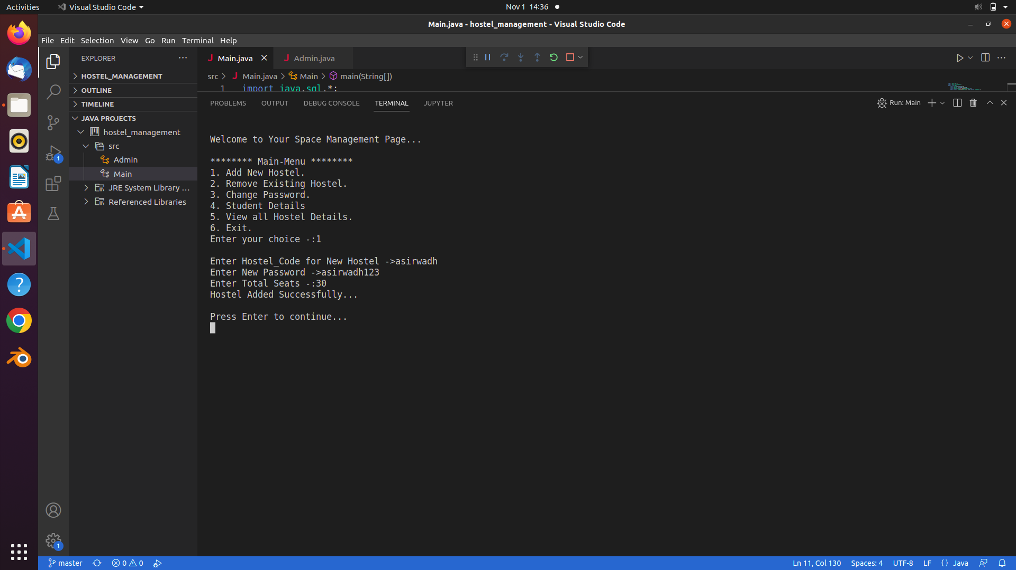

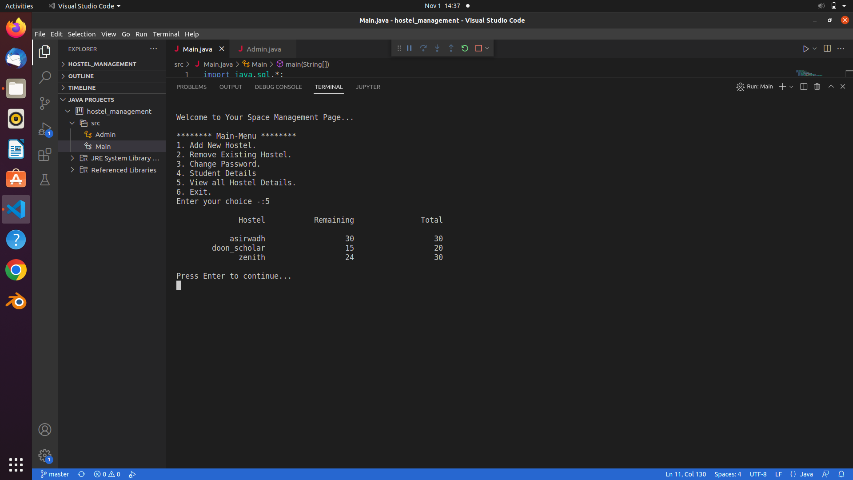

1. **Removing Hostel**

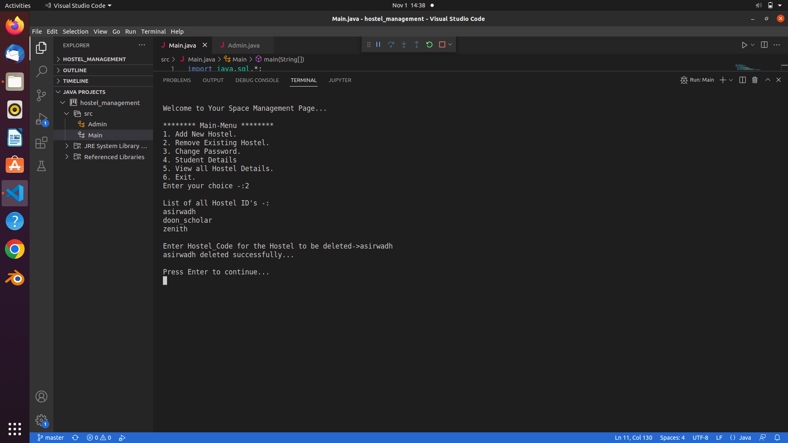

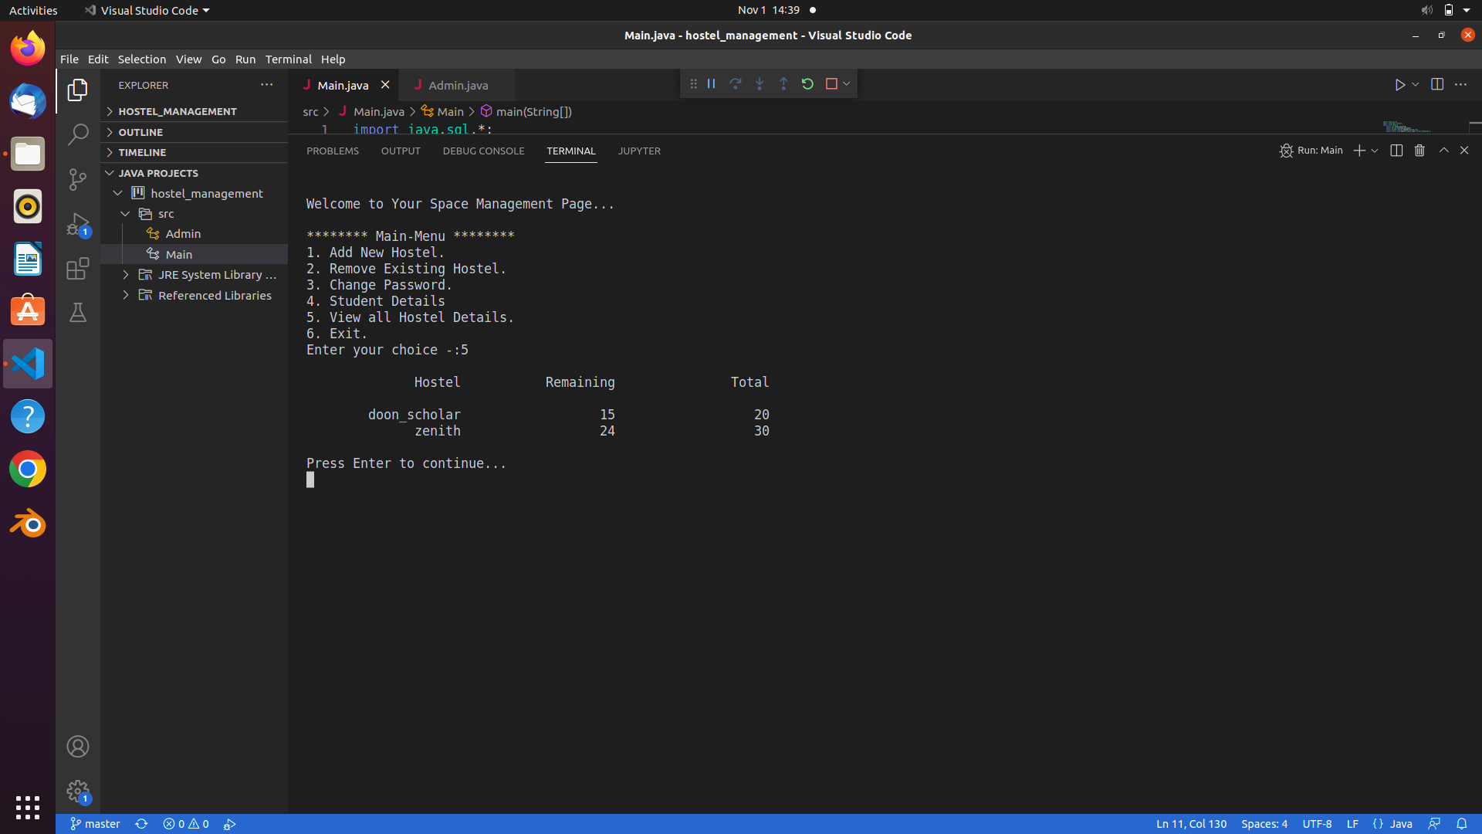

1. **Change Password**

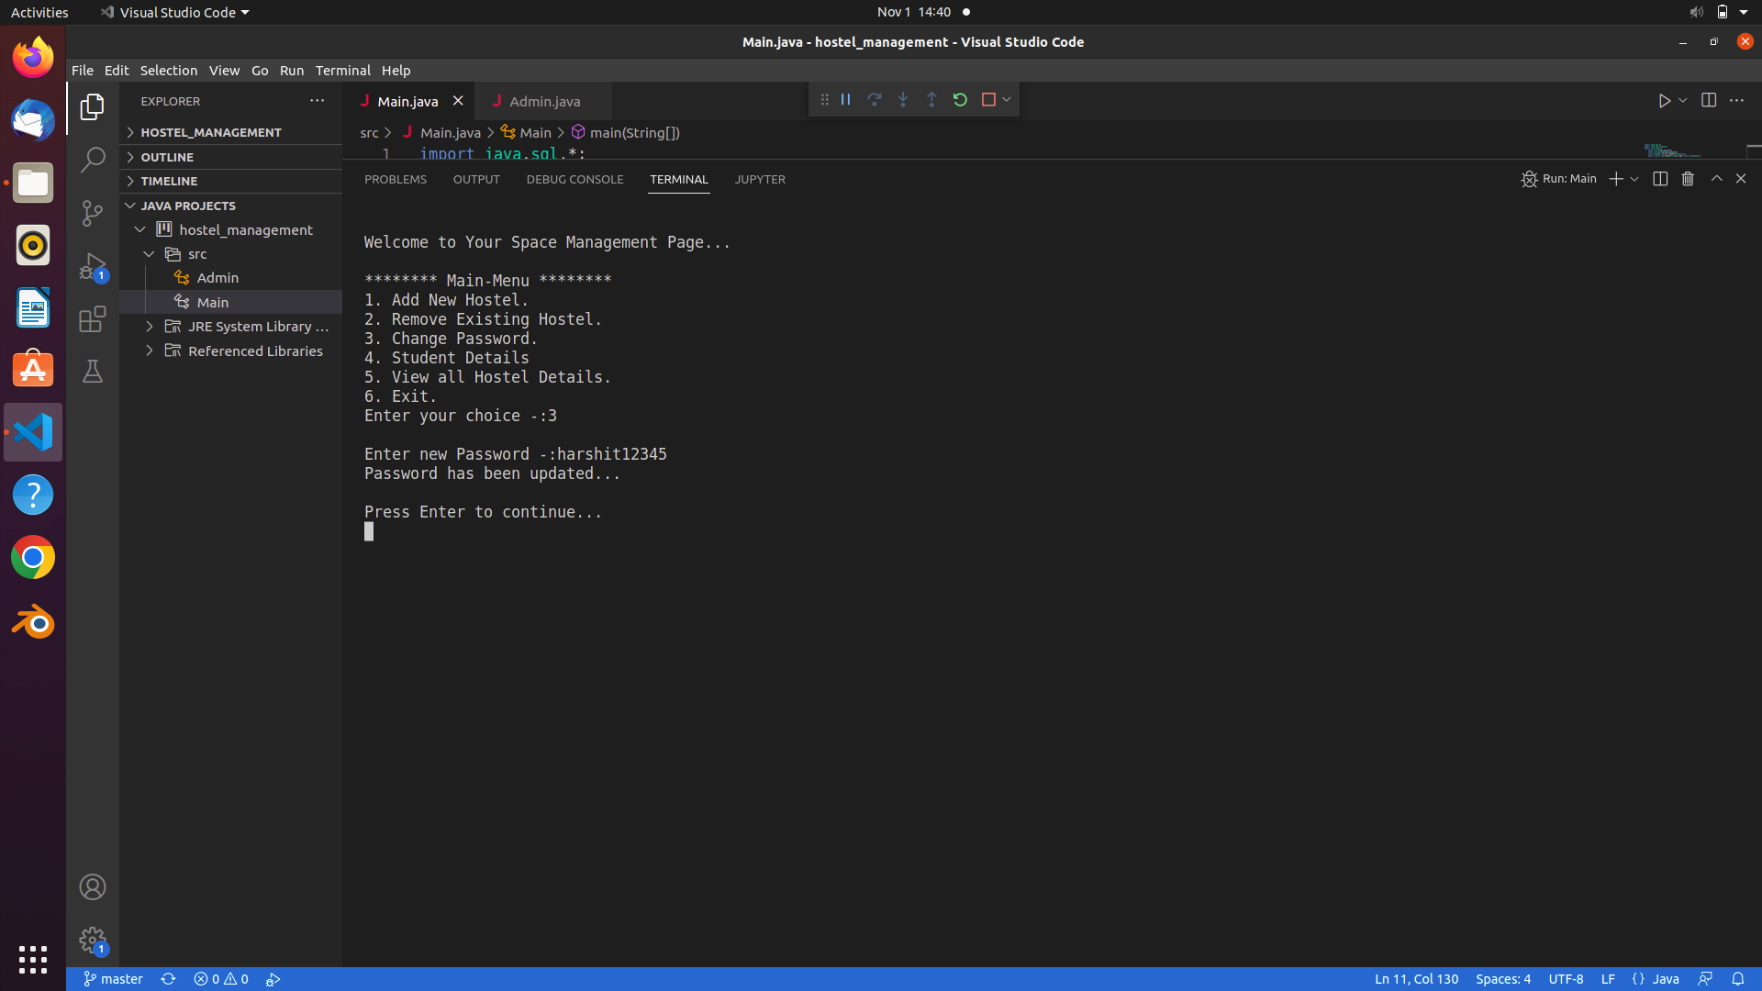

1. **Student Details**

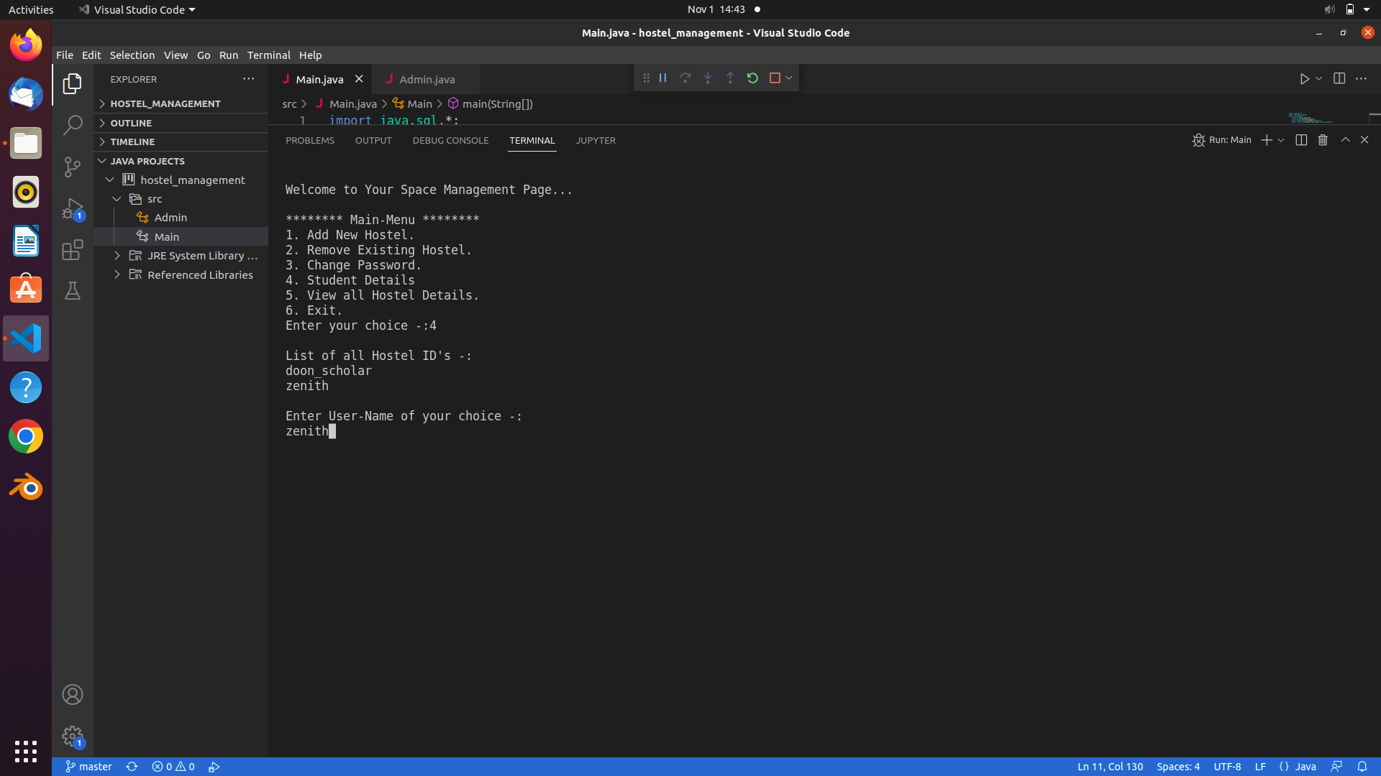

1. **All Hostels**



1. **Exit**

