 | Data Structures and Algorithms-II  (BCSE0401)  UNIT-1 |  | SESSION: 2025-26
 |  |  | COURSE/SEM: B. TECH/IV
Assignment Given Date: 30/01/2026  Assignment Submission Date: 06/02/2026 |  | MAXIMUM MARKS: 10
Faculty Name: - Dr. Sangeeta Arora |  | Faculty Mail Id: sangeeta.arora@niet.co.in
INSTRUCTIONS:

- Submit the assignment before the due date.
- Avoid copying the assignment, if found student will be penalized accordingly.
- Mention all the necessary details in your pdf file. All assignments should be in a pdf file format. No other format will be entertained.

Q. No. | Question Statement | CO | BLOOM’S KNOWLEDGE LEVEL
1. | Discuss terminology in Tree data structure with help of a proper example for each term. | CO1 | K1
2. | “Binary Tree data structure can be represented by using array and linked list.” Discuss the validity of the above statement with proper example. | CO1 | K1
3. | Give the C code for the following using recursion and iteration both, Also analyse the time complexity in both case:  - In-Order Traversal  - Pre-Order Traversal  - Post-Order Traversal | CO1 | K3
4. | - Give an algorithm to find the maximum element in a binary tree.  - Give an algorithm for finding the size of binary tree.  - Give an algorithm for finding the height (or depth) of the binary tree.  - Give an algorithm for finding the number of full nodes in the binary tree without using recursion.  - Write the pseudocode to traverse the tree in level order. | CO1 | K3
5. | Prove the following statement:  - Prove that in a binary tree ‘T’ the maximum nodes at any level ‘L’ is 𝟐^{𝒍}.  - Prove that in a binary tree ‘T’ the maximum number of  nodes with height is 𝟐^{𝒉+𝟏} − 𝟏.  - For any binary tree (non-empty) ‘T’ prove that  𝒏_{𝟎} = 𝒏_{𝟐} + 𝟏 where, 𝒏_{𝟎} =  𝑵𝒖𝒎𝒃𝒆𝒓 𝒐𝒇 𝒏𝒐𝒅𝒆𝒔 𝒐𝒇 𝒅𝒆𝒈𝒓𝒆𝒆 𝟎 (𝒊. 𝒆. 𝒏𝒐 𝒄𝒉𝒊𝒍𝒅) and  𝒏_{𝟐} =  𝑵𝒖𝒎𝒃𝒆𝒓 𝒐𝒇 𝒏𝒐𝒅𝒆𝒔 𝒐𝒇 𝒅𝒆𝒈𝒓𝒆𝒆 𝟐 (𝒊. 𝒆. 𝟐 𝒄𝒉𝒊𝒍𝒅𝒓𝒆𝒏)  - Prove that the height of a complete binary tree is log n. | CO1 | K4

6. | 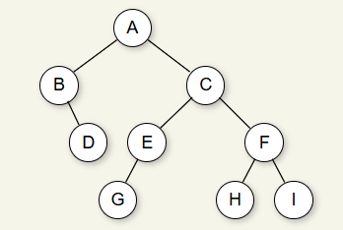  Find the In-order, Pre-order and Post-order traversal for the following binary tree:  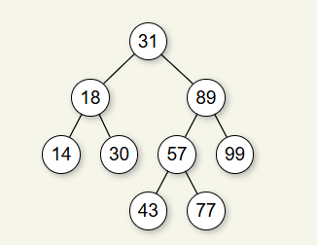  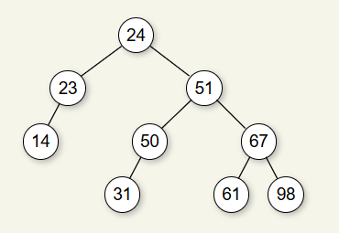 | CO1 | K2

7. | Create a Binary Tree from the given traversal:  i Pre-Order: 1 2 4 5 3 6  In-Order: 4 2 5 1 6 3  ii In-Order: 40 20 50 10 60 30  Post-Order: 40 50 20 60 30 10  iii Pre-Order: A B D I J F C G K H  In-Order: I D J B F A G K C H | CO1 | K2
8. | Define Binary Search Tree. Give a program to implement BST and to insert and delete in BST. | CO1 | K3
9. | Construct a Binary Search Tree by inserting the following sequence of number: 10,12,5,4,20,8,7,15 and 13.  After creating the binary tree delete the following node: 13, 5 and 10 from the above binary search tree created. | CO1 | K2
10. | Create an AVL Tree from the given nodes:  - 21,26,30,9,4,14,28,18,15,10,2,3,7  - Create an AVL tree by inserting numbers from 1 to 10.  - Create an AVL tree by inserting the following sentence:  “Jump dogs bad ”. | CO1 | K4
11. | Perform deletion in AVL Tree from the tree created above in the sequence mentioned below:  - 2, 15, 9, 21,14  - 8, 7, 2, 6 | CO1 | K3
12. | Discuss the following with proper example.Write the algorithm of both and analyse their time complexity:  - Binary Heaps  - Priority Queue | CO1 | K2
13. | Perform Heap Sort on the following listed numbers and give the algorithm to perform heap sort for the same.  82, 90, 10, 12, 15, 77, 55, 23 | CO1 | K2
14. | What are Threaded Binary Trees. Discuss its advantages and disadvantages. | CO1 | K2

