**Problem Statement 1.Find the Standard Deviation and Variance of the grouped data.**

import math

low_lim=[0,10,20,30,40,50] # lower limit

up_lim=[10,20,30,40,50,60] # upper limit

freq=[27,10,7,5,4,2] # m_ean=stat.mean(lower_values)

n=len(low_lim) # length of the data

freq_sum=0

for i in range(0,n):

freq_sum=freq_sum+freq[i]

xifi = 0

xifi2 = 0

for i in range(0,len(low_lim)):

xi = (up_lim[i] + low_lim[i])/2

xifi += (freq[i] * xi)

xifi2 += (freq[i] * xi * xi)

xmean = xifi / freq_sum

ss = xifi2 - ((xifi ** 2)/freq_sum)

var = ss/(freq_sum-1)

sd = math.sqrt(var)

print("Variance of above data is:- ",var)

print("Standard Deviation of above data is:- ",sd)

**Output:-**

PS C:\Users\Harsh\Desktop\ML> python -u "c:\Users\Harsh\Desktop\ML\SD.py"

Variance of above data is:- 222.55892255892255

Standard Deviation of above data is:- 14.918408848095112

**Problem Statement 2.Implement Finds Algorithm using python**

import csv

a =[]

with open("./data.csv","r") as csvfile:

for row in csv.reader(csvfile):

a.append(row)

print("\nTraining instances:- ",len(a)-1)

num_attr = len(a[0])-1

print("\nTotal attributes:-",num_attr)

print("\nInitial Hypothesis:- ")

hypothesis = ['0'] * num_attr

print(hypothesis)

for i in range(0, len(a)):

if a[i][num_attr] == 'yes':

for j in range(0, num_attr):

if hypothesis[j] == '0' or hypothesis[j] == a[i][j]:

hypothesis[j] = a[i][j]

else:

hypothesis[j] = "?"

print(hypothesis)

print("\nThe hypothesis of the training instance {} is: \n".format(i),hypothesis)

print("\nThe specific hypothesis for the training instance is: ")

print(hypothesis)

**Output:-**

PS C:\Users\Harsh\Desktop\ML> python -u "c:\Users\Harsh\Desktop\ML\Finds.py"

Training instances:- 4

Total attributes:- 6

Initial Hypothesis:-

['0', '0', '0', '0', '0', '0']

['sunny', 'warm', '?', 'strong', 'warm', 'same']

['sunny', 'warm', '?', 'strong', 'warm', 'same']

['sunny', 'warm', '?', 'strong', '?', 'same']

['sunny', 'warm', '?', 'strong', '?', '?']

The hypothesis of the training instance 4 is:

['sunny', 'warm', '?', 'strong', '?', '?']

The specific hypothesis for the training instance is:

['sunny', 'warm', '?', 'strong', '?', '?']

**Problem Statement 3.Implement Candidate Elimination Algorithm using python.**

import csv

with open("./data.csv","r") as csvfile:

csvf = csv.reader(csvfile)

data = list(csvf)

s = data[1][:-1]

print(s)

g = [['?' for i in range(len(s))]for j in range(len(s))]

for i in data:

if i[-1] == "yes":

for j in range(len(s)):

if i[j] != s[j]:

s[j] = "?"

g[j][j] = "?"

elif i[-1] == "no":

for j in range(len(s)):

if i[j] != s[j]:

g[j][j] = s[j]

else:

g[j][j] = "?"

gh = []

for i in g:

for j in i:

if j != "?":

gh.append(i)

print("\n Specific hypothesis:- \n",s)

print("\n General hypothesis:- \n",gh)

**Output:-**

PS C:\Users\Harsh\Desktop\ML> python -u "c:\Users\Harsh\Desktop\ML\CE.py"

['sunny', 'warm', 'normal', 'strong', 'warm', 'same']

Specific hypothesis:-

['sunny', 'warm', '?', 'strong', '?', '?']

General hypothesis:-

[['sunny', '?', '?', '?', '?', '?'], ['?', 'warm', '?', '?', '?', '?']]

**Problem Statement 4.Implement Linear Regression using python and numpy library.**

import numpy as np

import matplotlib.pyplot as plt

x = np.array([1,2,3,4,5])

y = np.array([7,14,15,18,19])

n = np.size(x)

x_mean = np.mean(x)

y_mean = np.mean(y)

Sxy = np.sum(x*y) - n*x_mean*y_mean

Sxx = np.sum(x*x) - n*x_mean*x_mean

b1 = Sxy/Sxx

b0 = y_mean - b1 * x_mean

print("\nSlope b1 is:- ",b1)

print("\nIntercept b0 is:- ",b0)

plt.scatter(x,y)

plt.xlabel("Independent variable X")

plt.ylabel("Dependent variable Y")

y_pred = b1 * x +b0

plt.scatter(x,y,color="red")

plt.plot(x,y_pred,color = "green")

plt.xlabel("X")

plt.ylabel("Y")

error = y - y_pred

se = np.sum(error ** 2)

print("\nSquared Error is ",se)

mse = se/n

print("\nMean Squared Error is ",mse)

rmse = np.sqrt(mse)

print("\nRoot mean Squared Error is ",rmse)

sst = np.sum((y-y_mean) ** 2)

r2 = 1 - (se/sst)

print("\nR square",r2)

plt.show()

**Output:-**

PS C:\Users\Harsh\Desktop\ML> python -u "c:\Users\Harsh\Desktop\ML\LinearReg.py"

Slope b1 is:- 2.8

Intercept b0 is:- 6.200000000000001

Squared Error is 10.800000000000004

Mean Squared Error is 2.160000000000001

Root mean Squared Error is 1.4696938456699071

R square 0.8789237668161435

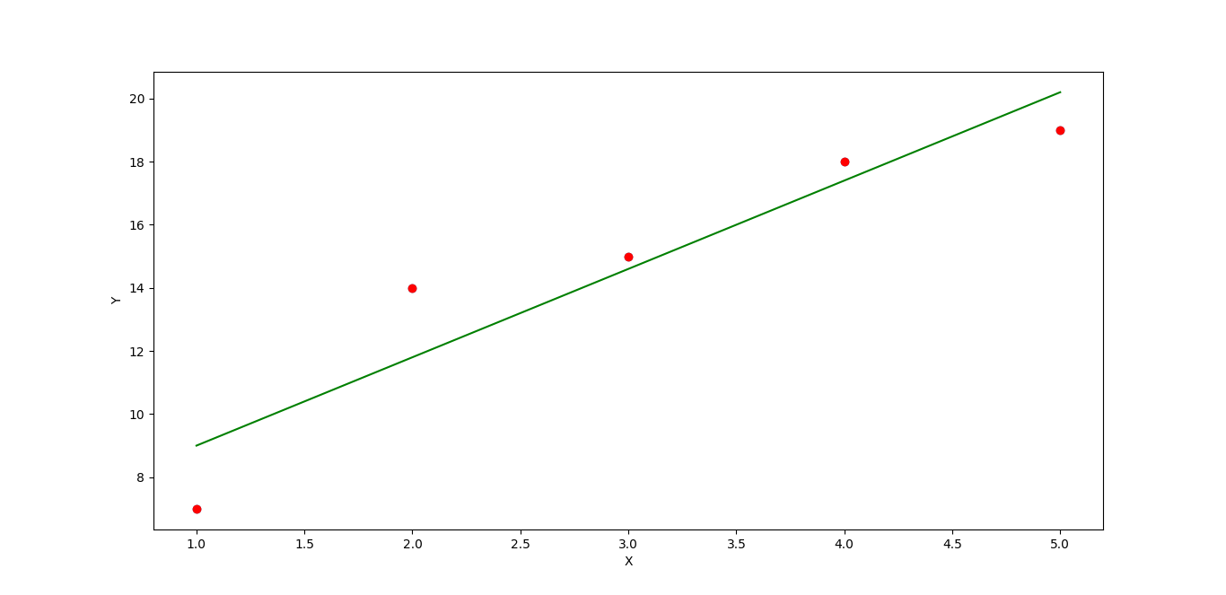

**Problem Statement 5.Implement Linear Regression using python without using any library.**

import matplotlib.pyplot as plt

import math

def mean(data):

sum = 0

for X in data:

sum += X

return sum/len(data)

x = [1,2,3,4,5]

y = [7,14,15,18,19]

n = len(x)

xm = mean(x)

ym = mean(y)

Sxy = 0

Sxx = 0

for i in range(len(x)):

Sxy += (x[i] * y[i])

Sxx +=(x[i] * x[i])

Sxy = Sxy - n * xm * ym

Sxx = Sxx - n * xm * xm

b1 = Sxy / Sxx

b0 = ym - b1 * xm

print("\nSlope b1 is:- ",b1)

print("\nIntercept b0 is:- ",b0)

yp = []

for i in range(len(x)):

yp.append(b0 + (b1 * x[i]))

plt.scatter(x,y,color="black")

plt.plot(x,yp,color="green")

plt.xlabel("X")

plt.ylabel("Y")

err = []

for i in range(len(y)):

err.append(y[i] - yp[i])

se = 0

for i in range(len(err)):

se += (err[i] ** 2)

print("\n Squared Error is ",se)

mse = se/n

print("\nMean Squared Error is ",mse)

rmse= math.sqrt(mse)

print("\nRoot mean Squared Error is ",rmse)

sst = 0

for i in range(len(y)):

sst += (y[i] - ym) ** 2

r2 = 1 - (se/sst)

print("\nR square",r2)

plt.show()

**Output:-**

PS C:\Users\Harsh\Desktop\ML> python -u "c:\Users\Harsh\Desktop\ML\LR.py"

Slope b1 is:- 2.8

Intercept b0 is:- 6.200000000000001

Squared Error is 10.800000000000004

Mean Squared Error is 2.160000000000001

Root mean Squared Error is 1.4696938456699071

R square 0.8789237668161435



**Problem Statement** **6.Implement KMeans algorithm using python.**

import matplotlib.pyplot as plt

import KMeans

from sklearn.cluster import KMeans

X = [4,5,10,4,3,11,14,6,10,12,2,4,5,10,12,13,9,8,7,11]

Y = [21,19,24,17,16,25,24,22,21,21,16,15,17,18,20,21,21,15,19,18]

data = list(zip(X,Y))

print(data)

inertias = []

for i in range(1,21):

Kmeans = KMeans(n_clusters=i)

Kmeans.fit(data)

inertias.append(Kmeans.inertia_)

plt.plot(range(1,21),inertias, marker='o')

plt.title("Elbow Method")

plt.xlabel("No of clusters.")

plt.ylabel("Inertia")

plt.show()

Kmeans = KMeans(n_clusters=2)

Kmeans.fit(data)

plt.scatter(X,Y,c=Kmeans.labels_)

plt.show()

**Output:-**

PS C:\Users\Harsh\Desktop\ML> python -u "c:\Users\Harsh\Desktop\ML\KMeans.py"

[(4, 21), (5, 19), (10, 24), (4, 17), (3, 16), (11, 25), (14, 24), (6, 22), (10, 21), (12, 21), (2, 16), (4, 15), (5, 17), (10, 18), (12, 20), (13, 21), (9, 21), (8, 15), (7, 19), (11, 18)]

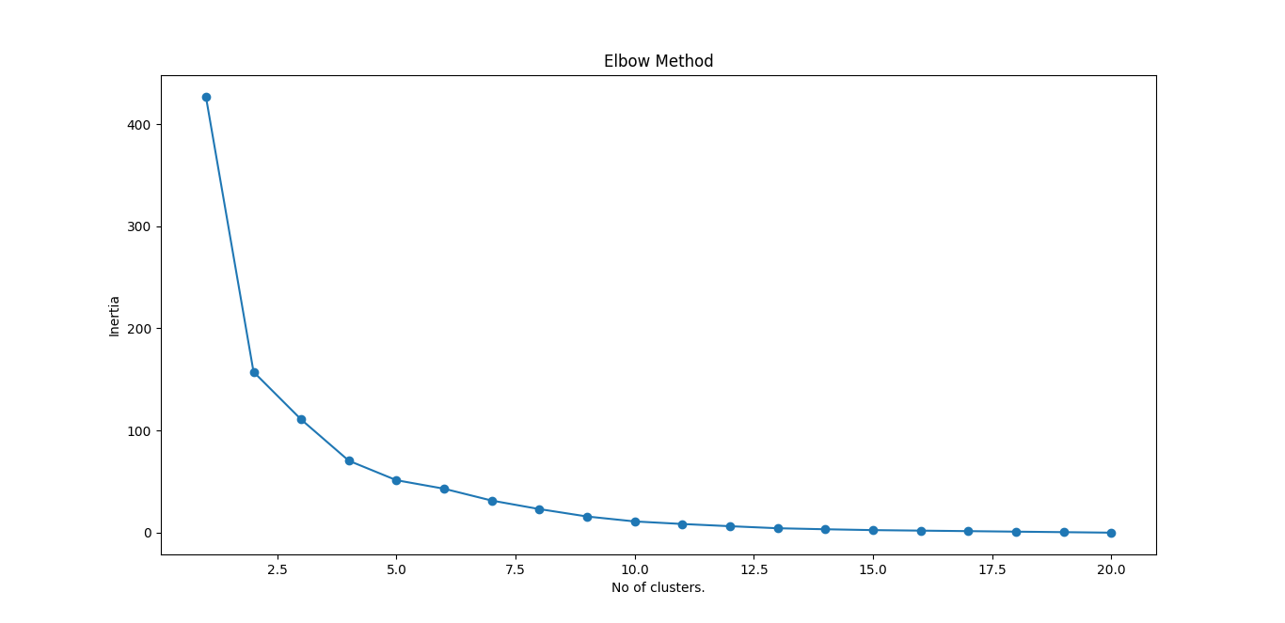

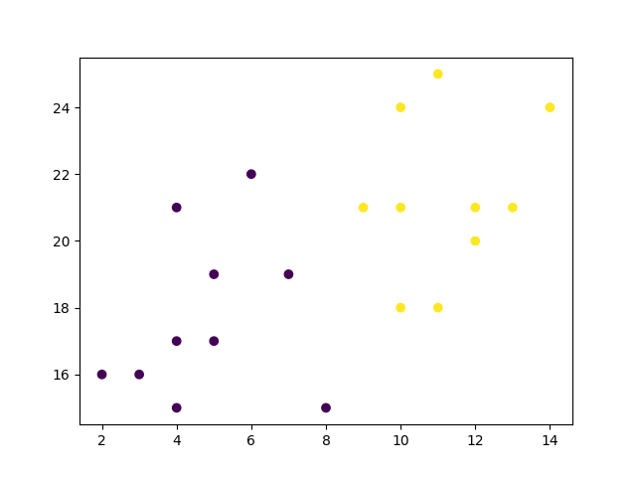

**Problem Statement 7.Implement KNN algorithm using python.**

import matplotlib.pyplot as plt

from sklearn.neighbors import KNeighborsClassifier

x = [4, 5, 10, 4, 3, 11, 14 , 8, 10, 12, 6, 9, 12, 5, 2, 3, 10, 8, 4, 5]

y = [21, 19, 24, 17, 16, 25, 24, 22, 21, 21, 16, 18, 20, 21, 22, 15, 19, 17, 13, 12]

classes = [0, 0, 1, 0, 0, 1, 1, 0, 1, 1, 0, 1, 1, 0, 1, 0, 1, 1, 0, 1]

data = list(zip(x, y))

print(data)

plt.scatter(x, y, c=classes)

plt.show()

knn = KNeighborsClassifier(n_neighbors=3)

knn.fit(data, classes)

new_x = 8

new_y = 21

new_point = [(new_x, new_y)]

prediction = knn.predict(new_point)

print(prediction)

plt.scatter(x + [new_x], y + [new_y], c=classes + [prediction[0]])

plt.text(x=new_x-1.7, y=new_y-0.7, s=f"new point, class: {prediction[0]}")

plt.show()

**Output:-**

PS C:\Users\Harsh\Desktop\ML> python -u "c:\Users\Harsh\Desktop\ML\KNN.py"

[(4, 21), (5, 19), (10, 24), (4, 17), (3, 16), (11, 25), (14, 24), (8, 22), (10, 21), (12, 21), (6, 16), (9, 18), (12, 20), (5, 21), (2, 22), (3, 15), (10, 19), (8, 17), (4, 13), (5, 12)]

[1]

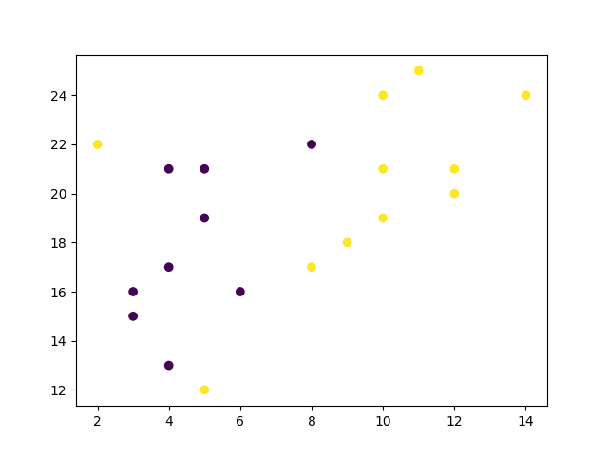

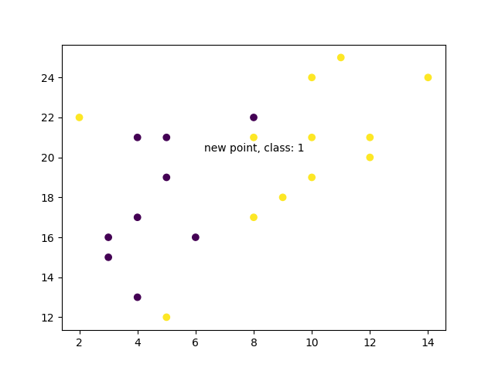

**Problem Statement 8.ID3 algorithm to construct decision tree using python**

import pandas as pd

from sklearn import tree

from sklearn.preprocessing import LabelEncoder

from sklearn.tree import DecisionTreeClassifier

from sklearn.model_selection import train_test_split

from sklearn import metrics

data = pd.read_csv("./dataset.csv")

print("The first 5 value of data is\n",data.head())

x =data.iloc[:,:-1]

print("The first 5 value of train data is\n",x.head())

y=data.iloc[:,-1]

print("The first 5 value of train output is\n",y.head())

le_outlook = LabelEncoder()

x.outlook = le_outlook.fit_transform(x.outlook)

le_temp = LabelEncoder()

x.temp = le_temp.fit_transform(x.temp)

le_humidity = LabelEncoder()

x.humidity = le_humidity.fit_transform(x.humidity)

le_windy = LabelEncoder()

x.windy = le_windy.fit_transform(x.windy)

print("Now the train date is\n",x.head())

le_playtenis = LabelEncoder()

y = le_playtenis.fit_transform(y)

print("Now the train data (target variable) is\n",y)

X_train,X_test,ytrain,ytest = train_test_split(x,y,test_size=0.2,shuffle=False)

print("Features in training set is \n",X_train)

print("Test set is \n",X_test)

classifier = DecisionTreeClassifier(criterion='entropy')

classifier.fit(X_train,ytrain)

pred1 = classifier.predict(X_test)

print("For input \n {0},\n we obtain {1}".format((X_test),le_playtenis.inverse_transform(pred1)))

print("Accuracy score is:- ",metrics.accuracy_score(ytest,pred1))

**Output:-**

PS C:\Users\Harsh\Desktop\ML> python -u "c:\Users\Harsh\Desktop\ML\ID3.py"

The first 5 value of data is

outlook temp humidity windy playtenis

0 sunny hot high False no

1 sunny hot high True no

2 overcast hot high False yes

3 rainy mild high False yes

4 rainy cool normal False yes

The first 5 value of train data is

outlook temp humidity windy

0 sunny hot high False

1 sunny hot high True

2 overcast hot high False

3 rainy mild high False

4 rainy cool normal False

The first 5 value of train output is

0 no

1 no

2 yes

3 yes

4 yes

Name: playtenis, dtype: object

Now the train date is

outlook temp humidity windy

0 2 1 0 0

1 2 1 0 1

2 0 1 0 0

3 1 2 0 0

4 1 0 1 0

Now the train data (target vaiable) is

[0 0 1 1 1 0 1 0 1 1 1 1 1 0]

Features in training set is

outlook temp humidity windy

0 2 1 0 0

1 2 1 0 1

2 0 1 0 0

3 1 2 0 0

4 1 0 1 0

5 1 0 1 1

6 0 0 1 1

7 2 2 0 0

8 2 0 1 0

9 1 2 1 0

10 2 2 1 1

Test set is

outlook temp humidity windy

11 0 2 0 1

12 0 1 1 0

13 1 2 0 1

For input

outlook temp humidity windy

11 0 2 0 1

12 0 1 1 0

13 1 2 0 1,

we obtain ['yes' 'yes' 'no']

Accuracy score is:- 1.0

**Problem Statement 9. Logistic Regression Algorithm using python**

import numpy as np

from sklearn import linear_model

x = np.array([3.78,2.44,2.09,0.14,1.72,1.67,4.92,4.37,4.96,4.52,3.69,5.88,2.98,3.33]).reshape(-1,1)

y = np.array([0,0,0,0,0,0,1,1,1,1,1,1,0,0])

logr = linear_model.LogisticRegression()

logr.fit(x,y)

predicted = logr.predict(np.array([3.46]).reshape(-1,1))

print(predicted)

def logit2prob(logr,x):

log_odds = logr.coef_*x+logr.intercept_

odds = np.exp(log_odds)

probability = odds/(1+odds)

return probability

print(logit2prob(logr,x))

**Output:-**

PS C:\Users\Harsh\Desktop\ML> python -u "c:\Users\Harsh\Desktop\ML\LogReg.py"

[0]

[[0.50904473]

[0.11909549]

[0.07356805]

[0.00407939]

[0.04328738]

[0.04024636]

[0.85437417]

[0.71771631]

[0.8617785 ]

[0.76155203]

[0.47486011]

[0.96190453]

[0.23504144]

[0.34345083]]

**Problem Statement 10. Implement Naïve Bayes Classifier using python.**

import pandas as pd

from sklearn import tree

from sklearn.preprocessing import LabelEncoder

from sklearn.naive_bayes import GaussianNB

data= pd.read_csv('./dataset.csv')

print("The first 5 values of data is :\n",data.head())

X = data.iloc[:,:-1]

print("\nThe First 5 values of train data is\n",X.head())

y = data.iloc[:,-1]

print("\nThe first 5 values of Train output is\n",y.head())

le_outlook = LabelEncoder()

X.outlook = le_outlook.fit_transform(X.outlook)

le_temp = LabelEncoder()

X.temp = le_temp.fit_transform(X.temp)

le_humidity = LabelEncoder()

X.humidity = le_humidity.fit_transform(X.humidity)

le_windy = LabelEncoder()

X.windy = le_windy.fit_transform(X.windy)

print("\nNow the Train data is :\n",X.head())

le_PlayTennis = LabelEncoder()

y= le_PlayTennis.fit_transform(y)

print("\nNow the Train output is\n",y)

from sklearn.model_selection import train_test_split

X_train, X_test, y_train, y_test = train_test_split(X,y,test_size=0.20)

classifier=GaussianNB()

classifier.fit(X_train,y_train)

from sklearn.metrics import accuracy_score

print("Accuracy is:- ",accuracy_score(classifier.predict(X_test),y_test))

**Output:-**

PS C:\Users\Harsh\Desktop\ML> python -u "c:\Users\Harsh\Desktop\ML\NaiveBai.py"

The first 5 values of data is :

outlook temp humidity windy playtenis

0 sunny hot high False no

1 sunny hot high True no

2 overcast hot high False yes

3 rainy mild high False yes

4 rainy cool normal False yes

The First 5 values of train data is

outlook temp humidity windy

0 sunny hot high False

1 sunny hot high True

2 overcast hot high False

3 rainy mild high False

4 rainy cool normal False

The first 5 values of Train output is

0 no

1 no

2 yes

3 yes

4 yes

Name: playtenis, dtype: object

Now the Train data is :

outlook temp humidity windy

0 2 1 0 0

1 2 1 0 1

2 0 1 0 0

3 1 2 0 0

4 1 0 1 0

Now the Train output is

[0 0 1 1 1 0 1 0 1 1 1 1 1 0]

Accuracy is:- 0.3333333333333333