**QUERY 3 --**

SELECT COUNT(t2.cus_gender) AS NoOfCustomers, t2.cus_gender FROM ( SELECT t1.cus_id, t1.cus_gender, t1.ord_amount, t1.cus_name FROM ( SELECT `order`.*, customer.cus_gender, customer.cus_name FROM `order` INNER JOIN customer WHERE `order`.cus_id=customer.cus_id HAVING `order`.ord_amount>=3000) AS t1 GROUP BY t1.cus_id) AS t2 GROUP BY t2.cus_gender;

C:\Users\HARSHIT\Desktop\Untitled.png

**QUERY 4 --**

SELECT product.pro_name, `order`.* FROM `order`, supplier_pricing, product WHERE `order`.cus_id=2 AND `order`.pricing_id=supplier_pricing.pricing_id AND supplier_pricing.pro_id=product.pro_id;

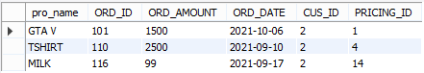

**QUERY 5 --**

SELECT supplier.* FROM supplier WHERE supplier.supp_id IN (SELECT supp_id FROM supplier_pricing GROUP BY supp_id HAVING COUNT(supp_id)>1) GROUP BY supplier.supp_id;

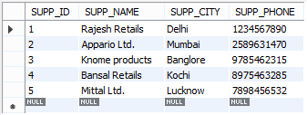

**QUERY 6 --**

SELECT category.cat_id, category.cat_name, MIN(t3.min_price) AS Min_Price FROM category INNER JOIN (SELECT product.cat_id, product.pro_name, t2.* FROM product INNER JOIN (SELECT pro_id, MIN(supp_price) AS Min_Price FROM supplier_pricing GROUP BY pro_id) AS t2 WHERE t2.pro_id=product.pro_id) AS t3 WHERE t3.cat_id=category.cat_id GROUP BY t3.cat_id;

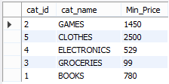

**QUERY 7 --**

SELECT product.pro_id, product.pro_name FROM `order` INNER JOIN supplier_pricing ON supplier_pricing.pricing_id=`order`.pricing_id INNER JOIN product ON product.pro_id=supplier_pricing.pro_id WHERE `order`.ord_date>"2021-10-05";

C:\Users\HARSHIT\Desktop\Untitled.png

**QUERY 8 --**

SELECT customer.cus_name, customer.cus_gender FROM customer WHERE customer.cus_name LIKE 'A%' OR customer.cus_name LIKE '%A';

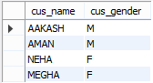

**QUERY 9 --**

BEGIN

SELECT report.supp_id, report.supp_name, report.Average,

CASE

WHEN report.Average =5 THEN 'Excellent Service'

WHEN report.Average >4 THEN 'Good Service'

WHEN report.Average >2 THEN 'Average Service'

ELSE 'Poor Service'

END AS Type_of_Service from

(SELECT final.supp_id, supplier.supp_name, final.Average from

(SELECT test2.supp_id, sum(test2.rat_ratstars)/count(test2.rat_ratstars) AS Average from

(SELECT supplier_pricing.supp_id, test.ORD_ID, test.RAT_RATSTARS FROM supplier_pricing INNER JOIN

(SELECT `order`.pricing_id, rating.ORD_ID, rating.RAT_RATSTARS FROM `order` INNER JOIN rating ON rating.`ord_id` = `order`.ord_id ) AS test

ON test.pricing_id = supplier_pricing.pricing_id)

AS test2 GROUP BY supplier_pricing.supp_id)

AS final INNER JOIN supplier where final.supp_id = supplier.supp_id) AS report;

END

