
Academic year 2024-2025 (Odd Sem)
DEPARTMENT OF
Computer Science & Engineering
Date |  | 8 Jan 2025 | Maximum Marks |  | 10+50
Course Code |  | CS354TA | Duration |  | 120 Min
Sem-V |  | CIE-II | Staff: HKK|ASP|SMS|MRA
THEORY OF COMPUTATION
(Common to CSE & ISE)
PART-A
 |  |  |  | Marks |  | BT | CO
1.1 | Define left recursion. Eliminate left recursion from the following grammar  S(L) | a, LL,S | S |  |  | 2 |  | L2 | CO4
1.2 | Convert the given CFG to PDA  Sa |aA | B, AaB | Ꜫ, BAa. |  |  | 2 |  | L2 | CO3
1.3 | Find context-free grammars for the languages L={{a^{n}b^{m} : n ≠ 2m}. |  |  | 2 |  | L3 | CO2
1.4 | Consider the following grammar with S as the start variable and a, ; ,< , > are as terminals. S<L|a, LaR|<LR, R>| ; L. How many distinct parse trees are there for the string <<a>; a>? |  |  | 1 |  | L3 | CO2
1.5 | Let G be the CFG and let “L” denotes the number of left most derivations, “R” denotes the number of right most derivations and “P” denotes the number of parse trees. Assume L, R, P are computed for a particular string. For a given CFG G and a string w, what is the relation between L, R, P (use relational operators)? |  |  | 1 |  | L1 | CO1
1.6 | Define DPDA. |  |  | 2 |  | L1 | CO1
PART-B
2.a | Construct PDA that accepts the language L = {Na(w )=Nb(w)+ Nc(w)} on ∑={a,b,c}. Give the graphical representation for PDA obtained. Show the moves made by the PDA for the string caacaabc. |  |  | 7 |  | L3 | CO4
2.b | Construct a finite automaton that accepts the language generated by the right linear grammar  S -> cA | baS, A -> bB | aC | Ɛ, B -> aA |bbC |Ɛ , C-> abA | baC | aS |  |  | 3 |  | L2 | CO1
3.a | 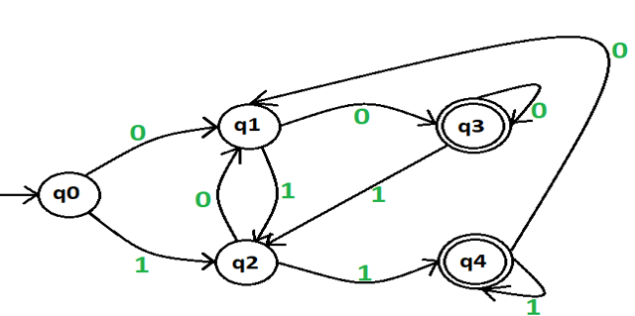  Find a left-linear grammar for the language accepted by the finite automata below |  |  | 6 |  | L3 | CO3
3.b | Write a note on the languages accepted by PDA |  |  | 4 |  | L1 | CO2
4.a | Define CNF. Transform the grammar with productions  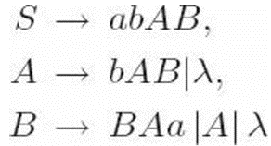  into Chomsky normal form |  |  | 6 |  | L3 | CO3
4.b | Define ambiguous grammar. Show that the following grammar is ambiguous and Construct an unambiguous grammar equivalent to this grammar.  SAB | aaB,  Aa | Aa,  Bb. |  |  | 4 |  | L2 | CO4
5 | Give an algorithm to convert PDA to CFG. Convert the following Pushdown Automata transitions to Context Free Grammar. Describe the language accepted by the CFG.  δ (q0,0,Z)=(q0,AZ)  δ (q0,1,Z)=(q0,BZ)  δ (q0,0,B)=(q0,Ꜫ)  δ (q0,1,A)=(q0,Ꜫ)  δ (q0,0,A)=(q0,AA)  δ (q0,1,B)=(q0,BB)  δ (q0,Ꜫ,Z)=(q1,Ꜫ) |  |  | 10 |  | L4 | CO3
6.a | Let L1= {a^{i}b^{j}c^{k} | i=j} and L2={ a^{i}b^{j}c^{k} | j=k }. Find L3=L1UL2 and L4=L1⋂L2 . Show that L1, L2 and L3 are CFLs but L4 is not CFL. |  |  | 6 |  | L2 | CO2
6.b | Discuss the applications of Context free grammars. |  |  | 4 |  | L2 | CO1

BT-Blooms Taxonomy, CO-Course Outcomes, M-Marks
Marks Distribution | Particulars | CO1 | CO2 | CO3 | CO4 | L1 | L2 | L3 | L4 | L5 | L6
 | Max Marks | 10 | 13 | 24 | 13 | 7 | 21 | 22 | 10 | - | -

Course Outcomes:
- Understand the fundamental concepts of theory of computations
- Analyze the tools of finite automata to various fields of computer science.
- Design solution model for complex problems, using the appropriate skills of automata theory for better results.
- Apply automata skills in situations that describe computation effectively and efficiently.
***********

