 | R V College of Engineering  Department of Computer Science and Engineering  CIE-I: Question Paper
Course:  (CS354TA) | THEORY OF COMPUTATION (21CS54) |  |  | Semester: 5th
Date: 26-11-2024 |  | Duration: 120 minutes | Staff: SMS/HKK/ASP/MRA
Name: |  | USN: | Section: |  | A,B,C,D,CD,CY,IS

PART-A
1 | Consider the following NFA. Compute δ*(q0, 001).  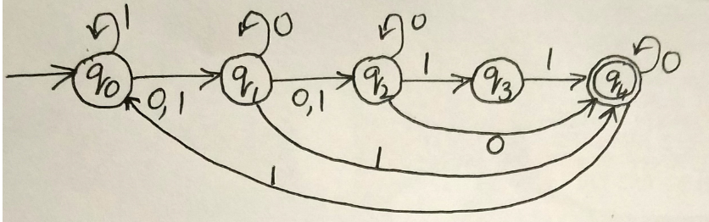 | 2 | L2 | CO1
2 | Consider the following ϵ-NFA. Compute ϵ-closure ({3, 5, 12}).  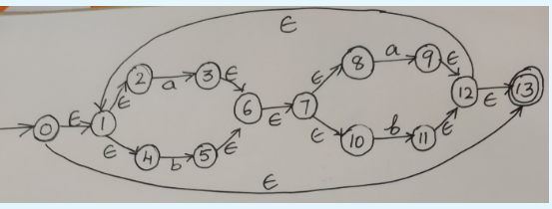 | 2 | L2 | CO1
3 | Consider two regular expressions r and s, where r=a*+b* and s=ab*+ba*+b*a+(a*b)*.  - Find a string corresponds to neither r nor s.  - Find a string corresponds to both r and s. | 2 | L1 | CO2
4 | For the language L= {ab, ac, c} over the alphabet ∑={a, b, c}. Find L⁴. | 2 | L1 | CO1
5 | Construct Ꜫ-NFA for the regular expressions (b + aba)*ba*, so that there is a recognizable correspondence between the regular expression and the transition diagram. | 2 | L1 | CO2

PART-B
1.a | Define regular expression. Give regular expressions which generates the following languages over the alphabet ∑={0, 1}.  - Set of all strings that do not end with 01.  - Set of all strings that do not contain the substring 00. | 6 | L3 | C03
1.b | Define ϵ-NFA, extended transition function of ϵ-NFA and language accepted by ϵ-NFA. | 4 | L1 | CO1
2. | Prove that for every ϵ-NFA there exists an equivalent DFA accepting the same language. For the ϵ-NFA shown below draw the equivalent DFA.  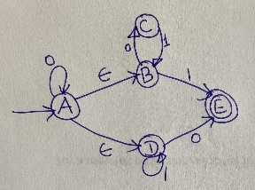 | 10 | L4 | CO4
3.a | For each of the following regular expressions, draw DFA recognizing the corresponding language.  - (a+b)*ab(a+b)*  - (a+b)*(ab+bba) | 4 | L4 | CO3
3.b | For the DFA shown below, use the minimization algorithm to find a minimum state DFA recognizing the same language.  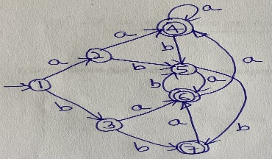 | 6 | L4 | CO3
4.a | Let M1, M2 and M3 are the DFA's pictured below recognizing languages L1, L2 and L3 respectively.  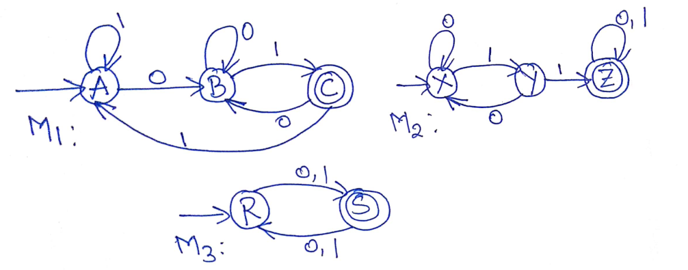  - L1-L2  - L1⋂ L3  - L2 U L3 | 6 | L4 | CO3
4.b | Describe decision algorithms to answer each of the following questions.  - Given a regular expression r and a DFA M, are the corresponding languages the same?  - Given two ϵ-NFAs, do they accept the same language? | 4 | L2 | CO1
5.a | State and prove pumping lemma for regular languages. Use pumping lemma to show that the following language is not regular L={xy | x,y ϵ{0,1}* and y is either x or x^{r}}. | 6 | L2 | CO2
5.b | Answer the following questions  - Let M1 and M2 are the two NFA- ϵ. In the construction of M_{u} (Union of M1 and M2) consider this alternative construction: Instead of a new state q_{u} and ϵ-transition from it to q1 and q2, make q1 the initial state of the new NFA- ϵ, and create a ϵ-transition from it to q2. Either prove that this works in general, or give an example in which it fails.  - In the construction of M_{c} (Concatenation), consider the simplified case in which M1 has only one accepting. Suppose that we eliminate the ϵ-transition from the accepting state of M1 to q2, and merge these two states into one. Either show that this would always works or give an example in which it fails. | 4 | L4 | CO3

