Course Code: CS354TA
USN

R.V.COLLEGE OF ENGINEERING

(Autonomous Institution Affiliated to VTU)
V Semester B.E
Model Question paper
THEORY OF COMPUTATION
Time: 03 Hours Maximum Marks: 100

Instructions to Candidate:
- Answer all questions from PART-A. PART-A questions to be answered in first three pages of the answer book.
- Answer question 2 and any one question from 3 and 4, any one question from 5 and 6, any one question from 7 and 8 AND any one question from 9 and 10 PART-B.

 | PART-A
1.1 | Consider the following automata. What is the set of reachable states for the input string 0011?  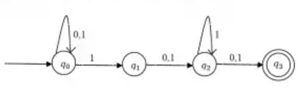 | 1
1.2 | The minimum state automaton equivalent to the below FA has how many number of states  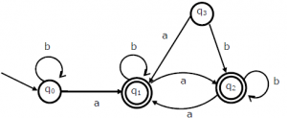 | 1
1.3 | Find R²₁₂=?  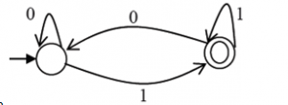 | 1
1.4 | Define ε –closure (q), where q ε Q of an automata. | 1
1.5 | In each case, find a string of minimum length in ∑= {0, 1} not in the language corresponding to the given regular expression.  - (0*+1*)(0*+1*)(0*+1*)  - 0*(100*)*1* | 1
1.6 | Describe the decision algorithm to answer the following question.  Given two DFA’s M1 and M2, are there any strings that are accepted by neither? | 1
1.7 | Give CFG for the language “The set of odd length strings in {a, b}* with the middle symbol a”. | 1
1.8 | Show that the grammar with indicated productions is ambiguous.  SaSb | aaSb | є | 1
1.9 | Define Left Most Derivation (LMD).  Give LMD for abaaba in the grammar with productions  SaSaSbS | aSbSaS |bSaSaS | є | 1
1.10 | Identify the nullable variables in the grammar given below.  S→AB|ABC, A→BA|BC|a| є, B→AC|CB|b|є, C→AB|BC|c | 1
1.11 | If G is a context free grammar in CNF and x ϵ L(G) with |x|=n. How many steps are there in the derivation of x in G? | 1
1.12 | Let G be the CFG with productions S→S+S|S-S|S*S|S/S|(S)|a  How many derivation strings are there for the string a+(a*a)/a-a? | 1
1.13 | DFA whose transition table is as below, here state A is the start state and states B, C are final states.  δ a b  A B B  B C C  C D D  D A B  What is the equivalent left linear grammar for the above DFA. | 1
1.14 | Consider the right linear grammar with the productions  A→aB | bD, B→aB | bC | €, C→aB | bC | €, D→aD | bD  Find the left linear grammar which is equivalent to the above right linear grammar. | 1
1.15 | Define Deterministic Push Down Automata. | 1
1.16 | What is the language generated by the Context Sensitive Grammar with the  productions S→ABCS | ABC, AB→BA, AC→CA, BC→CB, BA→AB,  CA→AC, CB→BC, A→a, B→b, C→c. | 1
1.17 | Obtain Turing Machine to accepts the language  L={w| w є {a, b}* and w ends with abb}. | 1
1.18 | What is the language generated by the right linear grammar with productions  S→aA | bC | b, B→aC | bA | a, A→aS | bB, C→aB | bS. | 1
1.19 | If L1 and L2 are recursively enumerable languages, then L1⋂ L2 is recursively  enumerable language. Is this statement is TRUE or FALE. | 1
1.20 | What is the solution to the instance of PCP given below.  List A List B  Xi Yi  1 1 010  2 0 10  3 10 101  4 01 100 | 1

 | PART-B
2 a | Find the regular expressions corresponding to each of the following subsets of {0,1}*.  - The language of all strings containing exactly two 0's.  - The language of all strings that do not end with 01. | 4
b | For the DFA below describe, either in words or by writing regular expressions, the strings that cause the DFA to be in each state.  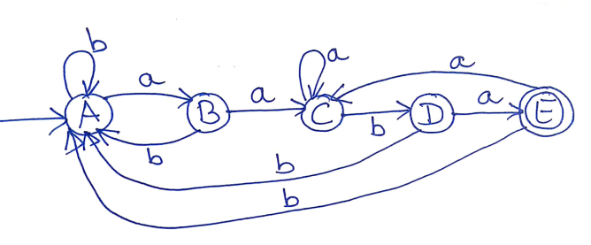 | 4
c | Explain the algorithm to find an equivalent NFA from the given NFA- ϵ. Use this algorithm to draw an NFA for the NFA- ϵ given below.  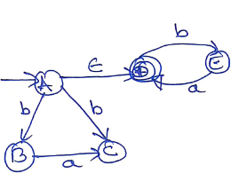 | 4
d | For the DFA shown below, use the minimization algorithm to find a minimum state DFA recognizing the same language.  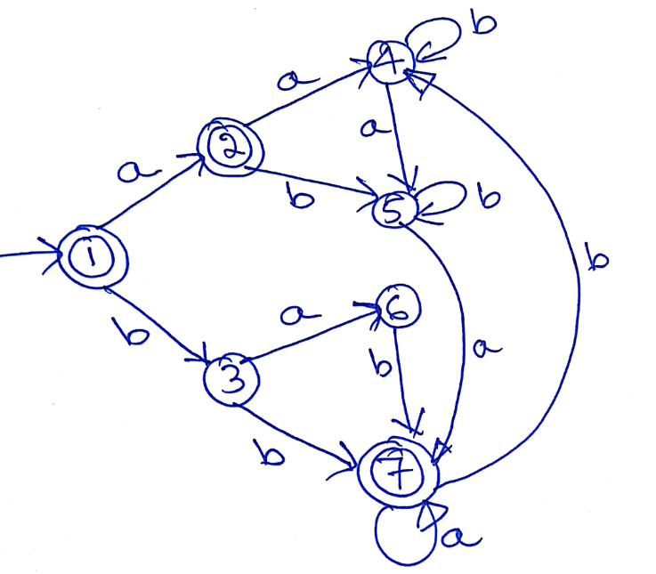 | 4
3 a | State and prove pumping lemma for regular languages. Use pumping lemma to show that the following languages are not regular.  - L={ww | w ϵ{0,1}*}.  b) L={xy | x,y ϵ{0,1}* and y is either x or x^{r}}. | 6
b | Describe decision algorithm to answer the following questions.  - Given two DFA's M1 and M2, are there any strings that are accepted by neither.  - Given a regular expression r and an DFA M, are the corresponding languages are same? | 4
c | Let M1, M2 and M3 are the DFA's pictured below recognizing languages L1, L2 and L3 respectively.  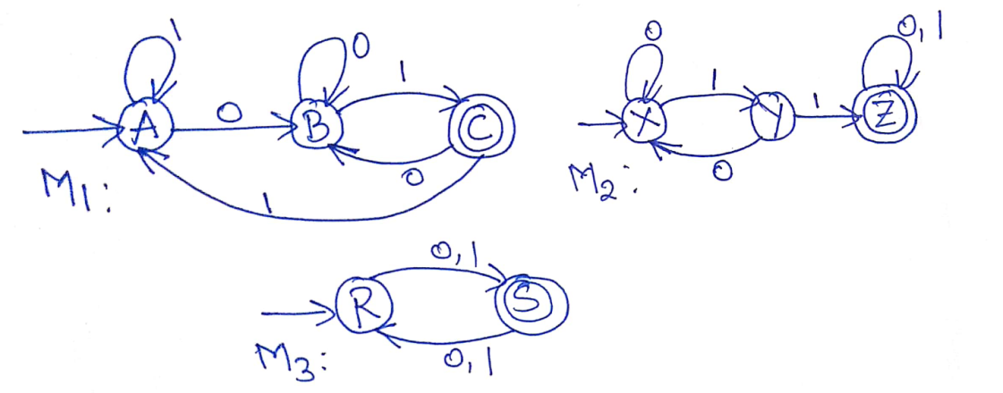  Draw DFA's recognizing the following languages.  - L1 U L2  - L1⋂ L2  - L1-L2 | 6
 | OR
4 a | Define CFG, Language generated by CFG, Left most derivation and Right most derivation. Consider the grammar below SS+S | S-S | S*S | S/S | (S) | a.  - Give two left most derivations for the string a+(a*a)/a-a.  - Give the derivation tree corresponds to each of the derivations in (i).  - How many distinct left most derivations of this string are there?  - How many derivation trees are there for the string a+a+a+a+a? | 4
b | In each case, given the context free grammar G, find an equivalent CFG with no useless variables.  - SABC | BaB, AaA | BaC | aaa, BbBb | a, CCA | AC  - SAB | AC, AaAb | bAa | a | є, BbbA | aaB | AB, CabCa | aDb | є, DbD | aC | 4
c | Define GNF grammar. Given below a CFG G, find a CFG G¹ in GNF generating L(G) – { є }. ABC, BCA | b, CAB | a | 4
d | Draw the NFA accepting the language generated by the grammar with productions S→abA|bB|aba, A→b|aB|bA, B→aB|aA | 4
5 a | Define PDA. Construct PDA for L={ww^{R} | w є {a,b}*}. Show by IDs the string abaaba is accepted. | 6
b | Let L be L(M1) for some PDA with empty stack M1=(Q,∑,Γ,δ,q₀,Z₀,ϕ), prove that there exists an final state PDA M2 such that L=L(M2). Construct empty stack PDA to accept L={w | w є {a,b}* and w is palindrome}. Convert it into equivalent final state PDA. | 4
c | What are steps to be followed while finding an equivalent PDA by empty stack for the given CFG. Find the equivalent PDA to the CFG with productions  S→aSb | bSa | abS | baS | Sab | Sba | є. Show that the string abaabb is generated by the given CFG and it is accepted by its equivalent PDA. | 6
 | OR
6 a | State and prove pumping lemma for context free languages.  Show that L={ww | w ∈{a,b}*} is not context free. | 6
b | Let L1={a^{i}b^{j}c^{k} | i< j } and L2={ a^{i}b^{j}c^{k} | i< k }. Show that L1 and L2 are context free but L3=L1∩ L2 is not context free. | 6
c | Decide whether the following languages are CFL or not.  - L={a^{n}b^{m}a^{m}b^{n}| m,n≥0}.  - L={xayb| x,yϵ{a,b}* and |x|=|y|}. | 4
7 a | Design Turing Machine to accept the language L={ w | ε {a, b}* and Na(w)=Nb(w)}. Trace the machine for the string baabab. | 6
b | Let x and y are two positive integers represented using unary notation. Design a Turing Machine that computes the function f(x,y), where x,y ϵ 1⁺  f(x, y) = x - y if x > y  f(x, y) = y - x if y>x  f (x, y)=0 if x = y | 6
c | If L₁ and L₂ are recursively enumerable languages over ∑, then show that  L₁ U L₂ is also recursively enumerable languages. | 4
 | OR
8 a | Design Turing Machine to perform the string reverse operation over ∑={a, b, c}. Use Instantaneous Descriptions to show operation on w=abac. | 8
b | Write a note on  - Multi tape Turing Machine  - Non deterministic Turing Machine | 6
c | Prove that every regular language is also a recursively enumerable language. | 2
9 a | Construct the Linear Bounded Automata for the language  L={ ww^{R} | w ε {a, b}*}. Trace the machine for the string aabbaa. | 8
b | Define Context Sensitive Grammar.  Give Context Sensitive Grammar to generate the language  L={ a^{n}b^{n}c^{n}d^{n} | n ≥1}. Show that the string aabbccdd is generated by the grammar. | 4
c | Write a note on Chomsky hierarchy. | 4
 | OR
10 a | Define Unrestricted Grammar. Give Unrestricted Grammar to generate the  language L={ w | ε {a, b, c}* and Na(w)=Nb(w)=Nc(W)}.Show that the string  acabcb is generated by the grammar. | 8
b | Write a note on undecidability. | 4
c | If the given language L is Context Sensitive Language, then L is recursively  enumerable language. Prove this statement. | 4

Q.P.Code
Course code: 21CS54 Course Title: Theory of Computation

PART-A
Q.No | 1.1 | 1.2 | 1.3 | 1.4 | 1.5 | 1.6 | 1.7 | 1.8 | 1.9 | 1.10
BT | 1 | 2 | 3 | 1 | 2 | 3 | 2 | 1 | 1 | 2
COs | 1 | 1 | 2 | 1 | 2 | 2 | 2 | 1 | 2 | 1
Q.No | 1.11 | 1.12 | 1.13 | 1.14 | 1.15 | 1.16 | 1.17 | 1.18 | 1.19 | 1.20
BT | 3 | 4 | 4 | 4 | 1 | 3 | 3 | 2 | 1 | 4
COs | 2 | 3 | 3 | 2 | 1 | 3 | 2 | 1 | 2 | 3

PART-B
Question No |  | BT level | COs Addressed |  | Question No |  | BT level | COs Addressed
2 | a | 2 | 1 |  | 3 | a | 3 | 2
 | b | 3 | 2 |  |  | b | 2 | 2
 | c | 4 | 3 |  |  | c | 4 | 3
 | d | 4 | 3 |  |  | d
4 | a | 3 | 3 |  | 5 | a | 3 | 3
 | b | 4 | 3 |  |  | b | 2 | 2
 | c | 4 | 4 |  |  | c | 2 | 3
 | d | 3 | 4 |  |  | d
6 | a | 2 | 2 |  | 7 | a | 4 | 4
 | b | 3 | 3 |  |  | b | 4 | 4
 | c | 3 | 4 |  |  | c | 3 | 2
 | d |  |  |  |  | d
8 | a | 4 | 4 |  | 9 | a | 4 | 4
 | b | 3 | 2 |  |  | b | 3 | 2
 | c | 3 | 2 |  |  | c | 1 | 1
 | d | 4 | 1 |  |  | d
10 | a | 3 | 3 |  |  | a
 | b | 2 | 1 |  |  | b
 | c | 2 | 1 |  |  | c
 | d |  |  |  |  | d

Signature of Scrutinizer Signature of Chairman

Name: Name:

