Mini-Lesson 2.1: AI Technologies
This page contains one mini-lesson. Please scroll down to view the mini-lesson.
Select to expand the lesson.

Lesson:

Machine Learning
Machine learning (ML) is a field of AI that allows computers to learn from data without being explicitly programmed. Imagine that you're teaching a child their ABCs. You show them letters and tell them the sounds they make. Machine learning works similarly but with data and algorithms instead of flashcards and a teacher. The data acts as the flashcards, and the algorithms are the learning mechanisms that identify patterns and relationships within the data.
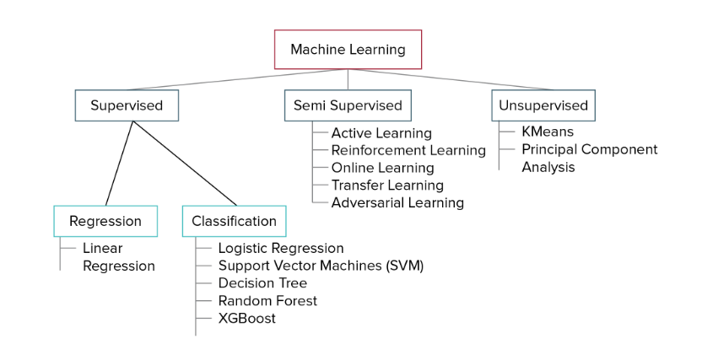
There are two main branches of ML:
- Supervised learning: This is like having a labeled set of flashcards. The data you train the algorithm on has labels, which are the desired outputs. For example, you might have a dataset of emails labeled as spam or not spam. The algorithm learns to identify the patterns that differentiate spam from legitimate emails. Here are some common algorithms used in supervised learning:
  - Regression: Used for predicting continuous values, such as house prices or stock prices. Common algorithms include:

    - Linear regression: This creates a best-fit line to predict a value based on a single input variable.
    - Support vector regression (SVR): This is more complex than linear regression and is useful for non-linear relationships.
  - Classification: This is used for predicting discrete categories, such as classifying an image as a cat or a dog. Common algorithms include:

    - Logistic regression: This predicts the probability of an event belonging to a specific class (often used for binary classification).
    - Decision trees: This creates a tree-like structure to classify data based on a series of questions about the features.
    - k-nearest neighbors (KNN): This classifies data points based on the labels of their nearest neighbors in the training data.
- Unsupervised learning: This is like giving a child a pile of unlabeled blocks and letting them build something creative. The data you provide has no labels. The algorithm finds hidden patterns or structures within the data on its own. Here are some common unsupervised learning algorithms:
  - Clustering: This groups similar data points together. It is useful for customer segmentation and anomaly detection. Common algorithms include:

    - k-means clustering: This groups data points into a predefined number of clusters.
    - Hierarchical clustering: This creates a hierarchy of clusters, like a nested set of folders.
  - Dimensionality reduction: This reduces the number of features in a dataset while preserving important information. It is useful for data visualization and improving efficiency of other algorithms. Common algorithms include:

    - Principal component analysis (PCA): This identifies the most important features that explain the variance in the data.
Here are some real-world applications of these ML branches:
- Supervised learning:
  - Regression: Predicting sales figures, loan defaults, or weather patterns.
  - Classification: Spam filtering, image recognition (such as facial recognition in photos), or fraud detection in financial transactions.
- Unsupervised learning:
  - Clustering: Grouping customers for targeted marketing campaigns or identifying anomalous network activity for security purposes.
  - Dimensionality reduction: Visualizing high-dimensional data for scientific research or compressing images for faster loading times.

The ML Lifecycle
The machine learning lifecycle is a repeatable process that guides you through the phases necessary to develop a successful ML system:
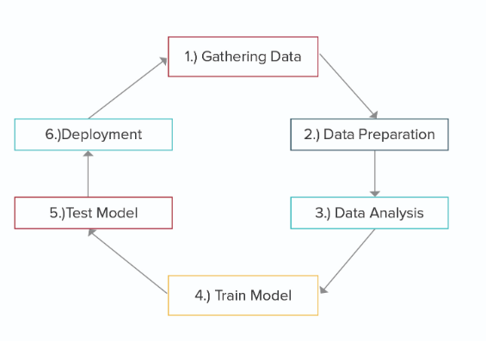
- Gathering the data: Gather the required data from various sources.
- Data cleaning and preparation: Preprocess the data to remove inconsistencies, handle missing values, and format it for analysis.
- Data analysis: Analyze the data using various analytical techniques and review the outcome. It starts with the determination of the type of problems, where you select the ML techniques, such as classification or regression.
- Model training: Choose the appropriate algorithms based on the problem type (such as regression or classification). Train the model using the cleaned dataset, adjusting its parameters to improve accuracy.
- Model evaluation: Use metrics such as accuracy, precision, recall, and ROC-AUC to evaluate the model's performance.
- Model deployment: Deploy the trained model into a production environment where it can start making predictions.

Basic Concepts and Terminologies

Overfitting
Overfitting occurs when an ML model learns the training data too well, capturing noise and details that do not generalize to new, unseen data. An overfitted model typically shows high accuracy on training data and low accuracy on validation/test data, and the model complexity is too high (too many parameters or too complex a model structure).
Underfitting
Underfitting occurs when a machine learning model is too simplistic to capture the underlying patterns in the training data. An underfitted model typically shows low accuracy on both training data and validation/test data, the model fails to capture the underlying trend of the data, and the model complexity is too low (too few parameters or overly simplistic model structure).
Bias and Variance
Bias is an error introduced in the model due to oversimplified assumptions. Variance is an error from sensitivity to small fluctuations in the training set. High bias can cause an algorithm to miss relevant relations (underfitting), while high variance can cause an algorithm to model the noise in the training data (overfitting).
Bias–Variance Trade-Off
Managing the trade-off between bias and variance is critical for building effective models. Ideally, you aim for low bias and low variance, but practically, reducing one increases the other.

Hyperparameters and Tuning
- Hyperparameters: These are the settings that can be adjusted to control the behavior of an ML algorithm (e.g., learning rate or number of trees in a forest).
- Hyperparameter tuning: The process of finding the combination of hyperparameters that produces the best performance. Techniques include:
  - Grid search: This systematically builds and evaluates a model for each combination of algorithm parameters specified in a grid.
  - Random search: This randomly samples algorithm parameters from a specified subset of the hyperparameter space.
  - Bayesian optimization: This uses probability to find the model that gives the best results.

