Classifiers [Mini-Lesson 2.2]
This page contains one mini-lesson. Please scroll down to view the mini-lesson.

Mini-Lesson 2.2: Classifiers [20 minutes]
In this activity, you will learn about linear classifiers and how they are useful for categorizing data.
Select to expand the lesson.

Lesson:
Linear classifiers are a class of algorithms used in machine learning for binary classification tasks, where the goal is to classify input data into one of two classes. In this case, the predictions are a linear combination of input features. A straight line separates the data points into two classes. If there are three features, a plane separates the data points into the two classes. A hyperplane will separate the two classes if there are “n” features.
Consider the simplest linear classifier in two dimensions: a simple two-dimensional case with two features ​ and ​.
The decision boundary is a line defined by:
Where , , are the y coefficient and coefficients of and , respectively. The equation of the straight line represents the linear decision boundary. Using the vector notation, the decision boundary line in this case is given by:
The decision boundary is selected when points above the decision boundary belong to a particular class, and points below the decision boundary belong to another class.
Concerning the diagram below, the two classes are . The linear classifier learns to arrive at this decision boundary, which separates both classes.
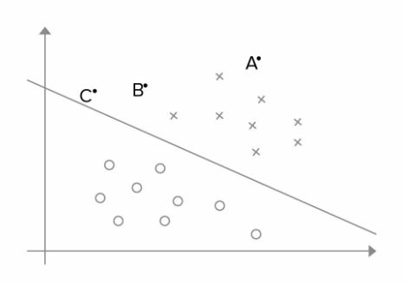
The linear classifier learns the coefficients of the decision boundary (weights) through a process called training. Training aims to find the optimal weights that minimize a predefined loss function.
The loss function is also called the cost function or hinge loss. This loss quantifies the difference between the predicted and the actual values. This loss is incurred for each misclassified example and is used to update the weights of the classifier to minimize this loss. A simple linear classifier's cost function (or total loss) is the sum of the hinge losses for all training examples, possibly with an additional regularization term to prevent overfitting. The goal of training the classifier is to minimize this cost function.
Here's a general overview of how this process may work if a neural network is used:
- Initialize Weights: Start by initializing weights to some random numbers.
- Calculate Predictions: For each data point in the training set, calculate the predicted class using the current weights and the equation:

- Calculate Loss: Calculate the loss between the predicted class and the true class labels.
- Update Weights: Use an optimization algorithm such as gradient descent to update the weights in the direction that reduces the loss. The update rule is typically based on the gradient of the loss function with respect to the weights.
- Repeat: Repeat steps 2–4 for a fixed number of iterations (epochs) or until the weights converge to a stable value.
- Final Decision Boundary: The final weights learned by the classifier represent the coefficients of the decision boundary.
The training process aims to find the weights that minimize the loss function, minimizing the classification error on the training data. Once the weights are learned, they can be used to classify new data points by calculating the dot product of the weights and the input features and applying the sign function. The sign function determines whether the new data points fall above or below the decision boundary.

