Mini-Lesson 2.4: Logistic Regression [15 minutes]
Logistic regression is a statistical method used for binary classification tasks, where the goal is to predict the probability that an instance belongs to a particular class.
Select to expand the lesson.

Lesson:
In logistic regression, the model calculates the probability that an instance belongs to the positive class using a logistic function (also called a sigmoid function). The output of the logistic function is then interpreted as a measure for the likelihood of the instance belonging to the positive class.
It is different from linear regression in the following manner:
- While linear regression is used to predict a continuous value, logistic regression is used to predict the probability that an instance belongs to a particular class. For example, whether the email is spam or whether a person has purchased a certain product are examples of classification using logistic regression.
- A linear function is used in linear regression to predict the output. In this case, the output is a linear combination of the input features. Logistic regression uses a sigmoid function to predict the probability. This predicted probability is a nonlinear function of input features.
Training a Logistic Regression Model
Training in logistic regression involves finding the optimal weights (parameters) that minimize the difference between the predicted probabilities and the actual class labels in the training data. This process is typically done using an optimization algorithm such as gradient descent.
Steps in Training a Logistic Regression Model
- Initialization: Initialize weights to small random numbers.
- Forward Pass: For each training instance, calculate the weights of each node.
- Apply Activation Function: Apply the sigmoidal activation function and calculate the probability.
- Calculate Loss: Using the predicted probabilities and the actual probabilities of the test set, compute the loss. This loss is also called the log loss or cross-entropy loss.
- Calculate Gradient: Calculate the gradient of loss with respect to each weight. Gradient indicates the magnitude and direction of change required to minimize the loss.
- Update Weight: Using the gradient descent algorithm, update the weights. The new weight is a sum of the old weight and the weight change.
- Repeat steps 2 to 6 until the weight converges or for a fixed number of iterations.
- Prediction: Once the weights are trained, predictions for new instances can be made using the learned weights and applying a decision threshold.

Mini-Lesson 2.5: Support Vector Machines (SVMs) [15 minutes]
A support vector machine (SVM) is a supervised machine learning algorithm for classification and regression tasks. In this lesson, you’ll learn how SVMs use hyperplanes to classify data.
Select to expand the lesson.

Lesson:
SVMs work by finding the hyperplane that best separates different classes in the feature space. A feature space is a multidimensional space where each dimension represents a feature or attribute of a data point. A hyperplane is a flat, multidimensional surface that divides a space into two half-spaces. In a two-dimensional space, a hyperplane is a straight line. In a three-dimensional space, it is a flat plane. In higher-dimensional spaces, it is a generalization of these concepts.
SVM as a Classifier
As a classifier, an SVM finds the hyperplane that separates the different classes. The hyperplane is the decision boundary, which is used as a classifier. The steps involved are the following:
- Data Preparation: For a dataset with labeled examples (each example has features and a class label), the first step is to prepare the data and choose the appropriate kernel function for the SVM. In the case of an SVM, kernel functions are used to map the input data into a higher-dimensional feature space, where the data points may be more easily separable by a hyperplane.
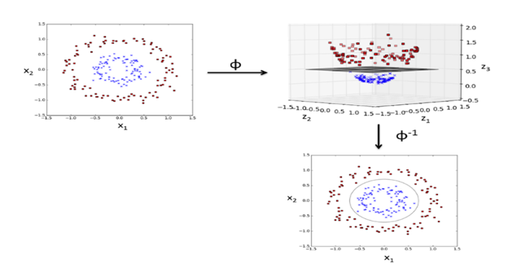
As shown in the figure above, a kernel function is chosen based on the distribution of the data points. This decision boundary or hyperplane segregates the data points into the red and blue classes.
- Training: The SVM algorithm learns from the labeled training data to find the optimal hyperplane that best separates the classes. Let’s see how training is accomplished in two dimensions of a simple linear SVM. In a linear SVM, the hyperplane is a straight line that separates both the classes.
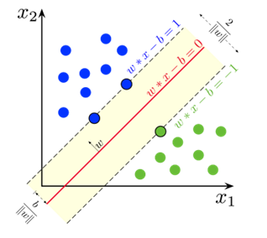
Initializing the SVM
- In the initialization phase, define the hyperplane w.x + b = 0, where w is the weight vector perpendicular to the hyperplane, x is the input feature vector, and b is the bias term. Initialize w and b to some initial values.
- For each training example, (x_{i},y_{i}), where x_{i} is the feature vector, and y_{i} is the class label, compute the decision function f(x_{i}) = w.x_{i} + b
- Update w and b to minimize the loss function. This loss is called hinge loss. It is used to measure the classification error of an SVM model and is designed to maximize the margin between classes while penalizing misclassifications. This minimization of hinge loss is the optimization process and involves adjusting the values of w and b.
- The margin is calculated. The margin is the distance between the hyperplane and the nearest data point. This nearest data point is called the support vector. These support vectors are used to define the optimal hyperplane and are critical for the classification process. Maximizing the margin helps the SVM generalize unseen data well and reduces overfitting.
- Once the training process is complete, the SVM obtains the optimal values of w and b, which define the hyperplane. The hyperplane can be used to classify unseen data points.
- The performance of the trained SVM is evaluated with the test set.
Comparative Analysis of Classification and Regression Algorithms
Feature | Classification | Regression
Output Type | Produces discrete, categorical labels (e.g., yes/no decisions, class labels). Suitable for datasets where the result is limited to specific categories. | Produces continuous numerical outputs (e.g., price, temperature). Ideal for predictions where the result can vary widely and is not limited to specific categories.
Common Algorithms | Logistic regression, support vector machines (SVM), decision trees, random forests, and naive Bayes. These algorithms are designed to handle data that can be easily segmented into distinct classes. | Linear regression, polynomial regression, and ridge/lasso regression. These methods are capable of modeling complex relationships by fitting a continuous curve to the data.
Evaluation Metrics | Focuses on classification accuracy, precision (positive predictive value), recall (sensitivity), F1 score, and the use of a confusion matrix to visualize the performance of the classifier across different classes. These metrics help in understanding the effectiveness of classification in correctly labeling each class. | Utilizes mean squared error (MSE), mean absolute error (MAE), and root mean squared error (RMSE) to measure the average error magnitude without considering direction. These metrics are crucial for evaluating how close the predicted values are to the actual values.
Use Cases | Widely used in applications where binary or multiclass sorting is required, such as email spam detection, medical diagnosis, and image classification. Classification is crucial in scenarios where discrete decisions need to be made. | Common in economics, finance, and other fields that require precise numerical forecasts, such as predicting stock prices, real estate values, and weather conditions. Regression fits naturally into contexts where the output is a quantity rather than a category.
Data Sensitivity | Generally more robust against outliers because the primary goal is to categorize inputs correctly rather than predict exact values. Misclassified points can often be handled through robust training methods or by adjusting decision thresholds. | More sensitive to outliers because the accuracy of the prediction depends heavily on the range and distribution of the dataset. Outliers can significantly skew the regression model, leading to poor performance on typical data.
Complexity | Depending on the complexity of the data and the number of classes, classification models can be straightforward (e.g., binary classification) or complex (multiclass problems). The complexity often influences the choice of algorithm and the feature engineering required. | Can involve complex data transformations and tuning, especially when dealing with non-linear relationships. Polynomial features, normalization, and regularization are common techniques used to improve regression model performance and handle overfitting.

Conclusion
The choice between classification and regression is determined by the nature of the output variable (categorical vs. continuous) and the specific requirements of the application. Understanding these differences is essential for selecting the right algorithm and achieving high-quality predictive performance in various domains.

