Mini-Lesson 3.1: Artificial Neurons and Gradient Descent [30 minutes]
In this mini-lesson, you will learn how an artificial neural network is structured and how it works. You will learn the steps to using gradient descent. By the end of this mini-lesson, you should be able to identify the components of an artificial neural network and calculate the gradient descent of a neural network.
Select to expand the lesson.

Lesson:
An artificial neural network (ANN) is a computer program inspired by the workings of the human brain. As the brain uses interconnected neurons, an ANN uses artificial neurons connected in a network. Each artificial neuron receives input, such as a pixel value (like handwritten numbers), and processes it to produce an output. This output is passed to other neurons in the network. The strength of the connection between neurons, called weights, determines the influence one neuron has on another. During training, the network adjusts these weights based on the examples it receives so that it gets better at recognizing patterns in the data.
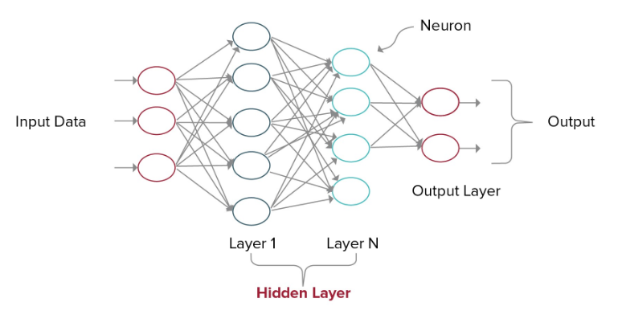
The basic parts of an ANN are:
- Input layer: This is the first layer of the network, where the input data is fed into the network. Each neuron in this layer represents a feature or input variable.
- Hidden layers: These are layers in between the input and output layers. Each hidden layer consists of neurons that perform computations on the input data. The number of hidden layers and neurons in each layer can vary depending on the complexity of the problem.
- Weights: Each connection between neurons in adjacent layers has a weight associated with it. These weights determine the strength of the connection and are adjusted during the training process to improve the network's performance.
- Activation function: Each neuron in the network applies an activation function to the weighted sum of its inputs. This function introduces nonlinearity to the network, allowing it to learn complex patterns in the data.
- Output layer: This is the final layer of the network, where the network's output is generated. The number of neurons in the output layer depends on the type of problem the network is solving (e.g., classification or regression).
- Bias: Each neuron typically has an associated bias, which allows the network to learn the optimal decision boundaries for the data.
- Loss function: This function measures how well the network is performing by comparing its output to the true labels in the training data. The goal of training is to minimize this loss function.
Optimizer: The optimizer is responsible for adjusting the weights of the network during training to minimize the loss function. Popular optimizers include gradient descent, stochastic gradient descent (SGD), and Adam, which are used to update the model's parameters based on the gradients calculated during backpropagation.
Layers connectivity: The way neurons in adjacent layers are connected can vary. In a fully connected layer, each neuron is connected to every neuron in the adjacent layer.
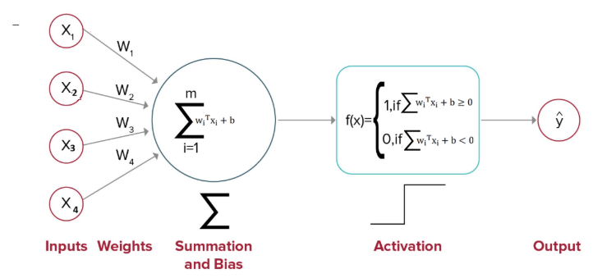
Comparison Between Biological Neurons and Artificial Neurons
ANNs are inspired by the structure and function of the human brain.
- Structure: Both human neurons and artificial neurons have a similar structure, with inputs, a processing unit, and outputs.
- Function: Information is passed from one neuron to another through connections.
Learning: Both systems are capable of learning from experience. In the human brain, this involves synaptic plasticity, where the strength of connections between neurons is adjusted based on the patterns of activity. In ANNs, learning is typically achieved through algorithms that adjust the weights of connections between neurons based on the error in the network's predictions.
Activation: Both human neurons and artificial neurons use an activation function to determine their output based on the inputs they receive. This allows both systems to model complex, nonlinear relationships in data.
Parallel processing: Both systems are capable of parallel processing, where multiple neurons or processing units can perform computations simultaneously.
Fault tolerance: Both systems exhibit some degree of fault tolerance. In the human brain, this is due to the redundancy of connections between neurons. In ANNs, this can be achieved through techniques such as dropout, which randomly removes connections between neurons during training to prevent overfitting.
Step-by-Step Learning Using Gradient Descent
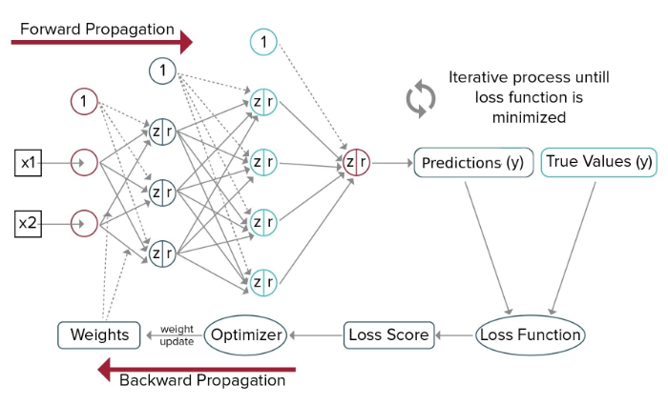
- Initialize weights: Start by initializing the weights of the neural network to small random values. These weights are the parameters that the network will learn during training.
- Forward pass: Perform a forward pass through the network. This involves propagating the input data through the network to compute the output. Each neuron in the network calculates its output based on the weighted sum of its inputs and applies an activation function to this sum.
- Compute loss: Calculate the loss, which is a measure of how well the network's output matches the true output (the labels in the training data).
- Compute gradient of loss: Calculate the gradient of the loss function with respect to the weights of the network.
- Update weights: Update the weights of the network using the gradient descent algorithm. The weights are updated in the opposite direction of the gradient to minimize the loss.
- Repeat: Repeat steps 2–5 for a fixed number of iterations (epochs) or until the loss converges to a satisfactory level. Each iteration through the entire dataset is called an epoch.
- Evaluate: After training is complete, evaluate the performance of the network on a separate validation or test dataset to see how well it generalizes to new, unseen data.
- Adjust hyperparameters: Experiment with different hyperparameters (learning rate, number of hidden layers, number of neurons per layer, etc.) to improve the performance of the network.
By iteratively updating the weights of the network using the gradient descent algorithm, the network learns to make better predictions and minimize the loss function, thereby improving its performance on the task it is trained for.
Types of Activation Function Used in ANNs
There are different types of activation functions used in ANNs. Some of the common ones are the following:
- Sigmoid: The sigmoid function is a smooth, S-shaped curve that maps input values to a range between 0 and 1. It is often used in the output layer of a binary classification problem, where the network needs to predict probabilities.
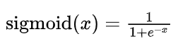
- Hyperbolic tangent (tanh): The tanh function is similar to the sigmoid function but maps input values to a range between −1 and 1. It is often used in hidden layers of the network.
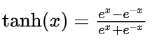
- Rectified linear unit (ReLU): The ReLU function is a simple nonlinear function that returns 0 for negative inputs and the input value for positive inputs.
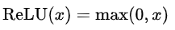
- Leaky ReLU: Leaky ReLU is similar to ReLU but allows a small, nonzero gradient for negative inputs. This helps to mitigate the "dying ReLU" problem, where neurons can become inactive and stop learning.
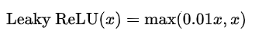
- Softmax: The softmax function is often used in the output layer of a multi-class classification problem, where the network needs to predict probabilities for each class. It converts the raw output values into probabilities that sum up to 1.
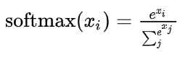
Other terminologies related to deep learning:
Epoch: One complete presentation of the entire training dataset to the learning algorithm — multiple epochs are often required to adequately train a model
Batch size: The number of training examples utilized in one iteration of model training
Dropout: A regularization technique that involves randomly setting a fraction of input units to 0 at each update during training time, which helps to prevent overfitting
Transfer learning: Leveraging a pretrained model on a new, related problem — popular in deep learning where large datasets are required to train a model from scratch

