Mini-Lesson 3.2: Multi-Layer Perceptrons (MLPs) [30 minutes]
In this mini-lesson, you will learn how MLPs work, which will prepare you to run implementations of single- and multi-layer perceptrons in Python.
Select to expand the lesson.

Lesson:
A perceptron is a type of artificial neuron or a basic building block of neural networks. It was first introduced in 1957 by Frank Rosenblatt. The perceptron is a simple model inspired by how a single neuron in the brain works. In its original form, it takes multiple binary inputs (0 or 1), each with an associated weight that determines its importance. The perceptron computes a weighted sum of its inputs, adds a bias term, and then applies an activation function to produce an output.
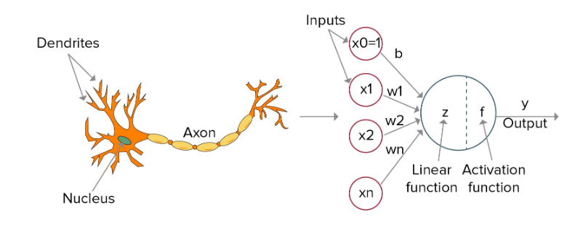
The output y is a weighted sum of the inputs x₁, x₂….x_{n} and weights w₁, w₂, ….w_{n} with a bias term x₀. An activation function is applied to the weighted sum to produce the output y. Perceptrons were initially used for binary classification tasks, where they could learn to separate two classes of data that are linearly separable.
Activation Functions
Choosing the right activation function for a deep learning model is crucial, as it significantly affects the model's ability to learn complex patterns and converge during training. In the original perceptron model, the activation function was a simple step function that outputs 1 if the weighted sum is above a certain threshold and 0 otherwise.

Sigmoid
When to use it: The sigmoid function is primarily used in the output layer of binary classification models, where the goal is to predict probabilities that are mapped between 0 and 1.
Why use it: It outputs values between 0 and 1, which are interpretable as probabilities.
Limitation: It suffers from vanishing gradients, which makes it less ideal for deep networks with many layers.

Hyperbolic Tangent (tanh)
When to use it: Tanh is useful in hidden layers where data needs to be normalized around 0, thus aiding in faster convergence.
Why use it: It outputs values between −1 and 1, effectively centering the data.
Limitation: Like the sigmoid function, tanh also suffers from vanishing gradients in deep networks.

Rectified Linear Unit (ReLU)
When to use it: ReLU is the default choice for many types of neural networks, especially in hidden layers of deep networks.
Why use it: It helps mitigate the vanishing gradient problem, allowing models to learn faster and perform better. ReLU only activates a neuron if the input is positive, which introduces nonlinearity without affecting the scale of the input for positive values.
Limitation: ReLU suffers from the "dying ReLU" problem, where some neurons effectively die during training and stop outputting anything other than 0.

Leaky ReLU
When to use it: Leaky ReLU is a variant of ReLU, which is used to address the dying ReLU problem.
Why use it: It allows a small, positive gradient when the unit is not active and so keeps the update alive during the training process.
Limitation: Its effectiveness can depend significantly on the choice of the small gradient.

Softmax
When to use it: Softmax is typically used in the output layer of a multi-class classification model.
Why use it: It squashes the outputs of each class into a probability distribution ranging between 0 and 1, where the sum of all probabilities is 1.
Limitation: It is only suitable for the output layer.
For practical implementation, start with ReLU for most scenarios because of its simplicity and efficiency, and then experiment with other functions if you encounter issues with model training or performance.
For more information, refer to the resource below:
Brownlee, J. (2021, January 22). How to choose an activation function for deep learning Links to an external site.. Machine Learning Mastery: Making Developers Awesome at Machine Learning.
Single-Layer Perceptron
A single-layer perceptron (SLP) is a type of neural network that consists of only one layer of output nodes. It is typically used for binary classification problems where the classes are linearly separable. Here are some scenarios in which a single-layer perceptron is appropriate:
- Linearly separable data: If your data can be separated into two classes by a linear decision boundary, a single-layer perceptron can be used to learn this boundary.
- Simple binary classification: SLPs are suitable for simple binary classification tasks where you want to classify inputs into two categories.
- Efficiency: SLPs are computationally efficient and can be trained quickly compared to more complex models such as multi-layer perceptrons.
- Interpretability: The output of a single-layer perceptron can be easily interpreted since it directly reflects the decision boundary learned by the model.
- Memory constraints: SLPs require less memory compared to deeper neural networks, making them suitable for environments with limited memory resources.
A single-layer perceptron is not suitable for a linearly nonseparable problem. A linearly nonseparable problem requires hidden layers in the neural network for classification. See the Python code for an XOR problem, which is linearly nonseparable:
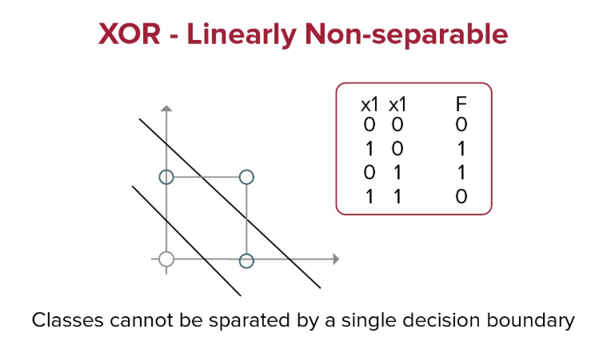
Multi-Layer Perceptron
A multi-layer perceptron (MLP) is a type of artificial neural network that consists of multiple layers of nodes, including an input layer, one or more hidden layers, and an output layer. Each node in a layer is connected to every node in the adjacent layers, and each connection has an associated weight. In an MLP, each node (or neuron) in the hidden layers and the output layer applies an activation function to the weighted sum of its inputs to produce an output. The most commonly used activation functions are the sigmoid, tanh, or ReLU functions. MLPs are capable of learning complex nonlinear relationships in data, making them suitable for a wide range of tasks, including classification, regression, and pattern recognition. They are trained using algorithms such as backpropagation, which adjusts the weights of the connections between neurons to minimize the difference between the predicted output and the actual output.
