Mini-Lesson 4.1: Intellectual Property and Residual Networks [30 minutes]
Select to expand the lesson.

Lesson:
Challenges of Deep Neural Networks
- Vanishing/Exploding gradients: As the network depth increases, gradients can become very small (vanishing) or very large (exploding), leading to inefficient training.
- Degradation problem: Increasing the depth of the network leads to saturation and degradation in performance.
- Optimization difficulty: Deeper networks can become harder to optimize effectively.
Understanding Residual Networks (ResNets)
Residual networks, or ResNets, are a type of deep learning model specifically designed to address the challenges of training very deep neural networks. They were introduced by Kaiming He and his colleagues in the 2015 paper Deep Residual Learning for Image Recognition Links to an external site. and have since become a cornerstone in the field of computer vision.
Key Concepts of ResNets
- Handling the degradation problem
Problem: As neural networks become deeper, they are expected to perform better. However, in practice, deeper networks often suffer from higher training-error rates. This is known as the degradation problem, where adding more layers to a deep network can result in performance that is worse, not better.
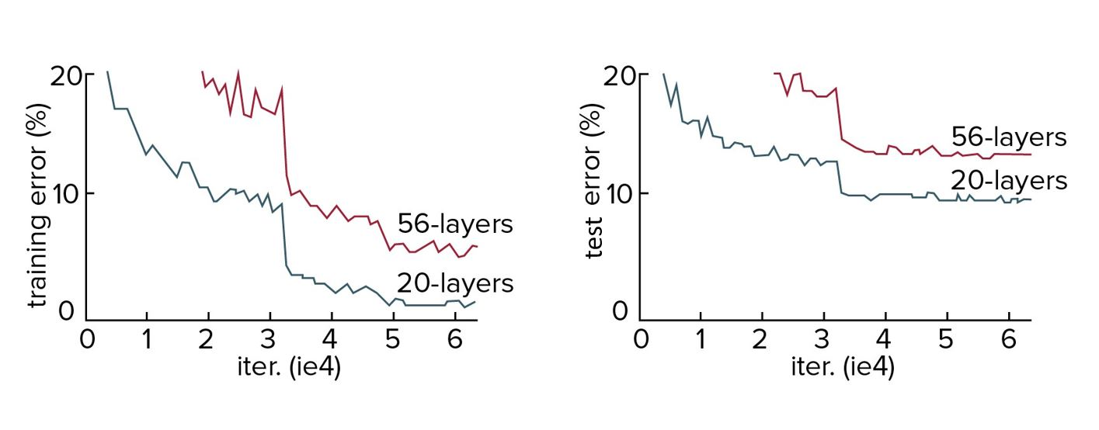
Solution: ResNets solve this issue by introducing residual connections, which allow gradients to flow through the network more effectively.
- Residual learning
Instead of learning the desired mapping directly, ResNet models learn the residuals, or differences, between the desired mapping and the input.
Initially, the desired mapping is H(x). We let the networks, however, fit the residual mapping F(x) = H(x)-x, as the network found it easier to optimize the residual mapping rather than the original mapping.
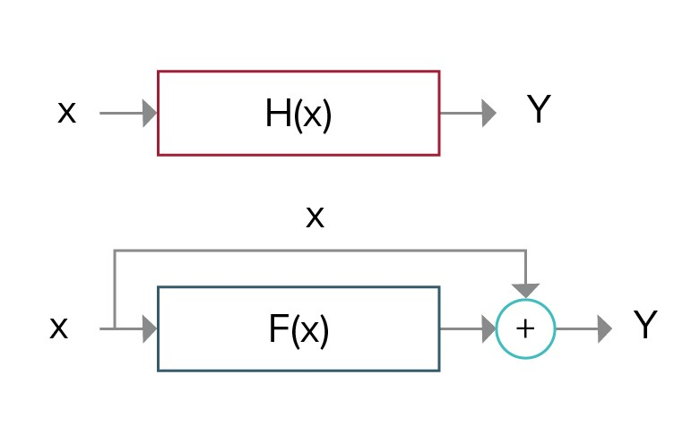
- Skip connections
Skip connections, or shortcut connections, bypass one or more layers by connecting an earlier layer to a later layer.
These connections help alleviate the vanishing-gradient problem by providing alternative paths for gradients to backpropagate, ensuring that the network can learn effectively, even with increased depth.
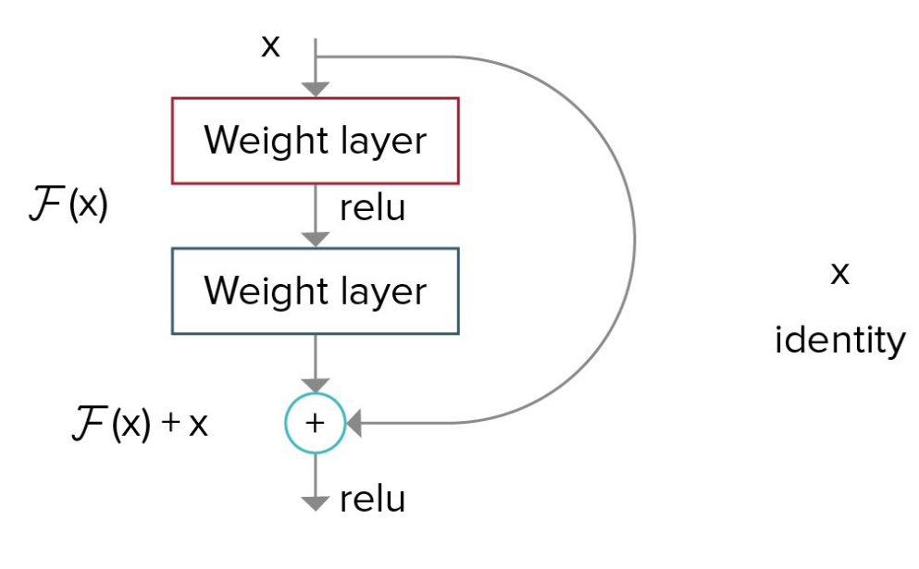
- Building blocks
Residual Block: The fundamental building block of ResNet consists of a few stacked layers and a shortcut connection that bypasses these layers.
Architecture: A typical residual block involves two or three convolutional layers with batch normalization and ReLU activation, and the output of these layers is added to the block's input, forming the output of the block.
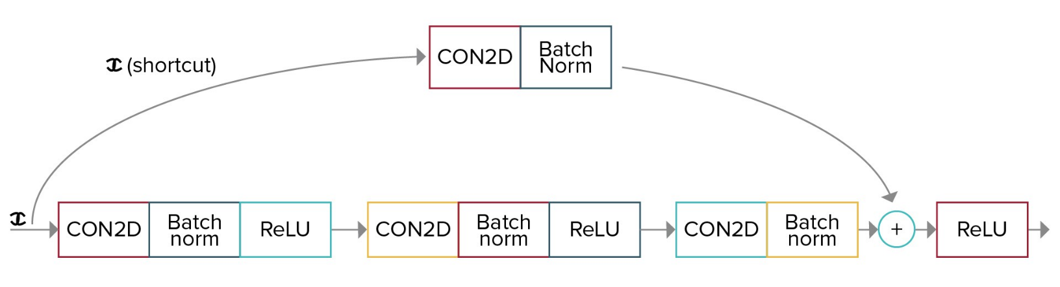
- ResNet variants
ResNet models come in various depths, commonly known as ResNet18, ResNet34, ResNet50, ResNet101, and ResNet152, with the number representing the total number of layers.
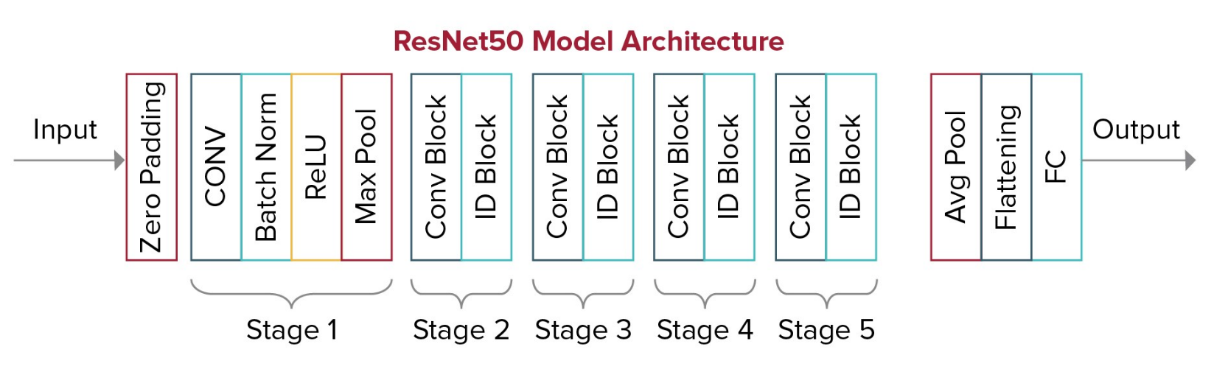
Impact on Performance
Accuracy: ResNets have significantly improved performance on challenging benchmarks such as ImageNet, leading to better accuracy compared with previous architectures.
Training: The architecture's design allows for easier and more effective training of very deep networks, enabling models to achieve higher accuracy without degradation.
Practical Applications of ResNets
Image classification: ResNets are widely used in image classification tasks due to their ability to handle complex patterns and large datasets effectively.
Object detection: ResNets serve as a backbone for many object detection frameworks, providing robust feature extraction capabilities.
Image segmentation: The architecture's depth and residual connections make it suitable for tasks requiring detailed image segmentation.
He, K., Zhang, X., Ren, S., and Sun, J. (2015) Deep residual learning for image recognition Links to an external site.. Microsoft Research.

