**Project Report**

On

**MUSICA**

*Submitted in the Partial Fulfillment for the*

*Award of Degree of*

***Bachelor of Technology***

*In*

***Computer Science and Engineering***



|  |  |
| --- | --- |
| **Submitted to:** | **Submitted By:** |
| **Mr. Jitendra Kumar** | **Avikar Agrawal** |
| **Assistant Professor** | **Harshit Shrimali** |
|  |  |

**Department of Computer Science & Engineering**

**VIVEKANANDA GLOBAL UNIVERSITY,**

**JAIPUR**

**SISYAWAS, SECTOR-36, NRI ROAD, JAGATPURA, JAIPUR, RAJASTHAN**

**(2019 – 2020)**



**VIVEKANANDA GLOBAL UNIVERSITY, JAIPUR**

**CERTIFICATE**

This is to be certified that the work, which is being presented in the project report titled “**MUSICA**”, submitted by “**Avikar Agrawal and Harshit Shrimali**” in partial fulfillment of the award of Bachelor of Technology in Computer Science & Engineering for the academic year of (2019-2020), submitted in the department of Computer Science & Engineering of Vivekananda Global University, Jaipur is an authentic record of the work under the supervision and valuable guidance of **Mr. Jitendra Kumar**, Assistant professor, Dept of Computer Science & Engineering.

The matter presented in the report embodies the result of the studies carried out of the students and has not been submitted for the award of any other degree in this any other institute.

**Jitendra Kumar Mr. Sitaram Gupta**

**(Assistant Professor, CSE Dept.) (HOD, CSE Dept.)**

**CANDIDATE`S DECLARATION**

I, **Avikar Agrawal & Harshit Shrimali** Roll No. **16TEC2CS004 & 16TEC2CS011** B. Tech (Semester- VII) of **Vivekananda Global University, Jaipur** hereby declares that the Project Report entitled **“MUSICA”** is an original work and data provided in the study is authentic to the best of our knowledge.This report has not been submitted to any other Institute for the award of any other degree.

**Harshit Shrimali**

**16TEC2CS011**

**Avikar Agrawal**

**16TEC2CS004**

**Place: JAIPUR**

**Date:**

**Acknowledgement**

I express my sincere gratitude to **Prof. (Dr.) Baldev Singh**, Dean, VGU for providing me an opportunity to undergo this Project Report as the part of the curriculum.

Mere words never suffix in expressing my feeling of gratitude to **Mr. Sitaram Gupta** Head of Department of CSE**,** VGU, Jaipur, for his valuable guidance, patience and encouragement throughout my study. He has not only given me a lot of important comments during Presentation, but also taught me some precious things out of the academic field.

I am extremely grateful to **Mr. Jitendra Kumar (**Assistant Professor), VGU, Jaipur for providing the adequate means and support to pursue this work. I am also thankful to faculty members of CSE Department.

Last but not least, I sincerely express my deepest appreciation to my family and the staff members of C-DAC, **Jaipur** (**Mr. Vinod Sir**) for their wholehearted support and the encouragement.

**Harshit Shrimali**

**16TEC2CS011**

**Avikar Agrawal**

**16TEC2CS004**

**ABSTRACT**

In this document it is explained the development of a project that has been presented in order to finish the degree in computer engineering. The content begins with an introduction where it is explained the motivations to undertake this project and the problem that is faced by the music lovers to buy musical instruments.

The music application is a online musical instrumental store. It is an android application store which work on android OS based smart phones. This app enables the user to buy musical instrument online and get delivered at home.

In the smart world we face many small problems many musicians and musical students face a lot of problem in buying musical instrument. So we brought a solution for all music lovers to get all musical instrument at one place with the help of their smart phones.

This document presents the first version of the project that has been developed, but over the time there will be added new features to extend the functionalities and utilities that the solution will provide to their users.

**Page No.**

**Contents**

**Chapter – 1: Introduction to Android………………..……..8**

**1.1:** Introduction…………………………………………………..8

**1.1.1:** History……...………………………………………9

**1.1.2:** Linux Kernel……………………………….….…..12

**1.2:** Components of Android………………………..…………...14

**1.3:** Objective of the project …………………………………….23

**Chapter -2: Project Architecture……………………..……24**

**2.1:** Activity Diagram ……………….…………………….……24

**2.2:** Application Database ………………………………………25

**Chapter- 3: Simulation & Results…………………………..……..27**

**3.1**: Simulation……………………………………………..……27

**3.2:** Results………………………………………………………30

**3.3:** Coding……………………………………………………….32

**Chapter- 4: Conclusion & Future Scope…….…………………..35**

**4.1**: Conclusion……………..……………………………………35

**4.2:** Future Scope of this Project………………………………..35

REFERENCES…………………………………………………………..36

**List of Figures:**

|  |  |  |
| --- | --- | --- |
| Figure Number | Name of the Figure | Page Number |
| Fig.1.1 | The pre-release version of Android | 9 |
| Fig.1.2 | HTC Dream – first Android Phone | 10 |
| Fig.1.3 | Activity | 14 |
| Fig.1.4 | Life Cycle of Activity | 15 |
| Fig.1.5 | Life Cycle of Fragment | 17 |
| Fig1.6 | Linear Layout | 19 |
| Fig1.7 | Relative Layout | 19 |
| Fig.1.8 | Table Layout | 20 |
| Fig.1.9 | Grid View Layout | 20 |
| Fig.1.10 | Tab Layout | 21 |
| Fig.1.11 | List view | 22 |
| Fig.1.12 | Grid View | 22 |
| Fig.2.1 | Activity Flow | 24 |
| Fig.2.2 | Google firebase Database | 25 |
| Fig: 2.3 | Image storage in google firebase | 26 |
| Fig: 3.1 | Android Studio | 27 |
| Fig 3.2 | Splash Screen | 28 |
| Fig 3.3 | Login Screen | 28 |
| Fig 3.4 | Login Credentials | 29 |
| Fig 3.5 | Home Screen | 29 |
| Fig 3.6 | Profile Page | 30 |
| Fig 3.7 | Menu Screen | 30 |
| Fig 3.8 | App Info | 31 |

**Chapter 1**

**INTRODUCTION TO ANDROID**

**1.1 INTRODUCTION**

**Android** is a mobile operating system developed by Google. It is based on a modified version of the Linux kernel and other open source software and is designed primarily for touchscreen mobile devices such as smartphones and tablets. In addition, Google has further developed Android TV for televisions, Android Auto for cars, and Wear OS for wrist watches, each with a specialized user interface. Variants of Android are also used on game consoles, digital cameras, PCs and other electronics.

Initially developed by Android Inc., which Google bought in 2005, Android was unveiled in 2007, with the first commercial Android device launched in September 2008. The operating system has since gone through multiple major releases, with the currently stable version being 9 "Pie", released in August 2018. Google released the first Android Q beta on all Pixel phones on March 13, 2019. The core Android source code is known as Android Open Source Project (AOSP) and is primarily licensed under the Apache License.

Android is also associated with a suite of proprietary software developed by Google, called Google Mobile Services(GMS) that very frequently comes pre-installed in devices, which usually includes the Google Chrome web browser and Google Search and always includes core apps for services such as Gmail, as well as the application store and digital distribution platform Google Play, and associated development platform. These apps are licensed by manufacturers of Android devices certified under standards imposed by Google, but AOSP has been used as the basis of competing Android ecosystems, such as Amazon.com Fire OS, which use their own equivalents to GMS.

Android has been the best-selling OS worldwide on smartphones since 2011 and on tablets since 2013. As of May 2017, it has over two billion monthly active users, the largest installed base of any operating system, and as of December 2018, the Google Play store features over 2.6 million apps.

**Chapter 1**

* + 1. **HISTORY**

Computer programmer Andy Rubin picked android.com as his personal website, and his colleagues used Android as his nickname at work. The name Andrew and the noun Android share the Greek root *Andros*, which means man. That eventually became the name of the company he founded, and the name of the operating system they developed.

[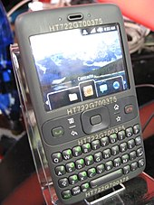](https://en.wikipedia.org/wiki/File:HTC_HT722G700375_20080211.jpg)

**Fig: 1.1 The "Sooner" prototype phone, running a pre-release version of Android**

Android Inc. was founded in Palo Alto, California, in October 2003 by Andy Rubin, Rich Miner, Nick Sears, and Chris White. Rubin described the Android project as "tremendous potential in developing smarter mobile devices that are more aware of its owner's location and preferences". The early intentions of the company were to develop an advanced operating system for digital cameras, and this was the basis of its pitch to investors in April 2004.The company then decided that the market for cameras was not large enough for its goals, and by five months later it had diverted its efforts and was pitching Android as a handset operating system that would rival Symbian and Microsoft Windows Mobile.

Rubin had difficulty attracting investors early on, and Android was facing eviction from its office space. Steve Perlman, a close friend of Rubin, brought him $10,000 in cash in an envelope, and shortly thereafter wired an undisclosed amount as seed funding. Perlman refused a stake in the company, and has stated "I did it because I believed in the thing, and I wanted to help Andy."

In July 2005, Google acquired Android Inc. for at least $50 million. Its key employees, including Rubin, Miner and White, joined Google as part of the acquisition. Not much was known about the secretive Android at the time, with the company having provided few details

**Chapter 1**

other than that it was making software for mobile phones. At Google, the team led by Rubin developed a mobile device platform powered by the Linux kernel. Google marketed the platform to handset makers and carriers on the promise of providing a flexible, upgradeable system. Google had "lined up a series of hardware components and software partners and signaled to carriers that it was open to various degrees of cooperation".

Speculation about Google's intention to enter the mobile communications market continued to build through December 2006.An early prototype had a close resemblance to a BlackBerry phone, with no touchscreen and a physical QWERTY keyboard, but the arrival of 2007's Apple iPhone meant that Android "had to go back to the drawing board". Google later changed its Android specification documents to state that "Touchscreens will be supported", although "the Product was designed with the presence of discrete physical buttons as an assumption, therefore a touchscreen cannot completely replace physical buttons".By 2008, both Nokia and BlackBerry announced touch-based smartphones to rival the iPhone 3G, and Android's focus eventually switched to just touchscreens. The first commercially available smartphone running Android was the HTC Dream, also known as T-Mobile G1, announced on September 23, 2008.

[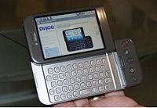](https://en.wikipedia.org/wiki/File:HTC_Android_T-Mobile_G1.jpg)

**Fig 1.2 : HTC Dream or T-Mobile G1, the first commercially released device running Android (2008)**

On November 5, 2007, the Open Handset Alliance, a consortium of technology companies including Google, device manufacturers such as HTC, Motorola and Samsung, wireless carriers such as Sprint and T-Mobile, and chipset makers such as Qualcomm and Texas Instruments, unveiled itself, with a goal to develop "the first truly open and comprehensive platform for mobile devices". Within a year, the Open Handset Alliance faced two other open source competitors, the Symbian Foundation and the LiMo Foundation, the latter also developing a Linux-based mobile operating system like Google. In September 2007,

**Chapter 1**

*InformationWeek* covered an E-value serve study reporting that Google had filed several patent applications in the area of mobile telephony.

Since 2008, Android has seen numerous updates which have incrementally improved the operating system, adding new features and fixing bugs in previous releases. Each major release is named in alphabetical order after a dessert or sugary treat, with the first few Android versions being called "Cupcake", "Donut", "Eclair", and "Froyo", in that order. During its announcement of Android KitKat in 2013, Google explained that "Since these devices make our lives so sweet, each Android version is named after a dessert", although a Google spokesperson told CNN in an interview that "It's kind of like an internal team thing, and we prefer to be a little bit — how should I say — a bit inscrutable in the matter, I'll say".

In 2010, Google launched its Nexus series of devices, a lineup in which Google partnered with different device manufacturers to produce new devices and introduce new Android versions. The series was described as having "played a pivotal role in Android's history by introducing new software iterations and hardware standards across the board", and became known for its "bloat-free" software with "timely ... updates". At its developer conference in May 2013, Google announced a special version of the Samsung Galaxy S4, where, instead of using Samsung's own Android customization, the phone ran "stock Android" and was promised to receive new system updates fast. The device would become the start of the Google Play edition program, and was followed by other devices, including the HTC One Google Play edition, and Moto G Google Play edition. In 2015, *Ars Technica* wrote that "Earlier this week, the last of the Google Play edition Android phones in Google's online storefront were listed as "no longer available for sale" and that "Now they're all gone, and it looks a whole lot like the program has wrapped up".

Eric Schmidt, Andy Rubin and Hugo Barra at a 2012 press conference announcing Google's Nexus 7 tablet

From 2008 to 2013, Hugo Barra served as product spokesperson, representing Android at press conferences and Google I/O, Google's annual developer-focused conference. He left Google in August 2013 to join Chinese phone maker Xiaomi. Less than six months earlier, Google's then-CEO Larry Page announced in a blog post that Andy Rubin had moved from the Android division to take on new projects at Google, and that Sundar Pichai would become the new Android lead. Pichai himself would eventually switch positions, becoming

**Chapter 1**

the new CEO of Google in August 2015 following the company's restructure into the Alphabet conglomerate, making Hiroshi Lockheimer the new head of Android.

In June 2014, Google announced Android One, a set of "hardware reference models" that would "allow [device makers] to easily create high-quality phones at low costs", designed for consumers in developing countries. In September, Google announced the first set of Android One phones for release in India. However, *Recode* reported in June 2015 that the project was "a disappointment", citing "reluctant consumers and manufacturing partners" and "misfires from the search company that has never quite cracked hardware". Plans to relaunch Android One surfaced in August 2015, with Africa announced as the next location for the program a week later. A report from *The Information* in January 2017 stated that Google is expanding its low-cost Android One program into the United States, although *The Verge* notes that the company will presumably not produce the actual devices itself.

Google introduced the Pixel and Pixel XL smartphones in October 2016, marketed as being the first phones made by Google, and exclusively featured certain software features, such as the Google Assistant, before wider rollout. The Pixel phones replaced the Nexus series, with a new generation of Pixel phones launched in October 2017.

**1.1.2 Linux Kernel**

Android's kernel is based on the Linux kernel's long-term support (LTS) branches. As of 2018, Android targets versions 4.4, 4.9 or 4.14 of the Linux kernel. The actual kernel depends on the individual device.

Android's variant of the Linux kernel has further architectural changes that are implemented by Google outside the typical Linux kernel development cycle, such as the inclusion of components like device trees, ashmem, ION, and different out of memory (OOM) handling. Certain features that Google contributed back to the Linux kernel, notably a power management feature called "wake locks", were initially rejected by mainline kernel developers partly because they felt that Google did not show any intent to maintain its own code. Google announced in April 2010 that they would hire two employees to work with the Linux kernel community, but Greg Kroah-Hartman, the current Linux kernel maintainer for the stable branch, said in December 2010 that he was concerned that Google was no longer

**Chapter 1**

trying to get their code changes included in mainstream Linux. Google engineer Patrick Brady once stated in the company's developer conference that "Android is not Linux", with *Computerworld* adding that "Let me make it simple for you, without Linux, there is no Android". *Ars Technica* wrote that "Although Android is built on top of the Linux kernel, the platform has very little in common with the conventional desktop Linux stack".

In August 2011, Linus Torvalds said that "eventually Android and Linux would come back to a common kernel, but it will probably not be for four to five years". In December 2011, Greg Kroah-Hartman announced the start of Android Mainlining Project, which aims to put some Android drivers, patches and features back into the Linux kernel, starting in Linux 3.3.Linux included the auto sleep and wake locks capabilities in the 3.5 kernel, after many previous attempts at merger. The interfaces are the same but the upstream Linux implementation allows for two different suspend modes: to memory (the traditional suspend that Android uses), and to disk (hibernate, as it is known on the desktop). Google maintains a public code repository that contains their experimental work to re-base Android off the latest stable Linux versions.

The flash storage on Android devices is split into several partitions, such as /system for the operating system itself, and /data for user data and application installations. In contrast to desktop Linux distributions, Android device owners are not given root access to the operating system and sensitive partitions such as /system are read-only. However, root access can be obtained by exploiting security flaws in Android, which is used frequently by the open-source community to enhance the capabilities of their devices, but also by malicious parties to install viruses and malware.

Android is a Linux distribution according to the Linux Foundation, Google's open-source chief Chris DiBona, and several journalists. Others, such as Google engineer Patrick Brady, say that Android is not Linux in the traditional Unix-like Linux distribution sense; Android does not include the GNU C Library (it uses Bionic as an alternative C library) and some of other components typically found in Linux distributions.

With the release of Android Oreo in 2017, Google began to require that devices shipped with new SoCs had Linux kernel version 4.4 or newer, for security reasons. Existing devices upgraded to Oreo, and new products launched with older SoCs, were exempt from this rule.

**Chapter 1**

**1.2 Components of Android**

**1.2.1 Activity**

An activity provides the window in which the app draws its UI. This window typically fills the screen but may be smaller than the screen and float on top of other windows. Generally, one activity implements one screen in an app. For instance, one of an app’s activities may implement a Preferences screen, while another activity implements a Select Photoscreen.

Most apps contain multiple screens, which means they comprise multiple activities. Typically, one activity in an app is specified as the main activity, which is the first screen to appear when the user launches the app. Each activity can then start another activity in order to perform different actions. For example, the main activity in a simple e-mail app may provide the screen that shows an e-mail inbox. From there, the main activity might launch other activities that provide screens for tasks like writing e-mails and opening individual e-mails. Although activities work together to form a cohesive user experience in an app, each activity is only loosely bound to the other activities; there are usually minimal dependencies among the activities in an app. In fact, activities often start up activities belonging to other apps. For example, a browser app might launch the Share activity of a social-media app.

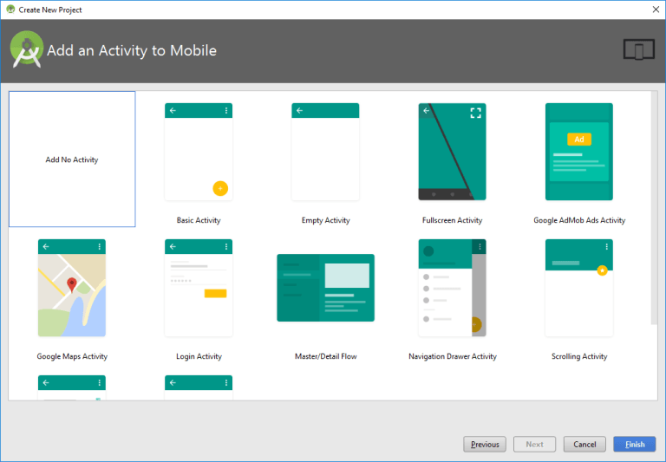**Fig 1.3 : Activity**

**Chapter 1**

**1.2.2 Life Cycle of an Activity**

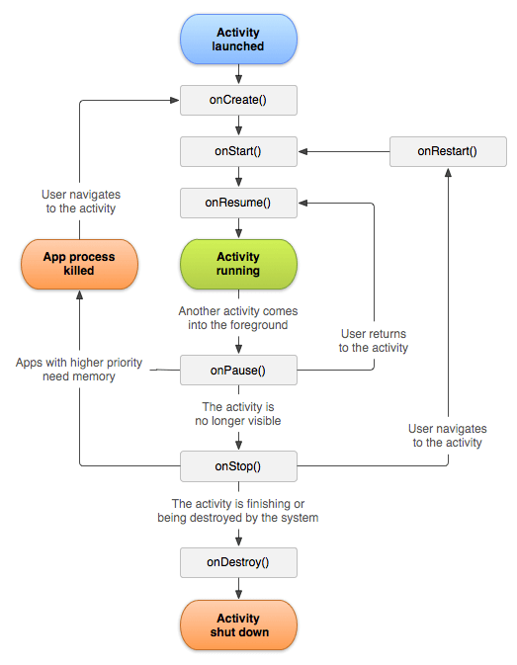

**Fig 1.4 : Lifecycle of an Activity**

**Android Activity Lifecycle** is controlled by 7 methods of android App Activity class. The android Activity is the subclass of Context Theme Wrapper class. An activity is the single screen in android. It is like window or frame of Java By the help of activity, you can place all your UI components or widgets in a single screen.

**Chapter 1**

The 7lifecycle method of Activity describes how activity will behave at different states.

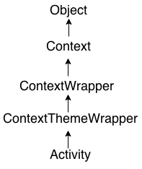

# **1.2.3** **Android Fragments**

**Android Fragment** is the part of activity, it is also known as sub-activity. There can be more than one fragment in an activity. Fragments represent multiple screen inside one activity.

Android fragment lifecycle is affected by activity lifecycle because fragments are included in activity.

Each fragment has its own life cycle methods that is affected by activity life cycle because fragments are embedded in activity.

The **Fragment Manager** class is responsible to make interaction between fragment objects.

## Android Fragment Lifecycle

## The lifecycle of android fragment is like the activity lifecycle. There are 12 lifecycle methods for fragment.

**Chapter 1**

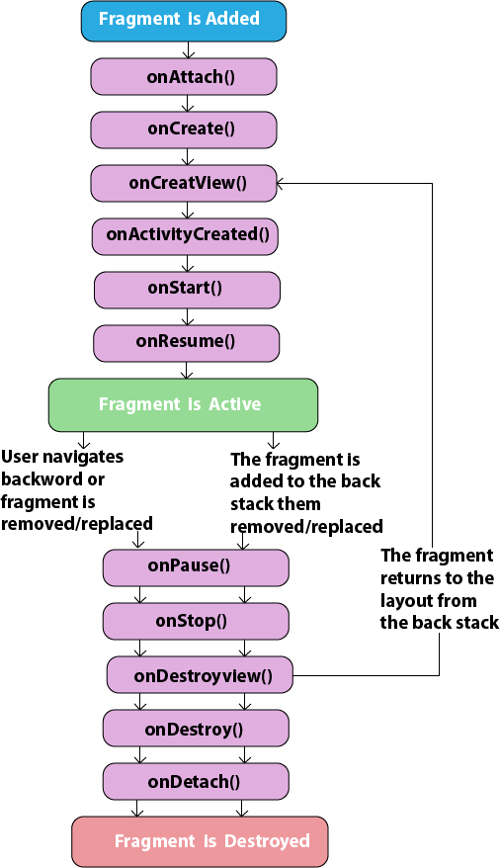

**Fig 1.5 Life Cycle of Fragment**

**Chapter 1**

**1.2.4 Layouts**

A Layout dictates the alignment of widgets (such as Text, Buttons, EditText box) as we see in the Android Application. All the visual structure we see in an android app is designed in a Layout. Every Layout is defined in an xml file which is located in **App > res > Layout** in New Android Studio.

**Types:** The layouts most commonly used are:

1. Linear Layout
2. Relative Layout

However there are several other layouts such as:

1. Web View Layout
2. Frame Layout
3. List View Layout
4. Grid View Layout
5. Web View Layout
6. Frame Layout
7. List View Layout
8. Grid View Layout

**Linear Layout:**

Linear Layout is a layout which aligns the widgets or elements in a linear (Straight) fashion. Linear Layout consists of two types of orientation:

1.Vertical Orientation,

2.Horizontal Orientation.

Vertical Orientation is shown above where the widgets such as Text View, Edit Text, and Button are aligned in a Vertical manner.

**Chapter 1**

## LinearLayout.png

**Fig 1.6 : Linear Layout**

## Relative Layout

Relative Layoutenforces to display elements in relations to each other. You can specify that, for instance, one UI element can be said to be placed on the left of another element, or on the bottom of another etc. Each UI element can also be positioned according to the layout’s borders (e.g. aligned to the right):

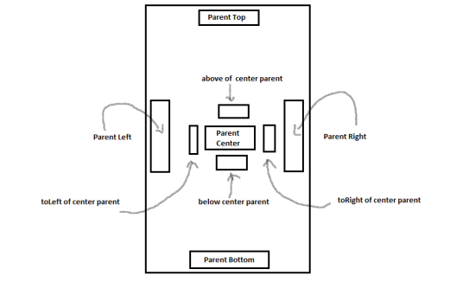

**Fig 1.7 : Relative layout**

**Chapter 1**

# Relative Layout is very powerful. Consider that for building mobile apps’ interfaces these can be run on multiple devices with different screens’ resolutions. *Relative Layout* allows (if properly built, of course) to adjust your set of controls easily to almost every type of screen. It’s quite specific and I personally found it difficult to understand and use initially, but it seems to be worth it.

# **Table Layout**

As its name suggests, Table Layout allows to group elements into rows and columns:

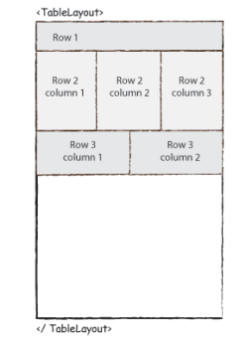

**Fig 1.8 : Table Layout**

May be useful when displaying some statistics or reports.

**Grid View**

Grid View displays items in two-dimensional grid. The list can be easily scrolled. This type of Layout is often used on screens displaying photos or similar sets of “blocks” to click:

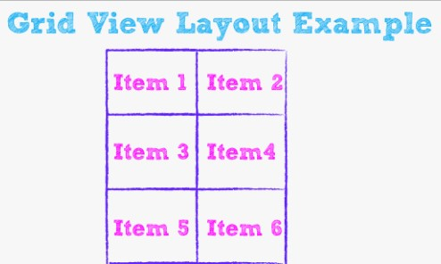

**Fig 1.9 : Grid View Layout**

**Chapter 1**

**Tab Layout**

Tabbed Layouts allow to introduce tabs in our Android application. Then, a single Activity may contain several tabs and user can easily switch between them. On each tab you can use different type of Layout.

## android tablayout 1

**Fig 1.10 : Tab Layout**

## List View

A List View is a View Layout where all the items are specified in the form of a list as shown in fig. below. It is one of the very useful form of layouts. List view, as shown in figure below consists of an order of List items as shown below.

**Chapter 1**

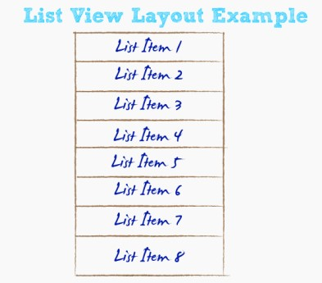

**Fig 1.11 : List View**

**Grid View**

Grid Viewdisplays items in two-dimensional grid. The list can be easily scrolled. This type of Layout is often used on screens displaying photos or similar sets of “blocks” to click:

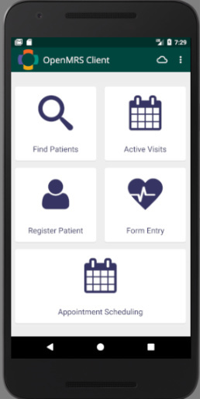

**Fig 1.12 : Grid View**

**Chapter 1**

**1.3 Objective of the Project**

The objective of the Project is to provide a platform to music lovers where they can buy all type of music instrument at a single place online.

The app provides Log in Interface with the idea of allowing only members to Log into the app. New members can register themselves.

The app internal home page provides a list wise view of instruments for viewing and purchasing different items

The app main objective here is to provide an easy way for purchasing musical instruments online.

**Chapter 2**

**PROJECT ARCHITECTURE**

**2.1 Activity Flow Diagram**

Here is the activity flow diagram of the android app.

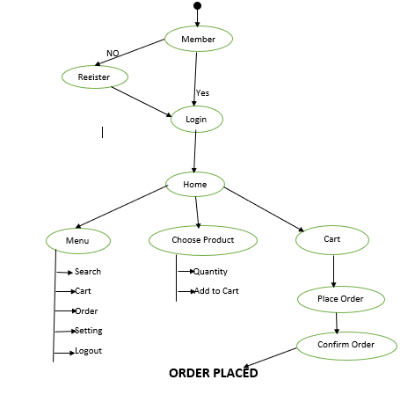

**Chapter 2**

**2.2 Application Database**

The database for the application used is google firebase. Google Firebase is online database provided by google. Its uses cloud storage for storing the data. It can be directly connected to android studio. It’s a virtual database for creating it we have to implement its link into android studio.

implementation 'com.google.firebase:firebase-auth:19.1.0'

implementation 'com.google.firebase:firebase-firestore:21.3.0'

Below image show the google firebase database where user info are stored.

Fig 2.2 : Google Firebase Database

**Chapter 2**

The below diagram shows the image storage in Google Firebase

**Fig 2.3 : Image storage in Google Firebase**

**Chapter 3**

**SIMULATION AND RESULTS**

**3.1** **SIMULATION**

**3.1.1 Tools Used**

* Android Studio
* Google Firebase
* Third party dependencies for API management

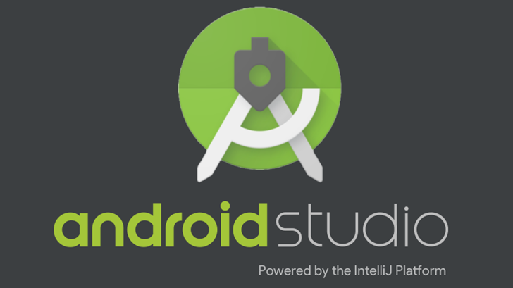

**Fig 3.1 Android Studio**

**Chapter 3**

**3.1.2 User Interface**

The following pictures provide the User Interface

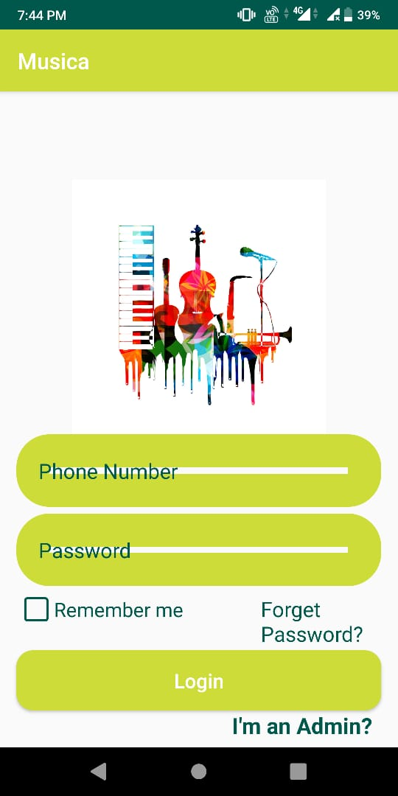

**Fig 3.2 : Splash Screen Fig 3.3: Log In Screen**

**Chapter 3**

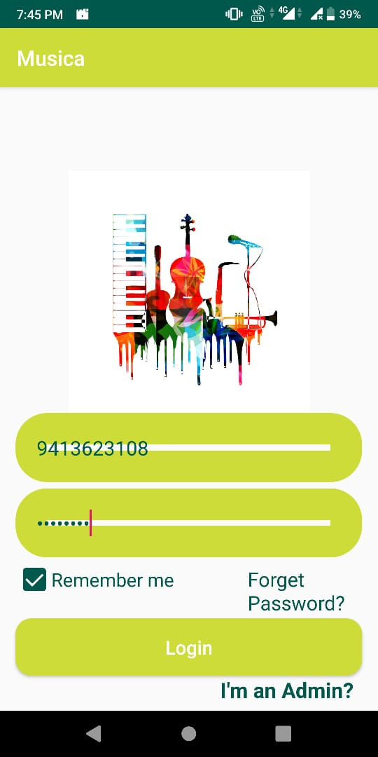

**Fig 3.4: Log In Credentials Fig 3.5: Home Screen**

**Chapter 3**

**Fig 3.6 : Profile Page Fig 3.7: Menu Screen**

**3.2 RESULTS**

The Application has been working with all the backend working fine. The Screenshots of the Information of the storage and

**Chapter 3**

**Fig 3.8 App Info**

**Chapter-3**

**Login Layout Code**

<?xml version="1.0" encoding="utf-8"?>

<RelativeLayout

xmlns:android="http://schemas.android.com/apk/res/android"

xmlns:app="http://schemas.android.com/apk/res-auto"

xmlns:tools="http://schemas.android.com/tools"

android:layout_width="match_parent"

android:layout_height="match_parent"

tools:context=".LoginActivity">

<ImageView

android:id="@+id/login_applogo"

android:layout_width="300dp"

android:layout_height="230dp"

android:layout_centerHorizontal="true"

android:layout_marginTop="80dp"

android:src="@drawable/logo" />

<EditText

android:id="@+id/login_phone_number_input"

android:layout_width="match_parent"

android:layout_height="wrap_content"

android:layout_below="@+id/login_applogo"

android:layout_marginLeft="15dp"

android:layout_marginRight="15dp"

android:background="@drawable/input_design"

android:hint="Phone Number"

android:inputType="number"

android:padding="20dp"

android:textColor="@color/colorPrimaryDark"

android:textColorHint="@color/colorPrimaryDark"

android:textSize="19sp" />

<EditText

android:id="@+id/login_password_input"

android:layout_width="match_parent"

android:layout_height="wrap_content"

android:layout_below="@+id/login_phone_number_input"

android:layout_marginLeft="15dp"

android:layout_marginTop="6dp"

android:layout_marginRight="15dp"

android:background="@drawable/input_design"

android:hint="Password"

android:inputType="textPassword

**Chapter 3**

android:padding="20dp"

android:textColor="@color/colorPrimaryDark"

android:textColorHint="@color/colorPrimaryDark"

android:textSize="19sp" />

<LinearLayout

android:id="@+id/linear_layout_1"

android:layout_width="match_parent"

android:layout_height="wrap_content"

android:layout_below="@+id/login_password_input"

android:layout_marginTop="5dp"

android:orientation="horizontal">

<com.rey.material.widget.CheckBox

android:id="@+id/remember_me_chkb"

style="@style/Material.Drawable.CheckBox"

android:layout_width="wrap_content"

android:layout_height="wrap_content"

android:layout_marginLeft="17dp"

android:gravity="center_vertical"

android:text="Remember me"

android:textColor="@color/colorPrimaryDark"

android:textSize="18sp"

app:cbd_strokeColor="@color/colorPrimaryDark" />

<TextView

android:id="@+id/forget_password_link"

android:layout_width="wrap_content"

android:layout_height="wrap_content"

android:layout_marginLeft="70dp"

android:text="Forget Password?"

android:textColor="@color/colorPrimaryDark"

android:textSize="19sp" />

</LinearLayout>

<Button

android:id="@+id/login_btn"

android:layout_width="match_parent"

android:layout_height="wrap_content"

android:layout_below="@+id/linear_layout_1"

android:layout_marginLeft="15dp"

android:layout_marginTop="5dp"

android:layout_marginRight="15dp"

android:background="@drawable/buttons"

android:padding="15dp"

android:text="Login"

**Chapter 3**

android:textAllCaps="false"

android:textColor="@android:color/white"

android:textSize="18sp" />

<TextView

android:id="@+id/admin_panel_link"

android:layout_width="wrap_content"

android:layout_height="wrap_content"

android:layout_below="@+id/login_btn"

android:layout_alignParentEnd="true"

android:layout_marginLeft="80dp"

android:layout_marginEnd="23dp"

android:layout_marginBottom="50dp"

android:text="I'm an Admin?"

android:textColor="@color/colorPrimaryDark"

android:textSize="20sp"

android:textStyle="bold" />

<TextView

android:id="@+id/not_admin_panel_link"

android:layout_width="wrap_content"

android:layout_height="wrap_content"

android:layout_below="@+id/login_btn"

android:layout_alignParentStart="true"

android:layout_marginStart="25dp"

android:layout_marginLeft="80dp"

android:text="I'm not an Admin?"

android:textColor="@color/colorPrimaryDark"

android:textSize="20sp"

android:textStyle="bold"

android:visibility="invisible" />

</RelativeLayout>

**Chapter 4**

**CONCLUSION AND FUTURE IMPROVEMENTS**

**4.1** CONCLUSION

The App has been developed with the help of tools like Android Studio and google firebase which provides a platform to purchase musical instrument online.

The App has features where user can check his orders in order list.

It has features to update user profile and if he forgot his password, he can change it.

Admin can also login through the same application.

**4.2** FUTURE SCOPE OF THIS PROJECT

The App`s Future Scope can be a thought of building a more dynamic and easily changeable application.

Other features like the below mentioned list can be added to get the application working in a very efficient manner:

* A feature of live tracking of the order.
* Product can be returned and replaced.
* Payment can be done through online mode like credit card, debit card, net banking, UPI mode.
* Customer support facility could be available for the users.

**REFERENCES:**

1. <https://en.wikipedia.org/wiki/Android_(operating_system)>
2. <https://www.javatpoint.com/android-tutorial>
3. <https://developer.android.com/guide>
4. Android Learning
5. https://Youtube.com
6. <https://github.com/>
7. <https://developer.android.com/reference/android/>