



Faculty of Technology

Department of Computer Engineering

## B. Tech.(CE) Semester – V

Advanced Technologies

(CE – 515)

## Discussion Forum

## (The Essence of Questioning)

By



# Harshit Tarsariya(CE133)

# (18CEUBG080)

Guided by

**Associate Prof. Prashant M. Jadav**





Faculty of Technology

Department of Computer Engineering



This is to certify that Advanced Technologies Project entitled

**“Discussion Forum”**

is the bonafide report of work carried out by

**Harshit Tarsariya(18CEUBG080)**

of Department of Computer Engineering ,Semester V , academic year 2020-2021.



|  |  |
| --- | --- |
| **Associate Prof. Prashant M. Jadav**  Professor of Department of Computer Engineering ,  Dharmsinh Desai  University,Nadiad | **Dr. C. K. Bhensdadia**  Head of Department of Computer Engineering, Dharmsinh Desai  University, Nadiad |
|  |  |

*Table of Contents*

1. Abstract 4
2. Introduction 5
   1. Project Details: Brief Introduction 5
   2. Technology and Tools Used 5
3. Software Requirement Specifications 6
   1. Scope 6
   2. System Functional Requirements 7
   3. Other Non‐Functional Requirements 11
4. Design 12
5. Implementation Details 18
   1. Modules 18
6. Screen‐shots of the System 20
7. Conclusion 23
8. Limitations of System 24
9. Future Extensions to the System …24

10 Bibliography………………………………………………………………………………….25

C:\Users\Harshit\AppData\Local\Microsoft\Windows\Clipboard\HistoryData\{9B6974ED-B951-4540-989A-DE09858FAD7A}\{9BB63DE3-3458-4E1D-A1CD-F6DD7550F555}\ResourceMap\{366CA3D9-3C4C-40D3-BBBA-03E88040FB91}

Abstract

C:\Users\Harshit\AppData\Local\Microsoft\Windows\Clipboard\HistoryData\{9B6974ED-B951-4540-989A-DE09858FAD7A}\{9BB63DE3-3458-4E1D-A1CD-F6DD7550F555}\ResourceMap\{366CA3D9-3C4C-40D3-BBBA-03E88040FB91}

Discussion Forum is the platform for sharing doubts regarding any topics and the community will respond back with their appropriate perspective .

Our platform provide support to the user with easy registration and login with ease of uploading their doubts or share some new ideas which can be useful for the community instantly at no cost.

**Discussion Forum**

The Essence of Questioning

© 2020

C:\Users\Harshit\AppData\Local\Microsoft\Windows\Clipboard\HistoryData\{9B6974ED-B951-4540-989A-DE09858FAD7A}\{9BB63DE3-3458-4E1D-A1CD-F6DD7550F555}\ResourceMap\{366CA3D9-3C4C-40D3-BBBA-03E88040FB91}

Introduction

C:\Users\Harshit\AppData\Local\Microsoft\Windows\Clipboard\HistoryData\{9B6974ED-B951-4540-989A-DE09858FAD7A}\{9BB63DE3-3458-4E1D-A1CD-F6DD7550F555}\ResourceMap\{366CA3D9-3C4C-40D3-BBBA-03E88040FB91}

Brief :



Discussion Forum is all about sharing doubts and ideas and get response from newly to professional contributor of community.

Tools Used :

Visual Studio Code

Technologies Used :

HTML 5

CSS

Bootstrap

Angular cli

Typescript

Express-Node JS

MongoDb

Platform Used :

localhost

C:\Users\Harshit\AppData\Local\Microsoft\Windows\Clipboard\HistoryData\{9B6974ED-B951-4540-989A-DE09858FAD7A}\{9BB63DE3-3458-4E1D-A1CD-F6DD7550F555}\ResourceMap\{366CA3D9-3C4C-40D3-BBBA-03E88040FB91}

Software Requirement Specification

C:\Users\Harshit\AppData\Local\Microsoft\Windows\Clipboard\HistoryData\{9B6974ED-B951-4540-989A-DE09858FAD7A}\{9BB63DE3-3458-4E1D-A1CD-F6DD7550F555}\ResourceMap\{366CA3D9-3C4C-40D3-BBBA-03E88040FB91}

Application Scope:

The software is mainly based on the discussion about various questions or topics or thread started by the users. All users are first requested to register and login. User can read various questions and are able to answer that, if they are logged in.

Type of Users:

1. End User

2. Admin User

C:\Users\Harshit\AppData\Local\Microsoft\Windows\Clipboard\HistoryData\{9B6974ED-B951-4540-989A-DE09858FAD7A}\{9BB63DE3-3458-4E1D-A1CD-F6DD7550F555}\ResourceMap\{366CA3D9-3C4C-40D3-BBBA-03E88040FB91}

Functional Requirements

C:\Users\Harshit\AppData\Local\Microsoft\Windows\Clipboard\HistoryData\{9B6974ED-B951-4540-989A-DE09858FAD7A}\{9BB63DE3-3458-4E1D-A1CD-F6DD7550F555}\ResourceMap\{366CA3D9-3C4C-40D3-BBBA-03E88040FB91}

R1 User Authentication

Description : In this module user can register and login by providing credentials

R1.1 Register

Input : First name, Last name, username, password, email, mobile number

Output : Successful message and mail is sent for confirmation for registered mail

Description : When user provides all information data is stored in database and user is successfully registered

R1.2 Login

Input : Unique username, password

Output : Message for logged in

Description : After providing details , user is validated against credentials and on successful validation redirected to home page

R1.3 Forget Password

Input : Username

Output : Otp is sent on the registered email-id of user

Description: After providing username , otp is sent on email and user is able to change password

R2 User Profile

Description : In this module user can see profile details and can edit and update it

R2.1 View Profile

Input : User selection

Output : Users profile with data is shown

Description : When user is selecting profile to see then user is shown the data of particular user

R2.2 Edit Profile

R2.2.1 Edit password

Input : Password, Confirm password

Output : Changes on page

Description : Logged In User after editing password database is reflected

R2.2.2 Edit Other information

Input : Edit selection

Output : Edited Profile after edit

Description : Logged In User changes the profile details such as first name,last name, email,mobile number

R3 Questions and Answer

Description : In this module user can add question , provide answer to particular questions , can delete questions (if admin) , get answers provided by particular profile, get answers provided by our followings

R3.1 Add Question

Input : Title , Question , Tags

Ouput : Question uploaded on feed

Description : Logged In user after adding question, it is uploaded on the feed

R3.2 Delete Question

Input : Delete Selection

Output : Deleted Successfully

Description : Questions can only be deleted by admin and general user can not delete questions as some of valuable time is spent by other user in answering that question

R3.3 Add Answer

Input : Answer Selection for particular question

Output : Answer published for particular question

Description : After pressing answer button user is redirected to answers page where user can see other answer and can provide answers

R3.4 Answers of profile

Input : Profile to visit

Output : Answered questions of particular profile

Description : User can see the answers provided by the particular user.

R3.5 Following Activity

Input : User selection

Output : Questions and Answers

Description : Logged In user can see all the answers and questions provided by the user who is followed by Logged In user

R4 Support Profile

R4.1 Follow profile

Input : Follow selection

Output : Followed Successfully

R4.2 Unfollow profile

Input : Unfollow selection

Output : Unfollowed Successfully

R5 Top Contribution

Input : All users answers

Output : top contributors encouraged by added them on Home page

R6 Trending Tags

Input : All tags of questions

Output : Top tags are shown on Home page

C:\Users\Harshit\AppData\Local\Microsoft\Windows\Clipboard\HistoryData\{9B6974ED-B951-4540-989A-DE09858FAD7A}\{9BB63DE3-3458-4E1D-A1CD-F6DD7550F555}\ResourceMap\{366CA3D9-3C4C-40D3-BBBA-03E88040FB91}

Non-Functional Requirements

C:\Users\Harshit\AppData\Local\Microsoft\Windows\Clipboard\HistoryData\{9B6974ED-B951-4540-989A-DE09858FAD7A}\{9BB63DE3-3458-4E1D-A1CD-F6DD7550F555}\ResourceMap\{366CA3D9-3C4C-40D3-BBBA-03E88040FB91}

1. Performance :

The System must be interactive and delays involved should be less. So in system fetching data and storing, there is not much delay.

2. Safety:

User details should be securely stored in database. The main security concern is user login , so proper login mechanism is created to prevent security flaws.

3. Database fetch :

Fetching all data at a time is not a reasonable approach , so data is fetched as and when required by the user , so delays can be reduced in searching data from large set of data .

C:\Users\Harshit\AppData\Local\Microsoft\Windows\Clipboard\HistoryData\{9B6974ED-B951-4540-989A-DE09858FAD7A}\{9BB63DE3-3458-4E1D-A1CD-F6DD7550F555}\ResourceMap\{366CA3D9-3C4C-40D3-BBBA-03E88040FB91}

Data Dictionary

C:\Users\Harshit\AppData\Local\Microsoft\Windows\Clipboard\HistoryData\{9B6974ED-B951-4540-989A-DE09858FAD7A}\{9BB63DE3-3458-4E1D-A1CD-F6DD7550F555}\ResourceMap\{366CA3D9-3C4C-40D3-BBBA-03E88040FB91}

Users :

|  |  |  |  |  |  |  |
| --- | --- | --- | --- | --- | --- | --- |
| Sr. no | Field Name | Data Type | Required | Unique | Pk/Fk | Referenced  Table |
| 1 | Username | String | Yes | Yes | Pk |  |
| 2 | Firstname | String | Yes | No |  |  |
| 3 | Lastname | String | Yes | No |  |  |
| 4 | Mobile | Int32 | Yes | Yes |  |  |
| 5 | Email | String | Yes | Yes |  |  |
| 6 | Password | String | Yes | No |  |  |
| 7 | Follower | Array | No | No |  |  |
| 8 | Following | Array | No | No |  |  |
| 9 | Contribution | Int32 | No | No |  |  |

Question Answers :

|  |  |  |  |  |  |  |
| --- | --- | --- | --- | --- | --- | --- |
| Sr. no | Field Name | Data Type | Required | Unique | Pk/Fk | Referenced  Table |
| 1 | _id | ObjectId | Yes(provided by DB) | Yes | Pk |  |
| 2 | Time | String | Yes | No |  |  |
| 3 | Title | String | Yes | No |  |  |
| 4 | Question | String | Yes | No |  |  |
| 5 | Asker | String | Yes | No | Fk | Users |
| 6 | Tags | Array | Yes | No |  |  |
| 7 | Answers | Array | No | No |  |  |
|  |  |  |  |  |  |  |

C:\Users\Harshit\AppData\Local\Microsoft\Windows\Clipboard\HistoryData\{9B6974ED-B951-4540-989A-DE09858FAD7A}\{9BB63DE3-3458-4E1D-A1CD-F6DD7550F555}\ResourceMap\{366CA3D9-3C4C-40D3-BBBA-03E88040FB91}

Data-flow diagram

C:\Users\Harshit\AppData\Local\Microsoft\Windows\Clipboard\HistoryData\{9B6974ED-B951-4540-989A-DE09858FAD7A}\{9BB63DE3-3458-4E1D-A1CD-F6DD7550F555}\ResourceMap\{366CA3D9-3C4C-40D3-BBBA-03E88040FB91}

Level-0

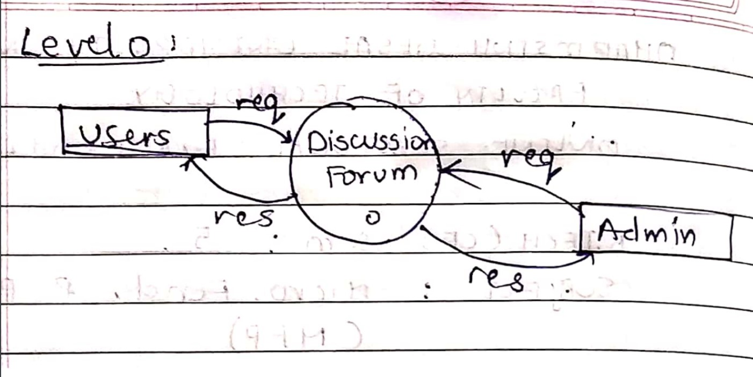

Level-1:

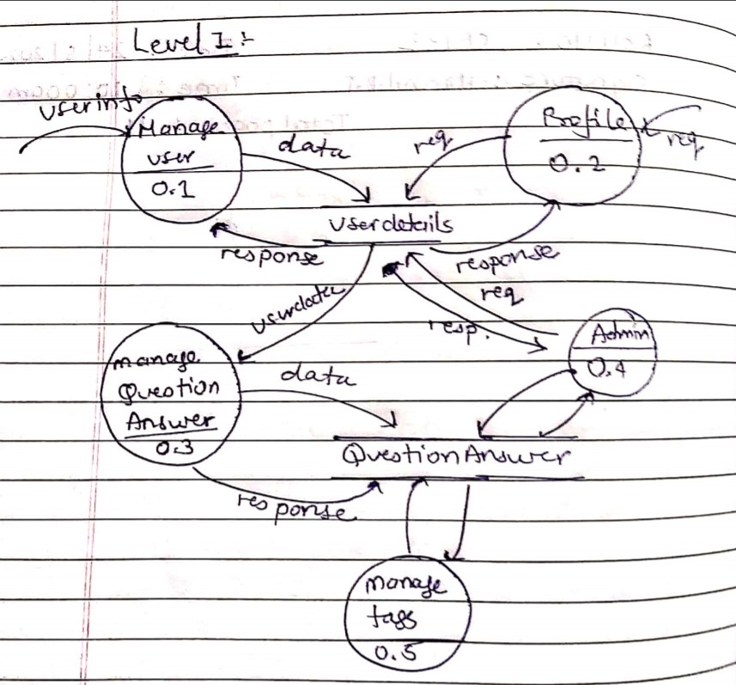

Level-2:

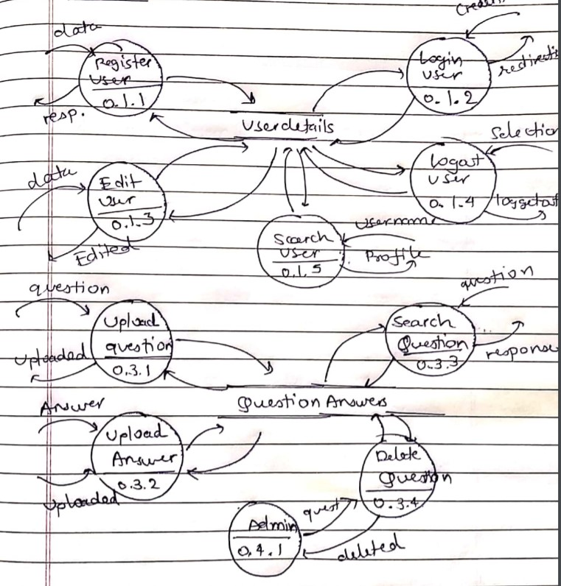

C:\Users\Harshit\AppData\Local\Microsoft\Windows\Clipboard\HistoryData\{9B6974ED-B951-4540-989A-DE09858FAD7A}\{9BB63DE3-3458-4E1D-A1CD-F6DD7550F555}\ResourceMap\{366CA3D9-3C4C-40D3-BBBA-03E88040FB91}

ER diagram

C:\Users\Harshit\AppData\Local\Microsoft\Windows\Clipboard\HistoryData\{9B6974ED-B951-4540-989A-DE09858FAD7A}\{9BB63DE3-3458-4E1D-A1CD-F6DD7550F555}\ResourceMap\{366CA3D9-3C4C-40D3-BBBA-03E88040FB91}

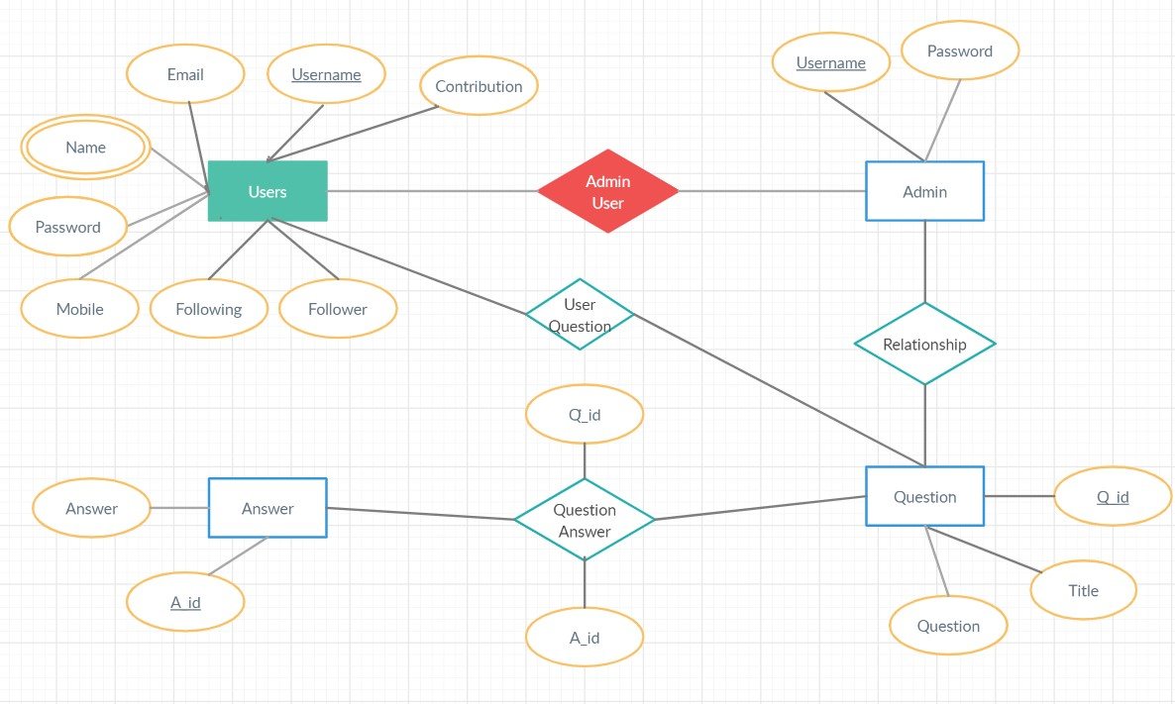

C:\Users\Harshit\AppData\Local\Microsoft\Windows\Clipboard\HistoryData\{9B6974ED-B951-4540-989A-DE09858FAD7A}\{9BB63DE3-3458-4E1D-A1CD-F6DD7550F555}\ResourceMap\{366CA3D9-3C4C-40D3-BBBA-03E88040FB91}

Implementation DetailsC:\Users\Harshit\AppData\Local\Microsoft\Windows\Clipboard\HistoryData\{9B6974ED-B951-4540-989A-DE09858FAD7A}\{9BB63DE3-3458-4E1D-A1CD-F6DD7550F555}\ResourceMap\{366CA3D9-3C4C-40D3-BBBA-03E88040FB91}

Module Description :

* Home Content module

This module gives the home page of the website which includes all the questions and answers provided by the users. This module does not require any login authentication

It contains buttons for login , signup , add question , answer etc.

Input : User Selection

Output : Home Page

* Login Module

This module takes credentials from user and verifies the user against the database , the credentials are correct then user is redirected to Home Content module.

If user forgot the password , module includes facility of changing password by just entering the username and the otp sent to the user’s registered email id, and on verification user can change the password.

Input : User Credentials

Output : Logging in user

* Registration Module

This module is used for the user to be registered and get extra benefits than unregistered user. It includes taking of various user data through form and validating it. On Successful registration user is sent a verification mail on registered email id.

Input : Users Information

Output : Corresponding Response

* Profile Module

This module is to maintain the user’s profile like updating user details like first name , last name, password . User can follow/unfollow the other user from this module . This module requires to user to be authenticated by login.

* Question Answer Module

This module is the core part of Discussion Forum which is used to add questions and the answers to corresponding questions. User can also see the questions of users who is followed by the logged in user. This module requires user to be authenticated by logging in.

Input : Users Selection

Output : Corresponding Response

C:\Users\Harshit\AppData\Local\Microsoft\Windows\Clipboard\HistoryData\{9B6974ED-B951-4540-989A-DE09858FAD7A}\{9BB63DE3-3458-4E1D-A1CD-F6DD7550F555}\ResourceMap\{366CA3D9-3C4C-40D3-BBBA-03E88040FB91}

ScreenshotsC:\Users\Harshit\AppData\Local\Microsoft\Windows\Clipboard\HistoryData\{9B6974ED-B951-4540-989A-DE09858FAD7A}\{9BB63DE3-3458-4E1D-A1CD-F6DD7550F555}\ResourceMap\{366CA3D9-3C4C-40D3-BBBA-03E88040FB91}

Registration :

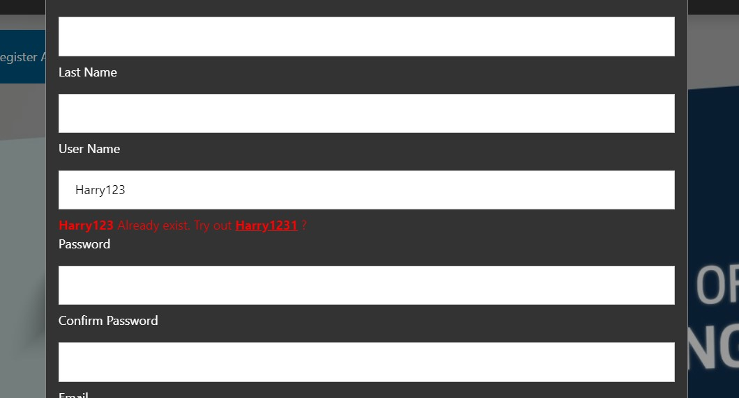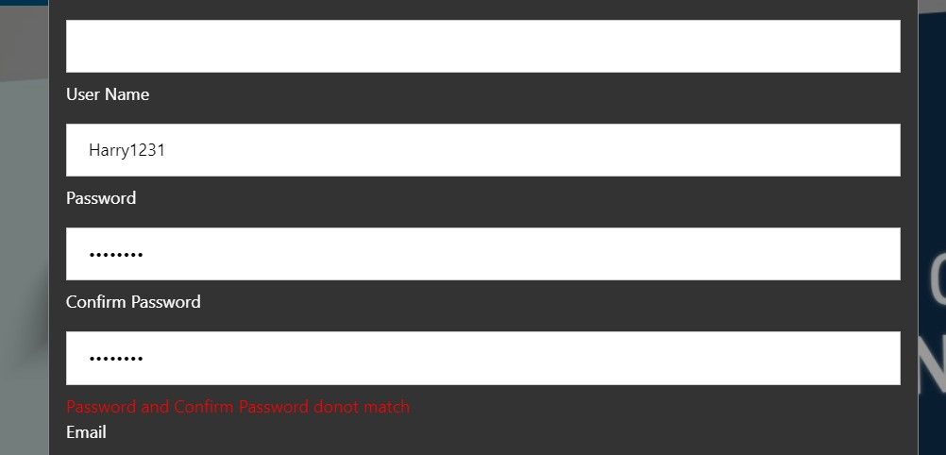

Home Page :

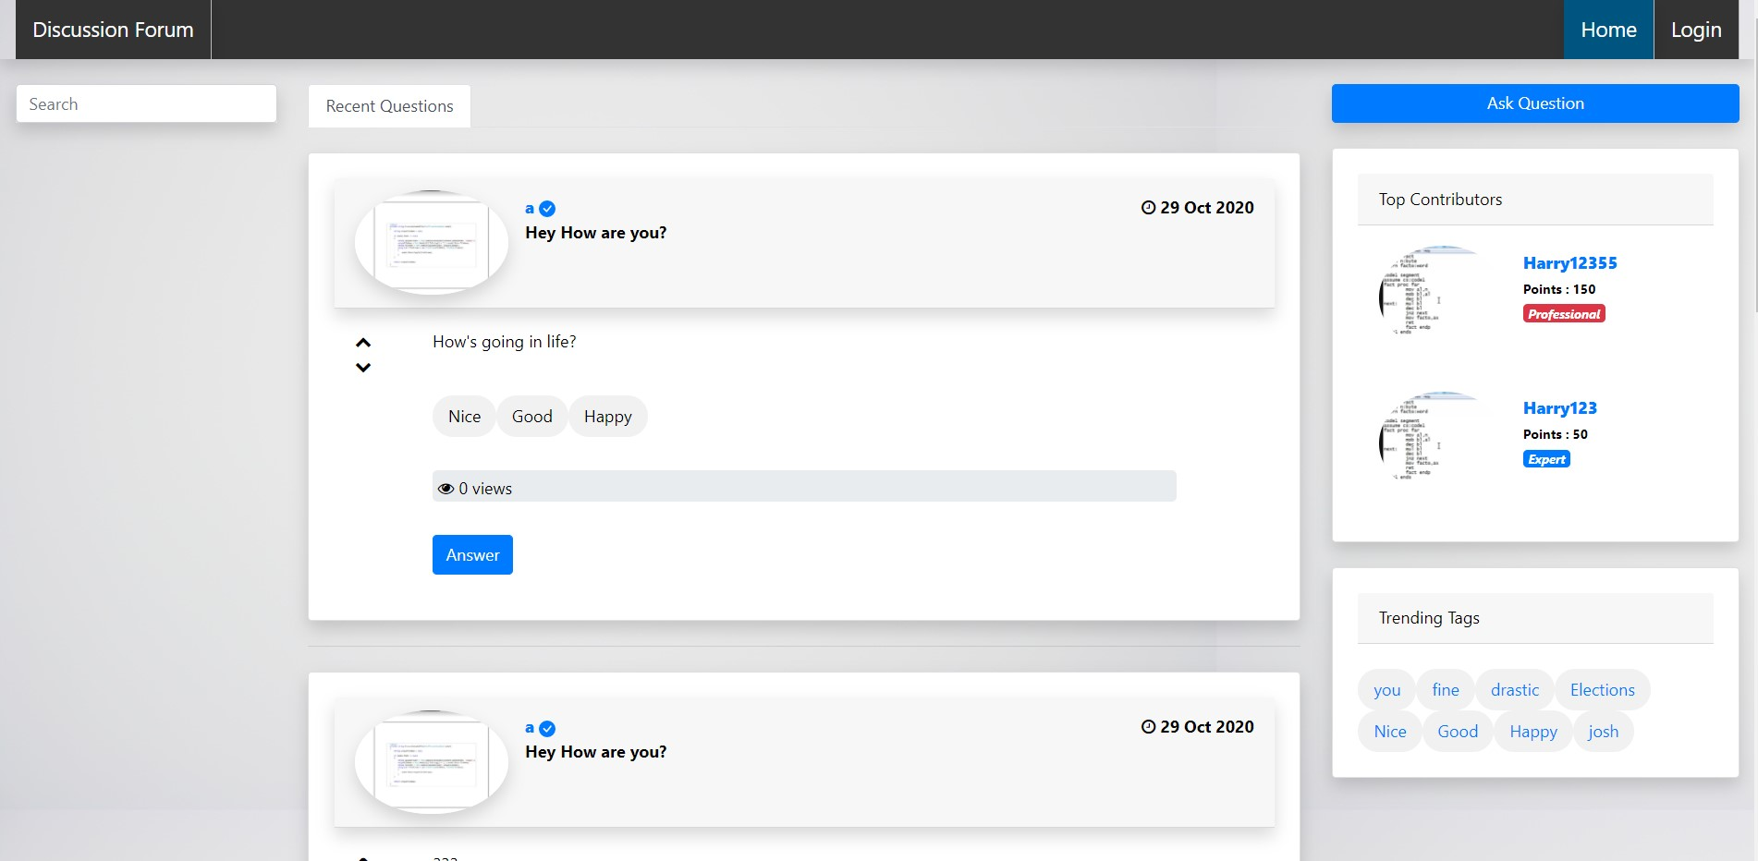

Profile Page :

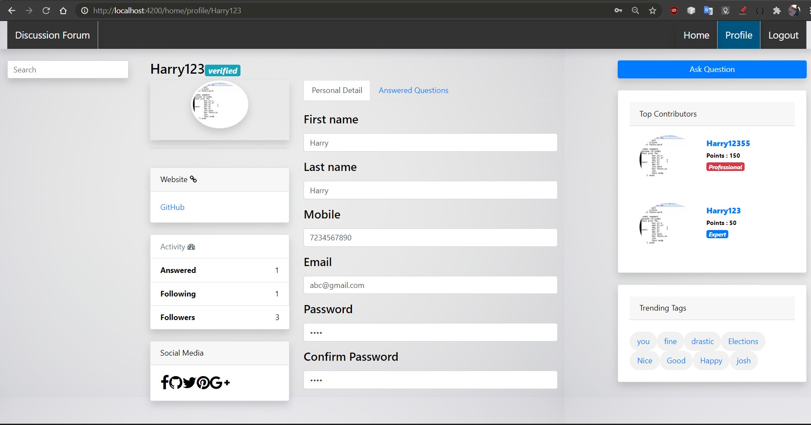

Home page for Admin :

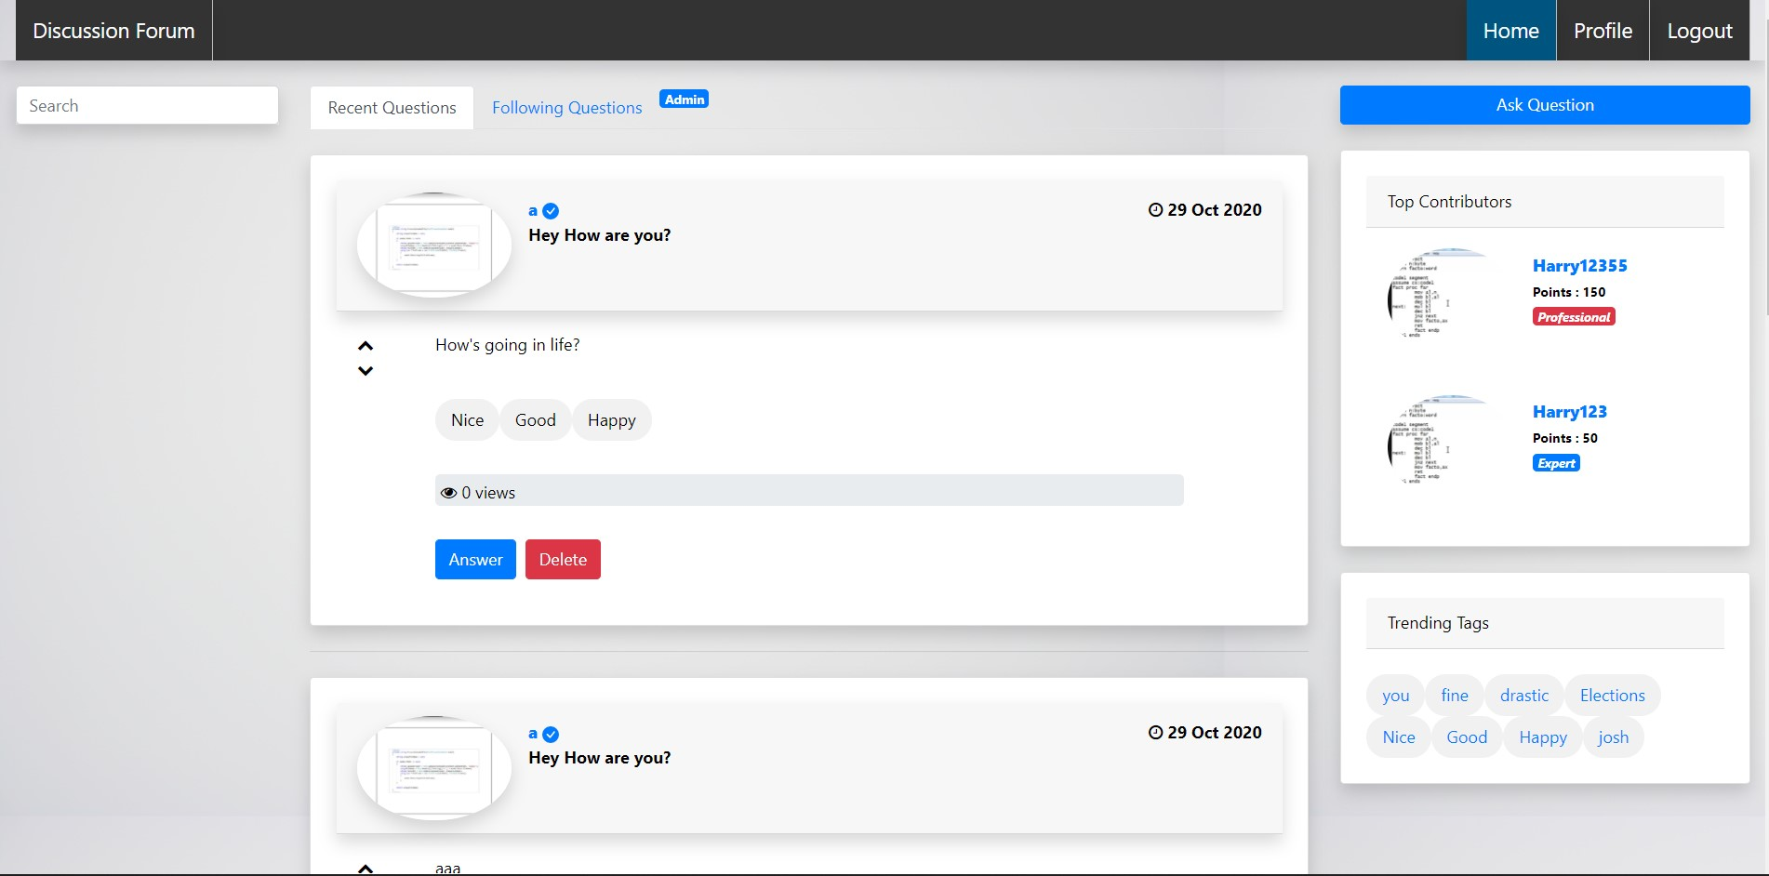

C:\Users\Harshit\AppData\Local\Microsoft\Windows\Clipboard\HistoryData\{9B6974ED-B951-4540-989A-DE09858FAD7A}\{9BB63DE3-3458-4E1D-A1CD-F6DD7550F555}\ResourceMap\{366CA3D9-3C4C-40D3-BBBA-03E88040FB91}

ConclusionC:\Users\Harshit\AppData\Local\Microsoft\Windows\Clipboard\HistoryData\{9B6974ED-B951-4540-989A-DE09858FAD7A}\{9BB63DE3-3458-4E1D-A1CD-F6DD7550F555}\ResourceMap\{366CA3D9-3C4C-40D3-BBBA-03E88040FB91}

The development of system was done after understanding the modules and their requirements.

Functionalities that are successfully implemented are:

* User Registration
* User Login
* User Page Authentication
* Upload Profile Photo
* Upload Question
* Upload Answer
* Change Password with Email verification
* Email verification after Registration
* Following specific Question Answer
* Profile specific Answers
* Search User’s profile with auto completion
* Lazy loading of posts rather than loading all in one time

C:\Users\Harshit\AppData\Local\Microsoft\Windows\Clipboard\HistoryData\{9B6974ED-B951-4540-989A-DE09858FAD7A}\{9BB63DE3-3458-4E1D-A1CD-F6DD7550F555}\ResourceMap\{366CA3D9-3C4C-40D3-BBBA-03E88040FB91}

Limitations and Future ExtensionsC:\Users\Harshit\AppData\Local\Microsoft\Windows\Clipboard\HistoryData\{9B6974ED-B951-4540-989A-DE09858FAD7A}\{9BB63DE3-3458-4E1D-A1CD-F6DD7550F555}\ResourceMap\{366CA3D9-3C4C-40D3-BBBA-03E88040FB91}

Limitations:

* Answer cannot be edited by user
* Question cannot be edited by user
* Once profile photo uploaded cannot be changed

Functionalities not implemented:

* Up-vote of Post
* Down-vote of Post
* Admin User Registration

Future Extensions:

* Admin Registration by strong validations
* Question/Answer can be edited
* Comments on Answers
* Change of Profile Photo
* Up-vote/Down-vote post
* Search based on Questions
* Admin can block user
* Private Message functionalities between the users
* Advertisement section for the Admin user and

Suggest interest based Question/Answers

C:\Users\Harshit\AppData\Local\Microsoft\Windows\Clipboard\HistoryData\{9B6974ED-B951-4540-989A-DE09858FAD7A}\{9BB63DE3-3458-4E1D-A1CD-F6DD7550F555}\ResourceMap\{366CA3D9-3C4C-40D3-BBBA-03E88040FB91}

BibliographyC:\Users\Harshit\AppData\Local\Microsoft\Windows\Clipboard\HistoryData\{9B6974ED-B951-4540-989A-DE09858FAD7A}\{9BB63DE3-3458-4E1D-A1CD-F6DD7550F555}\ResourceMap\{366CA3D9-3C4C-40D3-BBBA-03E88040FB91}

* <https://www.w3schools.com> – Html, CSS, Bootstrap, JavaScript
* <https://angular.io> – Angular
* <https://stackoverflow.com> – For solving problem
* <https://nodejs.org/en/> - For NodeJs setup