MANAV RACHNA INTERNATIONAL INSTITUTE OF RESEARCH AND STUDIES (MRIIRS)
School of Computer Application
Subject :- OBJECT ORIENTED PROGRAMMING USING JAVA (4.5CA201C01H)

Practical File
Harsit Thapa
25/SCA/BCDS/003

1. Write a program to find the factorial of n Number.
import java.util.Scanner;

public class first {
public static void main(String[] args) {
Scanner sc = new Scanner(System.in);

System.out.print(&quot;Enter a number: &quot;);
int n = sc.nextInt();
long fact = 1;
for (int i = 1; i &lt;= n; i++) {
fact *= i;
}
System.out.println(&quot;Factorial of &quot; + n + &quot; is: &quot; + fact);
}
}
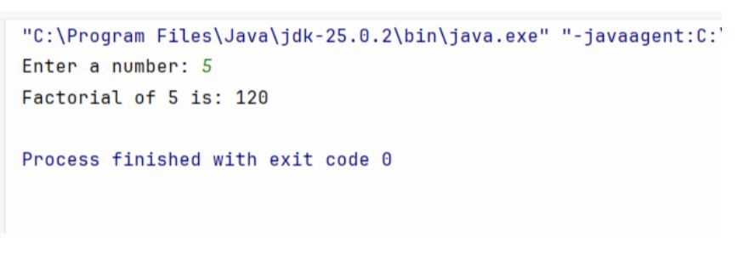
2. Write a program to find the sequence of Fibonacci series up to n
terms.
import java.util.Scanner;

public class first {
public static void main(String[] args) {
Scanner sc = new Scanner(System.in);

System.out.print(&quot;Enter number of terms: &quot;);
int n = sc.nextInt();
int a = 0, b = 1;
System.out.println(&quot;Fibonacci Series:&quot;);
for (int i = 1; i &lt;= n; i++) {
System.out.print(a + &quot; &quot;);
int next = a + b;
a = b;
b = next;
}
}
}
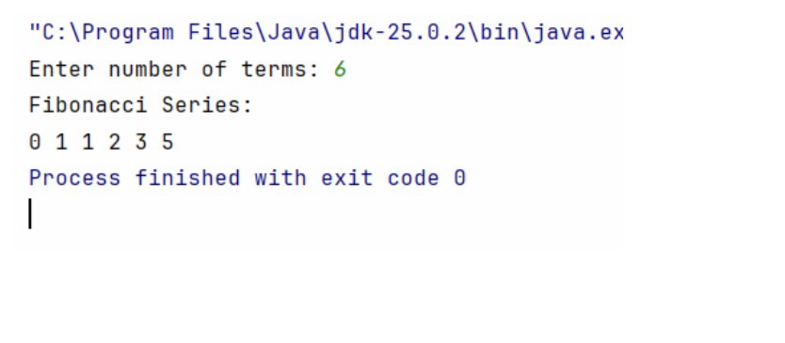
3. Write a program to check whether given number is palindrome or
not.
import java.util.Scanner;

public class first {
public static void main(String[] args) {
Scanner sc = new Scanner(System.in);

System.out.print(&quot;Enter a number: &quot;);
int num = sc.nextInt();

int original = num;
int reverse = 0;

while (num != 0) {
int digit = num % 10;
reverse = reverse * 10 + digit;
num /= 10;
}
if (original == reverse) {
System.out.println(&quot;Palindrome number&quot;);
} else {
System.out.println(&quot;Not a palindrome&quot;);
}
}
}
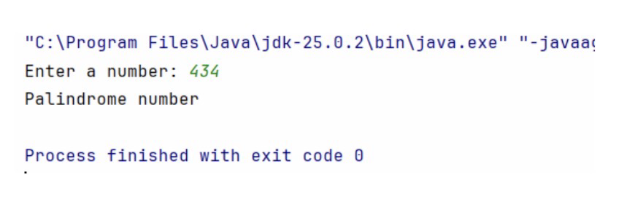
4. Write a program to find HCF of two numbers.
import java.util.Scanner;

public class first {
public static void main(String[] args) {
Scanner sc = new Scanner(System.in);

System.out.print(&quot;Enter first number: &quot;);
int a = sc.nextInt();

System.out.print(&quot;Enter second number: &quot;);
int b = sc.nextInt();
while (b != 0) {
int temp = b;
b = a % b;
a = temp;
}
System.out.println(&quot;HCF is: &quot; + a);
}
}
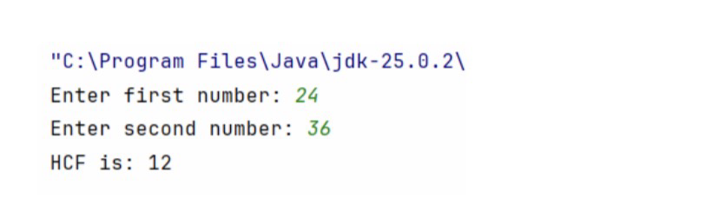

5. Write a Java Program that will display the sum of
1+1/2+1/3…..+1/n.
import java.util.Scanner;

public class first {
public static void main(String[] args) {
Scanner sc = new Scanner(System.in);

System.out.print(&quot;Enter value of n: &quot;);
int n = sc.nextInt();
double sum = 0.0;
for (int i = 1; i &lt;= n; i++) {
sum = sum + (1.0 / i);
}

System.out.println(&quot;Sum of series = &quot; + sum);
}
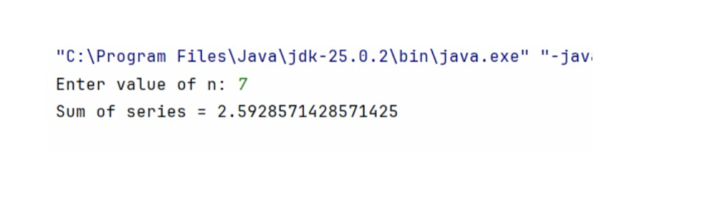
}

6. Write a Java Program to find product of two matrices.
import java.util.Scanner;

public class first {
public static void main(String[] args) {
Scanner sc = new Scanner(System.in);

int r1, c1, r2, c2;

System.out.print(&quot;Enter rows and columns of first matrix: &quot;);
r1 = sc.nextInt();
c1 = sc.nextInt();

System.out.print(&quot;Enter rows and columns of second matrix: &quot;);
r2 = sc.nextInt();
c2 = sc.nextInt();

if (c1 != r2) {
System.out.println(&quot;Matrix multiplication not possible&quot;);
return;
}
int[][] A = new int[r1][c1];
int[][] B = new int[r2][c2];
int[][] C = new int[r1][c2];

System.out.println(&quot;Enter first matrix:&quot;);

for (int i = 0; i &lt; r1; i++) {
for (int j = 0; j &lt; c1; j++) {
A[i][j] = sc.nextInt();
}
}

System.out.println(&quot;Enter second matrix:&quot;);
for (int i = 0; i &lt; r2; i++) {
for (int j = 0; j &lt; c2; j++) {
B[i][j] = sc.nextInt();
}
}
for (int i = 0; i &lt; r1; i++) {
for (int j = 0; j &lt; c2; j++) {
C[i][j] = 0;
for (int k = 0; k &lt; c1; k++) {
C[i][j] += A[i][k] * B[k][j];
}
}
}

System.out.println(&quot;Product Matrix:&quot;);
for (int i = 0; i &lt; r1; i++) {
for (int j = 0; j &lt; c2; j++) {
System.out.print(C[i][j] + &quot; &quot;);
}

System.out.println();
}
}
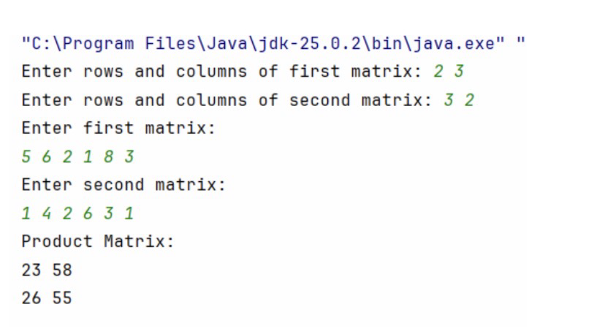
7. Write a Java Program to find sum and subtraction of two matrices.
import java.util.Scanner;

public class first {
public static void main(String[] args) {
Scanner sc = new Scanner(System.in);

int r, c;

System.out.print(&quot;Enter rows and columns: &quot;);
r = sc.nextInt();
c = sc.nextInt();

int[][] A = new int[r][c];
int[][] B = new int[r][c];
int[][] sum = new int[r][c];
int[][] diff = new int[r][c];

System.out.println(&quot;Enter first matrix:&quot;);
for (int i = 0; i &lt; r; i++) {
for (int j = 0; j &lt; c; j++) {
A[i][j] = sc.nextInt();
}
}
System.out.println(&quot;Enter second matrix:&quot;);
for (int i = 0; i &lt; r; i++) {
for (int j = 0; j &lt; c; j++) {
B[i][j] = sc.nextInt();
}
}
for (int i = 0; i &lt; r; i++) {
for (int j = 0; j &lt; c; j++) {
sum[i][j] = A[i][j] + B[i][j];
diff[i][j] = A[i][j] - B[i][j];
}
}
System.out.println(&quot;Sum Matrix:&quot;);
for (int i = 0; i &lt; r; i++) {

for (int j = 0; j &lt; c; j++) {
System.out.print(sum[i][j] + &quot; &quot;);
}
System.out.println();
}
System.out.println(&quot;Subtraction Matrix:&quot;);
for (int i = 0; i &lt; r; i++) {
for (int j = 0; j &lt; c; j++) {
System.out.print(diff[i][j] + &quot; &quot;);
}
System.out.println();
}
}
}
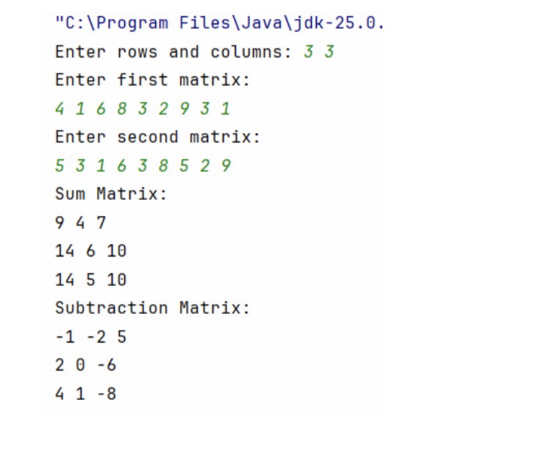
8. Write a Java Program to sort the list in ascending Order.
import java.util.Scanner;

public class first {
public static void main(String[] args) {
Scanner sc = new Scanner(System.in);

System.out.print(&quot;Enter number of elements: &quot;);
int n = sc.nextInt();

int[] arr = new int[n];

System.out.println(&quot;Enter elements:&quot;);
for (int i = 0; i &lt; n; i++) {
arr[i] = sc.nextInt();
}
for (int i = 0; i &lt; n - 1; i++) {
for (int j = 0; j &lt; n - i - 1; j++) {
if (arr[j] &gt; arr[j + 1]) {
int temp = arr[j];
arr[j] = arr[j + 1];
arr[j + 1] = temp;
}
}
}
System.out.println(&quot;Sorted Array:&quot;);

for (int i = 0; i &lt; n; i++) {
System.out.print(arr[i] + &quot; &quot;);
}
}
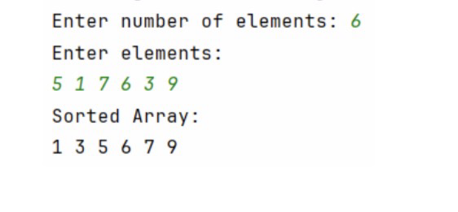
}

9. Write a Java Program to convert decimal into binary number.
import java.util.Scanner;

public class first {
public static void main(String[] args) {
Scanner sc = new Scanner(System.in);

System.out.print(&quot;Enter a decimal number: &quot;);
int num = sc.nextInt();

int[] binary = new int[32]; // array to store binary digits
int i = 0;
while (num &gt; 0) {
binary[i] = num % 2;

num = num / 2;
i++;
}
System.out.print(&quot;Binary number: &quot;);
for (int j = i - 1; j &gt;= 0; j--) {
System.out.print(binary[j]);
}
}
}
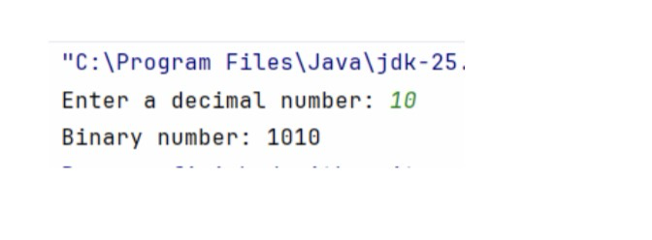

10. Write a Java Program to find largest and smallest of n numbers.
import java.util.Scanner;

public class first {
public static void main(String[] args) {
Scanner sc = new Scanner(System.in);

System.out.print(&quot;Enter number of elements: &quot;);
int n = sc.nextInt();

int num, largest, smallest;

System.out.print(&quot;Enter number 1: &quot;);
num = sc.nextInt();
largest = smallest = num;

for (int i = 2; i &lt;= n; i++) {
System.out.print(&quot;Enter number &quot; + i + &quot;: &quot;);
num = sc.nextInt();
if (num &gt; largest) {
largest = num;
}
if (num &lt; smallest) {
smallest = num;
}
}

System.out.println(&quot;Largest number = &quot; + largest);
System.out.println(&quot;Smallest number = &quot; + smallest);
}
}
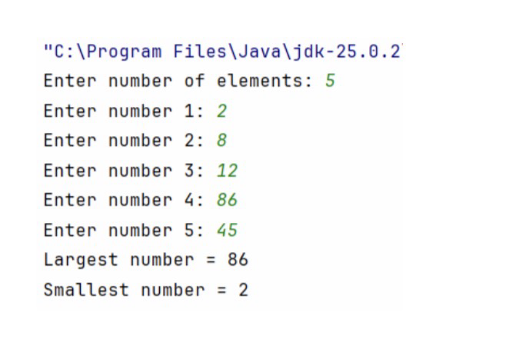
11. Write a Java program that shows the application of constructors.

class Student {
int id;
String name;
Student() {
id = 0;
name = &quot;Unknown&quot;;
}

Student(int i, String n) {
id = i;
name = n;
}
void display() {
System.out.println(&quot;ID: &quot; + id + &quot;, Name: &quot; + name);
}
}

public class first {
public static void main(String[] args) {
Student s1 = new Student(); // default constructor
Student s2 = new Student(101, &quot;Bhuvi&quot;); // parameterized
constructor

s1.display();
s2.display();
}
}

12. Write a Java program to find the electricity bill using inheritance.
import java.util.Scanner;

class Electricity {
int units;
double bill;

void input() {
Scanner sc = new Scanner(System.in);
System.out.print(&quot;Enter units consumed: &quot;);
units = sc.nextInt();

}
}

class Bill extends Electricity {
void calculate() {
if (units &lt;= 100) {
bill = units * 1.5;
} else if (units &lt;= 200) {
bill = 100 * 1.5 + (units - 100) * 2.5;
} else {
bill = 100 * 1.5 + 100 * 2.5 + (units - 200) * 4;
}
}

void display() {
System.out.println(&quot;Total Bill = &quot; + bill);
}
}

public class first {
public static void main(String[] args) {
Bill obj = new Bill();

obj.input();
obj.calculate();
obj.display();

}
}
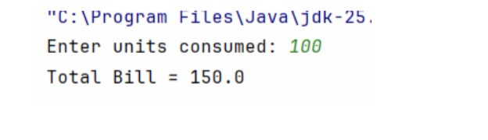

13. Write a program to count the number of objects created for a class
using static member function.
class Counter {
static int count = 0;

Counter() {
count++;
}

static void displayCount() {
System.out.println(&quot;Number of objects created: &quot; + count);
}
}

public class first {
public static void main(String[] args) {
Counter c1 = new Counter();
Counter c2 = new Counter();
Counter c3 = new Counter();

Counter.displayCount();

}
}
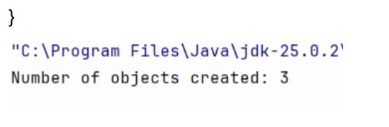

14. Create a class “Account” containing account No, and balance as
an instance variable. Derive the Account class into two classes
named “Savings” and “Current”. The “Savings” class should contain
instance variable named interest Rate, and the “Current” class
should contain instance variable called overdraft Limit. Define
appropriate methods for all the classes to enable functionalities to
check balance, deposit, and withdraw amount in Savings and
Current account.

import java.util.Scanner;

class Account {
int accNo;
double balance;

Account(int accNo, double balance) {
this.accNo = accNo;
this.balance = balance;
}

void deposit(double amount) {
balance += amount;

System.out.println(&quot;Deposited: &quot; + amount);
}

void checkBalance() {
System.out.println(&quot;Account No: &quot; + accNo);
System.out.println(&quot;Balance: &quot; + balance);
}
}
class Savings extends Account {
double interestRate;

Savings(int accNo, double balance, double interestRate) {
super(accNo, balance);
this.interestRate = interestRate;
}
void addInterest() {
double interest = balance * interestRate / 100;
balance += interest;
System.out.println(&quot;Interest added: &quot; + interest);
}

void withdraw(double amount) {
if (amount &lt;= balance) {
balance -= amount;
System.out.println(&quot;Withdrawn: &quot; + amount);
} else {

System.out.println(&quot;Insufficient balance&quot;);
}
}
}

class Current extends Account {
double overdraftLimit;

Current(int accNo, double balance, double overdraftLimit) {
super(accNo, balance);
this.overdraftLimit = overdraftLimit;
}

void withdraw(double amount) {
if (amount &lt;= balance + overdraftLimit) {
balance -= amount;
System.out.println(&quot;Withdrawn: &quot; + amount);
} else {
System.out.println(&quot;Overdraft limit exceeded&quot;);
}
}
}
public class BankDemo {
public static void main(String[] args) {
Savings s = new Savings(101, 5000, 5);
Current c = new Current(102, 3000, 2000);

System.out.println(&quot;Savings Account:&quot;);
s.deposit(1000);
s.withdraw(2000);
s.addInterest();
s.checkBalance();

System.out.println(&quot;\nCurrent Account:&quot;);
c.deposit(2000);
c.withdraw(4000);
c.checkBalance();
}
}
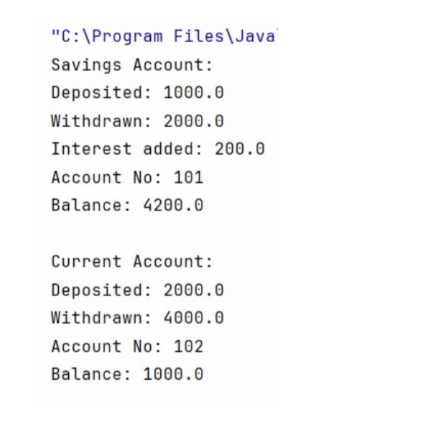

15. Write a program to demonstratethe use of ‘this’ and ‘static’
keyword.

class Demo {
int id;
String name;

static String college = &quot;ABC College&quot;;

Demo(int id, String name) {
this.id = id;
this.name = name;
}
static void changeCollege() {
college = &quot;XYZ College&quot;;
}

void display() {
System.out.println(id + &quot; &quot; + name + &quot; &quot; + college);
}
}

public class first {
public static void main(String[] args) {
Demo.changeCollege(); // static method call

Demo d1 = new Demo(1, &quot;Aman&quot;);
Demo d2 = new Demo(2, &quot;Bhuvi&quot;);

d1.display();
d2.display();
}
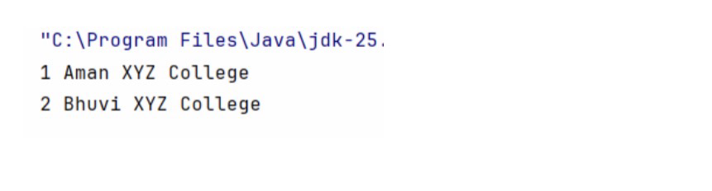
}

16. Describe abstract class called Shape which has three subclasses
say Triangle, Rectangle, and Circle. Define one method area () in
the abstract class and override this area () in these three
subclasses to calculate for specific object i.e. area () of Triangle
subclass should calculate area of triangle etc.
Same for Rectangle and Circle.

abstract class Shape {
abstract double area();
}
class Triangle extends Shape {
double base, height;
Triangle(double base, double height) {
this.base = base;
this.height = height;
}
double area() {

return 0.5 * base * height;
}
}
class Rectangle extends Shape {
double length, width;
Rectangle(double length, double width) {
this.length = length;
this.width = width;
}
double area() {
return length * width;
}
}
class Circle extends Shape {
double radius;
Circle(double radius) {
this.radius = radius;
}
double area() {
return Math.PI * radius * radius;
}
}
public class first {
public static void main(String[] args) {
Shape t = new Triangle(10, 5);
Shape r = new Rectangle(4, 6);
Shape c = new Circle(3);
System.out.println(&quot;Triangle Area: &quot; + t.area());
System.out.println(&quot;Rectangle Area: &quot; + r.area());
System.out.println(&quot;Circle Area: &quot; + c.area());

}
}
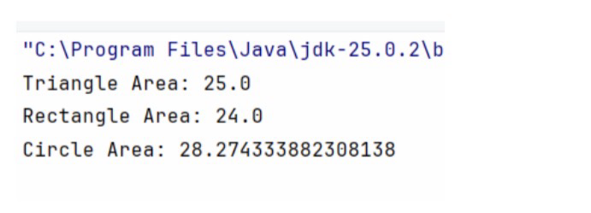

17. Write a java program to find the result sheet of a student using
Interfaces.

interface Marks {
void getMarks();
void displayResult();
}
class Student implements Marks {
int m1, m2, m3, total;
double avg;

public void getMarks() {
m1 = 80;
m2 = 75;
m3 = 85;
}
public void displayResult() {
total = m1 + m2 + m3;
avg = total / 3.0;

System.out.println(&quot;Marks: &quot; + m1 + &quot;, &quot; + m2 + &quot;, &quot; + m3);
System.out.println(&quot;Total: &quot; + total);
System.out.println(&quot;Average: &quot; + avg);
}
}
public class first {
public static void main(String[] args) {
Student s = new Student();
s.getMarks();
s.displayResult();
}
}
}
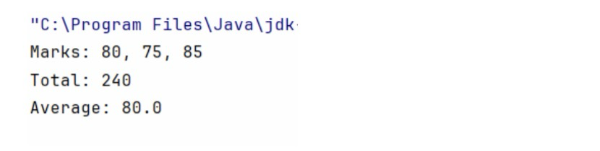
18. Write a java program which shows importing of classes from other
packages.

File1: Hello.java
package mypack;

public class Hello {
public void display() {

System.out.println(&quot;Hello from another package!&quot;);
}
}

File2: Main.java
import mypack.Hello;

public class Main {
public static void main(String[] args) {
Hello obj = new Hello();
obj.display();
}
}
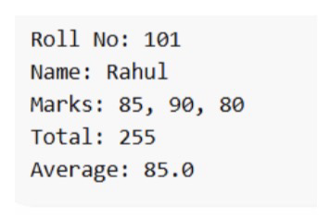

19. Assume that there are two packages, student and exam. A student
package contains Student class and the exam package contains
Result class. Write a program that generates mark sheet for
students.

File1: Student.java

package student;
public class Student {
protected int roll;
protected String name;

public Student(int roll, String name) {
this.roll = roll;
this.name = name;
}
public void displayStudent() {
System.out.println(&quot;Roll No: &quot; + roll);
System.out.println(&quot;Name: &quot; + name);
}
}

File2: Result.java

package exam;
import student.Student;

public class Result extends Student {
int m1, m2, m3, total;
double avg;

public Result(int roll, String name, int m1, int m2, int m3) {
super(roll, name);
this.m1 = m1;
this.m2 = m2;
this.m3 = m3;
}

public void calculate() {
total = m1 + m2 + m3;
avg = total / 3.0;
}
public void displayResult() {
displayStudent();
System.out.println(&quot;Marks: &quot; + m1 + &quot;, &quot; + m2 + &quot;, &quot; + m3);
System.out.println(&quot;Total: &quot; + total);
System.out.println(&quot;Average: &quot; + avg);
}

public static void main(String[] args) {
Result r = new Result(101, &quot;Rahul&quot;, 85, 90, 80);
r.calculate();
r.displayResult();
}
}
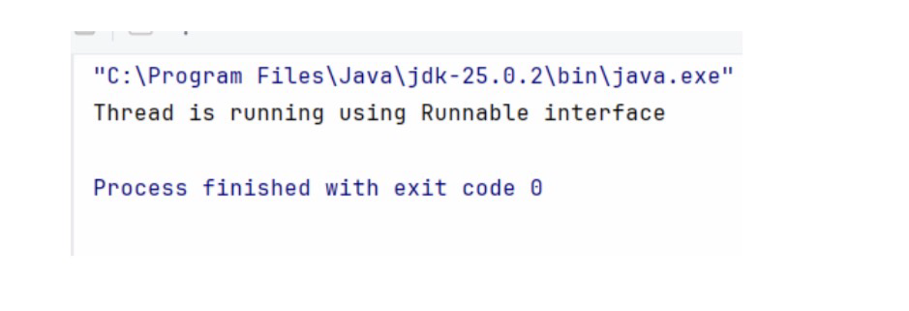

20. Write a program to implement the concept of threading by
implementing “Runnable” Interface.

class MyRunnable implements Runnable {

public void run() {
System.out.println(&quot;Thread is running using Runnable interface&quot;);
}
}

public class first {
public static void main(String[] args) {
MyRunnable obj = new MyRunnable();
Thread t = new Thread(obj);
t.start();
}
}
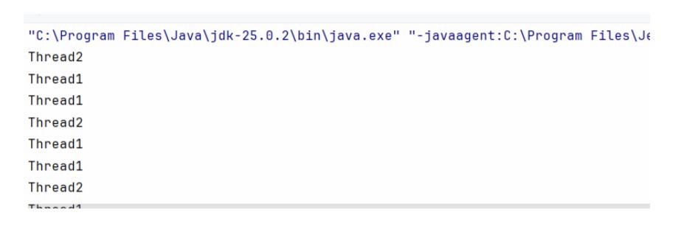

21. Write a program that executes two threads. One thread displays
“Thread1” every 2,000 milliseconds, and the other displays
“Thread2” every 4,000 milliseconds.

class Thread1 implements Runnable {
public void run() {
while (true) {

System.out.println(&quot;Thread1&quot;);
try {
Thread.sleep(2000);
} catch (InterruptedException e) {
System.out.println(e);
}
}
}
}

class Thread2 implements Runnable {
public void run() {
while (true) {
System.out.println(&quot;Thread2&quot;);
try {
Thread.sleep(4000);
} catch (InterruptedException e) {
System.out.println(e);
}
}
}
}

public class first {
public static void main(String[] args) {
Thread t1 = new Thread(new Thread1());

Thread t2 = new Thread(new Thread2());

t1.start();
t2.start();
}
}
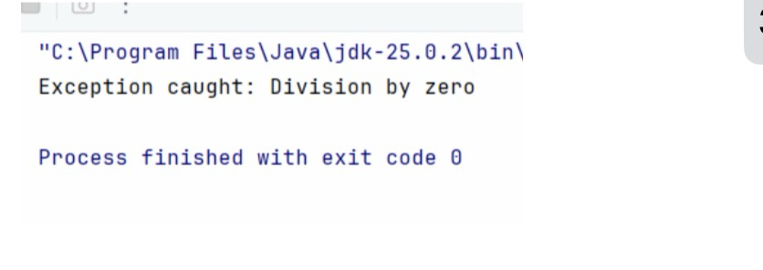

22. Write a java program which use try and catch for exception
handling.

public class first {
public static void main(String[] args) {
try {
int a = 10, b = 0;
int result = a / b;
System.out.println(result);
} catch (ArithmeticException e) {
System.out.println(&quot;Exception caught: Division by zero&quot;);
}
}
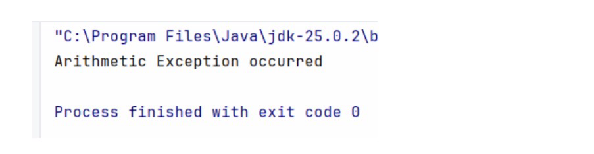
23. Write a java program which use multiple catch blocks.

public class first {
public static void main(String[] args) {
try {
int arr[] = new int[5];
arr[10] = 50 / 0;
} catch (ArithmeticException e) {
System.out.println(&quot;Arithmetic Exception occurred&quot;);
} catch (ArrayIndexOutOfBoundsException e) {
System.out.println(&quot;Array Index Out of Bounds Exception
occurred&quot;);
} catch (Exception e) {
System.out.println(&quot;General Exception occurred&quot;);
}
}
}
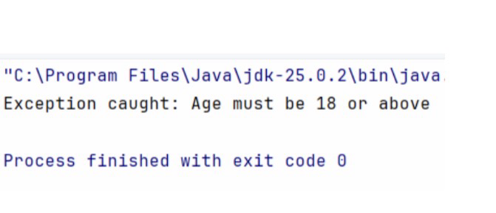

24. Write a java program which shows throwing our own exception.

class MyException extends Exception {
public MyException(String message) {
super(message);
}
}

public class first {
static void checkAge(int age) throws MyException {
if (age &lt; 18) {
throw new MyException(&quot;Age must be 18 or above&quot;);
} else {
System.out.println(&quot;Valid age&quot;);
}
}

public static void main(String[] args) {
try {
checkAge(16);
} catch (MyException e) {

System.out.println(&quot;Exception caught: &quot; + e.getMessage());
}
}
}
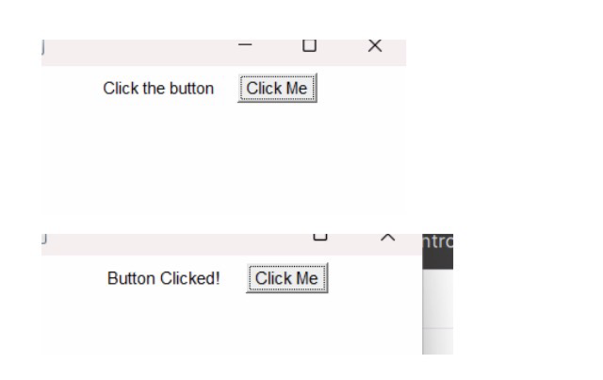

25. Write a program to handle Labels and Buttons using AWT
Controls.

import java.awt.*;
import java.awt.event.*;
public class first extends Frame implements ActionListener {
Label l;
Button b;
first() {
setLayout(new FlowLayout());
l = new Label(&quot;Click the button&quot;);
b = new Button(&quot;Click Me&quot;);
add(l);
add(b);
b.addActionListener(this);
setSize(300, 200);

setVisible(true);
}
public void actionPerformed(ActionEvent e) {
l.setText(&quot;Button Clicked!&quot;);
}
public static void main(String[] args) {
new first();
}
}
}
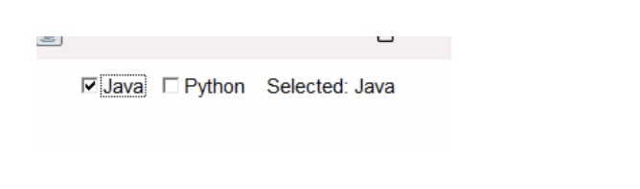
26. Write a program to handle Check Boxes using AWT Controls.
import java.awt.*;
import java.awt.event.*;

public class first extends Frame implements ItemListener {
Checkbox c1, c2;
Label l;

first () {

setLayout(new FlowLayout());

c1 = new Checkbox(&quot;Java&quot;);
c2 = new Checkbox(&quot;Python&quot;);
l = new Label(&quot;Select a language&quot;);

add(c1);
add(c2);
add(l);

c1.addItemListener(this);
c2.addItemListener(this);

setSize(300, 200);
setVisible(true);
}

public void itemStateChanged(ItemEvent e) {
String msg = &quot;&quot;;
if (c1.getState()) msg += &quot;Java &quot;;
if (c2.getState()) msg += &quot;Python &quot;;

l.setText(&quot;Selected: &quot; + msg);
}

public static void main(String[] args) {

new first ();
}
}

27. Write a program to handle Lists and Scroll Bars using AWT
Controls.

import java.awt.*;
import java.awt.event.*;

public class first extends Frame implements AdjustmentListener {
List list;
Scrollbar sb;
Label l;

first () {
setLayout(new FlowLayout());

list = new List(4, true);
list.add(&quot;C&quot;);
list.add(&quot;C++&quot;);
list.add(&quot;Java&quot;);
list.add(&quot;Python&quot;);

sb = new Scrollbar(Scrollbar.HORIZONTAL, 0, 10, 0, 100);
l = new Label(&quot;Scrollbar Value: 0&quot;);

add(list);
add(sb);
add(l);

sb.addAdjustmentListener(this);

setSize(300, 250);
setVisible(true);
}

public void adjustmentValueChanged(AdjustmentEvent e) {
l.setText(&quot;Scrollbar Value: &quot; + sb.getValue());
}

public static void main(String[] args) {
new first ();
}
}
