1. Suppose you have three concave mirrors A, B and C of focal lengths 10 cm, 15cm and 20 cm. For each concave mirror you perform the experiment of image formation for three values of object distances of 10 cm, 20 cm and 30 cm. Giving reason answer the following:
2. For the three object distances, identify the mirror/mirrors which will form an image of magnification – 1.
3. Out of the three mirrors identify the mirror which would be preferred to be used for shaving purposes/make-up.
4. For the mirror B draw ray diagram for image formation for object distances 10 cm and 20 cm.
5. A real, inverted and same size image as that of the object formed by the concave mirror will form an image of magnification of – 1. It is possible only when the object is placed at $C(R=2f)$. Hence for the object distances of 200 cm and 30 cm, the concave mirrors ‘A’ and ‘B’ will form the real, inverted and same size image as that of the object. Therefore, the concave mirrors ‘A’ and ‘B’ will form an image of magnification – 1.
6. The concave mirror ‘C’ of focal length 20 cm will be preferred to be used for shaving purposes/make-up. This is because when we bring our face within its focal length, it forms a virtual, erect and enlarged image of our face.
7. Ray diagram for image formation by mirror B
8. For object distance 10 cm

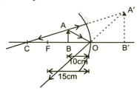

1. For object distances 20 cm

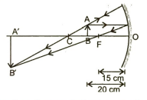

1. A student has focused the image of a candle flame on a white screen using a concave mirror. The situation is as given below:

Length of the flame = 1.5 cm

Focal length of the mirror = 12 cm

Distance of flame from the mirror = 18 cm

If the flame is perpendicular to the principal axis of the mirror, then calculate the following:

1. Distance of the image from the mirror
2. Length of the image.

If the distance between the mirror and the flame is reduced to 10 cm, then what would be observed on the screen? Draw ray diagram to justify your answer for this situation.

**Ans** Given: $h_{o}=+1.5 cm, f=-12 cm, u=-18 cm$

1. For a concave mirror, using mirror formula

$\frac{1}{f}=\frac{1}{v}+\frac{1}{u}$, we get

$\frac{1}{v}=\frac{1}{f}-\frac{1}{u}$

$=\frac{1}{-12}-\frac{1}{-18}$

$=-\frac{1}{12}+\frac{1}{18}=\frac{-3+2}{36}$

Or $\frac{1}{v}=-\frac{1}{36}$

Or $v=-36 cm$

So, the distance of the image from the mirror is 36 cm, the negative sign indicates that the image is formed on the same side of the object.

1. Using the formula $m=\frac{h_{i}}{h_{o}}=-\frac{v}{u}$

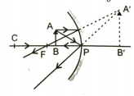

Or $h_{i}=-\frac{v}{u}×h_{o}$

$=\frac{-36}{-18}×1.5=-3.0 cm$

So, the length of the image if 3.0 cm

If the distance between the mirror and the flame is reduced to 10 cm, no image is formed on the screen as the object lies between the focus and the pole of the mirror. So, a virtual image behind the mirror is obtained as shown in the adjoining figure.

1. State the laws of refraction of light. Explain term absolute refractive index of a medium and write an expression to relate it with the speed of light in vacuum.
2. The absolute refractive indices of two media ‘A’ and ‘B’ are 2.0 and 1.5 respectively. If the speed of light in medium ‘B’ is $2×{10}^{8}$ m/s, calculate the speed of light in:
3. Vacuum
4. Medium ‘A’.

**Ans**

1. Laws of refraction of light

********

1. Given: $n_{A}=2.0, n_{B}=1.5$

From the above relation,

$n_{B}=\frac{C}{v_{B}},$

Where c = speed of light in vacuum.

And $v_{B}=$ speed of light in medium

‘B’ $=2×{10}^{8}$ m/s

$∴1.5=\frac{c}{2×{10}^{8}}$

Or $c=1.5×2×{10}^{8}=3×{10}^{8} ms^{-1}$

So, the speed of light in vacuum is $3×{10}^{8} ms^{-1}$.

1. Again, $n_{A}=\frac{C}{v_{A}},$ where $n_{A}=$ absolute refractive index of medium A

$v_{A}=$ Speed of light in medium A.

$∴ 2.0=\frac{3×{10}^{8}}{ v_{A}}$

Or $v_{A}=\frac{3×{10}^{8}}{ 2.0}=1.5×{10}^{8} ms^{-1}$.

So, the speed of light in medium ‘A’ is $1.5×{10}^{8} ms^{-1}$.

2. Draw a ray diagram to show the formation of image by a convex lens when an object is placed in front of the lens between its optical centre and principal focus.
3. In the above ray diagram mark the object distance (u) and the image-distance (v) with their proper signs (+ve or –ve as per the new Cartesian sign convention) and state how these distances are related to the focal length (f) of the convex lens in this case.
4. Find the power of a convex lens which forms a real, and inverted image of magnification – 1 of an object placed at a distance of 20 cm from its optical centre.

**Ans**

1. The formation of image by a convex lens when an object is placed in front of the lens between its optical centre and principal focus.

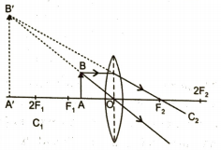

1. According to the new Cartesian sign convention, the object distance ‘u’ and the image distance ‘v’ both are negative as they are measured opposite to the direction of incident ray.

The object distance (u), image-distance (v) and the focal length of a convex lens is in the above case are related as given below.

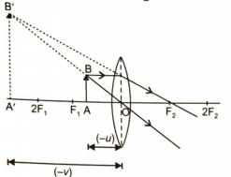

$\frac{1}{f}=\frac{1}{v}-\frac{1}{u}$

1. Given: $u=-20 cm, v=?, m=-1$

For a spherical lens, linear magnification is given by

$m=\frac{v}{u}$

$⟹$ $-1=\frac{v}{-20}$

$⟹$ $v=+20 cm$

Therefore, the power of the given convex lens is calculated as:

$P=\frac{1}{f(m)}=\frac{100 cm}{10 cm}$

$=+10$

$⇒$ $P=+10$ D

1. “A convex lens can form a magnified erect as well as inverted image of an object placed in front of it”. Draw ray diagram to justify this statement stating the position of the object with respect to the lens in each case.
2. An object of height 4 cm is placed at a distance of 20 cm from a concave lens of focal length 10 cm. use lens formula to determine the position of the image formed.

**Ans** A convex lens of focal length ‘f’ can be form

1. A magnified and erect image only when the object is placed between its focus ‘F’ and optical centre ‘O’ of the lens.

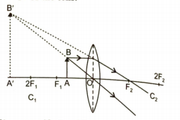

1. A magnified and inverted image when an object is placed in the following positions:
2. Between F1 and 2F1

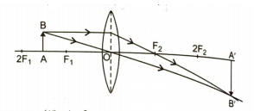

1. At focus ‘F1’.

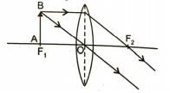

Therefore, for the given positions of the object with respect to convex lens, the given statement is justified.

**For concave lens**

Given: $h_{o}=+4 cm, u=-20 cm, f=-10 cm, v=?$

Using lens formula,

$\frac{1}{f}=\frac{1}{v}-\frac{1}{u}$

Or $\frac{1}{v}=\frac{1}{f}+\frac{1}{u}$

$=\frac{1}{-10}+\frac{1}{-20}=-\frac{1}{10}-\frac{1}{20}$

$=\frac{-2-1}{20}=-\frac{3}{20}$

Or $v=-\frac{20}{3}=-6.67 cm$

So, the image is formed on the same side of the object at 6.67 cm from the optical centre of a concave lens.

1. At what distance from a concave lens of focal length 20 cm, a 6 cm tall object be placed so as to obtain its image at 15 cm from the lens? Also calculate the size of the image formed. Draw a ray diagram to justify your answer for the above situation and label it.

**Ans** Given: $f=-20 cm, h_{o}=6 cm, v=-15 cm$

Using lens formula,

$\frac{1}{f}=\frac{1}{v}-\frac{1}{u}$

$⇒$ $\frac{1}{u}=\frac{1}{f}-\frac{1}{v}=\frac{1}{-15}+\frac{1}{-20}=-\frac{1}{60}$

$⇒$ $u=-60 cm$

Using the formula, $m=\frac{h_{i}}{h_{o}}=\frac{v}{u}$

$⇒$ $h_{i}=\frac{v}{u}×h_{o}=\frac{-15}{-60}=+1.5$

Therefore, a diminished image is formed and its size is 1.5 cm.

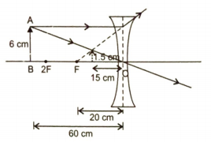

2. Under what condition will a glass lens placed in a transparent liquid become invisible?
3. Describe and illustrate with a diagram, how we should arrange two converging lenses so that a parallel beam of light entering one lens emerges as a parallel beam after passing through the second lens.
4. An object is placed t a distance of 3 cm from a concave lens of focal length 12 cm. Find the
5. Position and
6. Nature of the image formed.

**Ans**

1. When the refractive index of a glass lens becomes equal to the refractive index of a transparent liquid, the glass lens will become invisible.

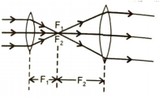

1. A parallel beam converges at focus of the first lens and emerges parallel as it is at the focus of second lens.
2. Given: $f=-12 cm, u=-3 cm$
3. Using mirror formula,

$\frac{1}{f}=\frac{1}{v}-\frac{1}{u}, we get$

$\frac{1}{v}=\frac{1}{f}+\frac{1}{u}$

$=\frac{1}{-12}-\frac{1}{3}=\frac{-1-4}{12}$

$⇒$ $v=-\frac{12}{5} cm$

1. v < 0, so the image is virtual.

|v|< |u|, so the image is diminished.

$∵$ $m=\frac{v}{u}=\frac{\frac{-12}{5}}{-3}=\frac{4}{5}$

Since m > 0 but |m| < 1, so the image is erect and diminished.

2. A concave lens is called a diverging lens. Explain this property with the help of diagram.
3. For a concave mirror draw a ray diagram to show the reflected ray when the ray of light incident obliquely on the pole of mirror.
4. What is the difference between virtual images produced by concave, plane and convex, mirrors?

**Ans**

1. A beam of light from an object is at infinity, parallel to the principal axis, falls on a concave lens. After refraction through it, the light appears to come from a fixed point on the same side of an object as shown, i.e. the concave lens spreads out parallel beam of light. Due to this property, the concave lens is called a diverging lens.

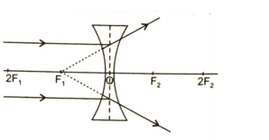



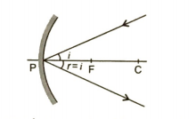

1. Difference between produced by
2. Concave mirror: magnified
3. Plane mirror: same size
4. Convex mirror: diminished
5. What is meant by power of a lens? Define S. I. unit.

You have two lenses A and B of focal lengths +10 cm and – 10 cm respectively. State the nature and power of each lens.

Which of the two lenses will form a virtual and magnified image of an object placed 8 cm from the lens? Draw a ray diagram to justify your answer.

**Ans** Power of Lens: The ability of a lens, to converge or diverge the ray of light after refraction, is called power (P) of the lens. It is defined as the reciprocal of the focal length, i.e. $P=\frac{1}{f}.$

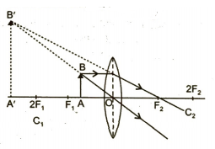

The SI unit of power of lens is ‘dioptre’. A lens of focal length 100 has a power of 1 dioptre, i.e. 1 dioptre = 1m-1

Given:

So the nature of the lens A is convex and lens B is concave.

Power of lens A, $P_{A}=\frac{100}{f_{A}}=\frac{100}{10}=+10 D$

Power of lens B, $P_{B}=\frac{100}{f_{B}}=-\frac{100}{10}=-10 D$

Convex lens will form a virtual and magnified image of an object placed 8 cm from the lens, because the object distance is less than that of the focal length of convex lens.

1. Why does a light ray incident on a rectangular glass slab immersed in any medium emerge parallel to itself? Explain using a diagram.

**Ans** Due to variation in the speed of light in different media, the light ray bends as it moves from one medium to another. Since there are two surfaces for refraction which are parallel, the light ray would bend in opposite sense in them equally, the emerging light ray is always parallel to the incident.

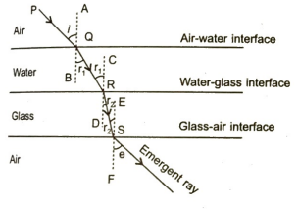

1. Refractive index of diamond with respect to glass is 1.6 and absolute refractive index of glass is 1.5. Find out the absolute refractive index of diamond.

Given: $n_{dg}=1.6. n_{g}=1.5$

Since $n_{dg}=\frac{n_{d}}{n_{g}}$

We have $n_{d}=n_{g}×n_{dg}=1.5×1.6=2.4$

1. Sudha finds out that a sharp image of the windowpane of her science laboratory is formed at a distance of 15 cm from the lens. She now tries to focus the building visible to her outside the window instead of the windowpane without disturbing the lens. In which direction will she move the screen to obtain the sharp image of the building? What is the approximate focal length of this lens?

She will move the screen towards the lens such that the final image is at the focus. The focal length will be slightly less than 15 cm as building can be treated as the object t infinite distance.

1. How are power and focal length of a lens related? You are provided with two lenses of focal length 20 cm and 40 cm respectively. Which lens will you use to obtain more convergent light?

Power of a lens is defined as the reciprocal of the focal length.

$P=\frac{1}{f(in m)}=\frac{100}{f(in cm)}$

$P_{20}=\frac{100}{20}=5 D$

$P_{40}=\frac{100}{40}=2.5 D$

So, the lens of 20 cm focal length will converge more.

1. Large numbers of tin stripes of black paint are made on the surface of a convex lens of focal length 20 cm to catch the image of a white horse. The image will be
2. A zebra of black stripes
3. A horse of black stripes
4. A horse of less brightness
5. A zebra of less brightness
6. You are given water, mustard oil, glycerin and kerosene. In which of these media a ray of light incident obliquely at same angle would bend the most?
7. Kerosene
8. Water
9. Mustard oil
10. Glycerin
11. A convex mirror of focal length ‘f’ produces an image $\frac{1}{m}th$ of the size of object, then the object distance is (m – 1)f numerically. [True/False]
12. Direction: Match column I with Column II.

|  |  |
| --- | --- |
| **Column I** | **Column II** |
| (A) Relative speed | (P) Concave lens |
| (B) Undeviated passage | (Q)Convex lens |
| (C) Divergence of rays | (R)Refractive Index |
| (D) Converging lens | (S)Ray through optical centre |

1. What is the value of 1n2×2n1?
2. The refractive indices of water and glass are 4/3 and 3/2 respectively. Write the relation and find the value of refractive index of water with respect to glass and glass with respect to water.
4. Two lenses have powers of (i) + 2D and (ii) – 4D. What is the nature and focal length of each lens?
5. N object is kept at a distance of 100 cm from each of the above lenses. Calculate the (i) image distance and (ii) magnification in each of the two cases.
7. With the help of ray diagram, state the meaning of refraction of light. State Snell’s law of refraction of light and also express it mathematically.
8. The refractive index of water with respect to vacuum is 4/3 and refractive index of vacuum with respect of glass is 2/3. If the speed of light in glass is $2×{10}^{8} ms^{-1}$, find the speed of light in (i) vacuum, (ii) water.
9. List the sign conventions that are followed in case of refraction of light through spherical lenses. Draw a diagram and apply these conventions in determining the nature and focal length of a spherical lens which forms three times magnified real image of an object placed 16 cm from the lens.
10. Analyze the following observation table showing variation of image distance (v) with object distance (u) in case of a convex lens and answer the questions that follow, without doing any calculations:

|  |  |  |
| --- | --- | --- |
| S. No. | Object distance u (cm) | Image distance v (cm) |
| 1 | $-90$ | $+18$ |
| 2 | $-60$ | $+20$ |
| 3 | $-30$ | $+30$ |
| 4 | $-20$ | $+60$ |
| 5 | $-18$ | $+90$ |
| 6 | $-10$ | $+100$ |

1. What is the focal length of the convex lens? Give reason in support of your answer.
2. Write the serial number of the observation which one is not correct. How did you arrive at this conclusion?
3. Take an appropriate scale to draw ray diagram for the observation at S. No. 4 and find the approximate value of magnification.