**Data Visualization Project on SDG**

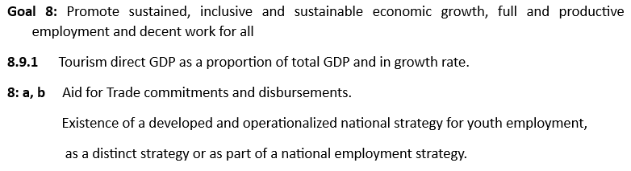

1. **Problem Statement:**

The objective of this analysis is to evaluate progress towards Sustainable Development Goal 8 (SDG 8) by analysing key economic indicators related to tourism, trade aid, and youth employment across various countries and regions. The study will focus on examining how tourism contributes to GDP, the impact of trade aid, and the existence of national strategies for youth employment. The analysis will aim to identify trends, gaps, and opportunities for enhancing economic growth, decent work, and sustainable development.

1. **Introduction**

Sustainable Development Goal (SDG) 8 focuses on **promoting inclusive and sustainable economic growth, employment, and decent work for all**. Critical to achieving this is an examination of key economic indicators, such as GDP growth, unemployment rates, and tourism's role in GDP. Global economic shifts, in particular, have disrupted economies, necessitating an analysis of how tourism, trade aid, and employment strategies play pivotal roles in economic recovery. This report analyses economic indicators across countries and regions to understand how these nations have adapted and rebuilt.

1. **Need for Addressing the Problem Statement**

Global economic disruptions have led to contractions in GDP, particularly in countries that are heavily reliant on **tourism** and international trade. Unemployment rates surged, especially among vulnerable groups like women and youth. Addressing these challenges is essential for designing interventions that promote recovery in sectors such as **tourism**, **youth employment**, and **shared prosperity**. Moreover, understanding the role of **aid for trade** and national employment strategies will offer insights into recovery strategies across different regions.

1. **Objectives**

**Objective 1:** Analyse the impact of the tourism sector on GDP across multiple regions over time.

**Objective 2**: Identify regional clustering patterns based on tourism growth metrics and group similar countries.

**Objective 3**: Forecast the trends in tourism-related economic growth based on past data.

**Objective 4:** Analyse Shared Prosperity Trends (2015-2018) Across Regions.

**Objective 5:** Explore Regional Tourism GDP Contribution in 2021.

**Objective 6:** Analyse the Relationship Between GDP Growth and Unemployment Rate Across Regions

**Objective 7:** Explore Tourism Impact on GDP Across Regions

**Objective 8:** Examine Unemployment Rate Distribution

**Objective 9:** Examine Regional Gap in GDP Losses

**Objective 10:** Assess Tourism's Contribution to GDP Across Various Regions in 2020

**Objective 11:** Analyse the Relationship Between Income Level, Prosperity, and Measured Variables

1. **Visual Analysis:**
2. Box Plot

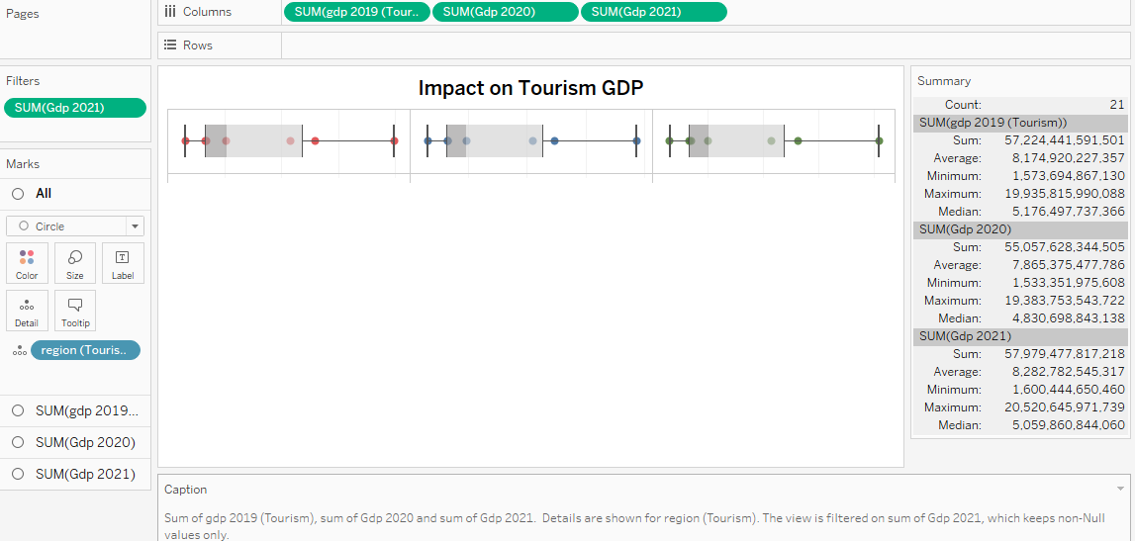

**Interpretation**:

* This visual presents a comparison of the total GDP contributed by the tourism sector in 2019, 2020, and 2021. Each dot represents a region's tourism GDP for a given year, and the statistical summary on the right provides insight into the distribution across regions.
* **Key Observations**:
  + **2019**: The sum of tourism GDP across all regions in 2019 was **57.22 trillion**. The average tourism GDP for regions was **8.17 trillion**, with a minimum value of **1.57 trillion** and a maximum of **19.93 trillion**.
  + **2020**: A decrease is observed in 2020, with the total tourism GDP dropping to **55.05 trillion**, and the average across regions falling to **7.87 trillion**. The minimum value is **1.53 trillion**, and the maximum is **19.38 trillion**.
  + **2021**: There is a recovery in 2021, with the total GDP returning to **57.97 trillion**, and the average rising to **8.28 trillion**.
* **Insight**:
  + This visual indicates a noticeable dip in 2020, likely due to global disruptions in tourism. However, 2021 shows signs of recovery, with tourism GDP across regions returning close to pre-2020 levels. The regions with higher GDP are showing more consistent contributions, while the smaller contributors show more fluctuations.

1. Clustering

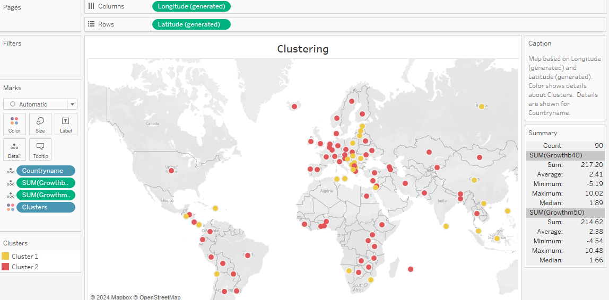

**Interpretation**:

* This is a geographical map visualization that clusters regions based on their tourism growth metrics, with each region represented by a coloured dot corresponding to a specific cluster.
* The clusters were formed using metrics like **growth in tourism-related GDP** for two periods, SUM(Growthb40) and SUM(Growthm50), and the countries are grouped based on similarities in these growth metrics.
* **Key Observations**:
  + Two clusters are visible, marked by different colours:
    - **Red Cluster**: Represents regions with relatively lower growth or negative trends in tourism GDP.
    - **Yellow Cluster**: Represents regions with higher growth in tourism GDP, suggesting more resilience or faster recovery in these areas.
* **Insight**:
  + This clustering analysis highlights the spatial distribution of regions in terms of their tourism GDP growth. It allows policymakers or stakeholders to quickly identify which regions are growing at a faster rate and which ones may need more attention or support to boost their tourism sector.

1. Forecasting

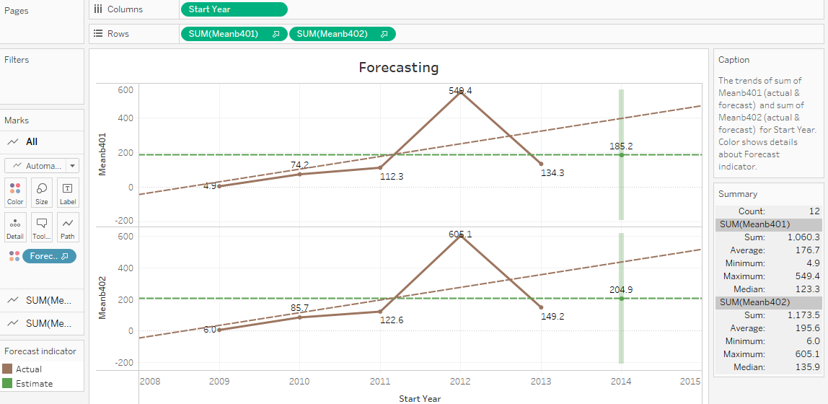

**Interpretation**:

* This chart shows actual and forecasted values for two growth measures: **Meanb401** and **Meanb402**, representing two different regions or sets of metrics for tourism-related GDP growth.
* **Key Observations**:
  + **2008-2011**: Both indicators show a rising trend, with **Meanhb402** showing a peak in 2012 at **605.1**. This indicates strong growth in tourism GDP during this period.
  + **2012-2014**: After the peak, there is a noticeable decline, and the forecast suggests a gradual recovery, but not to the previous peak levels by 2014.
  + **Forecast Indicator**: The green dashed lines indicate the expected trends, showing a return to positive growth but at a slower pace compared to the initial rise.
* **Insight**:
  + This forecasting visual helps in projecting the future growth of tourism GDP, showing a gradual recovery after a peak. It provides useful information for decision-makers to understand the likely future trends and to allocate resources accordingly. The forecasted values suggest caution, as the growth may not be as rapid as before, indicating the need for strategies to maintain or boost tourism contributions to the economy.

1. Area Chart

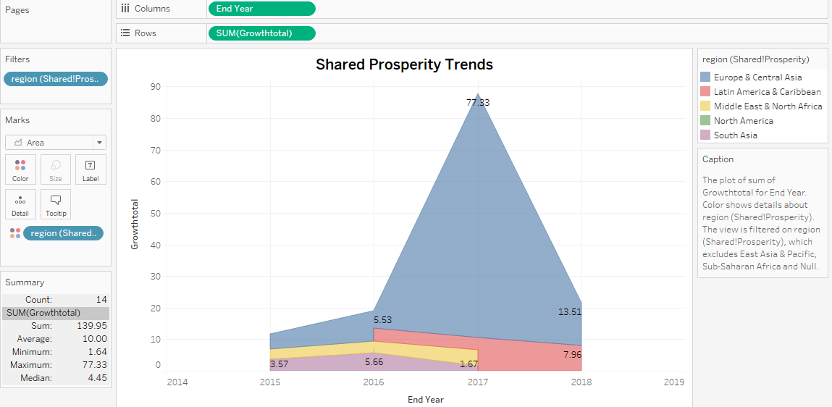

**Interpretation:**

* From 2015 to 2018, the growth in shared prosperity was highly dominated by **Europe & Central Asia** (blue section), with a notable spike in 2017, reaching 77.33 units. After 2017, the shared prosperity for this region saw a significant decline in 2018.
* Other regions such as **Latin America & the Caribbean** (red) and **North America** (yellow) had smaller but consistent contributions, with **Latin America** showing a slight increase in 2018.
* **Middle East & North Africa** and **South Asia** show minimal growth, indicating that shared prosperity was largely concentrated in Europe & Central Asia during this period.

1. Pie Chart

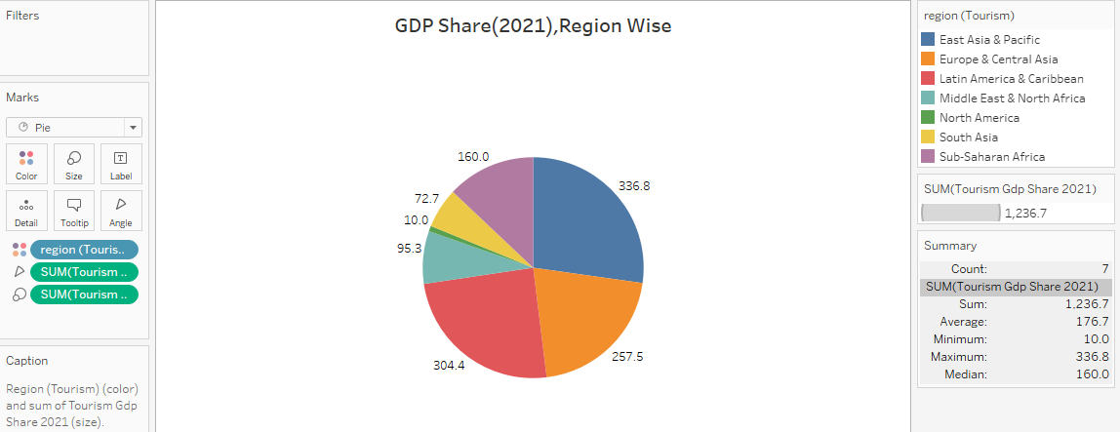

Interpretation:

* In 2021, **East Asia & Pacific** (blue) had the highest tourism GDP share at **336.8 units**, followed by **Europe & Central Asia** (red) with **304.4 units**, and **Latin America & Caribbean** with **257.5 units**.
* Other regions, such as **North America** and **South Asia**, had lower contributions (95.3 and 72.7 units, respectively), while **Sub-Saharan Africa** had the smallest share at **10 units**.
* This distribution shows that **East Asia & Pacific** and **Europe & Central Asia** were major contributors to the global tourism GDP in 2021, while regions like **Sub-Saharan Africa** were lagging behind.

1. Stacked Bar Chart

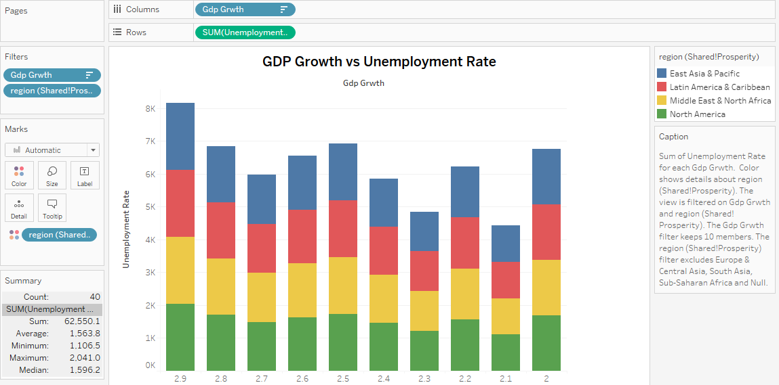

**Interpretation:** This stacked bar chart displays the unemployment rate segmented by region (East Asia & Pacific, Latin America & Caribbean, Middle East & North Africa, and North America) for different GDP growth levels. From the chart, we can observe:

* As GDP growth decreases from 2.9 to 2.0, the total unemployment rate fluctuates, with East Asia & Pacific (blue) consistently contributing the largest portion to the total unemployment rate.
* North America (green) shows a more balanced contribution, with significant unemployment at both high and low GDP growth rates.
* This objective would explore the correlation between economic growth (measured by GDP) and joblessness, highlighting how this relationship differs across regions.

1. Bar Chart

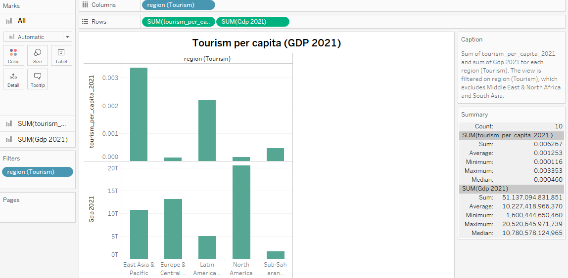

**Interpretation:** The dual-axis bar chart compares tourism per capita and GDP for different regions in 2021. The following insights can be drawn:

* East Asia & Pacific has the highest tourism per capita but ranks third in GDP.
* North America has a relatively low tourism per capita compared to its high GDP.
* This objective would investigate how tourism contributes to regional GDP, emphasizing the variation between regions like North America and East Asia & Pacific.

1. Text Table 1

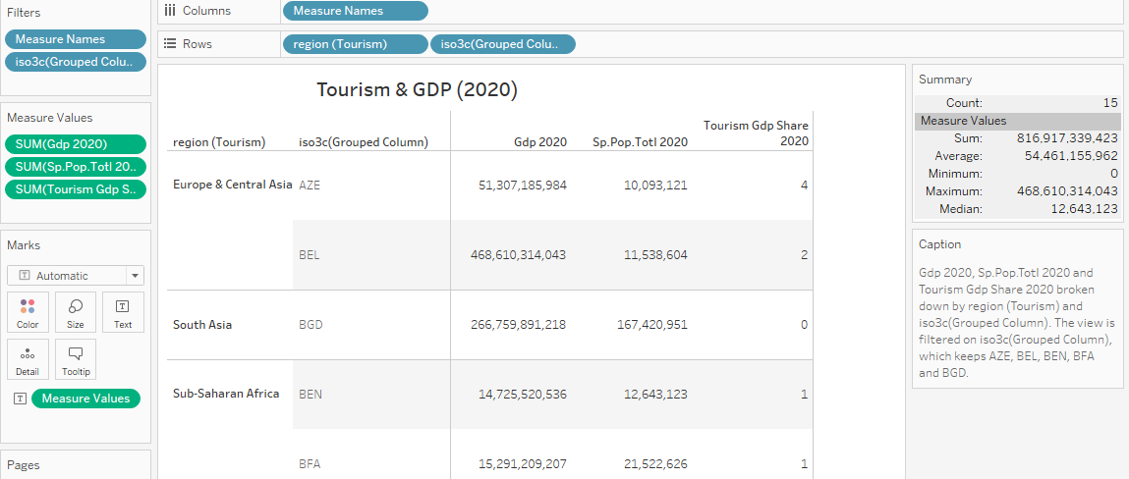

**Interpretation**:

* The table shows GDP figures for 2020, the population related to tourism, and tourism's share of GDP for regions like Europe, South Asia, and Sub-Saharan Africa.
* Europe & Central Asia's data, particularly for countries like Belgium (BEL), shows a high GDP contribution but a low percentage of tourism's share (only 2% for Belgium).
* In contrast, South Asian and Sub-Saharan African countries (such as Bangladesh and Benin) show minimal tourism's contribution to GDP.
* This analysis suggests that while tourism plays a crucial role in some regions, its impact varies widely. Regions relying more on tourism may have felt a more significant impact due to global travel restrictions during 2020.

1. Histogram

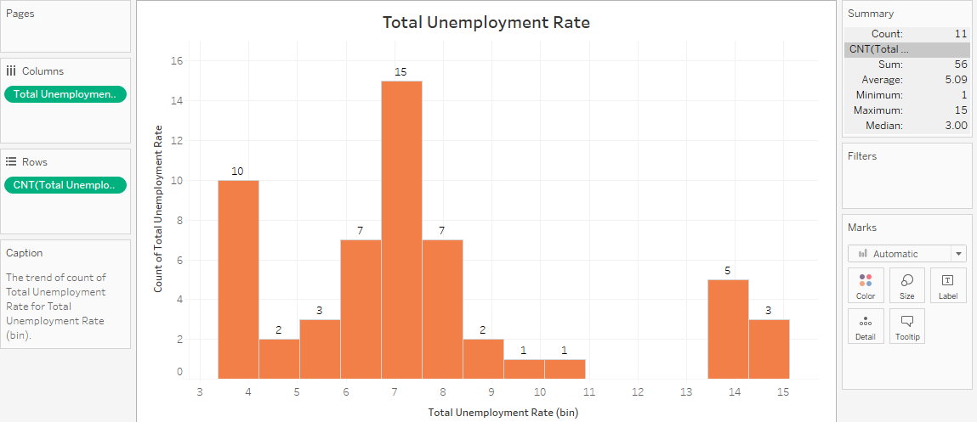

**Interpretation:** This histogram shows the frequency distribution of total unemployment rates across various bins. Key takeaways:

* The unemployment rate predominantly falls between 6 and 8, with the highest concentration at 7.
* The lowest unemployment rates (3-4) and the highest rates (13-15) are less frequent.
* This objective would aim to understand the distribution of unemployment rates across different countries or regions, focusing on why certain ranges (like 7%) are more common

1. Text Table 2

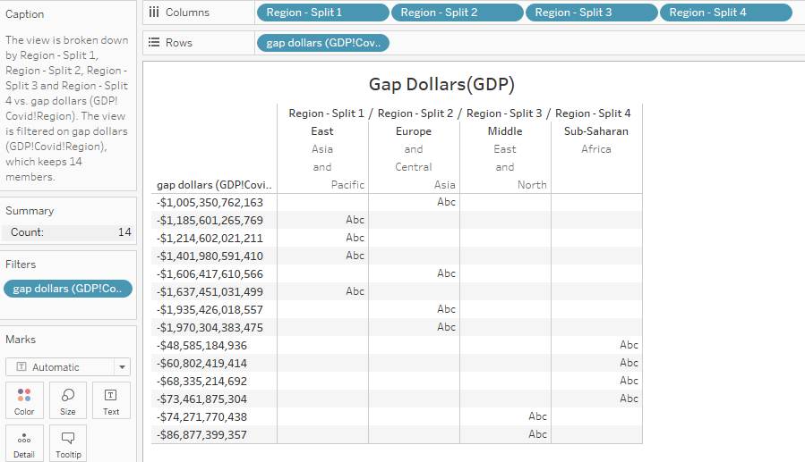

**Interpretation**:

* This visualization highlights the economic impact of COVID-19 on GDP across different regions, split into categories such as East Asia, Europe, Middle East, and Sub-Saharan Africa.
* The numbers show significant negative figures (in trillions of dollars), indicating substantial losses in GDP. For instance, East Asia and the Pacific show the highest gap at -$1,005 trillion, followed closely by Europe and Central Asia with losses over -$1,185 trillion.
* The blank cells for some regions indicate that those regions have not experienced a similar level of GDP loss compared to the others.
* This helps identify which regions have been most severely impacted by the pandemic, guiding recovery and aid priorities.

1. Scatter Plot

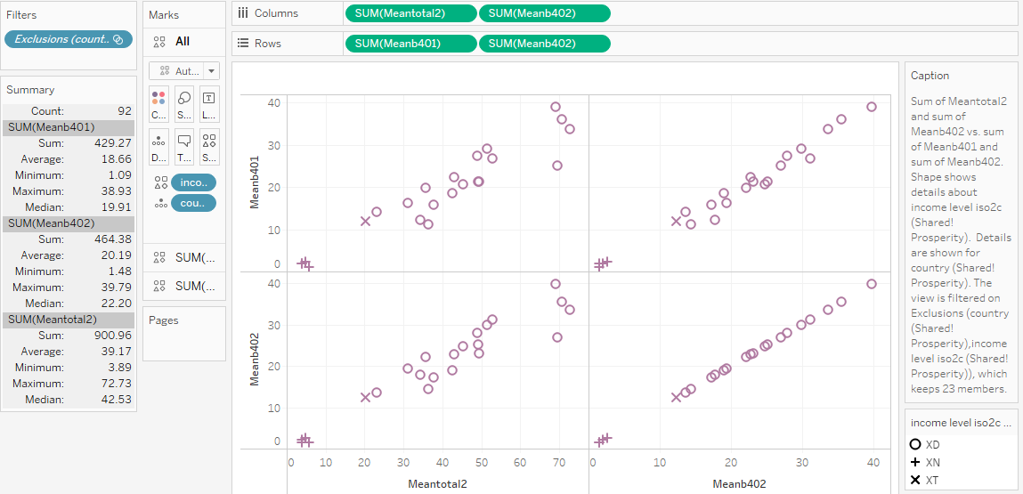

**Interpretation**:

* The scatter plot explores the relationship between two pairs of variables (Meantotal and Meanb datasets) for different income groups. The shape of the data points represent different income levels, denoted by "XD," "XN," and "XT."
* There seems to be a positive correlation between Meantotal2 and Meanb402, as well as between Meantotal1 and Meanb401. Countries with higher prosperity tend to show higher values in these measures.
* This suggests that certain income levels are associated with specific prosperity outcomes, though some countries or income levels (likely the outliers represented by "XD" and "XT") might exhibit distinct behaviours.

**Few Other Visualizations:**

1. Tree Map

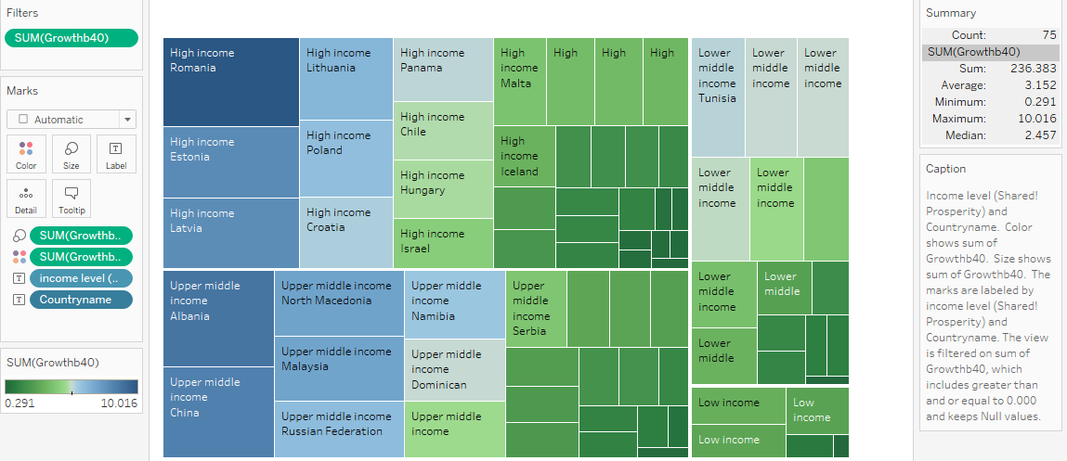

1. Text Table 3

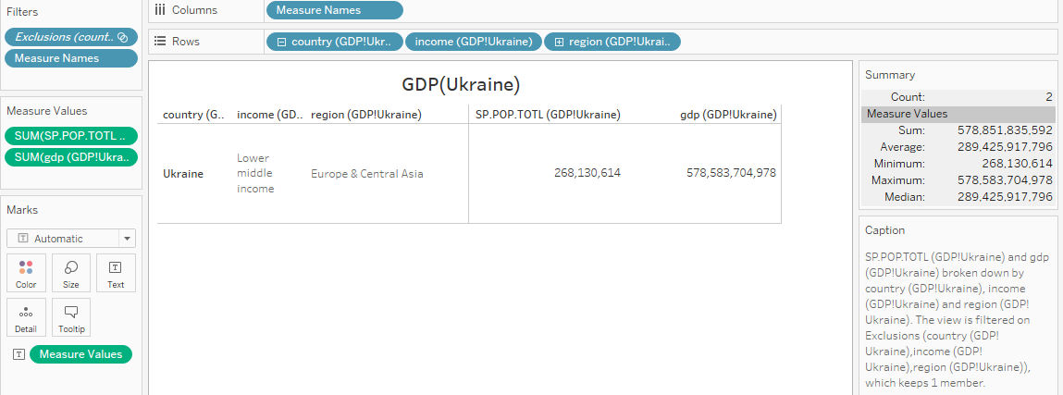

1. India (Text Table 4)

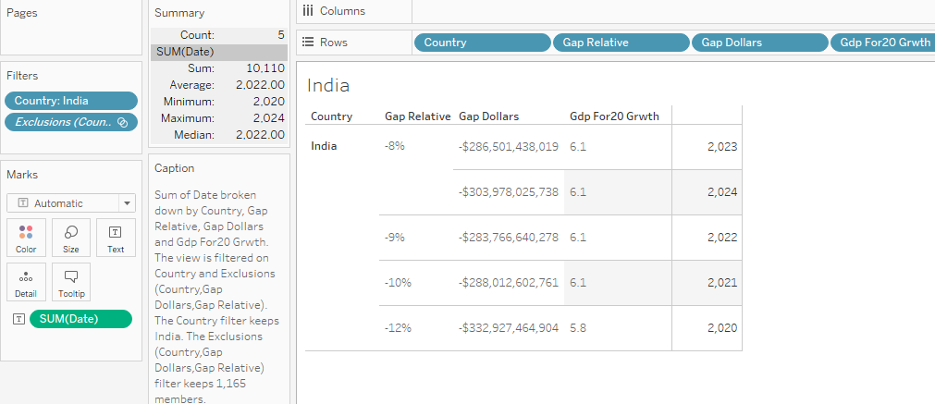

Dashboard 1: (Unemployment)

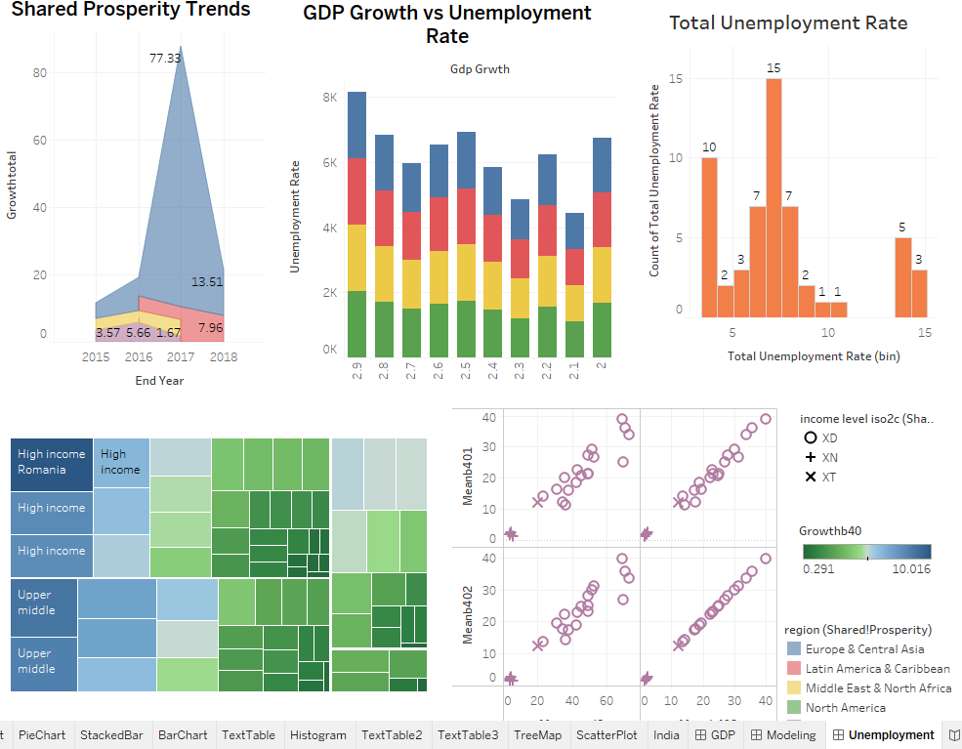

Dashboard 2: (Data Modelling)

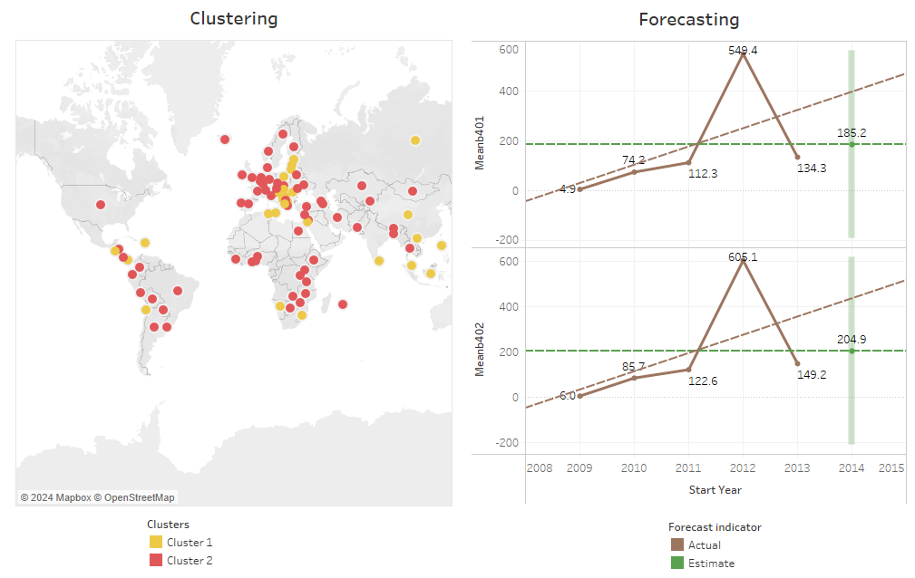

Dashboard 3: (GDP)

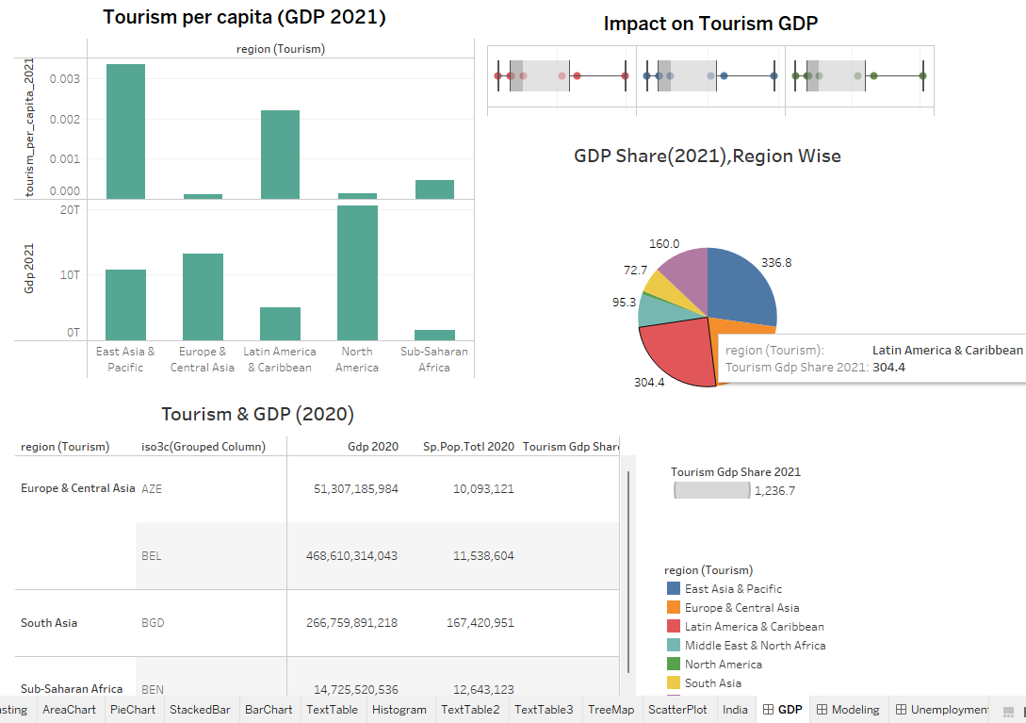

Data Story:

Scene 1: (Clustering)

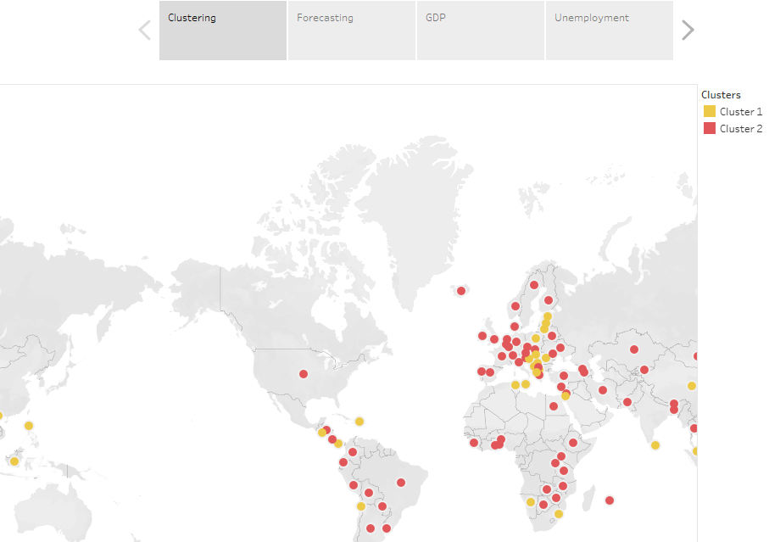

Scene 2: (Forecasting)

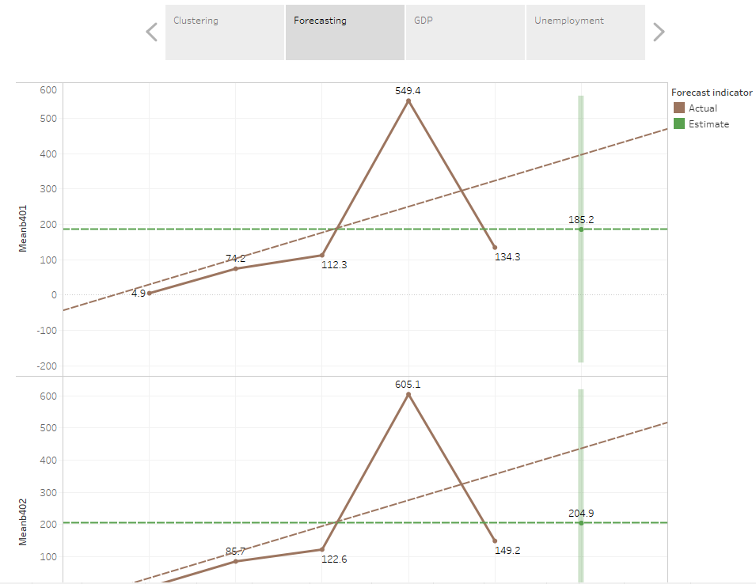

Scene 3: (GDP)

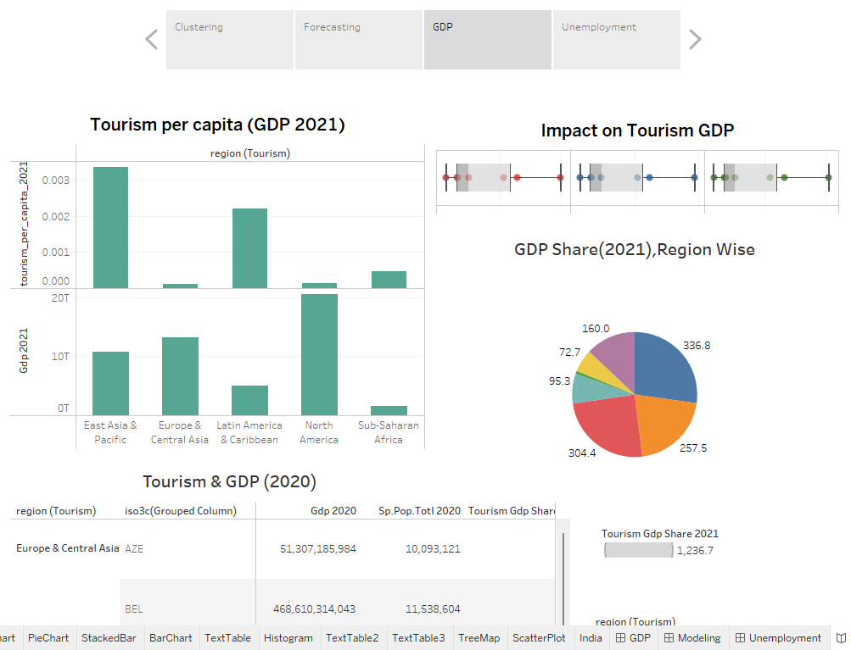

Scene 4: (Unemployment)

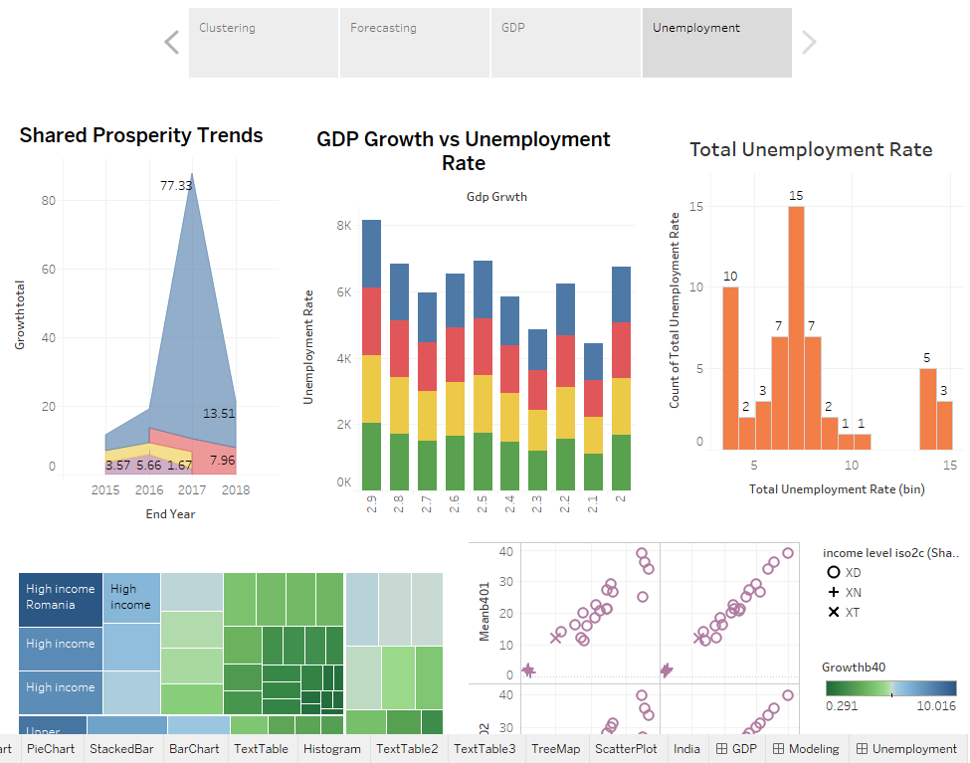

1. **Interpretation:**

* **Tourism GDP** experienced a dip in 2020 due to global disruptions, but it showed signs of recovery in 2021. Regions with higher tourism GDP displayed more stability, while smaller contributors were more volatile.
* **Regional clustering** shows differences in tourism growth, with some areas showing resilience and faster recovery, while others experienced lower or negative growth.
* **Forecasting trends** reveal gradual growth recovery post-2012, though not at the same pace as earlier periods, emphasizing the need for strategic planning to sustain momentum.
* **Shared prosperity** was concentrated in Europe & Central Asia from 2015-2018, but East Asia & Pacific led in tourism GDP by 2021.
* **Unemployment rates** were shown to fluctuate with GDP growth, especially in regions like East Asia & Pacific, where economic slowdowns had a larger impact on joblessness.
* The **economic impact of COVID-19** was most severe in East Asia and Europe, highlighting the need for focused recovery efforts in these areas.

Overall, this analysis highlights the varying impacts of tourism on regional economies and the importance of targeted recovery and support strategies to stabilize growth, particularly post-pandemic.

1. **Conclusion**

In conclusion, the analysis highlights the significant impact of tourism on regional GDP, with a noticeable dip in 2020 due to global disruptions and a recovery in 2021. Key regions like East Asia & Pacific and Europe & Central Asia were major contributors, while others showed slower recovery. The study also emphasizes the link between GDP growth and unemployment, suggesting the need for targeted strategies to support regions lagging behind. Overall, the findings provide valuable insights for policymakers to enhance tourism growth and economic resilience.

The recent global disruptions have caused significant economic upheavals, with tourism-dependent and developing countries suffering sharp declines in GDP and employment. Countries with **youth employment strategies** and access to **aid for trade** have shown resilience in recovery. However, more inclusive policies are needed to promote **shared prosperity** and **sustainable growth**. Rebuilding the tourism sector will be critical for long-term economic stability in several regions.

1. **Bibliography and References**

**Websites:**

* <https://sdgs.un.org/goals/goal8>
* <https://thesdgvizproject.com/data/>

**Book Chapter (Part of a research-based book on the Sustainable Development Goals (SDGs)):**

<https://www.cambridge.org/core/books/sustainable-development-goals-their-impacts-on-forests-and-people/sdg-8-decent-work-and-economic-growth-potential-impacts-on-forests-and-forestdependent-livelihoods/C881A1CC4EE9BFB1F92BF2244D631F7A>

**Research Articles:**

* <https://link.springer.com/article/10.1007/s10663-021-09526-5>
* <https://pmc.ncbi.nlm.nih.gov/articles/PMC10694193/>

**Citation:**

Chigbu BI, Nekhwevha F. Exploring the concepts of decent work through the lens of SDG 8: addressing challenges and inadequacies. Front Sociol. 2023 Nov 20;8:1266141. doi: 10.3389/fsoc.2023.1266141. PMID: 38053676; PMCID: PMC10694193.