Is Deep Learning Necessary for Short-Term AQI Forecasting? A Leakage-Free Benchmark of Classical and Recurrent Models across 20 Indian Cities
[Author 1 Name]  [Department]  [Institution]  [City, Country]  [email] | [Author 2 Name]  [Department]  [Institution]  [City, Country]  [email] | [Author 3 Name]  [Department]  [Institution]  [City, Country]  [email]

 | [Author 4 Name]  [Department]  [Institution]  [City, Country]  [email] | [Professor Name (Designation)]  [Department]  [Institution]  [City, Country]  [email]

Abstract: A city can only prepare for a high-pollution day if someone forecasts it, and recurrent neural networks are often proposed for forecasting the daily Air Quality Index (AQI). Many comparisons in this area, however, estimate same-day AQI from same-day pollutant levels, fit preprocessing before splitting the data, or report no persistence baseline. We compared persistence, ridge regression, support vector regression, Random Forest, XGBoost, LSTM and GRU on CPCB data from 20 Indian cities (2015 to 2020) at lead times of one, three and seven days. Every model saw the same seven-day input window, preprocessing used training data only, and stochastic models were run with five seeds. XGBoost had the best mean rank at all three lead times. The LSTM ranked last one day ahead and was significantly worse than XGBoost. Before the COVID-19 lockdown of March 2020, XGBoost cut the one-day-ahead RMSE of persistence by 10.4% (Friedman p = 0.004; Holm-corrected Wilcoxon p < 0.001), while the recurrent networks improved on it by 1.0% at most. No model beat persistence during the lockdown. The LSTM's shortfall against XGBoost shrank in cities with longer records (Spearman ρ = 0.56, p = 0.010), which suggests that about four years of daily data per city is too little for it. For daily city-level AQI we would start from a tuned gradient-boosted tree model and always check it against persistence.
Keywords: air quality index, time-series forecasting, LSTM, GRU, XGBoost, persistence baseline, data leakage, India
I. Introduction
In 2017, air pollution was linked to about 1.24 million deaths in India, roughly one in eight deaths in the country [1]. The Central Pollution Control Board (CPCB) reports a daily Air Quality Index (AQI) that combines up to eight pollutant concentrations into six categories, from Good to Severe [2]. If the next day's AQI could be forecast reliably, hospitals and city agencies would have a day to prepare for a Poor or Very Poor day.
Many groups have applied machine learning (ML) to this problem, from support vector regression and tree ensembles to recurrent neural networks such as the Long Short-Term Memory (LSTM) network [3], [4], [5], [6], [7], and the reported accuracies are often very high. Some of these numbers are hard to interpret. A model that estimates today's AQI from today's pollutant levels mostly relearns the CPCB formula, since the index is computed from those levels [2]. When interpolation, scaling or outlier removal is applied before the data are split, or early stopping uses the test set, information from the test period leaks into training [8]. Few studies report persistence (tomorrow's AQI equals today's), which is the usual reference for short-range forecasts [9].
We wanted to know whether recurrent networks still beat classical models once these problems are removed. Using public CPCB records for 20 Indian cities [10], we built a benchmark in which every model sees the same seven-day input window, all preprocessing is fitted on the training period, gaps are filled from past values only and hyperparameters are chosen on a separate validation period. We compare persistence, ridge regression (MLR), support vector regression (SVR), Random Forest (RF), XGBoost, LSTM and GRU at lead times of one, three and seven days, run each stochastic model with five seeds, and test the differences statistically across cities. We also look at which inputs the models rely on, using SHAP, and at how they behaved during the COVID-19 lockdown of March 2020, which falls inside our test period.
Section II reviews related work and Section III describes the data. The methods are in Section IV, the results in Section V and the discussion in Section VI.
II. Literature Review
A. Classical Machine Learning Approaches
Zhu et al. proposed hybrid models for daily AQI forecasting in Chinese cities and found that they outperformed single models [3]. Ameer et al. compared decision trees, Random Forest, gradient boosting and multilayer perceptrons for pollution prediction in smart cities [4], and Castelli et al. applied support vector regression in California [11]. For India, Gupta et al. compared SVR, Random Forest and CatBoost on CPCB data [5], Ravindiran et al. evaluated boosting and bagging ensembles for Visakhapatnam [12], and Pant et al. compared several supervised learners [13]. In most of these studies the tree ensembles did well and were cheap to train.
B. Deep and Hybrid Recurrent Models
The LSTM [14] and the simpler Gated Recurrent Unit (GRU) [15] keep information over long sequences through gated memory cells. Janarthanan et al. combined SVR and LSTM for AQI prediction in Chennai [6], Seng et al. proposed a spatiotemporal LSTM [16], and both Yan et al. [17] and Zhang and Li [18] reported gains from CNN-LSTM models in Beijing. Drewil and Al-Bahadili tuned LSTMs with metaheuristic search [19]. Hybrid LSTM-GRU models have been proposed for Delhi [7] and for daily AQI in general [20], and Barthwal and Goel combined convolutional and LSTM layers to classify AQI in urban India [21].
C. Comparative Studies and Evaluation Practice
Model families have been compared directly by Mishra and Gupta [22], Aram et al. [23] and Özüpak et al. [24], and Sidhu et al. modelled AQI across many Indian cities and states [25]. Kalantari et al. asked whether AQI forecasting needs shallow or deep learning [26]; we ask the same question for India. CPCB data have large gaps [27], and Rao et al. [28] and Lawrence and Bhathmanabhan [29] studied how imputation choices affect AQI models for Indian cities. Outside air quality, Kapoor and Narayanan traced many irreproducible ML results to data leakage [8], and the forecasting literature recommends comparing every method with simple benchmarks such as persistence [9].
We have not found a study on Indian AQI that compares recurrent networks with properly implemented classical learners on identical, leakage-free inputs, at several lead times, across many cities, against persistence and with significance tests. This paper reports such a comparison.
III. Data and Study Area
A. Source and Coverage
We use the public Air Quality Data in India (2015 to 2020) collection [10], which compiles daily city-level averages from CPCB continuous monitoring stations. Its city-day table has 29,531 records for 26 cities between 2015-01-01 and 2020-07-01. Each record gives the concentrations of twelve pollutants (PM_{2.5}, PM₁₀, NO, NO₂, NO_{x}, NH₃, CO, SO₂, O₃, benzene, toluene and xylene) and the AQI computed with the CPCB definition [2]. The AQI itself is reported on 24,850 city-days. On those days xylene is missing 61.9% of the time, PM₁₀ 28.5% and NH₃ 26.3%, in line with the data quality problems reported for this network [27].
We keep the 20 cities with at least 300 days of reported AQI. They are quite different (Fig. 1): the median daily AQI is below 70 in Thiruvananthapuram and above 250 in Delhi and Ahmedabad.
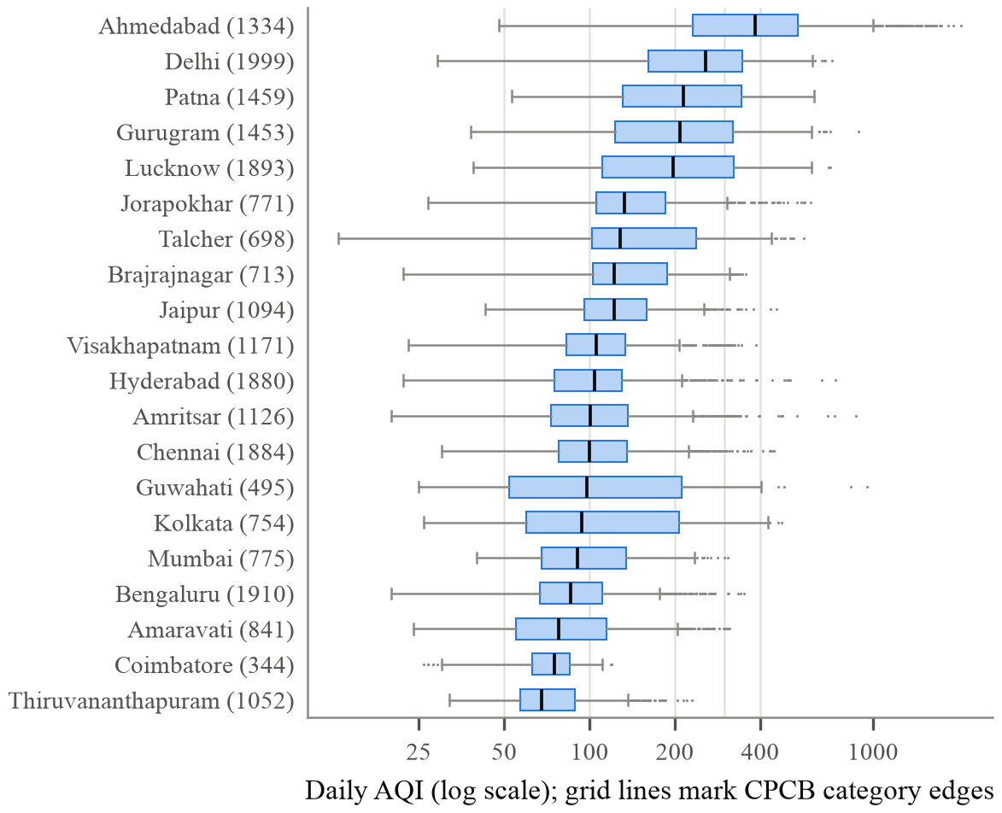
Fig. 1. Distribution of daily AQI in the 20 study cities (number of reported days in brackets), ordered by median. Grid lines mark the CPCB category boundaries at 50, 100, 200, 300 and 400.
B. Forecasting Task
A forecast is issued on every day t with a reported AQI and targets day t+h, where h is 1, 3 or 7 days. We score it only if the AQI was also reported on the target day. The forecast origins of each city are split in time order into training (first 70%), validation (next 10%) and test (last 20%) periods, which gives 16,177 training, 2,303 validation and 4,645 test forecasts across the 20 cities for h = 1. All test periods end in mid-2020. On average 48% of each one falls after the nationwide COVID-19 lockdown of 25 March 2020 [30]. Table I gives the numbers for each city.
TABLE I. Per-city forecasting data (h = 1)
City | Train / val / test | Test period | Inputs
Ahmedabad | 908 / 129 / 261 | 19-10 to 20-07 | 11
Amaravati | 555 / 79 / 159 | 20-01 to 20-07 | 13
Amritsar | 763 / 109 / 218 | 19-11 to 20-07 | 13
Bengaluru | 1330 / 190 / 381 | 19-06 to 20-07 | 12
Brajrajnagar | 468 / 67 / 135 | 19-12 to 20-06 | 11
Chennai | 1310 / 187 / 375 | 19-06 to 20-07 | 11
Coimbatore | 223 / 31 / 65 | 20-04 to 20-06 | 12
Delhi | 1390 / 198 / 399 | 19-05 to 20-07 | 12
Gurugram | 980 / 140 / 281 | 19-09 to 20-07 | 10
Guwahati | 339 / 48 / 98 | 20-03 to 20-07 | 11
Hyderabad | 1306 / 186 / 375 | 19-06 to 20-07 | 13
Jaipur | 759 / 108 / 218 | 19-11 to 20-07 | 12
Jorapokhar | 510 / 73 / 147 | 20-01 to 20-07 | 8
Kolkata | 522 / 74 / 151 | 20-02 to 20-07 | 12
Lucknow | 1315 / 187 / 377 | 19-06 to 20-07 | 10
Mumbai | 538 / 76 / 155 | 20-01 to 20-07 | 6
Patna | 986 / 140 / 283 | 19-09 to 20-07 | 11
Talcher | 461 / 65 / 133 | 20-01 to 20-07 | 11
Thiruvananthapuram | 728 / 104 / 208 | 19-12 to 20-07 | 10
Visakhapatnam | 786 / 112 / 226 | 19-11 to 20-07 | 13
Inputs: AQI plus the pollutants retained for that city (pollutants with more than 50% missing values in the training period are dropped). Dates are given as yy-mm.
IV. Methodology
Fig. 2 shows the pipeline. Everything that depends on the data is estimated from the training period of each city, and no input ever comes from after the forecast origin.
A. Leakage-Free Preprocessing
For each city, a pollutant is dropped when more than half of its training-period values are missing or when it never changes. If a monitor misses a day, we reuse its last reading for up to a week; after that, the gap gets the training-period median. We deliberately avoided interpolation. Interpolating across a gap needs the reading that comes after it, and nobody has that reading when the forecast is made. Days with extreme AQI stay in every split, since those are the days a warning system is meant to catch and an interquartile-range filter would throw many of them away. Inputs are standardised to zero mean and unit variance using statistics from the training set.
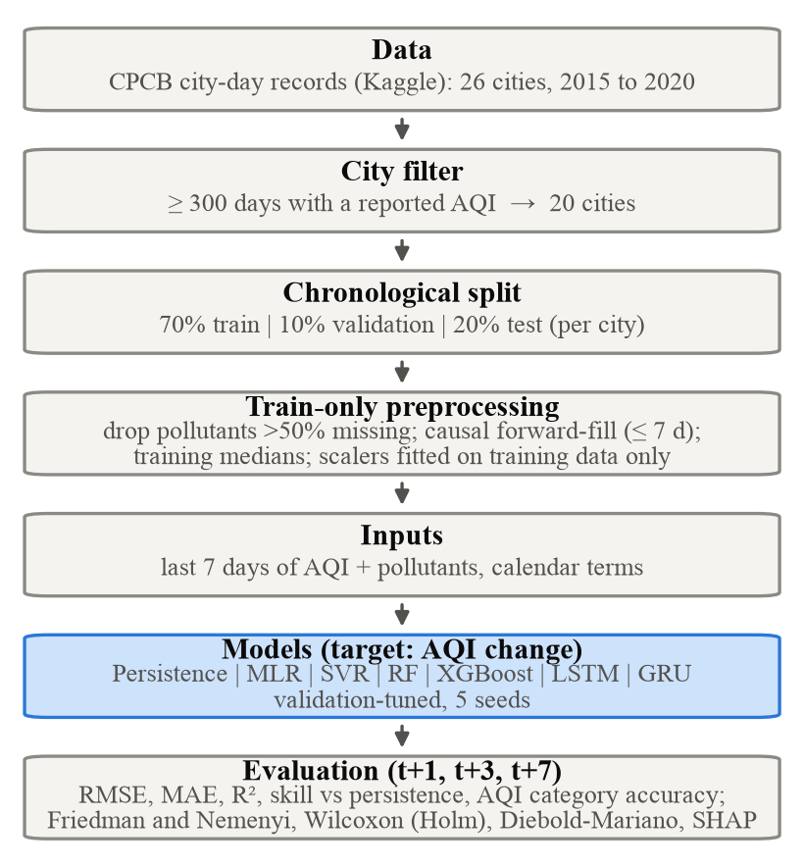
Fig. 2. Leakage-free forecasting pipeline used for every city, lead time and model.
B. Inputs and Learning Target
Every model gets the AQI and the retained pollutant readings for the seven days up to and including day t, plus four calendar terms for the target day (sine and cosine of the day of the week and of the day of the year). The tabular models see this window as one flat vector, and the recurrent models see it as a sequence of seven steps. Each model predicts the change in AQI over the lead time, so the forecast is
$ŷ_{t+h} = y_{t} + f(x_{t})$ (1)
where y_{t} is the AQI on the forecast origin and f is the learned model. Persistence is the case f ≡ 0, so every model is a learned correction to persistence. Section V-F tests how much this choice matters.
C. Models
We picked seven forecasters so that each model family used in earlier work is represented. Persistence simply repeats today's value (ŷ_{t+h} = y_{t}). MLR is least squares with an L2 (ridge) penalty, which we added because the pollutant lags are strongly correlated. SVR uses a radial basis function kernel [31], and Random Forest [32] and XGBoost [33] stand for bagged and boosted trees. The two recurrent models, an LSTM [14] and a GRU [15], have two layers each, and their last hidden state goes through a small fully connected head (two layers, dropout 0.2). The search space for every model is given in Table II.
TABLE II. Hyperparameter search spaces (selected on validation RMSE)
Model | Search space / settings
MLR | α ∈ {10⁻³, 10⁻², 0.1, 1, 10, 100}
SVR | C ∈ {1, 10, 100}; ε ∈ {0.05, 0.1}; γ = 1/(d·Var(x))
RF | 300 trees; max depth ∈ {none, 15}; min leaf ∈ {1, 5}; max features ∈ {0.33, 1.0}
XGBoost | depth ∈ {3, 5, 7}; min child weight ∈ {1, 5}; learning rate 0.03; subsample 0.8; early stopping (100 rounds)
LSTM / GRU | 2 layers; hidden units ∈ {32, 64}; dropout 0.2; Adam (lr 10⁻³, weight decay 10⁻⁴); batch 32; ≤ 300 epochs; early stopping (patience 30)

D. Training Protocol
For every city and lead time we train each configuration in Table II on the training period and keep the one with the lowest validation RMSE. The neural networks are trained with Adam [34] on the mean squared error. Their learning rate is halved after ten epochs without validation improvement, gradients are clipped at a norm of 1, and the best validation checkpoint is restored at the end. Random Forest, XGBoost, LSTM and GRU are then retrained with five seeds and their test metrics averaged (MLR and SVR are deterministic). The test period is used once, for the final evaluation. Everything ran on the CPU of an Apple M3 Pro laptop with scikit-learn [35], XGBoost [33] and PyTorch [36]. The code and every individual forecast are released with the paper.
E. Evaluation Metrics
For n test forecasts with observations y_{i} and forecasts ŷ_{i}, we compute the root mean squared error and the mean absolute error,
$RMSE = \sqrt{\frac{1}{n}\sum_{i=1}^{n}{{(y_{i}−ŷ_{i})}^{2}}}$ (2)
$MAE = \frac{1}{n}\sum_{i=1}^{n}{|y_{i}−ŷ_{i}|}$ (3)
together with R² and the mean absolute percentage error. RMSE values cannot be compared directly between cities with very different pollution levels, so our main metric is the skill score relative to persistence,
$Skill = 1 − \frac{{RMSE}_{model}}{{RMSE}_{persistence}}$ (4)
which is positive when a model beats persistence and comparable across cities [9]. The public sees the AQI as a category, so we also report category accuracy: the fraction of test days on which the forecast lands in the same CPCB category as the observed AQI [2].
F. Statistical Testing and Interpretation
Following Demšar [37], we rank the models by RMSE within each city and compare the ranks with the Friedman test [38]. Two models whose mean ranks differ by less than the Nemenyi critical difference (CD) are not significantly different at the 5% level. We compare the best-ranked model with each of the others using Wilcoxon signed-rank tests over cities [39] with Holm correction [40]. Inside each city, the Diebold-Mariano (DM) test [41] with the correction of Harvey et al. [42] checks whether a model's squared errors differ from those of persistence. To see which inputs the XGBoost forecasts depend on, we use TreeSHAP [43], [44].
V. Results
A. One-Day-Ahead Accuracy
One day ahead, persistence on its own already reaches a mean R² of 0.64 (median 0.72; Table III), so a large part of tomorrow's AQI is already in today's value. Only the two tree ensembles have a positive mean skill. Random Forest has the lowest mean RMSE (33.1 against 35.7 for persistence), and Random Forest and XGBoost each beat persistence in 13 of the 20 cities. On average the recurrent networks do worse than persistence (LSTM −0.149, GRU −0.132), and so does ridge regression. The median skill is positive for every model, though, so the means are dragged down by large errors in a handful of cities (Section V-D). Persistence still has the best category accuracy (75%). The learned models cut large errors, but now and then they push a forecast over a category boundary that persistence would not have crossed.
TABLE III. Mean one-day-ahead test performance over 20 cities
Model | RMSE | MAE | R² | Skill | Med. skill | Pre-LD skill | Cat. acc. | Wins
Persistence | 35.7 | 22.5 | 0.64 | 0 | 0 | 0 | 75% | n/a
MLR | 36.8 | 27.0 | 0.47 | −0.14 | +0.02 | +0.02 | 69% | 10
SVR | 35.0 | 24.9 | 0.65 | −0.02 | +0.05 | +0.04 | 71% | 12
RF | 33.1 | 23.3 | 0.67 | +0.03 | +0.08 | +0.10 | 73% | 13
XGBoost | 33.6 | 22.2 | 0.67 | +0.03 | +0.06 | +0.10 | 72% | 13
LSTM | 37.3 | 25.5 | 0.57 | −0.15 | +0.01 | −0.01 | 70% | 11
GRU | 36.2 | 25.1 | 0.58 | −0.13 | +0.02 | +0.01 | 71% | 13
Skill is 1 − RMSE/RMSE_{persistence}, so positive values mean better than persistence. Pre-LD refers to test days before the 25 March 2020 lockdown (18 cities). Wins is the number of cities in which the model's RMSE is below that of persistence. Values are averaged over cities and, for RF, XGBoost, LSTM and GRU, over five seeds. MLR denotes ridge-regularised linear regression. The best value in each column is in bold.
B. Before and During the COVID-19 Lockdown
The lockdown that began on 25 March 2020 cut vehicular and industrial emissions sharply [30], and it falls inside every test period. Fig. 3 splits the test days of the 18 cities that have at least 30 days on each side. Before the lockdown, XGBoost and Random Forest lower the RMSE of persistence by 10.4% and 10.1% on average, and XGBoost beats persistence in 16 of the 18 cities. The GRU, ridge regression and LSTM stay very close to persistence (+0.010, +0.015 and −0.013). During the lockdown every model is worse than persistence. XGBoost loses the least (−0.069) and ridge regression the most (−0.596). Our reading is that models trained on earlier years expect pollution to drift back to its usual seasonal level. That did not happen while emissions stayed low, and persistence, which assumes nothing about the season, adjusted at once.
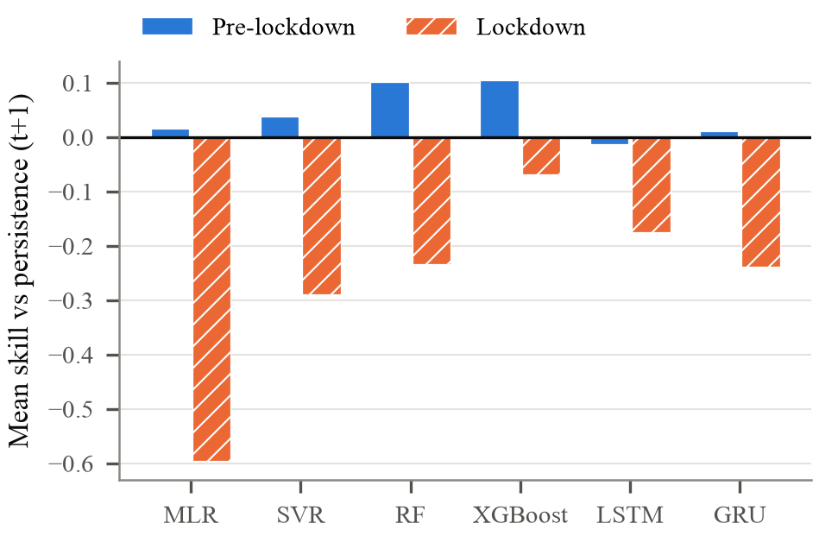
Fig. 3. One-day-ahead skill relative to persistence on test days before and during the 2020 lockdown, averaged over the 18 cities that have at least 30 test days in each period.
C. Effect of Lead Time
Fig. 4 and Table IV add the three- and seven-day forecasts. Persistence gets worse quickly as the lead time grows (mean RMSE 35.7, 56.9 and 62.8), but so do the learned models: their inputs say nothing about the weather that will control dispersion over the coming week. XGBoost has the lowest mean RMSE at both longer horizons (55.2 and 59.9) and beats persistence in 14 and 13 cities, with mean skills of −0.056 and +0.026. The recurrent networks do not catch up at longer horizons (LSTM −0.099 and −0.079). The spread between seeds is small next to the differences between models.
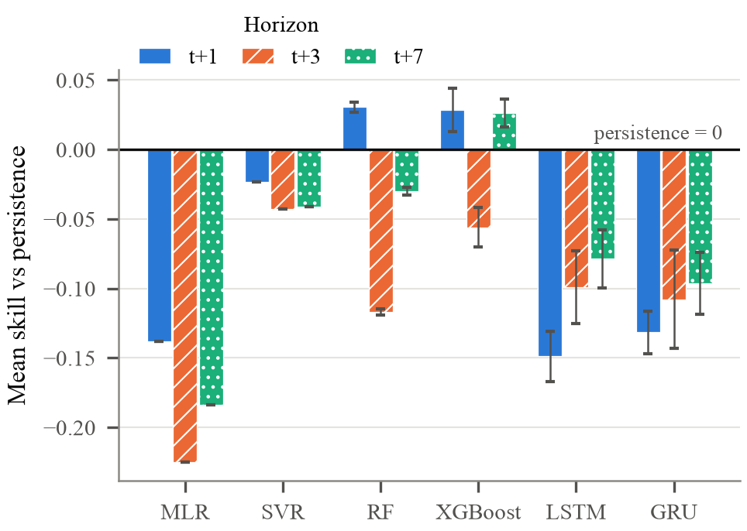
Fig. 4. Mean skill relative to persistence over 20 cities at lead times of one, three and seven days (all test days). Error bars show the standard deviation of the 20-city mean across five seeds; MLR and SVR are deterministic.
TABLE IV. RMSE and Diebold-Mariano outcomes by lead time
Model | RMSE t+1 | RMSE t+3 | RMSE t+7 | DM t+1 | DM t+3 | DM t+7
Persistence | 35.7 | 56.9 | 62.8 | n/a | n/a | n/a
MLR | 36.8 | 64.0 | 67.5 | 6 / 6 | 3 / 6 | 2 / 2
SVR | 35.0 | 57.8 | 62.1 | 7 / 3 | 4 / 3 | 1 / 5
RF | 33.1 | 58.3 | 65.2 | 8 / 1 | 3 / 5 | 2 / 1
XGBoost | 33.6 | 55.2 | 59.9 | 9 / 2 | 6 / 3 | 5 / 1
LSTM | 37.3 | 58.8 | 64.0 | 3 / 7 | 3 / 5 | 3 / 4
GRU | 36.2 | 58.7 | 64.3 | 5 / 5 | 3 / 6 | 2 / 5
DM gives the number of cities in which the model is significantly better / worse than persistence (Diebold-Mariano test with the HLN correction, p < 0.05).
D. City-Level Results and the Role of Data Size
Results differ a lot between cities (Fig. 5). In 16 of the 20 cities, at least one model does better than persistence. The best case is Brajrajnagar, where the top model reaches a skill of +0.29, and Visakhapatnam and Lucknow come next (both +0.20). In the other four cities, Amaravati, Thiruvananthapuram, Guwahati and Coimbatore, nothing we tried beat persistence. None of them has more than 728 training days, Coimbatore has only 223, and at least 47% of each one's test days come after the lockdown started. These cities are the main reason the mean skills in Table III are so low.
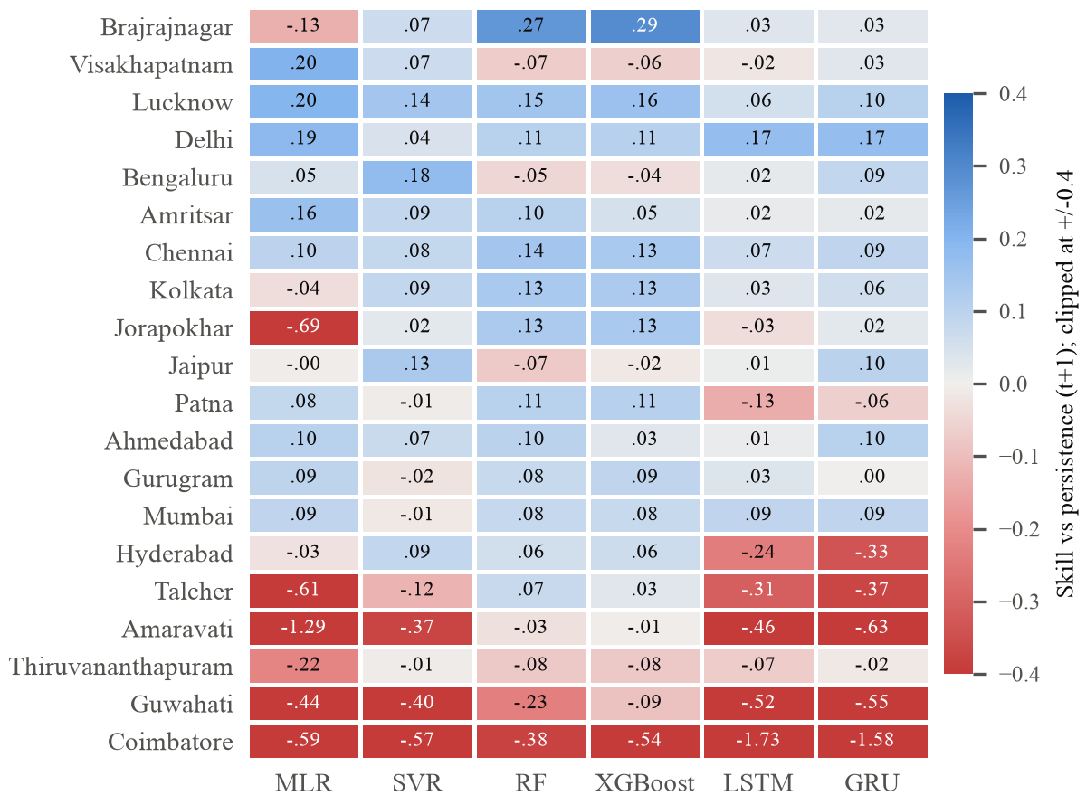
Fig. 5. One-day-ahead skill relative to persistence for every city (rows, ordered by best skill) and model (columns). Blue cells beat persistence and red cells are worse. The colour scale is clipped at ±0.4, but the printed values are not.
How much training data a city has turns out to matter a great deal for the recurrent networks and hardly at all for the tree ensembles. Across cities, the LSTM's skill rises with the number of training forecasts (Spearman ρ = 0.53, p = 0.016), and so does its skill relative to XGBoost (ρ = 0.56, p = 0.010; Fig. 6). XGBoost shows no significant dependence on data size (ρ = 0.29, p = 0.214). In Delhi and Bengaluru, which have the longest records, the LSTM is slightly better than XGBoost (in Delhi +0.17 against +0.11). In most cities with fewer than 600 training days it falls well behind.
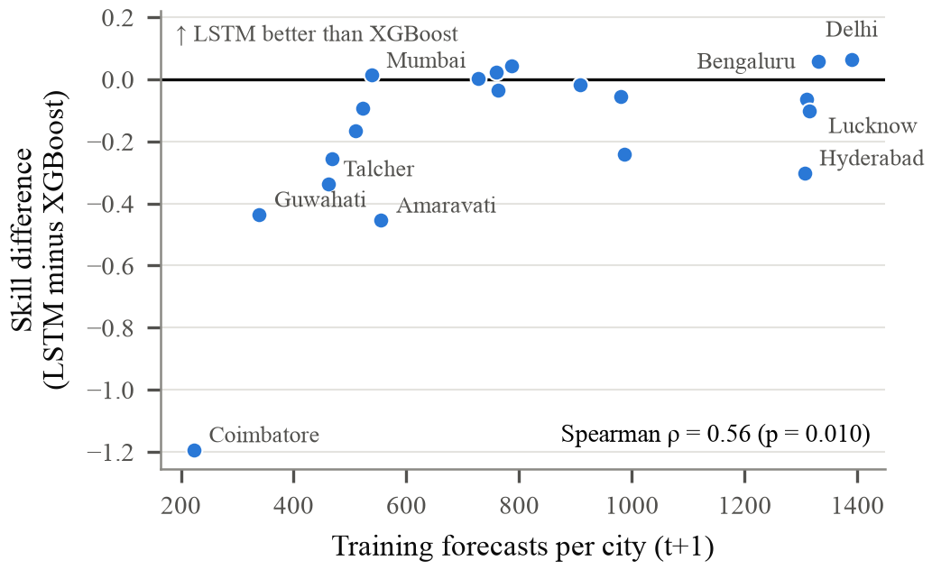
Fig. 6. Difference in one-day-ahead skill between the LSTM and XGBoost, plotted against the number of training forecasts in each city. Positive values favour the LSTM.
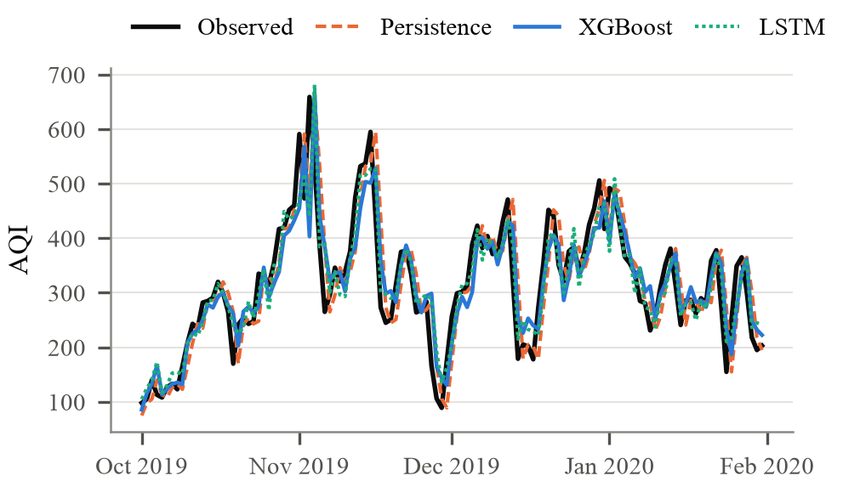
Fig. 7. Observed and one-day-ahead forecast AQI in Delhi during the 2019-20 winter pollution season (test period). The XGBoost and LSTM forecasts are averaged over five seeds.
Fig. 7 shows the Delhi forecasts for the winter of 2019-20. Every forecast, persistence included, tends to react to the steepest rises about a day late. The learned models mostly differ from persistence when an episode ends, because they do not carry the previous day's peak forward.
E. Statistical Significance
Taken over all test days, the Friedman test gives only weak evidence that the models differ at t+1 (χ² = 11.0, p = 0.089) and none at t+3 (p = 0.488) or t+7 (p = 0.375). XGBoost still has the best mean rank at every lead time (Fig. 8). It is significantly more accurate than the LSTM at t+1 (Holm p = 0.010), but not than persistence (p = 0.086) or the other learners. On the pre-lockdown test days of the 18 cities the differences are significant (χ² = 19.0, p = 0.004). XGBoost ranks first there (2.89) and persistence last (5.56), and XGBoost is significantly better than persistence (Holm p < 0.001), though we cannot separate it statistically from Random Forest or the other learners. City by city, the DM test finds XGBoost significantly better than persistence in 9 cities and worse in 2; for the LSTM the counts are 3 and 7 (Table IV).
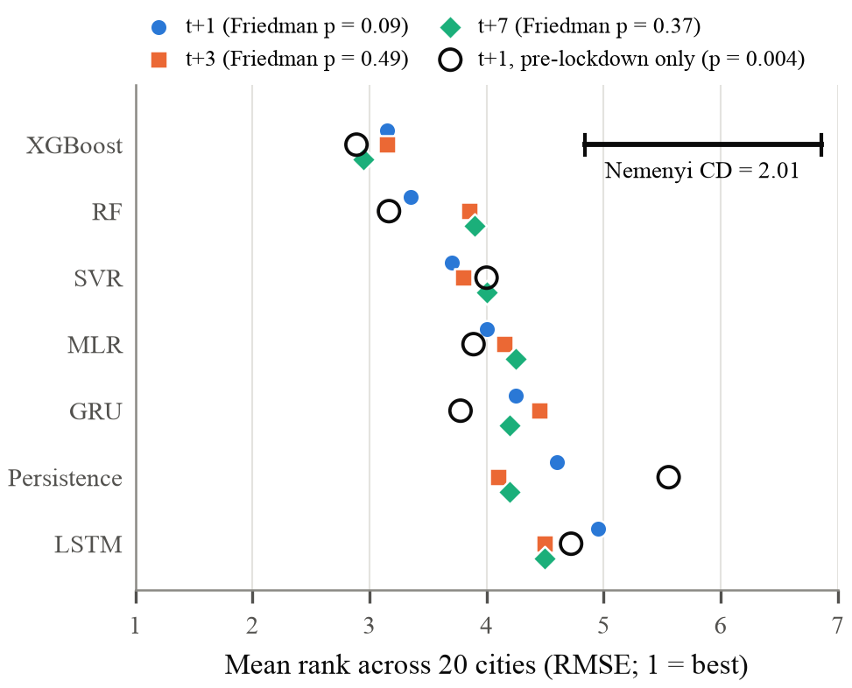
Fig. 8. Mean rank of each model across the 20 cities (RMSE, 1 = best) at each lead time, and on pre-lockdown test days only (hollow circles). Models whose ranks differ by less than the Nemenyi critical difference are not significantly different (α = 0.05).
F. Effect of the Learning Target and the Inputs
Table V looks at two design choices at t+1. The first is the target. Most earlier studies train models to predict the AQI level. When we do the same, mean skill drops for MLR (−0.138 to −0.265), SVR (−0.023 to −0.562), XGBoost (+0.028 to −0.138) and LSTM (−0.149 to −0.215); only the GRU barely changes (−0.132 to −0.125). No model beats persistence with the level target, because each one has to reproduce an absolute pollution level that drifts between the training and test periods. The second choice is the input set, which we vary with the level target. XGBoost does worse with past AQI alone (−0.308) or pollutants alone (−0.242) than with both (−0.138). Ridge regression is the opposite case: it does better with AQI history alone (−0.066 against −0.265), probably because about 90 correlated lag features are too many for a linear model fitted on a few hundred days.
TABLE V. Ablation at t+1: mean skill relative to persistence
Model | Change target, all inputs | Level target, all inputs | Level, AQI history only | Level, pollutants only
MLR | −0.138 | −0.265 | −0.066 | −0.525
SVR | −0.023 | −0.562 | n/a | n/a
XGBoost | +0.028 | −0.138 | −0.308 | −0.242
LSTM | −0.149 | −0.215 | −0.214 | −0.360
GRU | −0.132 | −0.125 | n/a | n/a
The first column is the main protocol (five seeds); the ablations use three seeds. RF was left out of the ablations to save computation time. n/a: not run.
G. What the Models Rely On
TreeSHAP gives a fairly simple picture of the one-day-ahead XGBoost model (Fig. 9). Past AQI gets the largest share of the attribution (30%), PM_{2.5} gets 17% and PM₁₀ 12%, while each of the remaining inputs gets 6% or less. Looking at the days in the window, 46% sits on the most recent day and 18% on the day before; the five older days get between 6% and 8% each. The model is therefore mostly adjusting today's value from the latest AQI and particulate readings. It hardly uses the longer patterns that recurrent networks are designed for.
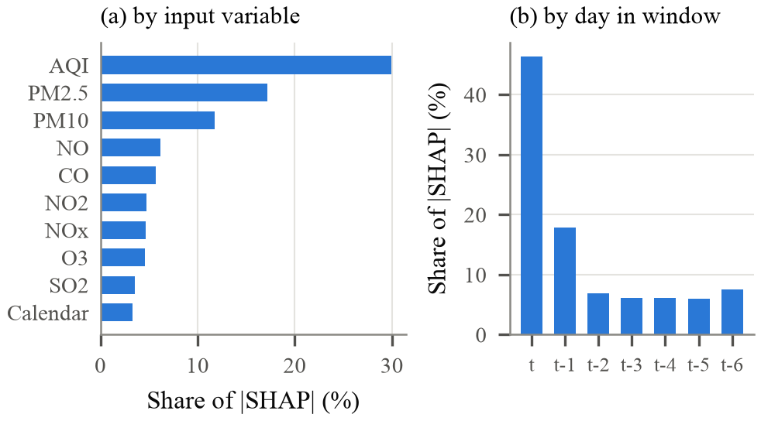
Fig. 9. Mean share of absolute SHAP attribution for the one-day-ahead XGBoost forecasts, averaged over 20 cities: (a) by input variable, summed over the seven days of the window; (b) by day in the window, summed over variables.
VI. Discussion
A. Is Deep Learning Necessary?
For daily city-level AQI forecasting from the CPCB records, our results say no. With identical inputs and no leakage, the LSTM and GRU did not beat a tuned gradient-boosted tree model on average at any lead time, and the LSTM was significantly worse than XGBoost. They fall furthest behind where data are scarce (Fig. 6), so longer records, hourly data or training pooled across cities might change the picture. Earlier reports of high accuracy for deep models [6], [7], [22] used different protocols and cannot be compared directly with ours. Our results add multi-city evidence from India to the question Kalantari et al. raised [26].
B. Why Persistence Is Hard to Beat
Daily AQI is strongly autocorrelated. It is computed from 24-hour averages [2], and the weather that traps or disperses pollutants usually lasts several days. A model without weather information can only look backwards, and most of what it can learn about tomorrow is already in today's value. Whatever advantage is left is fragile, as the lockdown showed. This is also why R² is a poor yardstick here: persistence scores 0.64 without learning anything.
C. Recommendations for Practice
A few practical points follow from this study. Persistence, and the skill relative to it, should be reported next to R². Preprocessing should be fitted on training data alone, gaps filled from past values only, and the test set kept away from both tuning and early stopping [8]. Models should predict the change in AQI, because predicting the level made almost every model worse (Table V). If we had to pick one model to start with, it would be a tuned gradient-boosted tree. We would switch to a recurrent network only if it won on held-out data, and after a shock like the 2020 lockdown we would retrain, or simply fall back to persistence until enough new data had come in.
D. Limitations
The whole study rests on one public collection, and it stops in mid-2020. Some test periods are therefore short, and every one of them overlaps the lockdown. Each city had one chronological split rather than a rolling-origin evaluation, and each was trained on its own data only. We did not use meteorological data, because they were not available for all cities. Our conclusions may not hold for station-level or hourly forecasting.
VII. Conclusion
We compared seven forecasters for daily AQI in 20 Indian cities under a leakage-free protocol, with identical inputs, three lead times, five seeds and significance tests. Persistence was a strong baseline. Only the tree ensembles, and XGBoost in particular, improved on it consistently, by about 10% in RMSE before the 2020 lockdown. The recurrent networks cost more to train without being more accurate, and they did worst where little training data was available. During the lockdown no model beat persistence; what the models had learned from earlier years no longer applied once emissions dropped. Next, we plan to add meteorological forecasts, test on data after 2020 with rolling origins, and pool training data across cities, which may be what deep models need to become useful here.
VIII. Acknowledgment
The authors thank [Professor Name, Designation, Department, Institution] for guidance and support throughout this work. We also thank the Central Pollution Control Board for making its monitoring data public, and the curator of the Kaggle collection used in this study. An AI assistant (Claude, Anthropic) helped write the analysis code, run the experiments, and draft and edit this manuscript. The authors reviewed all code, results and text and take full responsibility for the content of this paper.
IX. References
[1] K. Balakrishnan et al., “The impact of air pollution on deaths, disease burden, and life expectancy across the states of India: the Global Burden of Disease Study 2017,” Lancet Planet. Health, vol. 3, no. 1, pp. e26-e39, 2019, doi: 10.1016/S2542-5196(18)30261-4.
[2] Central Pollution Control Board, “National Air Quality Index,” Control of Urban Pollution Series CUPS/82/2014-15, Ministry of Environment, Forest and Climate Change, New Delhi, India, 2014.
[3] S. Zhu, X. Lian, H. Liu, J. Hu, Y. Wang, and J. Che, “Daily air quality index forecasting with hybrid models: A case in China,” Environ. Pollut., vol. 231, pp. 1232-1244, 2017, doi: 10.1016/j.envpol.2017.08.069.
[4] S. Ameer et al., “Comparative analysis of machine learning techniques for predicting air quality in smart cities,” IEEE Access, vol. 7, pp. 128325-128338, 2019, doi: 10.1109/ACCESS.2019.2925082.
[5] N. S. Gupta, Y. Mohta, K. Heda, R. Armaan, B. Valarmathi, and G. Arulkumaran, “Prediction of air quality index using machine learning techniques: A comparative analysis,” J. Environ. Public Health, vol. 2023, Art. no. 4916267, 2023, doi: 10.1155/2023/4916267.
[6] R. Janarthanan, P. Partheeban, K. Somasundaram, and P. Navin Elamparithi, “A deep learning approach for prediction of air quality index in a metropolitan city,” Sustain. Cities Soc., vol. 67, Art. no. 102720, 2021, doi: 10.1016/j.scs.2021.102720.
[7] N. Sarkar, R. Gupta, P. K. Keserwani, and M. C. Govil, “Air quality index prediction using an effective hybrid deep learning model,” Environ. Pollut., vol. 315, Art. no. 120404, 2022, doi: 10.1016/j.envpol.2022.120404.
[8] S. Kapoor and A. Narayanan, “Leakage and the reproducibility crisis in machine-learning-based science,” Patterns, vol. 4, no. 9, Art. no. 100804, 2023, doi: 10.1016/j.patter.2023.100804.
[9] R. J. Hyndman and G. Athanasopoulos, Forecasting: Principles and Practice, 3rd ed. Melbourne, Australia: OTexts, 2021.
[10] R. Rao (Vopani), “Air quality data in India (2015-2020),” Kaggle dataset (compiled from CPCB records), 2020. [Online]. Available: https://www.kaggle.com/datasets/rohanrao/air-quality-data-in-india
[11] M. Castelli, F. M. Clemente, A. Popovič, S. Silva, and L. Vanneschi, “A machine learning approach to predict air quality in California,” Complexity, vol. 2020, Art. no. 8049504, 2020, doi: 10.1155/2020/8049504.
[12] G. Ravindiran, G. Hayder, K. Kanagarathinam, A. Alagumalai, and C. Sonne, “Air quality prediction by machine learning models: A predictive study on the Indian coastal city of Visakhapatnam,” Chemosphere, vol. 338, Art. no. 139518, 2023, doi: 10.1016/j.chemosphere.2023.139518.
[13] A. Pant, S. Sharma, M. Bansal, and M. Narang, “Comparative analysis of supervised machine learning techniques for AQI prediction,” in Proc. Int. Conf. Adv. Comput. Technol. Appl. (ICACTA), 2022, pp. 1-4, doi: 10.1109/ICACTA54488.2022.9753636.
[14] S. Hochreiter and J. Schmidhuber, “Long short-term memory,” Neural Comput., vol. 9, no. 8, pp. 1735-1780, 1997, doi: 10.1162/neco.1997.9.8.1735.
[15] K. Cho et al., “Learning phrase representations using RNN encoder-decoder for statistical machine translation,” in Proc. Conf. Empirical Methods Natural Lang. Process. (EMNLP), 2014, pp. 1724-1734, doi: 10.3115/v1/D14-1179.
[16] D. Seng, Q. Zhang, X. Zhang, G. Chen, and X. Chen, “Spatiotemporal prediction of air quality based on LSTM neural network,” Alexandria Eng. J., vol. 60, no. 2, pp. 2021-2032, 2021, doi: 10.1016/j.aej.2020.12.009.
[17] R. Yan, J. Liao, J. Yang, W. Sun, M. Nong, and F. Li, “Multi-hour and multi-site air quality index forecasting in Beijing using CNN, LSTM, CNN-LSTM, and spatiotemporal clustering,” Expert Syst. Appl., vol. 169, Art. no. 114513, 2021, doi: 10.1016/j.eswa.2020.114513.
[18] J. Zhang and S. Li, “Air quality index forecast in Beijing based on CNN-LSTM multi-model,” Chemosphere, vol. 308, Art. no. 136180, 2022, doi: 10.1016/j.chemosphere.2022.136180.
[19] G. I. Drewil and R. J. Al-Bahadili, “Air pollution prediction using LSTM deep learning and metaheuristics algorithms,” Meas.: Sensors, vol. 24, Art. no. 100546, 2022, doi: 10.1016/j.measen.2022.100546.
[20] E. Hossain, M. A. U. Shariff, M. S. Hossain, and K. Andersson, “A novel deep learning approach to predict air quality index,” in Proc. Int. Conf. Trends Comput. Cognit. Eng., Adv. Intell. Syst. Comput., Springer, 2020, pp. 367-381, doi: 10.1007/978-981-33-4673-4_29.
[21] A. Barthwal and A. K. Goel, “Advancing air quality prediction models in urban India: A deep learning approach integrating DCNN and LSTM architectures for AQI time-series classification,” Model. Earth Syst. Environ., vol. 10, pp. 2935-2955, 2024, doi: 10.1007/s40808-023-01934-9.
[22] A. Mishra and Y. Gupta, “Comparative analysis of air quality index prediction using deep learning algorithms,” Spat. Inf. Res., vol. 32, pp. 63-72, 2024, doi: 10.1007/s41324-023-00541-1.
[23] S. A. Aram et al., “Machine learning-based prediction of air quality index and air quality grade: A comparative analysis,” Int. J. Environ. Sci. Technol., vol. 21, pp. 1345-1360, 2024, doi: 10.1007/s13762-023-05016-2.
[24] Y. Özüpak, F. Alpsalaz, and E. Aslan, “Air quality forecasting using machine learning: Comparative analysis and ensemble strategies for enhanced prediction,” Water Air Soil Pollut., vol. 236, Art. no. 464, 2025, doi: 10.1007/s11270-025-08122-8.
[25] K. K. Sidhu, H. Balogun, and K. O. Oseni, “Predictive modelling of air quality index (AQI) across diverse cities and states of India using machine learning: Investigating the influence of Punjab’s stubble burning on AQI variability,” arXiv:2404.08702, 2024.
[26] E. Kalantari, H. Gholami, H. Malakooti, A. R. Nafarzadegan, and V. Moosavi, “Machine learning for air quality index (AQI) forecasting: Shallow learning or deep learning?,” Environ. Sci. Pollut. Res., vol. 31, pp. 62962-62982, 2024, doi: 10.1007/s11356-024-35404-1.
[27] D. Sharma and D. L. Mauzerall, “Analysis of air pollution data in India between 2015 and 2019,” Aerosol Air Qual. Res., vol. 22, no. 2, Art. no. 210204, 2022, doi: 10.4209/aaqr.210204.
[28] R. S. Rao, L. R. Kalabarige, B. Alankar, and A. K. Sahu, “Multimodal imputation-based stacked ensemble for prediction and classification of air quality index in Indian cities,” Comput. Electr. Eng., vol. 114, Art. no. 109098, 2024, doi: 10.1016/j.compeleceng.2024.109098.
[29] S. Lawrence and S. Bhathmanabhan, “Evaluating machine learning models and imputation strategies for air quality index forecasting in urban India,” Environ. Monit. Assess., vol. 197, Art. no. 1303, 2025, doi: 10.1007/s10661-025-14700-4.
[30] S. Mahato, S. Pal, and K. G. Ghosh, “Effect of lockdown amid COVID-19 pandemic on air quality of the megacity Delhi, India,” Sci. Total Environ., vol. 730, Art. no. 139086, 2020, doi: 10.1016/j.scitotenv.2020.139086.
[31] C. Cortes and V. Vapnik, “Support-vector networks,” Mach. Learn., vol. 20, no. 3, pp. 273-297, 1995, doi: 10.1007/BF00994018.
[32] L. Breiman, “Random forests,” Mach. Learn., vol. 45, no. 1, pp. 5-32, 2001, doi: 10.1023/A:1010933404324.
[33] T. Chen and C. Guestrin, “XGBoost: A scalable tree boosting system,” in Proc. 22nd ACM SIGKDD Int. Conf. Knowl. Discov. Data Min., 2016, pp. 785-794, doi: 10.1145/2939672.2939785.
[34] D. P. Kingma and J. Ba, “Adam: A method for stochastic optimization,” in Proc. Int. Conf. Learn. Represent. (ICLR), 2015.
[35] F. Pedregosa et al., “Scikit-learn: Machine learning in Python,” J. Mach. Learn. Res., vol. 12, pp. 2825-2830, 2011.
[36] A. Paszke et al., “PyTorch: An imperative style, high-performance deep learning library,” in Adv. Neural Inf. Process. Syst., vol. 32, 2019, pp. 8024-8035.
[37] J. Demšar, “Statistical comparisons of classifiers over multiple data sets,” J. Mach. Learn. Res., vol. 7, pp. 1-30, 2006.
[38] M. Friedman, “The use of ranks to avoid the assumption of normality implicit in the analysis of variance,” J. Amer. Statist. Assoc., vol. 32, no. 200, pp. 675-701, 1937, doi: 10.1080/01621459.1937.10503522.
[39] F. Wilcoxon, “Individual comparisons by ranking methods,” Biometrics Bull., vol. 1, no. 6, pp. 80-83, 1945, doi: 10.2307/3001968.
[40] S. Holm, “A simple sequentially rejective multiple test procedure,” Scand. J. Statist., vol. 6, no. 2, pp. 65-70, 1979.
[41] F. X. Diebold and R. S. Mariano, “Comparing predictive accuracy,” J. Bus. Econ. Statist., vol. 13, no. 3, pp. 253-263, 1995, doi: 10.1080/07350015.1995.10524599.
[42] D. Harvey, S. Leybourne, and P. Newbold, “Testing the equality of prediction mean squared errors,” Int. J. Forecast., vol. 13, no. 2, pp. 281-291, 1997, doi: 10.1016/S0169-2070(96)00719-4.
[43] S. M. Lundberg and S.-I. Lee, “A unified approach to interpreting model predictions,” in Adv. Neural Inf. Process. Syst., vol. 30, 2017, pp. 4765-4774.
[44] S. M. Lundberg et al., “From local explanations to global understanding with explainable AI for trees,” Nat. Mach. Intell., vol. 2, no. 1, pp. 56-67, 2020, doi: 10.1038/s42256-019-0138-9.

