DATANATION Project Report
Project Question/Objective
- Using the DataNation dataset, perform the following tasks:Step-by-Step
- Create separate City names by removing city codes.
- Create a State → City hierarchy
- Build a Filled Map
- Calculate Death Rate and show it using Shape Map
- Change color of shapes for better interpretation
- Create a Dashboard and Story
Implementation Guide
Step 1: Data Connection & Preparation
1. Open Tableau Desktop
2. Connect to the DataNation.csv dataset
3. Check that fields like State, City, Confirmed Cases, and Deaths have correct data types
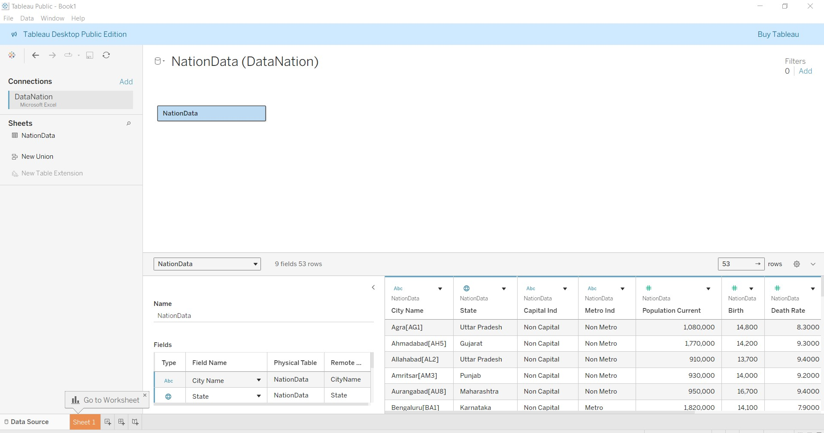
Data successfully loaded into Tableau with proper field recognition
Verified data types using Fields table at the bottom right of tableu.
State automatically recognized as Geographic Role
City, Capital Ind, Metro Ind recognized as Text (ABC)
Population, Birth Rate, Death Rate, Per Person Income recognized as Number (#)
Last Election Date identified correctly as Date.

Step 2: Create separate Cities by removing the Code associated with each cities.
Created a calculated field City with the formula:
Dragged City to Rows shelf
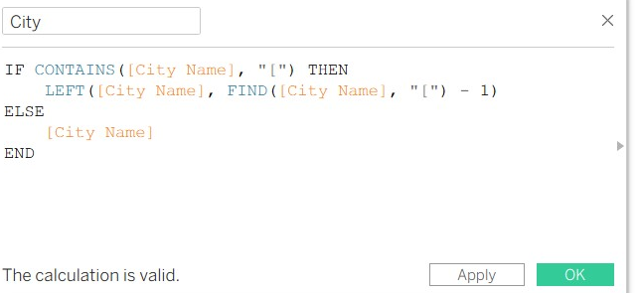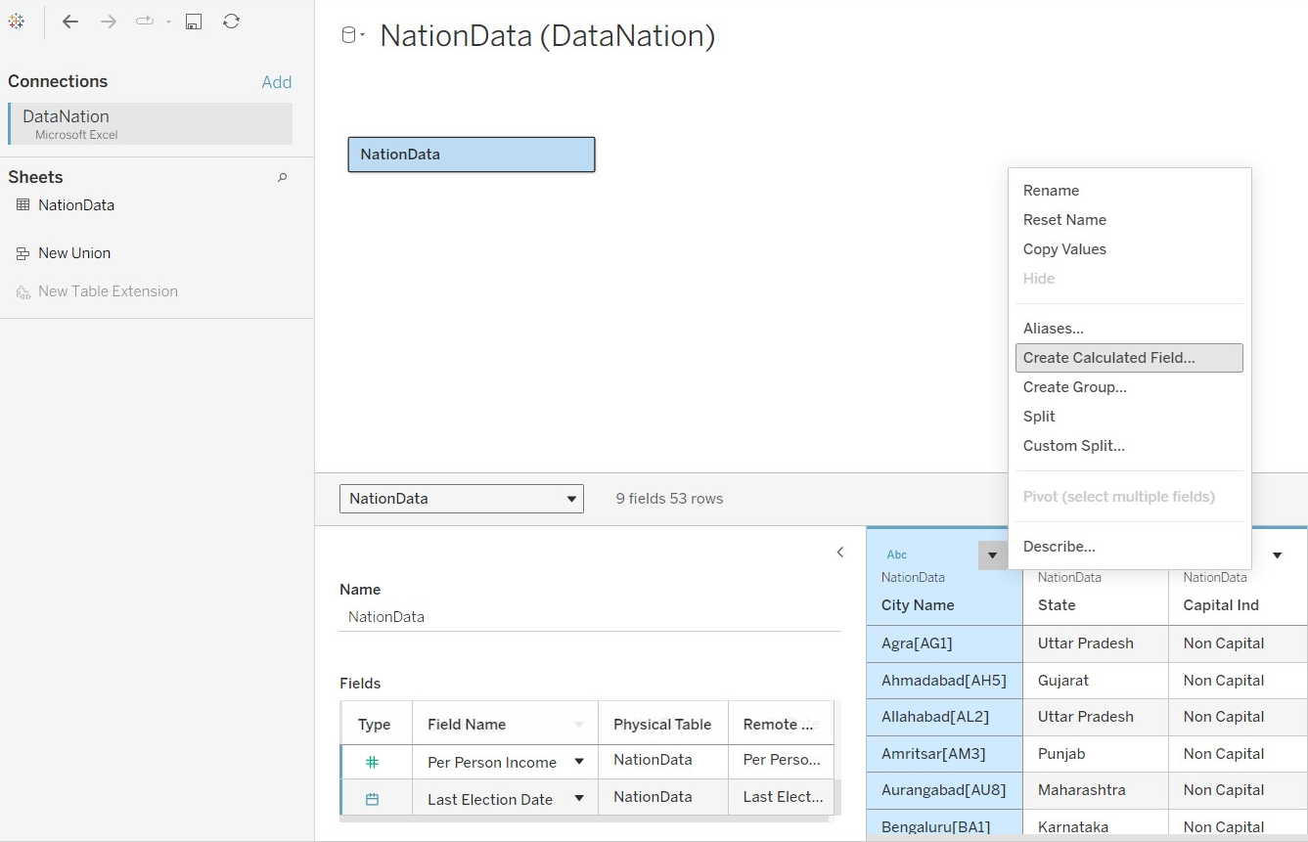
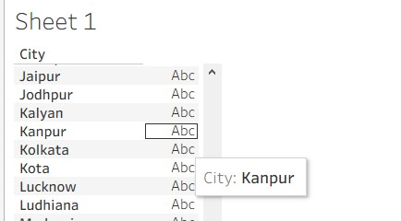

Step 3: Create a heirarchy of the state and city
Drag City onto State → Create Hierarchy → name it State → City.
Drag the hierarchy to Rows shelf to see states expandable to cities.
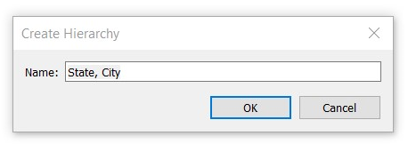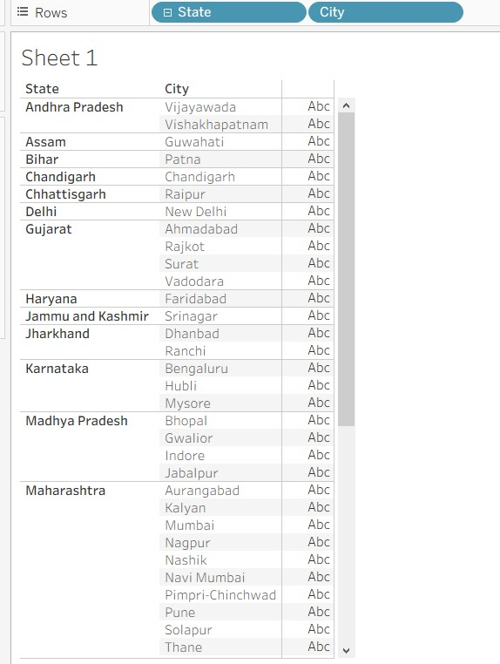

Step 4 : Visualize cities on a map.
- In the Data pane, double-click State → Tableau will automatically create a map showing all states.
- Double-click City → Tableau now plots city points on top of the states.
At this point, you should see small dots or marks representing each city.
Go to the Marks card (middle-left of the screen).
Currently, it might say Automatic. Click the dropdown.
Select Map → Filled Map.
Now each state appears as a filled shape, and cities are marked on it.
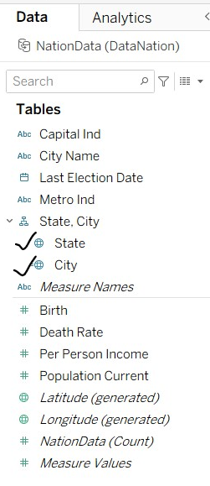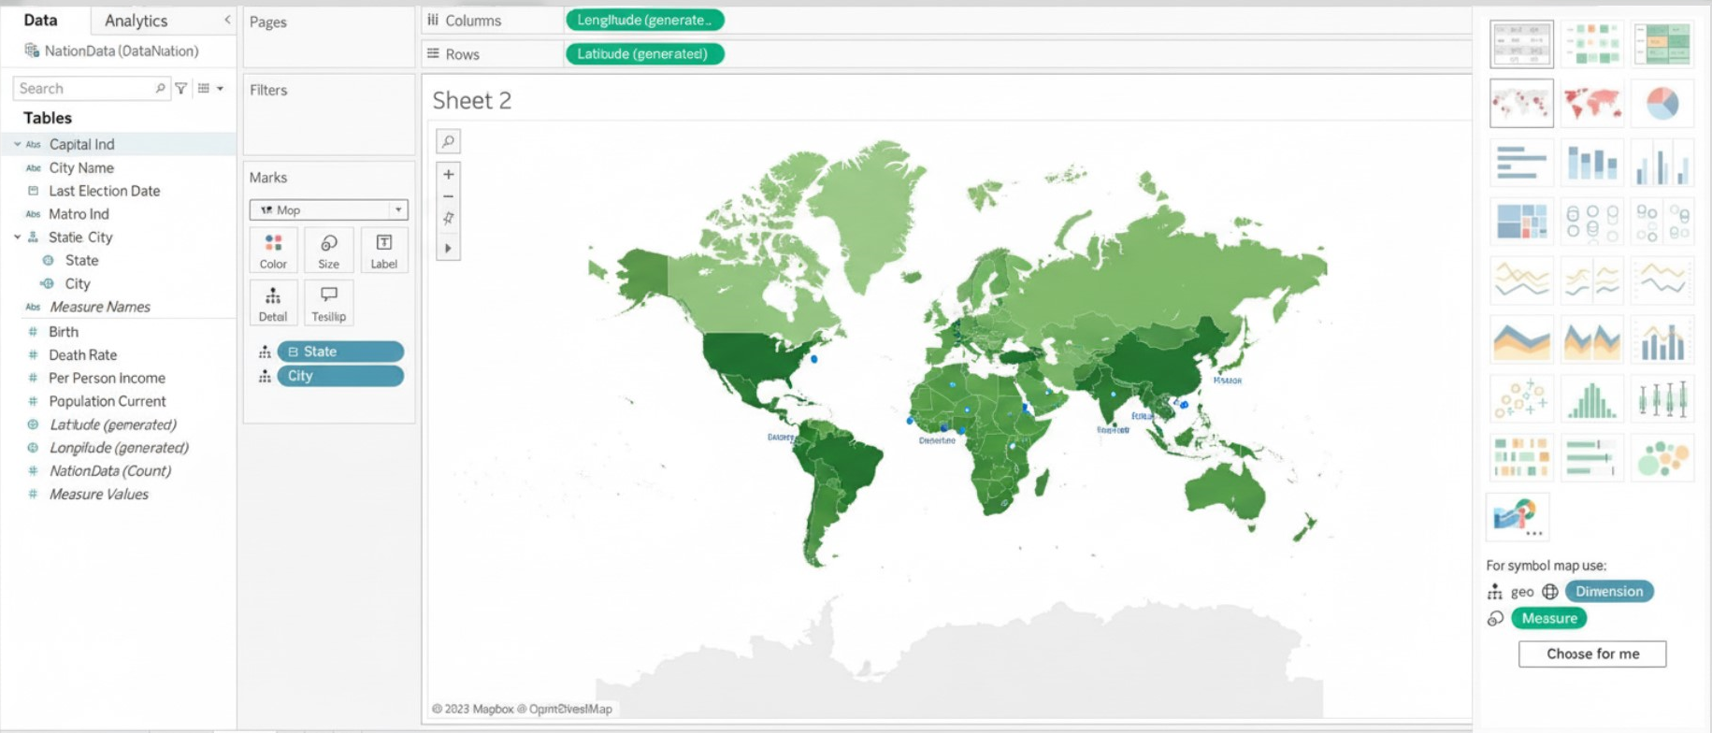

Step 5: Find the Death Rate for Cities with a ShapeCard.
The State and City fields were set with correct Geographical Roles.
The City field was used to generate the map view.
The Marks card was changed to Shape to represent each city.
Death Rate was dragged to Shape and Color to visually indicate variations.
Colors were adjusted to highlight differences in death rate clearly.
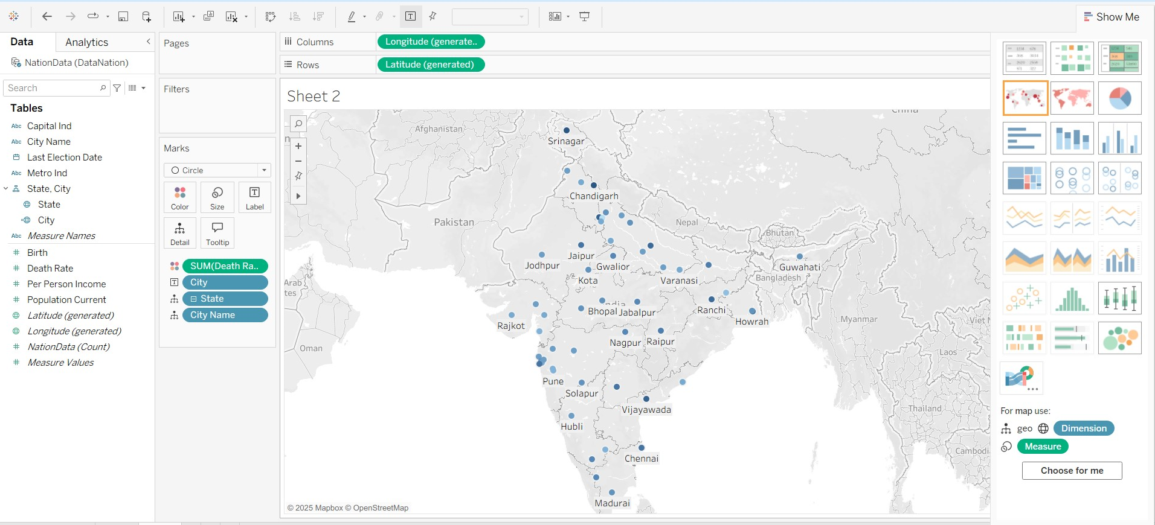
Tools Used
- Tableau Desktop/Public
- Data nation.csv dataset
Files Created
- `Data nation.twbx` (Tableau packaged workbook)
- Project Report Document

