SYMBIOSIS CENTER OF CORPORATE AND
PROFESSIONAL LEARNING
(A Unit of Symbiosis Skills and Professional University)

NEW STORE LAUNCH FEASIBILITY
& EXPANSION STRATEGY
Historical Market Performance Analysis for Retail Expansion

Name: Harshita Malhotra
Guide: Abhinash Jena

Batch Code: DBA 07 – KIET
Year: 2027

INDEX
Sr. No. | Content | Page
1 | Introduction | 3
2 | Literature Review / Background Study | 3
3 | Problem Statement & Objectives | 4
4 | Methodology / System Design | 5
5 | Implementation / Execution | 8
6 | Results & Analysis | 9
7 | Conclusion | 13
8 | References | 13
9 | Appendices | 14

1. Introduction

1.1 Background
Retail expansion decisions should be supported by evidence rather than based only on intuition. A market may have high sales but lower profitability, while another may show consistent performance across years and regions. This project uses historical retail transaction data to identify markets that deserve further consideration for a new store or branch.
The analysis uses 100,000 Indian retail transaction records covering 2019–2023. The workbook compares Sales, Profit, Orders and Profit Margin across states, regions, product categories, customer segments and years.

1.2 Significance of the Project
- Provides a single view of sales, profit, order volume and profitability.
- Compares historical performance across Indian states and regions.
- Highlights category, segment and yearly patterns that support expansion discussions.
- Creates an explainable shortlist for further feasibility investigation.

1.3 Scope of Work
- Data preparation and validation in Microsoft Excel.
- State, region, category, segment and year-wise analysis.
- Calculation of Sales, Profit, Orders, Profit Margin and Average Order Value.
- Transparent screening of candidate states using historical Sales and Profit.
- Excel dashboard and supporting summary tables.
Out of scope: actual store rent, footfall, competitor density, population, logistics cost, investment amount and other location-specific feasibility variables.

2. Literature Review / Background Study
Retail analytics commonly uses historical sales, profitability, geography, product category and time trends to compare market performance. Dashboards and summary tables help convert transaction-level information into decision-oriented market comparisons.

2.1 Gap Identified
A basic sales dashboard can show which states perform well, but it does not automatically convert those observations into an expansion shortlist. This project adds a simple screening rule based on state Sales and Profit compared with the ten-state averages.

3. Problem Statement & Objectives

3.1 Problem Statement
The business has historical retail transaction data across multiple Indian markets but needs a clear way to identify which markets show stronger evidence for further branch-expansion investigation. Looking only at sales may hide profitability differences, while looking only at profit may ignore transaction scale.

3.2 Objectives
- Measure overall Sales, Profit, Orders and Profit Margin.
- Compare historical performance across ten Indian states.
- Identify strong regions and product categories.
- Study Sales and Profit patterns from 2019 to 2023.
- Compare Consumer and Corporate segment performance.
- Apply a transparent High Potential rule to shortlist candidate states.
- Build an Excel dashboard for business stakeholders.

3.3 Stakeholder Analysis
Stakeholders were identified based on who provides requirements/data, consumes the analysis, or is affected by the expansion decision.
Stakeholder | Interest / Need | Constraint | Influence
Senior Management | Expansion decision, market recommendation, historical performance, business insights, market selection | Needs concise and reliable evidence for expansion decisions | High
Expansion Strategy Team | Market comparison, state performance, candidate ranking, expansion opportunity, geographic targeting | Location-specific information such as rent, footfall and competition is outside the current dataset | High
Finance & Operations | Sales performance, profitability, order volume, profit margin, operational feasibility | Financial and operational feasibility variables such as investment cost, logistics cost and other location-specific costs are outside the current dataset | High
Data Analyst | Data preparation, data cleaning & validation, KPI calculation, market analysis, dashboard, business insights, data limitations | Data quality and available business variables limit the analysis | Medium

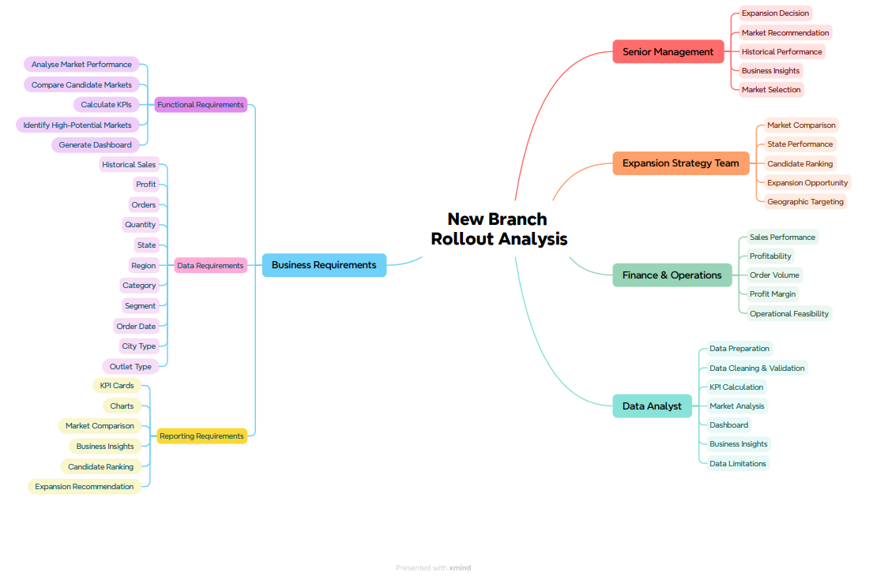
Figure 3.1: Stakeholder & Requirement Mind Map

4. Methodology / System Design

4.1 Tools & Technologies
- Microsoft Excel – data preparation, formulas, summary calculations, dashboard and charts.
- Lookup and conditional formulas – supporting transparent transformations and classification.
- Charts and KPI cards – visual comparison and decision communication.

4.2 Data Source
The analysis uses the Kaggle dataset “Indian Store Data” by Abu Humza Khan. The supplied workbook contains 100,000 Indian retail records covering 2019–2023, with fields including State, Region, Category, Segment, Order Date, Order ID, Sales, Profit, Quantity and Discount.
Dataset link: https://www.kaggle.com/datasets/abuhumzakhan/store-data/data
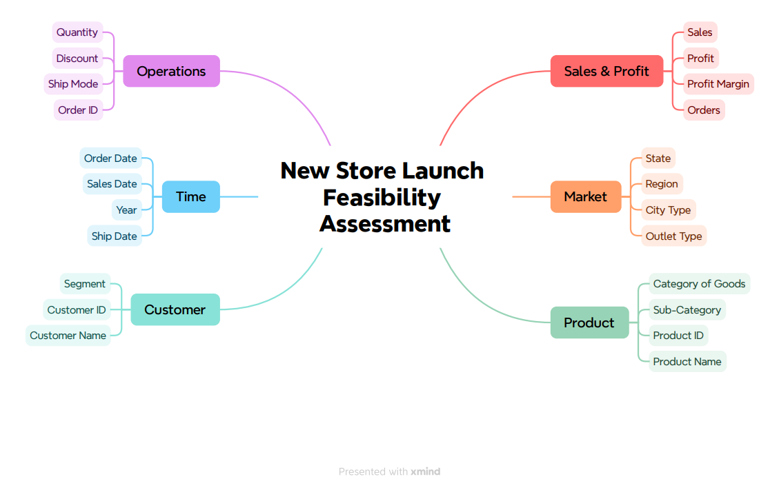
Figure 4.1: Data Model Fishbone Diagram for New Store Launch Feasibility Assessment

4.3 Workbook Data Flow
Raw Data → Cleaned Data → KPI Definitions → Summary Calculations → Dashboard

4.4 Business Process Flow
The process starts with defining the expansion objective and requirements, followed by data collection and validation. Historical market performance is analysed, candidate markets are screened, shortlisted markets are reviewed and the final recommendation is documented.
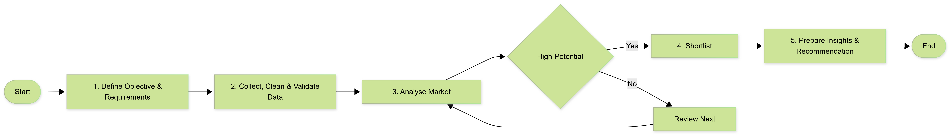
Figure 4.2: Business Process Flow for New Branch Rollout Analysis

4.5 UML Activity Diagram

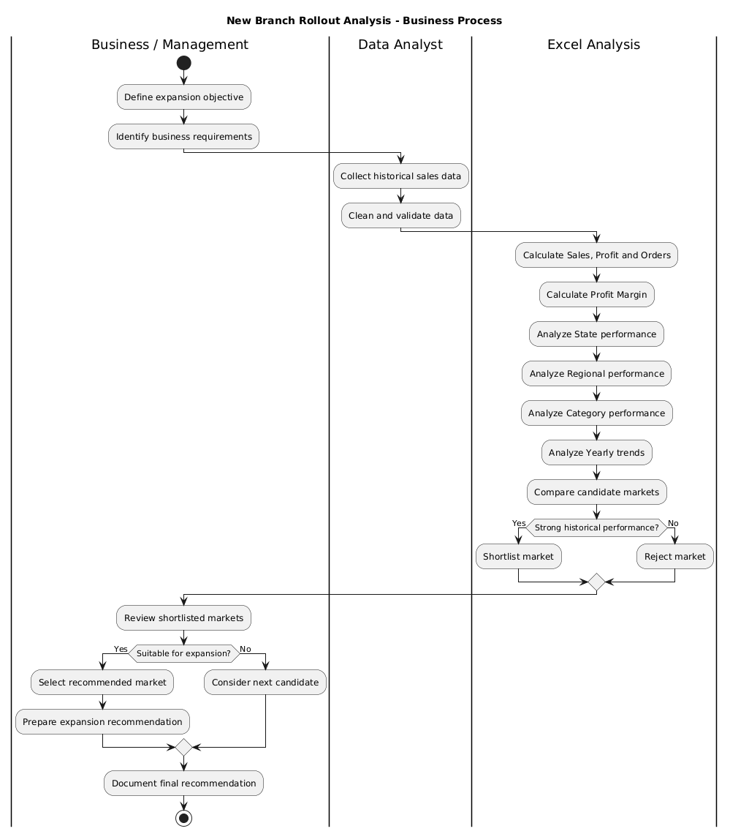
Figure 4.3: UML Activity Diagram for New Branch Rollout Analysis

5. Implementation / Execution

5.1 Data Preparation
The workbook contains a Raw_Data sheet and a Cleaned_Data sheet. The cleaned structure standardizes the fields required for analysis, including State, Region, Category, Segment, Order Date, Order ID, Sales, Profit, Quantity, Discount and derived Profit Margin.

5.2 Key Calculations
Measure | Logic | Purpose
Sales | SUM of Sales | Measures revenue generated.
Profit | SUM of Profit | Measures historical profitability.
Orders | COUNT of Order ID | Measures transaction volume.
Profit Margin | Profit ÷ Sales | Shows profitability efficiency.
AOV | Sales ÷ Orders | Shows average value per order.
High Potential | State Sales ≥ average AND State Profit ≥ average | Creates a transparent shortlist.

5.3 Workbook Structure
Sheet | Purpose
README | Project purpose, objective, screening rule, time basis and limitations.
Raw_Data | Original transaction-level data.
Cleaned_Data | Analysis-ready fields used for calculations.
KPI_definitions | KPI definitions and business rules.
Summary_Calculations | State, region, category, segment and yearly summaries.
Dashboard | Executive KPIs, candidate shortlist and key insights.

The workbook is designed to keep the calculations understandable and traceable from the source data to the final dashboard.

6. Results & Analysis

6.1 Overall Results
KPI | Result
Total Sales | ₹2,508.44 million
Total Profit | ₹375.53 million
Total Orders | 100,000
Overall Profit Margin | 14.97%
Average Order Value | ₹25,084.41
States Analysed | 10
Years Analysed | 2019–2023

These values were recalculated directly from the Cleaned_Data sheet of the submitted Excel workbook to ensure consistency with the reported analysis.

6.2 State Performance

Rank | State | Sales (₹M) | Profit (₹M) | Orders | Margin | Screen
1 | Rajasthan | 255.85 | 38.30 | 10,240 | 14.97% | High Potential
2 | Maharashtra | 252.38 | 37.89 | 10,001 | 15.01% | High Potential
3 | Punjab | 253.99 | 37.87 | 10,154 | 14.91% | High Potential
4 | West Bengal | 250.75 | 37.74 | 9,852 | 15.05% | Review
5 | Madhya Pradesh | 251.56 | 37.64 | 10,020 | 14.96% | High Potential

The ten-state averages used for screening are approximately ₹250.84 million in Sales and ₹37.55 million in Profit.
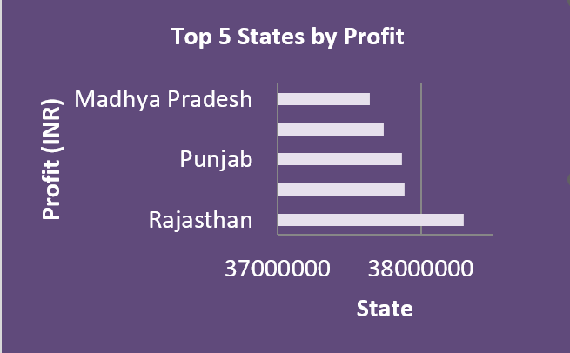
Figure 6.1: Top 5 States by Historical Profit

6.3 High Potential Candidate Screening
Rajasthan: Sales ₹255.85M and Profit ₹38.30M; both meet the ten-state averages.
Maharashtra: Sales ₹252.38M and Profit ₹37.89M; both meet the ten-state averages.
Punjab: Sales ₹253.99M and Profit ₹37.87M; both meet the ten-state averages.
Madhya Pradesh: Sales ₹251.56M and Profit ₹37.64M; both meet the ten-state averages.
Four states pass the current historical screening rule: Rajasthan, Maharashtra, Punjab, Madhya Pradesh. These are markets for further feasibility investigation, not automatic branch-opening decisions.

6.4 Regional Performance
Region | Sales (₹M) | Profit (₹M) | Margin
East | 635.32 | 95.15 | 14.98%
South | 629.06 | 94.22 | 14.98%
North | 624.45 | 93.10 | 14.91%
West | 619.61 | 93.06 | 15.02%

East is the strongest region by both Sales and Profit. West has the highest regional margin, showing why scale and profitability should be considered together.

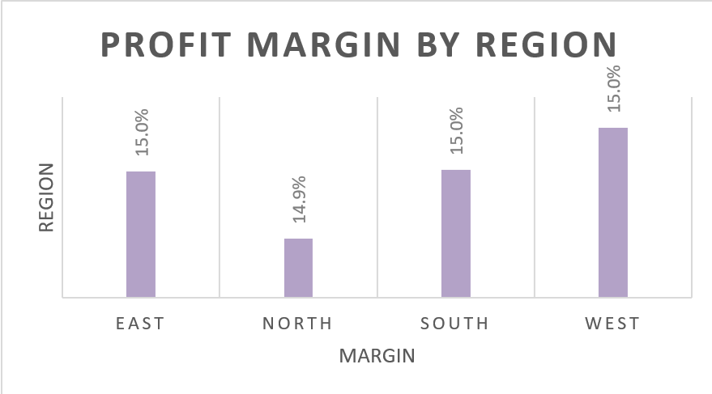
Figure 6.2: Profit Margin Comparison Across Regions

6.5 Category Performance

Category | Sales (₹M) | Profit (₹M)
Sessional Fruits & Vegetables | 419.94 | 62.77
Household Items | 419.79 | 62.87
Electric Appliances | 418.83 | 62.70
Dairy Products | 418.01 | 62.59
Fast Food | 417.85 | 62.79
Furniture | 414.02 | 61.81

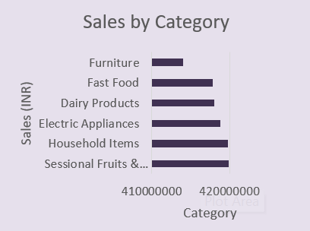
Figure 6.3: Sales Distribution Across Product Categories

6.6 Segment & Year-wise Performance
Consumer Sales: ₹1,253.30M (49.96%).
Corporate Sales: ₹1,255.14M (50.04%).
The two segments are almost evenly divided, so the current analysis does not indicate dependence on a single customer segment.

Year-wise Performance
Year | Sales (₹M) | Profit (₹M)
2019 | 502.18 | 75.15
2020 | 500.76 | 75.04
2021 | 501.28 | 75.13
2022 | 501.95 | 75.04
2023 | 502.27 | 75.18

Sales remain broadly stable across 2019–2023. The historical pattern therefore supports market comparison based on consistent performance rather than a strong growth-rate argument.

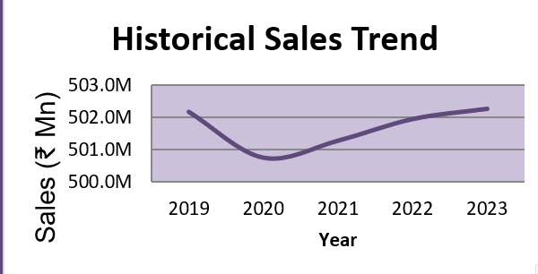
Figure 6.4: Historical Sales Trend

6.7 Key Insights
- Rajasthan is the strongest historical market in the current analysis, ranking first by profit.
- Rajasthan, Maharashtra, Punjab and Madhya Pradesh pass the High Potential screen.
- East is the strongest region by both Sales and Profit.
- Category performance is relatively close, so expansion should not depend on a single category.
- Consumer and Corporate Sales are almost evenly divided.
- Sales are broadly stable from 2019 to 2023.

7. Conclusion
The project converts a large Indian retail transaction dataset into a practical market-screening analysis for a new store launch. Microsoft Excel was used to organize, calculate, summarize and visualize performance across states, regions, categories, segments and years.
The analysis identifies Rajasthan as the strongest historical market and shortlists Rajasthan, Maharashtra, Punjab and Madhya Pradesh for further investigation. The recommendation is deliberately presented as a screening result rather than a final investment decision.

7.1 Business Recommendation
Based on historical Sales and Profit performance, Rajasthan should be considered the first market for detailed feasibility investigation. The other shortlisted states can be evaluated as secondary candidates.

7.2 Limitations & Next Steps
- The dataset does not contain actual store rent, footfall, competition, population, logistics cost or investment cost.
- Historical performance does not guarantee future branch performance.
- The High Potential rule uses only historical state Sales and Profit.
- Before an actual launch decision, location-specific market research and financial feasibility should be added.

8. References
Kaggle – Indian Store Data, Abu Humza Khan.
https://www.kaggle.com/datasets/abuhumzakhan/store-data/data
Microsoft Excel documentation – formulas, tables and charts.
Course materials on business analytics, requirement engineering, business process mapping and UML activity diagrams.

9. Appendices

Appendix A – Project Evidence
- Stakeholder & Requirement Mind Map
- Data Model Fishbone Diagram
- Business Process Flow
- UML Activity Diagram
- Final Excel Executive Dashboard screenshot
- Selected Excel charts supporting the Results & Analysis section

Appendix B – Excel Executive Dashboard

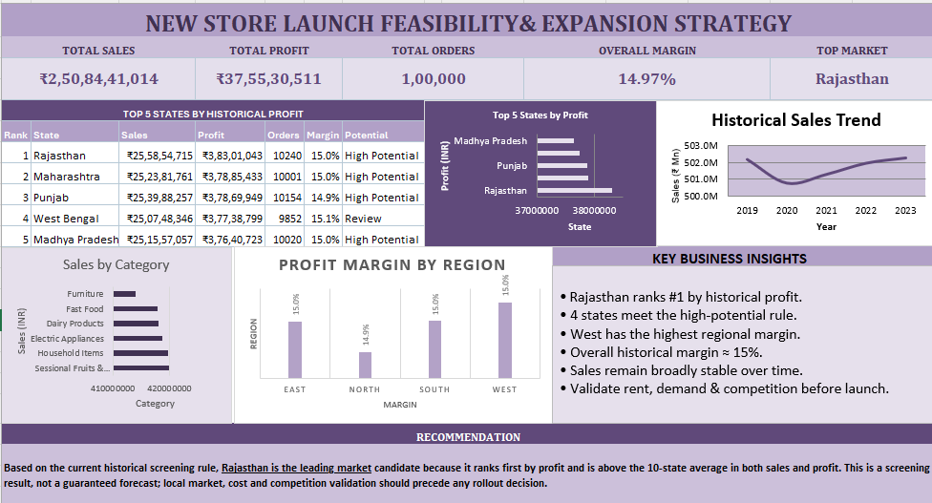

Appendix C – Important Assumptions
- Historical performance is used as an initial screening indicator, not a guarantee of future performance.
- High Potential means both state Sales and state Profit are at or above their ten-state averages.
- Final expansion approval requires additional market-specific evidence.
- All numerical results in this report were recalculated from the Cleaned_Data sheet of the submitted workbook.

