**A SEMINAR REPORT ON**

**“REAL TIME CHAT APPLICATION”**

SUBMITTED TO JAI NARAIN VYAS UNIVERSITY,

JODHPUR

IN PARTIAL FULFILLMENT FOR AWARD OF DEGREE

OF

**BACHELOR IN COMPUTER APPLICATIONS**

(BATCH 2022-2025)

SUBMITTED BY

**Harshita Sankhla**

UNDER THE GUIDANCE OF

**Mrs. Mamta Arora**

(**Asst. Prof.**)

 

**LUCKY INSTITUTE OF PROFESSIONAL STUDIES**

Affiliated to

**JAI NARAIN VYAS UNIVERSITY, JODHPUR**



##### **Faculty of Information Technology**

**Lucky Institute of Professional Studies**

**Jodhpur**

# CERTIFICATE

This is to certify that the seminar report titled “Quantum Computing” is an original work carried out by Harshita Sankhla under the supervision of Mamta Arora (Asst. Prof.). The report has been completed and submitted as part of the requirements for the award of Bachelor in Computer Applications from Lucky Institute of Professional Studies.

This report has been carried out during the academic year 2024-2025 and is an authentic record of the work done by Harshita Sankhla

**Mrs. Mamta Arora**

Asst. Prof.

Faculty of Information Technology

Date:

**ACKNOWLEDGMENT**

The success and final outcome of this seminar report required a lot of guidance and assistance from many people and we are extremely privileged to have got this all along the completion of the report. All that I have done is only due to such supervision and assistance and we would not forget to thank them.

I am grateful to the mentor **Mrs. Mamta Arora (Asst. Prof.)** for giving guidelines to make the report successful. The interest and attention which has shown so graciously lavished upon this work.

I extend my thanks to **Dr. Saurabh Khatri (HoD, IT)** for his cooperation, guidance, encouragement, inspiration, support and attention led to completing this report.

I would like to give sincere thanks to **Dr. Manish Kachhawaha (Director)** and **Mr. Arjun Singh Sankhala (Principal)** for providing a cordial environment to exhibit my abilities to the fullest.

Yours Sincerely,

**Harshita Sankhla**

# DECLARATION

I hereby declare that this Seminar is a record of original work done by me under the supervision and guidance of Mrs. Mamta Arora (Asst. Prof.). I further certify that this report work has not formed the basis for the award of the Degree/Diploma or similar work to any candidate of any university and no part of this report is reproduced as it is from any source without seeking permission.

Student name: Harshita Sankhla

Roll no: 23BCA23279

Date:

## 

## 

Abstract

Quantum computing is an advanced field of computing that leverages the principles of quantum mechanics to perform calculations far faster than classical computers. Unlike traditional computers, which use bits to represent data as either 0 or 1, quantum computers use quantum bits or qubits, which can exist in multiple states at the same time due to a property called superposition. This allows quantum computers to solve complex problems more efficiently.

In addition to superposition, entanglement is another important concept. When qubits become entangled, the state of one qubit can depend on the state of another, even if they are far apart. This phenomenon enables quantum computers to perform multiple calculations simultaneously, offering a huge advantage over classical computers.

Quantum computing has the potential to revolutionize many industries. It can improve fields such as cryptography, where it could break current encryption methods, or help in drug discovery by simulating complex molecules. It could also assist in optimizing supply chains, improving machine learning algorithms, and advancing artificial intelligence. Moreover, quantum computing can help address problems that are too complex for classical computers, such as predicting weather patterns with higher accuracy or simulating physical systems for scientific research.

However, there are still challenges, such as making quantum computers stable enough for practical use and reducing errors caused by quantum noise. Developing algorithms that can effectively use quantum processors is another challenge. Despite these obstacles, quantum computing promises to unlock new possibilities in technology and problem-solving that were previously unimaginable.

In summary, quantum computing is a groundbreaking technology that harnesses the power of quantum mechanics to process information in ways that classical computers cannot, offering transformative potential for many fields. As the technology matures, it could lead to solutions for some of the world's most pressing challe.

Table of Contents

|  |  |  |
| --- | --- | --- |
| **S.NO.** | **TOPICS** | **PAGE NO.** |
| 1 | Introduction To Quantum Computing | **1-2** |
| **2** | **Fundamentals of Quantum Computing** | **3-7** |
|  | 2.1 Classical Computing vs. Quantum Computing | 4 |
|  | 2.2 Qubits and Quantum States | 5 |
|  | 2.3 Superposition and Entanglement | 6 |
|  | 2.4 Quantum Gates and Circuits | 7 |
| **3** | **Key Concepts in Quantum Mechanics** | **8-9** |
| **4** | **Quantum Algorithms** | **10-11** |
| **5** | **Quantum Hardware** | **12-15** |
| **6** | **Applications of Quantum Computing** | **16-18** |
| **7** | **Current Challenges and Research Directions** | **19-22** |
| **8** | **Future Prospects and Implications** | **23-27** |
| **9** | **Conclusion** | **28-29** |
| **10** | **References** | **30-32** |
| **11** | **Appendices** | **33-36** |

## 1. Introduction To Quantum Computing

## 1.1 Background and Motivation

## Quantum computing is a rapidly emerging field that combines the principles of quantum mechanics with computer science to revolutionize data processing. Unlike classical computers that process information in binary bits, quantum computers use quantum bits (qubits), which allow for the simultaneous representation of multiple states due to quantum phenomena like superposition and entanglement. This innovation holds the potential to solve complex problems that are currently beyond the reach of classical computers, particularly in areas such as cryptography, drug discovery, optimization, and artificial intelligence.

## The motivation for exploring quantum computing stems from its ability to address challenges faced by current computing systems, such as limitations in speed and efficiency when dealing with large-scale, intricate computations. With quantum computing, the possibilities for solving problems across a variety of fields are immense and transformative, which is why it has attracted significant research and investment.

## 1.2 Objectives and Scope

## The primary objective of this report is to provide an overview of quantum computing, focusing on its key concepts, potential applications, and current challenges. The report aims to:

## Explain the fundamental principles of quantum mechanics that enable quantum computing, including superposition and entanglement.

## Explore the potential applications of quantum computing in fields such as cryptography, drug discovery, and optimization.

## Discuss the current challenges in developing stable and practical quantum computers.

## Present an outlook on the future of quantum computing and its impact on industries and society.

## The scope of the report includes an exploration of the basic concepts of quantum computing, its practical uses, and ongoing research efforts. It does not delve into the deep technicalities of quantum algorithms but aims to give a broad understanding of the field's significance.

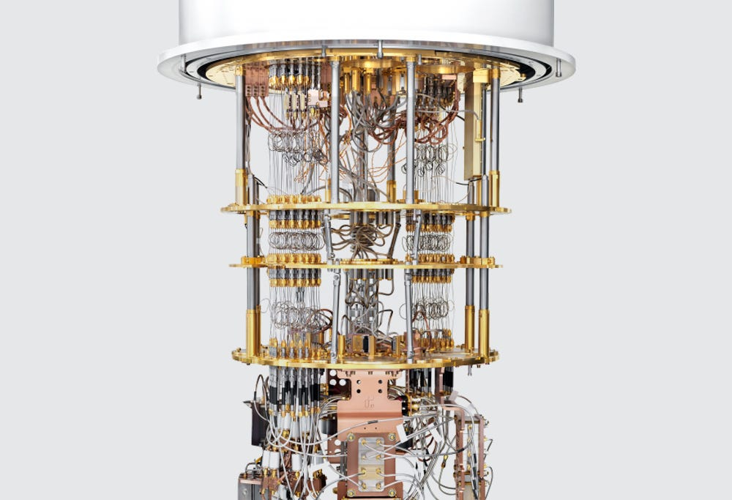

**Quantum Computer**

# 2. Fundamentals of Quantum Computing

## 2.1 Classical Computing vs. Quantum Computing

## Classical computing, which forms the basis of almost all modern computing systems, is based on bits, the fundamental unit of information. A bit can either be 0 or 1, and all computations and data processing in classical computers are done through combinations of these 0s and 1s. Classical computers perform calculations sequentially, meaning they process one operation at a time, although modern advancements like multi-core processors and parallel computing allow for some degree of simultaneous processing.

## Quantum computing, on the other hand, leverages the principles of quantum mechanics, which govern the behavior of particles at the atomic and subatomic levels. Unlike classical computers, which use bits to represent data, quantum computers use quantum bits or qubits. Qubits are fundamentally different from classical bits because they can represent both 0 and 1 simultaneously due to the principle of superposition. This property enables quantum computers to perform many calculations at the same time.

## Quantum computing is not merely faster than classical computing for some tasks, but it offers exponential speedup, particularly for problems involving large-scale computations that are infeasible for classical systems. For example, problems such as simulating complex molecular structures, factoring large numbers (important for cryptography), or optimizing large systems can benefit immensely from quantum computing.

## 

## 2.2 Qubits and Quantum States

The evolution of real-time chat applications can be traced back to the early days of the internet, A qubit is the basic unit of information in quantum computing. Unlike classical bits, which can be either 0 or 1, a qubit can exist in a superposition of both states at the same time. This means a qubit can be in a state where it has a probability of being 0 and a probability of being 1 until it is measured. This superposition property allows quantum computers to perform many calculations simultaneously.

The state of a qubit is represented mathematically as a quantum state, which can be described by a vector in a complex vector space. A qubit's state can be written as a combination of both 0 and 1, expressed as:

**Qubit state=α∣0⟩+β∣1⟩**

Where **α** and **β** are complex numbers that represent the probability amplitudes for the qubit being in state 0 or 1, and the sum of the squares of their magnitudes (|α|² + |β|²) must equal 1. The values of α and β determine the probability of measuring the qubit as 0 or 1 when observed. If the qubit is measured, it will collapse into one of the states, either 0 or 1, with the corresponding probability.

In addition to the basic two states (0 and 1), a qubit can also be in any superposition of these states, allowing quantum computers to store and process much more information in parallel than classical computers.

## 2.3 Superposition and Entanglement

Two of the most critical properties of quantum computing are **superposition** and **entanglement**, which enable quantum computers to perform complex tasks more efficiently than classical systems.

* **Superposition**: This is the ability of a qubit to exist in multiple states at once. Instead of being in a definite state of 0 or 1, a qubit in superposition can be in a state that is simultaneously both 0 and 1. For example, a qubit can be in a superposition of states such that it has a 50% chance of being measured as 0 and a 50% chance of being measured as 1. The true power of superposition lies in the fact that quantum computers can perform calculations on all possible states at once, exponentially increasing their computational capacity. This allows quantum computers to handle vast amounts of data and perform multiple computations simultaneously, which classical computers cannot achieve in a reasonable time frame.
* **Entanglement**: Entanglement is a quantum phenomenon where two or more qubits become linked in such a way that the state of one qubit is directly related to the state of the other, even if the qubits are far apart in space. Once qubits become entangled, the measurement of one qubit’s state instantly determines the state of the other qubit(s), regardless of the distance separating them. This interconnectedness is what allows quantum computers to perform multiple operations in parallel and is a fundamental feature of quantum computing algorithms.

Entanglement can be used for tasks such as quantum teleportation (the transfer of quantum states between distant particles) and quantum cryptography, which ensures secure communication by making eavesdropping virtually impossible. When qubits are entangled, they allow quantum computers to solve problems with far greater efficiency compared to classical systems.

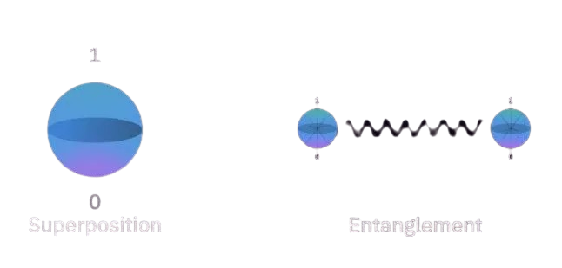

**2.4 Quantum Gates and Circuits**

Just as classical computing relies on logic gates (AND, OR, NOT) to perform computations on bits, quantum computing relies on quantum gates to manipulate qubits. However, unlike classical gates, quantum gates operate on qubits in ways that exploit the principles of quantum mechanics, such as superposition and entanglement.

* **Quantum Gates**: Quantum gates are the fundamental building blocks of quantum algorithms. They operate on qubits and change their state. A quantum gate can manipulate a qubit’s state, perform operations such as flipping a qubit’s value, or create entanglement between qubits. Some of the most important quantum gates include:
  + Hadamard Gate (H): This gate creates a superposition state, meaning it transforms a qubit from a definite state (0 or 1) into a superposition of both 0 ,1.
  + Pauli-X Gate: Also known as the quantum NOT gate, this flips the state of a qubit, changing it from 0 to 1 or from 1 to 0. It is analogous to the classical NOT gate.
  + Pauli-Y and Pauli-Z Gates: These gates rotate the qubit's state around the Y and Z axes, respectively. They are important for manipulating qubits in more advanced quantum algorithms.
  + CNOT Gate (Controlled-NOT): This is a two-qubit gate that flips the state of one qubit (the target qubit) only if the other qubit (the control qubit) is in state 1. The CNOT gate is essential for creating entanglement between qubits.
* **Quantum Circuits**: Quantum circuits are sequences of quantum gates applied to qubits to perform complex operations. Just as classical computers use logic circuits to process data, quantum circuits combine quantum gates to solve problems. A quantum circuit typically begins with qubits initialized in a base state (such as 0), and then a series of quantum gates are applied to manipulate their states. The final state of the qubits after all operations have been applied is measured, giving the solution to the problem.

Quantum circuits can be used to implement quantum algorithms like Shor’s algorithm for integer factorization (which could break classical encryption methods) or Grover’s algorithm for searching through unsorted databases faster than classical algorithms.

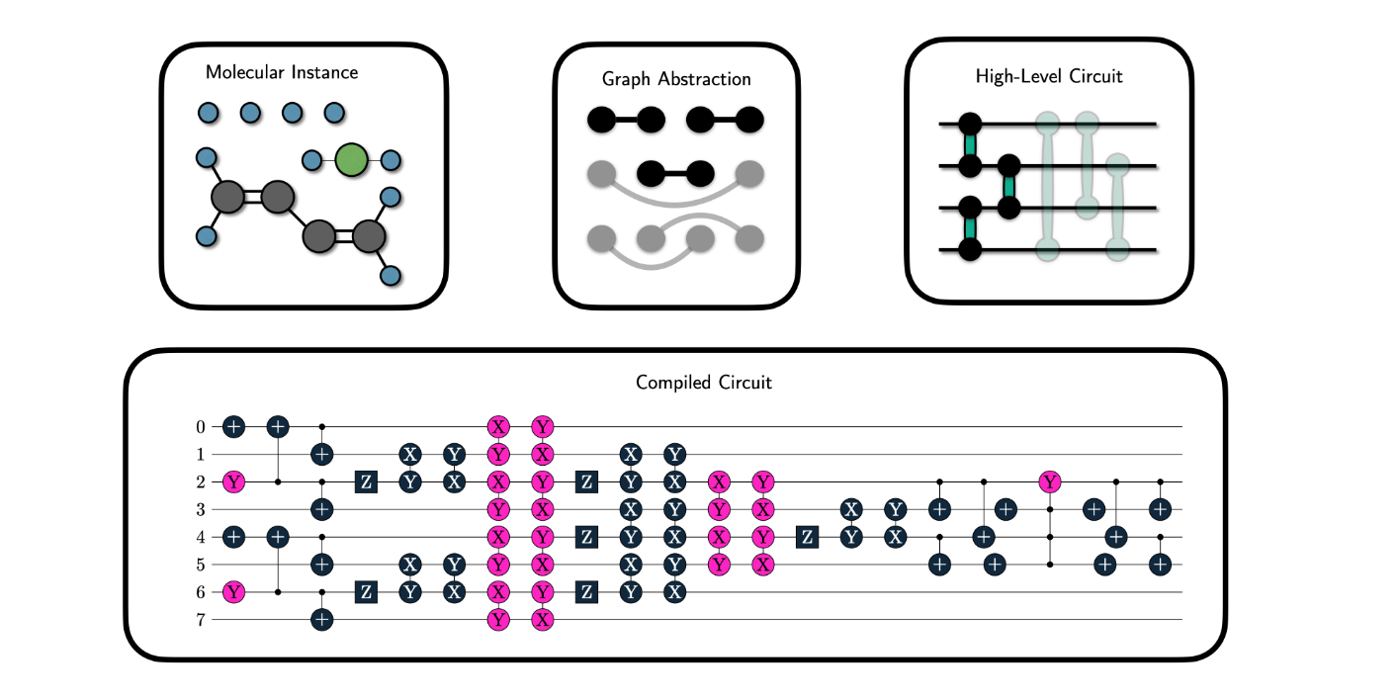

**Quantum Circuits**

# 3. Key Concepts in Quantum Mechanics

## 3.1 Principles of Quantum Mechanics

Quantum mechanics is the fundamental theory that describes the behavior of matter and energy at very small scales, such as atoms and subatomic particles. Unlike classical mechanics, quantum mechanics is governed by principles like superposition, entanglement, and wave-particle duality. Superposition refers to the ability of quantum systems (like qubits) to exist in multiple states at once. For example, a qubit can be both 0 and 1 simultaneously, as opposed to classical bits which are either 0 or 1.

Entanglement is another key concept, where particles become linked in such a way that the state of one particle is directly related to the state of another, no matter how far apart they are. Wave-particle duality means that particles such as electrons can behave both as particles and as waves, depending on how they are observed

**3.2 Quantum Measurement and Decoherence**

Quantum measurement is a process in which a quantum system (like a qubit) is observed, causing it to collapse into one of its possible states. For instance, when you measure a qubit in superposition, it will collapse to either 0 or 1. The measurement itself is a crucial aspect of quantum mechanics, as it affects the system.

Decoherence refers to the loss of quantum coherence between the states of a system, typically due to its interaction with the environment. When this happens, quantum systems begin to behave more classically, and their quantum properties (like superposition) are lost. Decoherence is one of the major challenges in building practical quantum computers, as it leads to errors in quantum computations.

**3.3 Quantum Error Correction**

Quantum error correction is a set of techniques used to protect quantum information from errors due to decoherence and other quantum noise. Since qubits are highly sensitive to their surroundings, even small interactions with the environment can cause errors. Quantum error correction codes are designed to detect and correct these errors without measuring the quantum state directly (which would collapse the superposition).

These codes rely on encoding the quantum information in a way that allows recovery from errors. One well-known method is the Shor code, which encodes a single logical qubit into multiple physical qubits to reduce the chances of an error affecting the computation.

# 

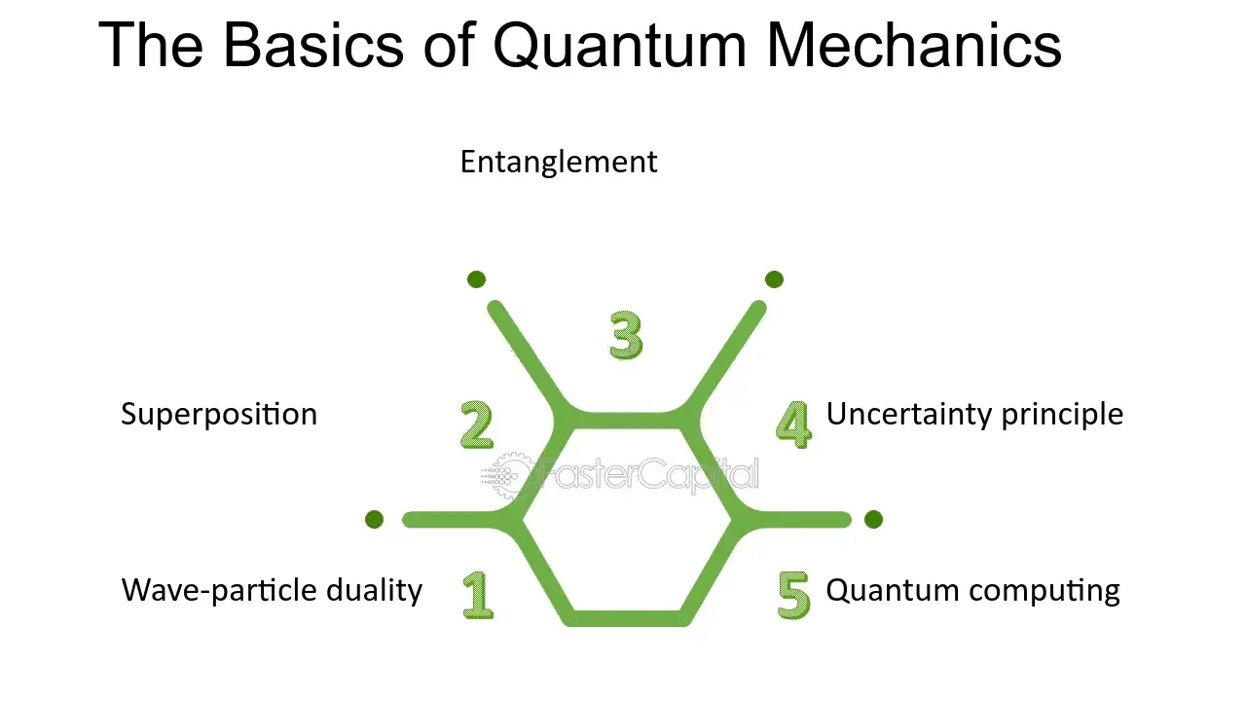

# 4. Quantum Algorithms

## 4.1 Introduction to Quantum Algorithms

## Quantum algorithms leverage the unique properties of quantum mechanics, such as superposition and entanglement, to solve problems more efficiently than classical algorithms. Unlike classical algorithms that operate on binary bits, quantum algorithms work on quantum bits (qubits), which can exist in multiple states simultaneously. This allows quantum computers to perform certain calculations exponentially faster than classical computers.

## The power of quantum algorithms comes from their ability to process many possibilities at once. Classical algorithms typically process one possibility at a time, but quantum algorithms, by exploiting quantum parallelism, can consider multiple possibilities at the same time. This can drastically reduce the time needed to solve certain types of complex problems.

* **Quantum Speedup**: Quantum computers can outperform classical computers in solving certain problems faster by leveraging quantum parallelism.
* **Quantum Parallelism**: Quantum algorithms use the ability of qubits to represent multiple states simultaneously, allowing for faster problem-solving.
* **Speed and Complexity**: Quantum algorithms have the potential to solve problems that are currently intractable for classical computers.

**4.2 Shor's Algorithm for Factoring**

Shor's algorithm is one of the most famous quantum algorithms, developed by Peter Shor in 1994. It solves the problem of integer factorization, which is the process of finding the prime factors of a large number. Classical computers take an exponential amount of time to factorize large numbers, especially when the number is very large, which is the basis for many encryption methods, such as RSA.

## Shor's algorithm can factor large numbers in polynomial time, which is exponentially faster than any known classical algorithm. This breakthrough has profound implications for cryptography, as many encryption systems rely on the difficulty of factorizing large numbers. If quantum computers can run Shor's algorithm efficiently, it could break current encryption schemes.

## 4.3 Grover's Algorithm for Search

## Grover's algorithm, developed by Lov Grover in 1996, is a quantum algorithm designed for searching an unsorted database or solving black-box problems. In classical computing, if you have a database with N items and you are searching for a specific item, you would need to check each item one by one, taking O(N) time.

## Grover's algorithm reduces this search time to O(√N), meaning it can search an unsorted database exponentially faster than classical algorithms. This makes it particularly useful in situations where you need to search large databases or perform optimization tasks.

* **Unsorted Database Search**: Grover’s algorithm is designed to search through unsorted data faster than classical search algorithms.
* **Quantum Speedup**: While classical algorithms require O(N) time, Grover’s algorithm requires O(√N) time, giving it a quadratic speedup.
* **Applications**: Useful in database search, cryptography, and optimization problems.

## 4.4 Other Notable Quantum Algorithms

## In addition to Shor's and Grover's algorithms, there are other quantum algorithms that have shown promise for solving complex problems. These algorithms often take advantage of quantum parallelism and other quantum properties to outperform classical counterparts.

* **Quantum Fourier Transform (QFT)**: A quantum version of the classical Fourier transform, used in many quantum algorithms, including Shor's algorithm.
* **Quantum Approximate Optimization Algorithm (QAOA)**: An algorithm designed for solving combinatorial optimization problems, like the traveling salesman problem.
* **Quantum Walks**: A quantum algorithm that generalizes classical random walks, useful for solving certain types of graph traversal problems.

# 5. Quantum Hardware

## 5.1 Quantum Computer Architectures

Quantum computer architecture refers to the overall design and structure of quantum computers. Unlike classical computers that use a simple architecture of processors, memory, and I/O systems, quantum computers require specialized architectures to manage and manipulate quantum bits (qubits). Quantum computing architectures include quantum gates, quantum circuits, and systems that can handle the unique behaviors of qubits like superposition and entanglement.

Common architectures for quantum computing include:

* **Gate-based Quantum Computing**: This is the most common model where quantum operations are performed using quantum gates, similar to logic gates in classical computing. Quantum gates are applied to qubits to perform operations like entanglement and superposition.
* **Measurement-based Quantum Computing**: This model focuses on using entangled quantum states for computation, where the measurement of certain qubits leads to computation.
* **Topological Quantum Computing**: This architecture seeks to use anyons (quasi-particles) for robust qubits that are less prone to errors due to decoherence.

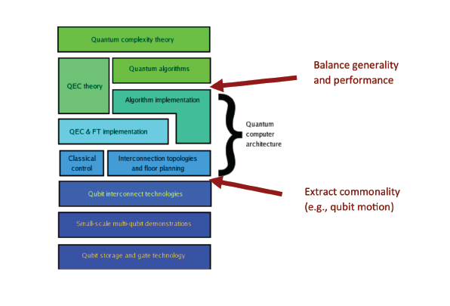 Quantum Computer Architecture

**5.2 Types of Qubits (Superconducting, Trapped Ions, etc.)**

Qubits are the fundamental units of quantum computing, and their physical implementation plays a critical role in the performance and scalability of quantum computers. Different types of qubits are used in quantum computers, each with its advantages and challenges.

## Superconducting Qubits: These qubits are made using circuits of superconducting material, where the qubit is represented by the state of the current in the circuit. Superconducting qubits are widely used in many quantum computing platforms, including IBM and Google’s quantum computers. They are highly controllable but are sensitive to noise and require extremely low temperatures.

## Trapped Ion Qubits: In this type of qubit, ions (charged atoms) are trapped in electromagnetic fields and manipulated using lasers to perform quantum operations. Trapped ions are highly stable and have long coherence times but are difficult to scale to large numbers of qubits.

## Photonic Qubits: These qubits use the quantum properties of photons, such as polarization, to encode information. Photonic qubits are resistant to decoherence and can travel long distances, making them ideal for quantum communication.

## Topological Qubits: This type of qubit uses anyons (special quasi-particles) and has the potential for more stable quantum computing. While still in the experimental phase, topological qubits promise to be less susceptible to errors due to decoherence.

## 5.3 Challenges in Building Quantum Computers

Building a practical and scalable quantum computer comes with numerous challenges due to the fragile nature of quantum states. Some of the key challenges are:

* **Decoherence and Noise**: Quantum systems are highly sensitive to their environments, and even small disturbances can lead to loss of information (decoherence). Minimizing quantum noise is one of the biggest challenges in quantum computing.
* **Scalability**: It is difficult to scale up the number of qubits in a quantum computer while maintaining their coherence and minimizing errors. As the number of qubits increases, so does the complexity of controlling and interacting with them.
* **Error Correction**: Quantum error correction is vital to ensure reliable computation, but it requires many physical qubits to represent a single logical qubit. This introduces the problem of overhead and the need for new error correction codes.
* **Temperature Requirements**: Many quantum computing systems, such as superconducting qubits, need to operate at extremely low temperatures (near absolute zero), which requires complex and expensive cryogenic systems.

## 5.4 Recent Advancements in Quantum Hardware

Despite the challenges, significant progress has been made in quantum hardware in recent years. Some key advancements include:

* **Quantum Supremacy**: In 2019, Google’s quantum computer, Sycamore, achieved "quantum supremacy" by solving a specific problem faster than the world’s fastest classical supercomputer. This was a significant milestone in quantum computing.
* **Improved Qubit Fidelity**: Researchers have been working on improving the fidelity (accuracy) of qubits, which directly impacts the performance of quantum computers. This includes advancements in qubit design, error correction techniques, and quantum gate operations.
* **Quantum Networks**: Progress is being made in creating quantum communication networks, using photonic qubits to transmit quantum information over long distances, a key component of quantum internet.
* **Commercial Quantum Computers**: Companies like IBM, Google, and Rigetti are making strides in building commercially available quantum computers. IBM’s Quantum Hummingbird, for example, is a 65-qubit processor that has shown considerable improvements over earlier models

# 6. Applications of Quantum Computing

## 6.1 Cryptography and Security

## Quantum computing has the potential to revolutionize the field of cryptography, particularly in the context of data encryption and security. Classical cryptography relies on problems like prime factorization (e.g., RSA encryption) or discrete logarithms, which are computationally hard for classical computers to solve. However, quantum computers, through algorithms like Shor's algorithm, can break these cryptographic systems by factoring large numbers in polynomial time, which classical computers can't do efficiently.

## This means that the encryption methods we rely on for secure communication, financial transactions, and data storage could become vulnerable in the era of quantum computing. To counter this, researchers are developing quantum-resistant cryptography, which aims to create encryption methods that are secure even against quantum attacks. Post-quantum cryptography is a major area of research, and quantum key distribution (QKD) is one technique that allows secure communication using the principles of quantum mechanics, ensuring that any attempt to intercept the communication will be detected.

## Quantum Threat to Current Cryptosystems: Quantum computers could potentially break widely used encryption methods like RSA and ECC.

## Post-Quantum Cryptography: Developing new encryption methods that are resistant to quantum attacks.

## Quantum Key Distribution (QKD): A method of secure communication that uses quantum mechanics to prevent eavesdropping.

## 6.2 Drug Discovery and Material Science

One of the most exciting prospects of quantum computing is its potential to revolutionize drug discovery and materials science. The behavior of molecules, atoms, and chemical reactions follows quantum mechanical principles, which are often too complex to model accurately with classical computers. Quantum computers, however, can simulate quantum systems directly, opening the door to more accurate and efficient simulations of molecular interactions and material properties. This could drastically accelerate the process of designing new drugs and materials.

In drug discovery, quantum computing could enable researchers to simulate the behavior of molecules, predict their interactions with target proteins, and identify promising drug candidates in a fraction of the time it would take with classical methods. This is particularly significant in the search for treatments for complex diseases like cancer, Alzheimer's, and rare genetic disorders, where finding effective drugs is a long and costly process. In materials science, quantum computing could help design advanced materials with specific properties, such as superconductors or more efficient battery materials, by simulating how atoms interact at the quantum level. This could lead to breakthroughs in energy storage, electronics, and manufacturing.

## 6.3 Optimization Problems

Optimization is at the core of many real-world problems, ranging from logistics and supply chain management to financial portfolio optimization and transportation scheduling. These problems often involve finding the best possible solution from a vast set of possible combinations, which is a computationally intensive task for classical computers. Quantum computers can offer significant improvements in solving such problems.

For example, **quantum annealing** is a quantum algorithm that has been specifically designed to solve optimization problems. Quantum annealers, like those developed by companies such as D-Wave, can evaluate many possible solutions to an optimization problem simultaneously, allowing them to quickly find the best solution or a near-optimal one. This has far-reaching applications in industries like logistics, where optimizing delivery routes, managing supply chains, or scheduling production can result in significant cost savings. In finance, quantum computing could improve portfolio optimization by considering more variables and finding the best asset allocation strategies with greater precision and speed.

## 6.4 Machine Learning and Artificial Intelligence

Quantum computing is increasingly being seen as a tool to enhance the capabilities of machine learning (ML) and artificial intelligence (AI). The fundamental reason for this is that quantum computers can process large volumes of data and perform complex computations exponentially faster than classical computers. This enables new approaches in training AI models, processing big data, and optimizing machine learning algorithms.

Quantum machine learning (QML) could dramatically improve tasks such as classification, clustering, and regression, which are common in ML applications. For instance, quantum computers can exploit quantum superposition and entanglement to perform data analysis much faster than classical computers, making it possible to handle more complex datasets, such as large-scale genomic data, in real time. Quantum-enhanced feature selection and optimization algorithms could also lead to more accurate and efficient models. In natural language processing (NLP), quantum computing could help accelerate the training of neural networks, allowing for faster language translation, sentiment analysis, and speech recognition. Moreover, AI systems built with quantum-enhanced algorithms could exhibit superior pattern recognition, predictive analytics, and decision-making capabilities, leading to more intelligent automation and smart systems across industries like healthcare, robotics, and autonomous vehicles.

# 

# 

# 7. Current Challenges and Research Directions

## 7.1 Technical Challenges (Scalability, Error Rates, etc.)

Quantum computing holds immense promise, but there are still several significant technical challenges that need to be addressed before it can achieve its full potential. Some of the key challenges include scalability, error rates, and hardware limitations.

* **Scalability**: Quantum computers require qubits (quantum bits) to process information. A quantum computer's power grows exponentially with the number of qubits, but building systems with large numbers of qubits is a major challenge. Current quantum computers have relatively few qubits (ranging from a few dozen to a few hundred), and adding more qubits without compromising their reliability and coherence is technically demanding. The challenge is to scale quantum systems while maintaining control over each qubit and their quantum entanglement.
* **Error Rates and Decoherence**: Quantum systems are highly sensitive to external noise and environmental interference, which can cause errors. Quantum information is prone to **decoherence**, where qubits lose their quantum state due to interaction with the environment, leading to a loss of information. In addition, qubits are susceptible to errors like flipping states or unintended interactions between qubits. Researchers are working on developing **quantum error correction** codes and techniques to minimize these errors, but it is still a major hurdle, as error correction itself often requires many additional physical qubits.
* **Fault Tolerance**: Achieving fault tolerance is essential for practical quantum computing. Currently, quantum computers are not fault-tolerant, meaning that errors can accumulate rapidly, rendering computations unreliable. Research is focused on making quantum systems fault-tolerant by using error-correcting codes and designing algorithms that can correct errors during computation, ensuring that quantum algorithms can execute without losing precision.
* **Hardware and Material Constraints**: Building reliable qubits requires sophisticated and expensive technology, and there is still a lack of consensus about which type of qubit (e.g., superconducting qubits, trapped ions, or topological qubits) will prove to be the most efficient and scalable in the long term. Each technology has its own set of challenges, including energy dissipation, qubit connectivity, and the need for extreme cooling (many quantum systems need to be maintained at near absolute zero temperatures).

## 7.2 Research Frontiers in Quantum Computing

Quantum computing research is rapidly evolving, with several frontiers emerging in the field. These include improving quantum hardware, developing quantum algorithms, and exploring new areas of application.

* **Quantum Algorithms**: The development of quantum algorithms is a major area of focus. While algorithms like Shor's for factoring large numbers and Grover's for searching databases have demonstrated quantum advantage, many more are needed to tackle real-world problems. New quantum algorithms that can leverage quantum parallelism to solve complex problems in areas like cryptography, optimization, and machine learning are under active development. Quantum machine learning, quantum simulation, and quantum search algorithms are some of the key areas of algorithmic innovation.
* **Quantum Software and Programming Languages**: As quantum hardware evolves, there is also a need for quantum software frameworks and programming languages. These languages will enable developers to write quantum algorithms that can be executed on various quantum computers. Current initiatives include **Qiskit** by IBM, **Cirq** by Google, and **Quipper**, a quantum programming language, among others. Research is focused on improving the usability, performance, and scalability of these tools so that quantum computing can become more accessible to developers from a variety of disciplines.
* **Quantum Networks and Communication**: Quantum communication and quantum networks are another exciting frontier. Quantum key distribution (QKD) is already being explored for secure communication, but the broader concept of a **quantum internet** is under investigation. This would allow quantum computers to communicate with each other, sharing quantum entanglement and enabling distributed quantum computing, which could exponentially increase computational power. Building large-scale quantum networks is a challenge due to the need for reliable entanglement transfer over long distances, but progress is being made with quantum repeaters and satellite-based quantum communication experiments.
* **Quantum Hardware Advancements**: Research is continuously advancing on different types of quantum hardware. Some of the most promising areas include **superconducting qubits**, which are widely used by companies like Google and IBM; **trapped-ion qubits**, which have shown remarkable coherence times and fidelity; and **topological qubits**, which aim to be more stable and less prone to errors. Researchers are also exploring hybrid quantum-classical systems, which combine classical computing power with quantum capabilities, to make quantum computing more practical for a broader range of applications.

**7.3** Qu**antum Computing Ecosystem and Key Players**

The quantum computing ecosystem is rapidly growing, with a mix of established technology giants, startups, academic institutions, and government initiatives all contributing to the development of quantum technologies.

Key Industry Players:

* + **IBM**: IBM has been at the forefront of quantum computing with its IBM Quantum initiative, offering access to quantum computers via the cloud. IBM’s Qiskit platform is widely used in academia and industry for developing quantum algorithms.
  + **Google**: Google is another leader in quantum computing, most notably achieving quantum supremacy in 2019 with its Sycamore processor. Google’s Cirq is a leading framework for quantum software.
  + **Microsoft**: Microsoft is taking a unique approach with its focus on topological qubits, aiming to build more stable quantum systems. Their Quantum Development Kit and the Q# programming language are integral to their efforts in quantum computing
  + **Intel**: Intel is heavily involved in quantum computing, developing quantum chips based on superconducting qubits. Their focus is on making quantum hardware scalable and integrating quantum processors into a classical computing environment.
  + **Amazon**: Amazon Web Services (AWS) is working on providing cloud-based quantum computing solutions through Amazon Braket, allowing users to run quantum algorithms on different types of quantum hardware.
  + **Academic Institutions:** Leading universities such as MIT, Harvard, Stanford, and the University of Oxford are conducting cutting-edge research in quantum theory, quantum hardware, and quantum algorithms. Their research outputs are critical for advancing the fundamental principles that will underpin future quantum technologies.
  + **Government Initiatives:** Governments around the world are investing heavily in quantum research. The U.S. Department of Energy, the European Union’s Quantum Flagship Program, and China’s National Quantum Information Science Program are just a few examples of large-scale governmental efforts to support quantum computing research. These initiatives fund both academic and industry research, providing grants and support to push the boundaries of quantum technologies.
  + **Industry-Academic Collaborations:** As quantum research is highly interdisciplinary, collaborations between academia and industry are crucial. Many tech giants partner with universities to develop new quantum algorithms, hardware, and applications. The IBM Q Network and Microsoft’s Station Q are examples of such collaborations, where the goal is to foster open innovation between academic researchers, industry professionals, and startups in the quantum ecosystem.

# 8. Future Prospects and Implications

## 8.1 Potential Impact on Technology and Industrpy

## Quantum computing holds the potential to radically transform multiple industries and technological fields by enabling more efficient computations, accelerating problem-solving, and offering new ways to address complex challenges. Its future impact on technology and industry is expected to be vast and disruptive.

## Advancements in AI and Machine Learning: As quantum computers become more capable, they will allow for the processing of massive datasets at speeds unachievable by classical computers. This could lead to breakthroughs in artificial intelligence (AI), including faster and more accurate training of machine learning models. Quantum-enhanced AI could unlock new applications in predictive analytics, personalized medicine, and autonomous systems.

## Revolutionizing Industries: Quantum computing could have a profound impact on a wide range of industries, including pharmaceuticals, logistics, finance, energy, and manufacturing. For instance, in drug discovery, quantum simulations could dramatically reduce the time it takes to design new drugs and analyze their effectiveness. Similarly, in materials science, quantum computing could help design novel materials with specific properties, such as more efficient solar panels or stronger alloys for aerospace. In logistics and transportation, quantum algorithms could optimize supply chains, reducing costs and increasing efficiency on a global scale.

## Boosting Cybersecurity: While quantum computers pose a threat to current cryptographic methods, they also have the potential to enhance security. Quantum encryption methods like Quantum Key Distribution (QKD) could provide near-unbreakable encryption, allowing for secure communication in sensitive areas like national defense, banking, and personal privacy.

## Financial Services: In the financial industry, quantum computing could be used for portfolio optimization, risk analysis, and fraud detection by processing vast amounts of financial data with higher speed and precision. It could also enable the development of new financial models and strategies that are not possible with classical computing due to the complexity of the required computations.

## 8.2 Ethical and Societal Considerations

## As quantum computing continues to evolve, it will raise important ethical, social, and legal questions that must be addressed to ensure its responsible development and deployment. These considerations range from issues of privacy to global security implications.

## Privacy and Data Security: One of the primary concerns surrounding quantum computing is its ability to break widely used encryption techniques. If quantum computers can break current cryptographic protocols, sensitive data in fields like banking, healthcare, and government could be compromised. However, this also presents an opportunity to develop more secure encryption methods through quantum technologies, such as Quantum Key Distribution (QKD). The question remains: how quickly can we transition to quantum-resistant encryption before current systems are undermined?

## Job Displacement and Economic Impact: As quantum computing grows, it may displace jobs in industries that rely on classical computing. For example, many traditional IT jobs may become obsolete as automation and quantum-enhanced systems take over certain tasks. However, new job opportunities will likely arise in quantum computing development, quantum programming, and the emerging quantum-related ecosystem. Preparing the workforce for these transitions through education and training will be key to minimizing potential negative societal impacts.

## Access and Equity: The power of quantum computing is likely to be concentrated in the hands of a few large corporations and governments due to the significant cost and expertise required to develop and operate quantum systems. This could create disparities in access to quantum technologies, with smaller companies, developing countries, and individuals potentially left behind. It’s crucial to ensure that quantum technology is accessible and equitable, promoting global cooperation and collaboration to address these challenges.

## Weaponization and Security Risks: The capabilities of quantum computing could also have military implications. For example, the ability to break encryption methods used for secure communications could pose significant national security risks. Governments may invest heavily in developing quantum systems for defense purposes, which could lead to a new arms race in quantum technologies. Ensuring that quantum computing is developed and used in a manner that minimizes global security risks will require international collaboration and regulation.

## 8.3 Future Trends in Quantum Computing

## The future of quantum computing is filled with exciting possibilities and rapidly evolving trends. Over the coming decades, we can expect significant advancements in both hardware and software, leading to the practical application of quantum computing across various fields.

## Quantum Supremacy and Beyond: While quantum supremacy has already been achieved for certain types of problems, we can expect to see a broader range of problems where quantum computers outperform classical systems. However, true quantum advantage, where quantum computers can solve problems that are infeasible for classical computers, is still a few years away. Ongoing research in quantum error correction, fault tolerance, and scalability will pave the way for more widespread and practical applications of quantum computing.

## Hybrid Quantum-Classical Systems: One of the emerging trends is the development of hybrid systems that combine classical computing with quantum computing. These systems will use quantum processors to solve specific sub-problems within a broader classical framework, enabling industries to take advantage of quantum capabilities without the need for fully quantum systems. For example, hybrid systems could be used in optimization, simulation, and machine learning applications, where quantum computers tackle complex problems, and classical systems manage the rest of the computation.

## Quantum Cloud Computing: As quantum computers are highly specialized and expensive, quantum cloud services will likely become more prevalent. Companies like IBM, Google, and Amazon are already offering cloud-based quantum computing platforms that allow users to access quantum hardware remotely. As quantum computing resources become more accessible, there will be a significant growth in the number of businesses and individuals experimenting with quantum algorithms without needing their own quantum hardware.

## Quantum Machine Learning and AI Integration: Quantum-enhanced machine learning is expected to be one of the key areas of growth for quantum computing. As quantum computers become more powerful, they will provide significant advantages in solving complex machine learning problems. Quantum algorithms could revolutionize areas like natural language processing, computer vision, and robotics by enabling faster data analysis and the identification of patterns that are currently too complex for classical systems.

## International Quantum Cooperation: Given the global nature of quantum research, international cooperation will be crucial in advancing quantum technology. Many countries, including the U.S., China, and those in the European Union, are investing heavily in quantum research. Collaborative efforts in standards development, quantum network infrastructure, and regulatory frameworks will shape the future of quantum technology. Initiatives such as the Quantum Internet and quantum communications will require global collaboration to realize their full potential.

## Post-Quantum Cryptography: As quantum computers grow in power, one of the most immediate needs will be the development and deployment of post-quantum cryptography algorithms that are resistant to quantum attacks. Research into these new encryption methods will be essential for ensuring the continued security of sensitive data in a world where quantum computing is widespread.

# 

# 9**.** Conclusion

## 9.1 Summary of Key Points

Quantum computing represents a profound shift in the field of computation, offering the potential to solve problems that are currently intractable for classical computers. As explored, its applications span several industries, including cryptography, drug discovery, material science, optimization, and AI. Quantum computing's ability to process vast amounts of data simultaneously and perform complex computations at exponentially higher speeds than classical computers position it as a transformative technology for the future.

1. **Applications**: Quantum computing is already being explored in areas such as cryptography (with quantum key distribution for secure communication), drug discovery (simulating molecules and compounds for faster development of treatments), optimization (solving complex logistical problems), and machine learning (enhancing AI algorithms and data processing).
2. **Challenges**: Despite its promise, quantum computing faces significant hurdles, including scalability, error rates, and hardware limitations. The need for quantum error correction and fault-tolerant systems is crucial before quantum computers can be widely adopted for practical use.
3. **Research Directions**: Research is focused on advancing quantum algorithms, improving quantum hardware, and developing quantum software. Innovations in hybrid quantum-classical systems, quantum networks, and quantum machine learning are shaping the future of the field.
4. **Implications**: The advent of quantum computing will have profound societal and ethical implications, particularly around data security, privacy, and potential job displacement. As the technology evolves, it will be crucial to address these issues through responsible development, international cooperation, and the creation of equitable access to quantum advancements.

## 9.2 Final Thoughts and Future Outlook

Quantum computing is still in its early stages, but its potential to revolutionize multiple fields is undeniable. While it will take time to overcome the technical and practical challenges involved in scaling quantum systems, ongoing advancements in quantum error correction, hardware development, and algorithmic research are bringing us closer to realizing the full capabilities of quantum machines.

Looking ahead, we can expect a gradual transition from early-stage quantum computers used for specialized research to more powerful systems capable of solving real-world problems in areas such as healthcare, climate science, cybersecurity, and finance. The development of quantum cloud computing platforms will democratize access to quantum resources, enabling businesses and researchers worldwide to experiment with quantum algorithms.

The next decade will likely see continued progress toward achieving **quantum advantage**, where quantum computers solve problems that classical systems cannot, and the integration of quantum technologies into everyday applications will become more apparent. As industries, governments, and research institutions collaborate on this frontier, quantum computing is poised to reshape the technological landscape.

However, it is important to remain mindful of the ethical and societal impacts. As quantum computing could potentially disrupt current security systems and lead to shifts in job markets, a balanced and thoughtful approach will be required to ensure that its benefits are shared equitably, and its risks are carefully managed. Education, collaboration, and regulation will play key roles in guiding the responsible development and use of quantum technologies.

In conclusion, quantum computing holds the promise of a new era in technology, one that could unlock solutions to some of humanity’s most pressing challenges. As research progresses and practical applications begin to emerge, quantum computing will undoubtedly play a central role in shaping the future of technology, science, and society.

**10.** **References**

## 10.1 Books, Articles, and Papers Cited

1. **Nielsen, M. A., & Chuang, I. L.** (2010). *Quantum Computation and Quantum Information* (10th ed.). Cambridge University Press.

* This book is a comprehensive resource on quantum mechanics and quantum computing, often regarded as the foundational text in the field.

1. **Shor, P. W.** (1994). *Algorithms for Quantum Computation: Discrete Logarithms and Factoring*. Proceedings of the 35th Annual Symposium on Foundations of Computer Science. IEEE.

* This seminal paper introduced Shor’s algorithm for integer factorization, a breakthrough in demonstrating the power of quantum computers.

1. **Grover, L. K.** (1996). *A Fast Quantum Mechanical Algorithm for Database Search*. Proceedings of the 28th Annual ACM Symposium on Theory of Computing.

* Grover's algorithm introduced a quantum approach to searching unsorted databases, significantly improving classical search methods.

1. **Arute, F., et al.** (2019). *Quantum Supremacy Using a Programmable Superconducting Processor*. Nature, 574(7779), 505-510.

* This paper from Google's Quantum AI team details their achievement of quantum supremacy, demonstrating the power of quantum processors.

1. **Preskill, J.** (2018). *Quantum Computing in the NISQ Era and Beyond*. Quantum, 2, 79.

* Preskill discusses the challenges of the current "Noisy Intermediate-Scale Quantum" (NISQ) era and the future of quantum computing.

## 10.2 Additional Resources for Further Reading

1. **IBM Quantum** (2023). *IBM Quantum Computing Overview*. Retrieved from https://www.ibm.com/quantum-computing

* IBM’s platform for quantum computing, offering cloud-based quantum computers and resources to learn about quantum technologies.

1. **Google AI Blog** (2020). *Quantum Computing: The Path to Practical Quantum Advantage*. Retrieved from https://ai.googleblog.com

* An insightful blog by Google AI that explores the advancements in quantum computing and the path toward practical quantum advantage.

1. **Microsoft Quantum** (2023). *Quantum Computing: The Basics*. Retrieved from <https://www.microsoft.com/quantum>

* Microsoft’s platform dedicated to quantum research and development, featuring detailed resources on quantum computing and quantum algorithms.

1. **Quantum Computing for the Determined** (YouTube Channel).

* This popular YouTube channel offers video tutorials and explanations on quantum computing for beginners and enthusiasts alike.

1. **“The Age of Quantum Computing” by Robert S. Williams** (2022). *Nature Reviews Physics, 4*(2), 109-123.

* An overview of the current state of quantum computing, its potential applications, and the challenges in scaling quantum technologies.

## 10.3 Academic Journals

1. **Nature Quantum Information:** This is a leading journal that publishes cutting-edge research in the field of quantum computing and quantum information science.
2. **Quantum Information & Computation:** A journal that focuses on quantum algorithms, cryptography, and the theoretical and practical aspects of quantum computing.
3. **Physical Review Letters:** This journal frequently publishes groundbreaking research in quantum computing, including theoretical studies and experimental results.

## 10.3 Online Learning Resources

1. **Qiskit by IBM** (<https://qiskit.org>)

* A comprehensive open-source quantum computing framework, providing tutorials, exercises, and resources for learning quantum programming.

1. **edX** - Introduction to Quantum Computing

* This free online course offered by institutions such as MIT and UC Berkeley introduces the basics of quantum mechanics and quantum computing.

1. **Coursera** - Quantum Computing for Everyone

* A beginner-friendly course that covers quantum computing concepts and applications, ideal for those without a deep physics background.

**11. Appendices**

## 11.1 Glossary of Terms

* **Qubit (Quantum Bit)**: The fundamental unit of quantum information, analogous to a classical bit, but capable of existing in a superposition of states (0 and 1 simultaneously) due to quantum mechanics.
* **Quantum Superposition**: The phenomenon where a quantum system can exist in multiple states at once, allowing qubits to perform computations in parallel.
* **Quantum Entanglement**: A quantum phenomenon in which the states of two or more qubits are linked together, such that the state of one qubit instantly affects the state of another, regardless of distance.
* **Quantum Tunneling**: A quantum phenomenon where particles pass through energy barriers that would be insurmountable according to classical physics. This is used in some quantum algorithms and quantum annealing.
* **Quantum Algorithm**: A computational procedure that uses quantum mechanics principles, such as superposition and entanglement, to solve problems faster than classical algorithms.
* **Quantum Supremacy**: The point at which a quantum computer performs a task that would be impossible or infeasible for a classical computer to accomplish in a reasonable amount of time.
* **Quantum Key Distribution (QKD)**: A technique used in quantum cryptography to securely exchange encryption keys between two parties by utilizing quantum mechanics principles like superposition and entanglement.
* **Quantum Decoherence**: The loss of quantum coherence, where a quantum system's superposition of states collapses into a single classical state due to interaction with the environment, leading to errors in quantum computing.
* **Quantum Error Correction**: Techniques used to protect quantum information from errors due to decoherence or other quantum noise, essential for making quantum computers reliable.
* **Quantum Advantage**: The theoretical point where quantum computers can solve specific real-world problems faster or more efficiently than the best classical computers.
* **NISQ (Noisy Intermediate-Scale Quantum)**: A stage in quantum computing where quantum devices have tens or hundreds of qubits but are still prone to noise and errors, making them suitable for certain tasks but not yet for large-scale fault-tolerant quantum computing.
* **Quantum Cloud Computing**: The provision of quantum computing power over the internet, allowing users to access and experiment with quantum computers remotely without the need to own one.

## 11.2 Supplementary Information

### 11.2.1 Overview of Quantum Hardware

Quantum computers require specialized hardware to operate, with several types of qubits currently being researched, including:

* **Superconducting Qubits**: These use superconducting circuits to represent qubits, and they are widely used by companies like IBM and Google.
* **Trapped-Ion Qubits**: These qubits are created by trapping ions in electromagnetic fields and manipulating them with lasers. They have long coherence times and high accuracy.
* **Topological Qubits**: These are still in experimental stages but promise to be more stable and resistant to errors. They are being explored by Microsoft.
* **Photonic Qubits**: Photons are used to represent qubits, and they can be transmitted over long distances, making them useful for quantum communication and networks.

### 11.2.2 Quantum Computing Software Platforms

Several platforms and programming languages are developed to make quantum computing accessible, such as:

* **Qiskit** (IBM): An open-source framework for programming quantum computers, offering tools for quantum circuit design and execution.
* **Cirq** (Google): A Python-based framework that allows users to design and run quantum algorithms on Google’s quantum processors.
* **Q#** (Microsoft): A quantum programming language integrated with the .NET ecosystem, providing a high-level language for quantum algorithms.

### 11.2.3 Applications of Quantum Computing in Industry

* **Healthcare**: Quantum simulations can accelerate drug discovery by modeling complex molecular interactions.
* **Cryptography**: Quantum computers could potentially break current encryption systems but also enable new encryption methods, such as quantum key distribution (QKD).
* **Supply Chain Optimization**: Quantum algorithms could optimize supply chains by analyzing complex logistics data faster and more efficiently.
* **Climate Modeling**: Quantum computers could simulate complex climate systems, leading to better predictions and strategies for mitigating climate change.

### 11.2.4 Ethical Considerations

As quantum computing develops, ethical concerns like data security, privacy, and equitable access to the technology must be addressed to avoid widening the digital divide or creating new security risks.

## 11.3 Quantum Computing Milestones and Timeline

This section could include significant milestones in the history of quantum computing, such as the development of quantum algorithms, hardware breakthroughs, and major research papers. It would provide a timeline of key achievements, such as:

* 1985: Development of quantum algorithms by David Deutsch and Lov K. Grover.
* 1994: Shor’s Algorithm introduced.
* 2019: Google achieves quantum supremacy with Sycamore processor.
* 2020: IBM and other companies launch quantum cloud services.

## 11.4 Quantum Computing Programming Languages and Tools

## An expanded section could list additional programming languages, frameworks, and tools available for quantum computing:

* **Qiskit** (IBM): Open-source framework for quantum computing.
* **Cirq** (Google): A quantum programming framework specifically designed for Google's quantum processors.
* **Forest** (Rigetti Computing): A cloud-based platform and set of tools for quantum algorithm development.
* **PennyLane** (Xanadu): A quantum machine learning library with support for hybrid quantum-classical systems.
* **Quipper:** A high-level functional programming language for quantum computing.

**11.5 Quantum Algorithms and Their Applications (Expanded)**

A deeper dive into specific quantum algorithms and their real-world applications could provide more understanding of how quantum computing could be practically applied:

* **Shor’s Algorithm:** For factoring large numbers and its potential impact on cryptography.
* **Grover’s Algorithm:** Used for searching unsorted databases.
* **Quantum Phase Estimation:** A key algorithm used for many quantum algorithms, such as factoring and simulation of quantum systems.
* **Quantum Approximate Optimization Algorithm (QAOA):** Applied for solving optimization problems like the traveling salesman problem.