ASSIGNMENT-C
Collection Name: students
db.students.insertMany([
{
student_id: 1,
name: "Amit",
age: 20,
marks: 85,
department: "CSE",
subjects: ["DBMS", "OS", "CN"],
email: "amit@gmail.com"
},
{
student_id: 2,
name: "Neha",
age: 22,
marks: 72,
department: "ECE",
subjects: ["Signals", "VLSI"],
email: null
},
{
student_id: 3,
name: "Rahul",
age: 19,
marks: 90,
department: "CSE",
subjects: ["DBMS", "AI", "ML"]
},
{
student_id: 4,
name: "Sneha",
age: 21,
marks: 65,
department: "IT",
subjects: ["Web", "DBMS"],
email: "sneha@gmail.com"
},
{
student_id: 5,
name: "Karan",
age: 23,
marks: 78,
department: "CSE",
subjects: ["CN", "OS"],
email: "karan@gmail.com"
}
]);

- Find students with marks greater than 80.
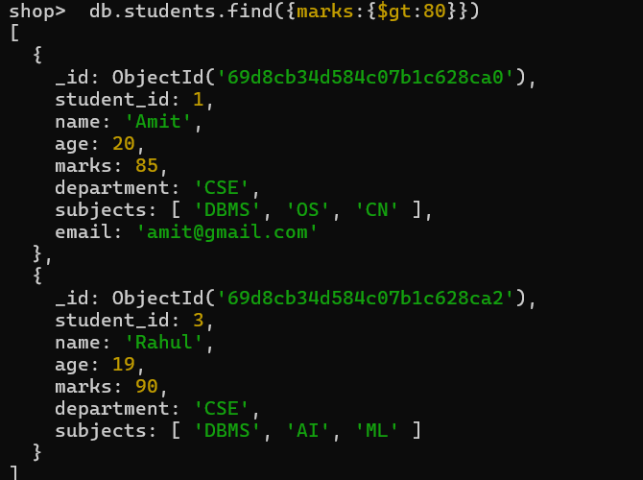

- Find students aged less than or equal to 20.
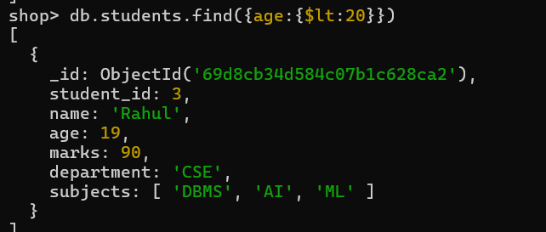

- Find students with marks between 70 and 85.
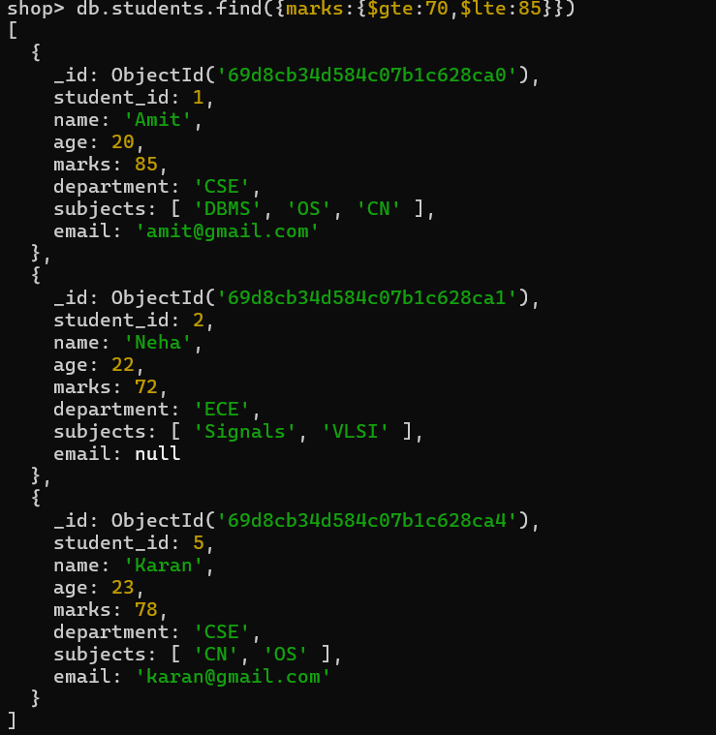

- Find students not belonging to CSE department.
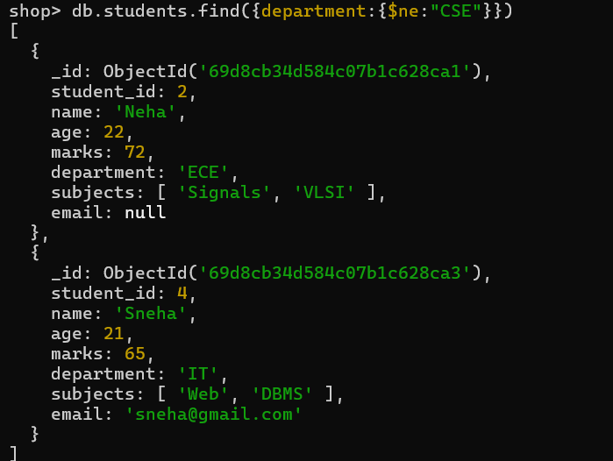

- Find students whose age is exactly 21.
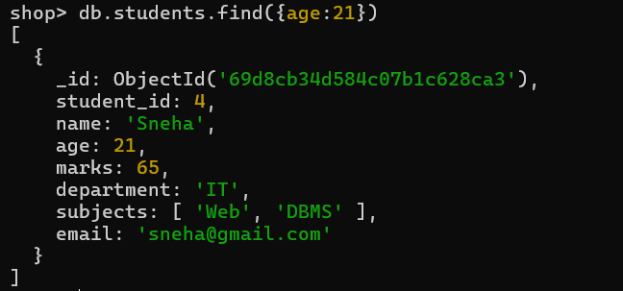
- Find students with marks less than 75.
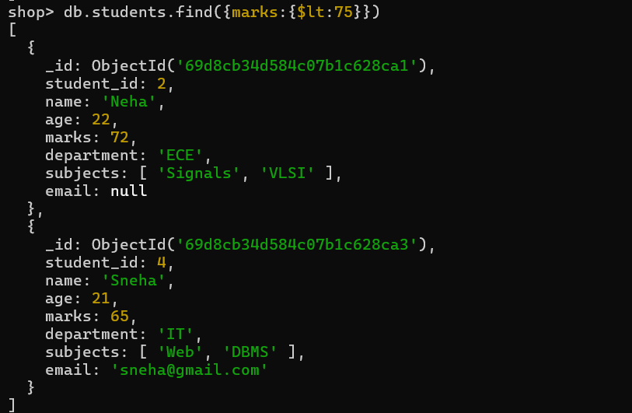

- Find students whose department is either CSE or IT.
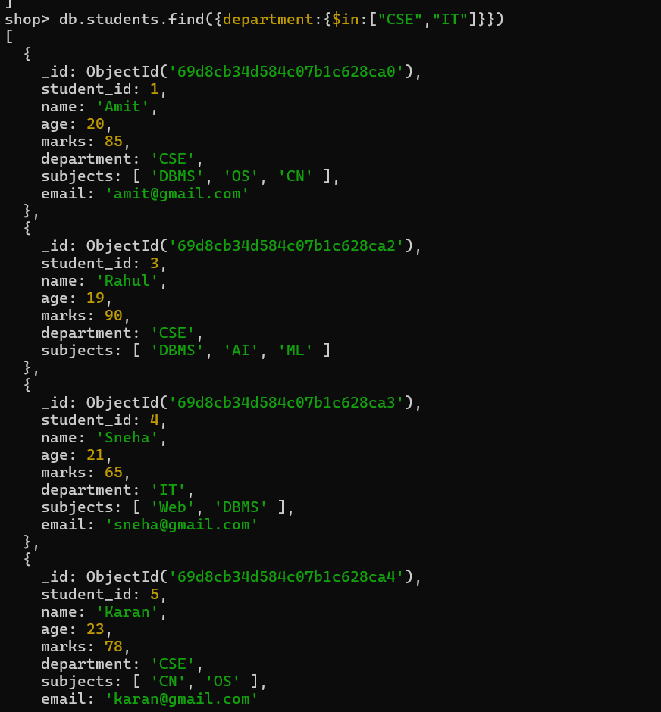

- Find CSE students with marks above 80.
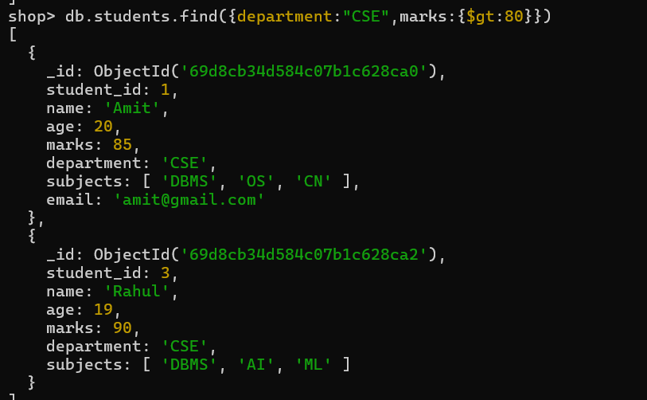

- Find students who are in CSE or have marks above 85.
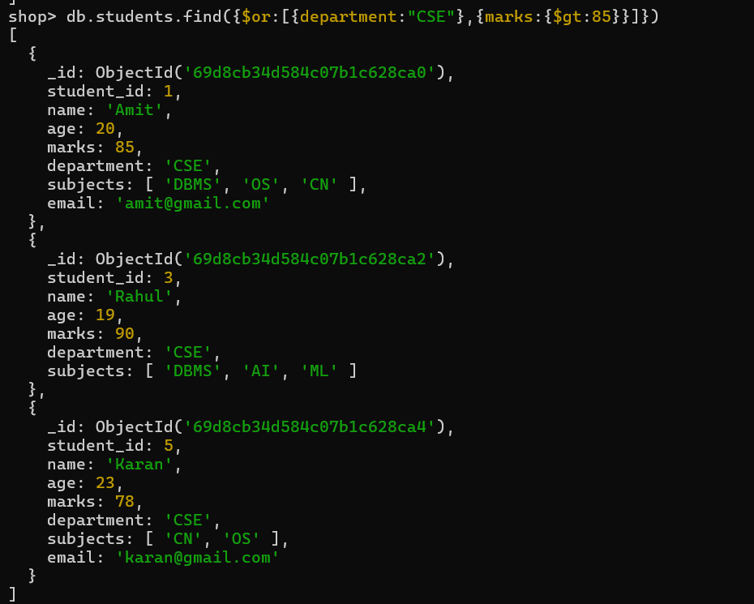

- Find students who are NOT in IT department.
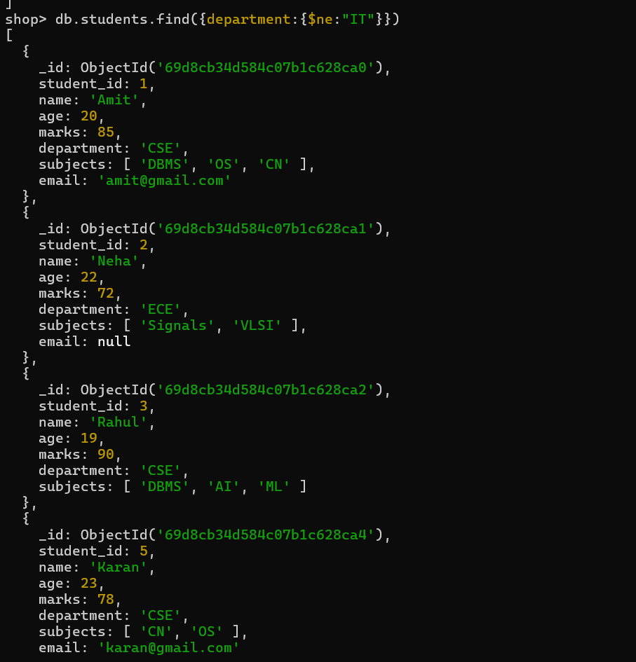

- Find students with marks not between 70 and 85.
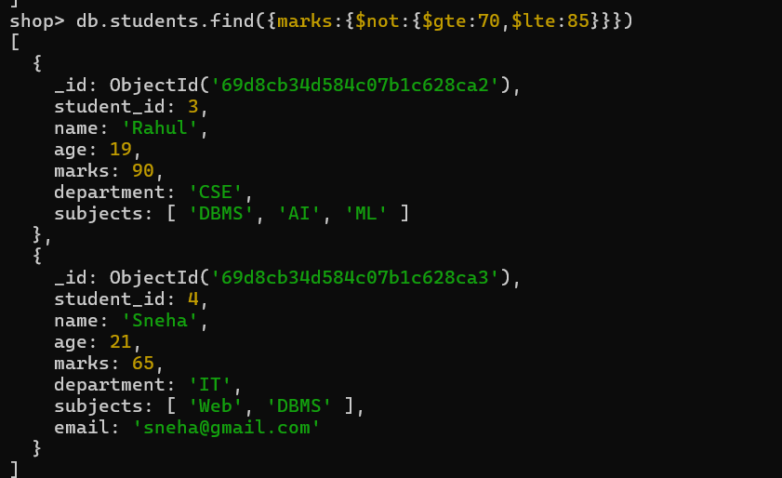

- Find students aged above 20 and not in ECE.
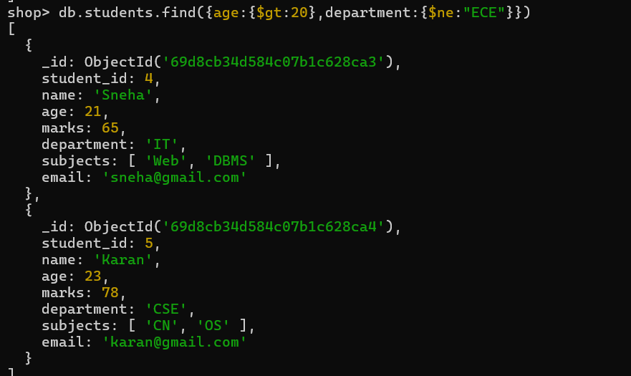

- Find students who are either IT students or have marks less than 70.
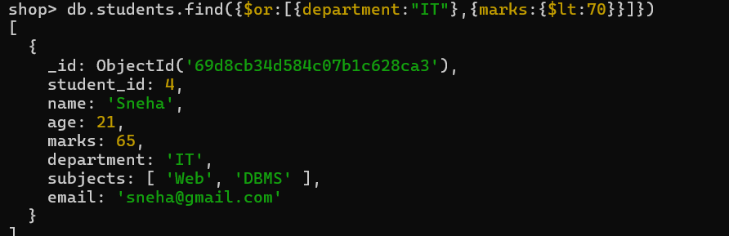

- Find students who are not CSE and not IT.
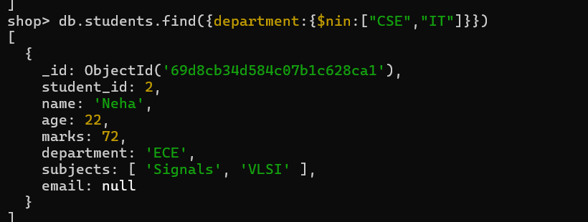

- Find students who have an email field.
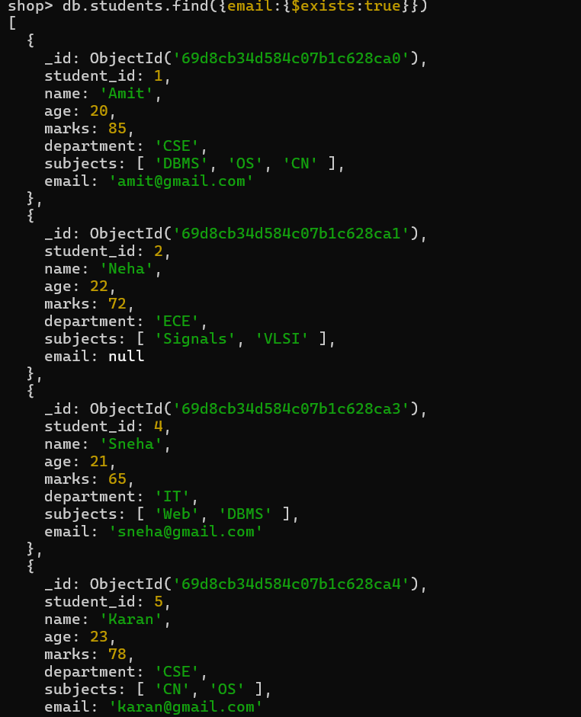

- Find students who do not have an email field.
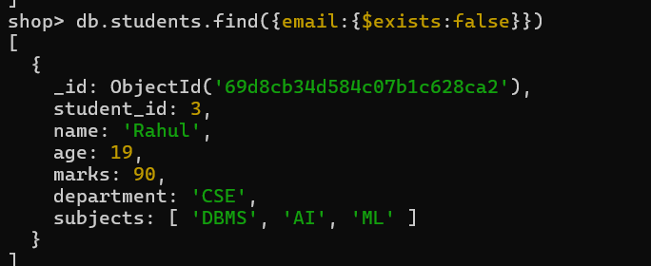

- Find students whose email value is null.
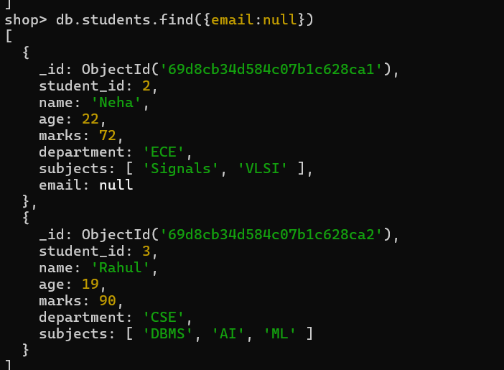

- Find students whose marks field is of type integer.
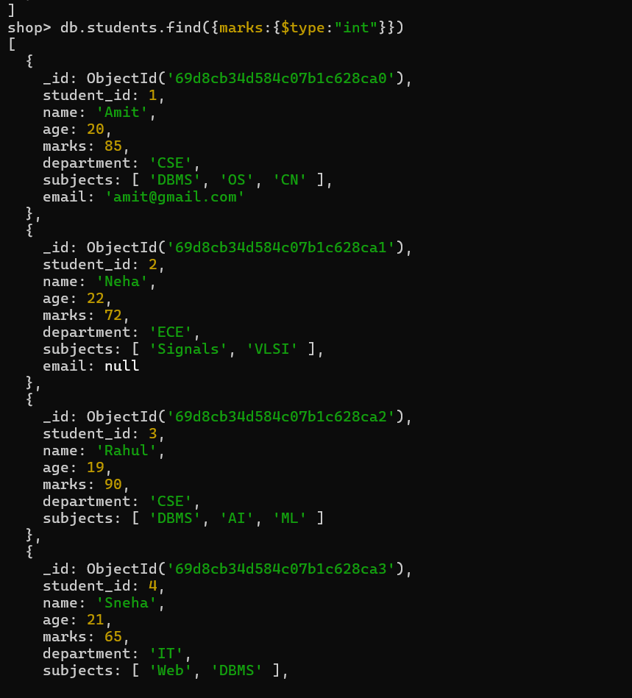
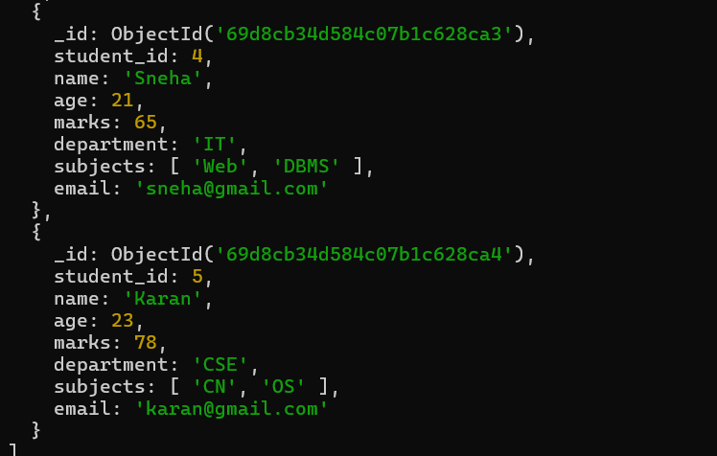

- Find students who have subjects’ field.
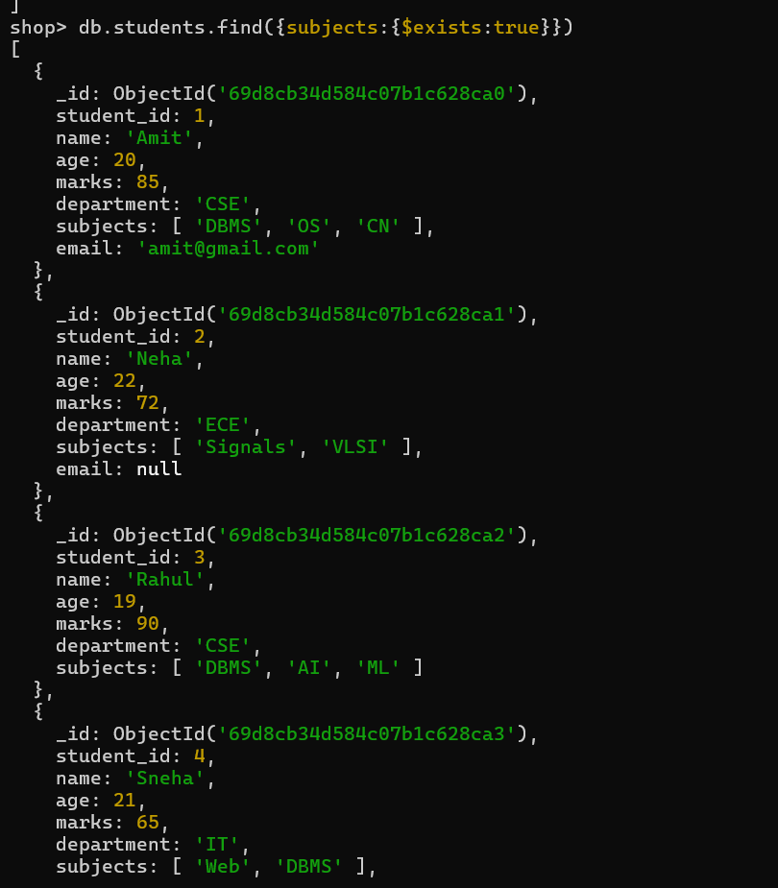
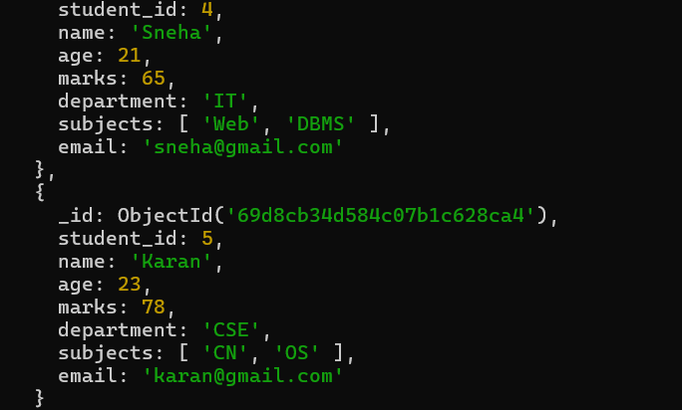

- Find students whose age field is missing.

- Find students where marks modulo 5 equals 0.
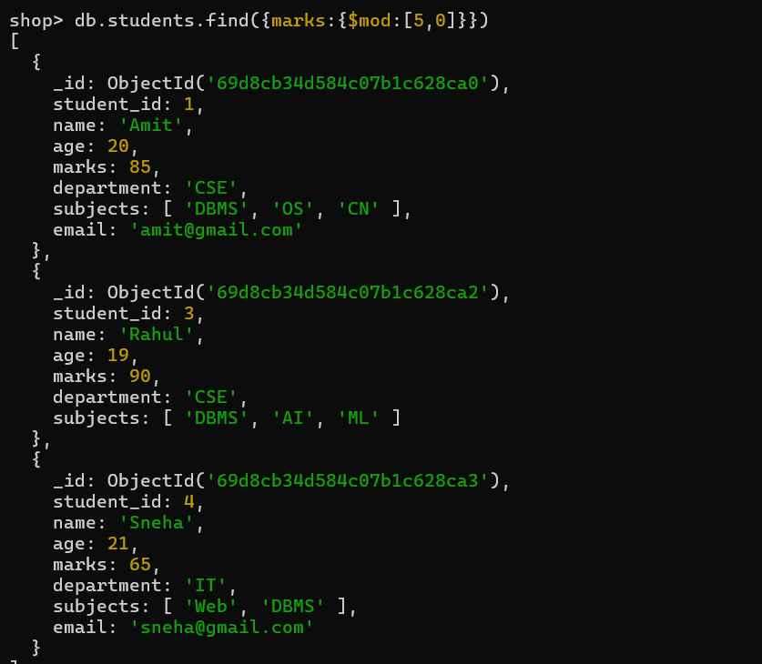

- Find students whose name starts with letter “A”.
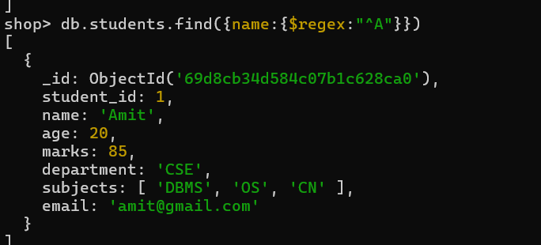

- Find students whose email ends with gmail.com.
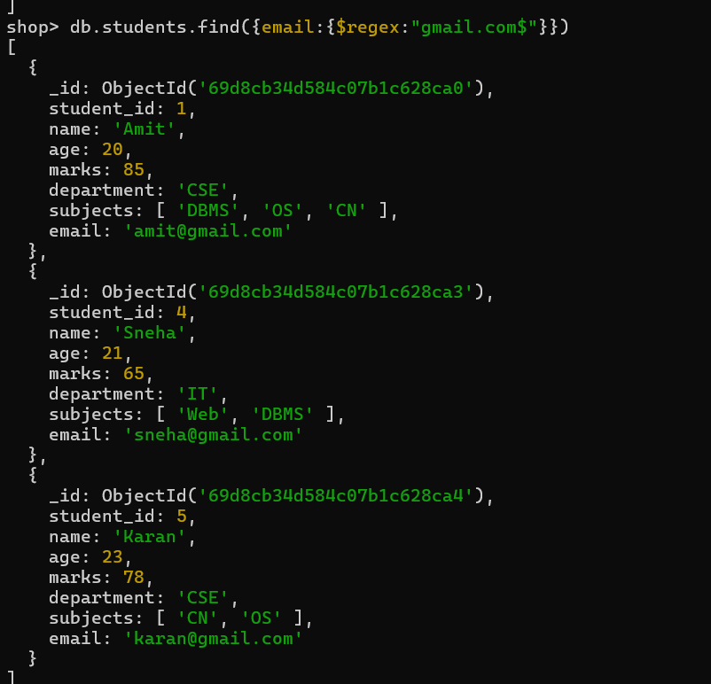

- Find students who have more than 2 subjects.
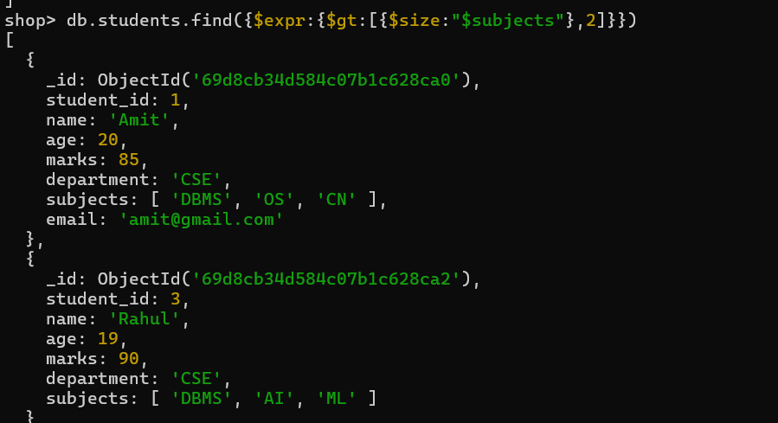

- Find students whose marks are greater than their age × 3.

