Game Design Document

Fill up the Following document

1. Write the title of your project.

The Castle Escape

1. What is the goal of the game?

The goal of the project is to not touch the monsters and scoring based on collection of coins and distance

1. Write a brief story of your game?

In this game there will be a player or soldier who will try to escape from the world because he was captured in a cage in the castle and trying to escape from it without getting killed by the monsters and other obstacles.

1. Which are the playing characters of this game?

* Playing characters are the ones which respond to the user based on the input from the user
* Cars, monkeys, dinos, wizards etc, are the playing characters in the game.

|  |  |  |
| --- | --- | --- |
| Number | Character Name | What can this character do? |
| 1 | Alex-soldier | This can run with the commands of buttons and up-arrow keys |
| 2 |  |  |
| 3 |  |  |
| 4 |  |  |
| 5 |  |  |
| 6 |  |  |
| 7 |  |  |
| 8 |  |  |

1. Which are the Non Playing Characters of this game?

* Non Playing characters are the ones which don't have an action or a behaviour when the user interacts with the game.
* Hurdles, stones, bananas, coins, etc are non playing characters in the game.

|  |  |  |
| --- | --- | --- |
| Number | Character Name | What can this character do? |
| 1 | Monsters | This can be at one place and kill everyone |
| 2 | Obstacles | This could also kill anyone if they touches it |
| 3 | Coins | They are just in the bases of earning |
| 4 |  |  |
| 5 |  |  |
| 6 |  |  |
| 7 |  |  |
| 8 |  |  |

Draw your imagination of this game. What does this game look like?

* Draw the game either on your computer or on paper,
* Add images of scenes of the game to show each of the playing and non-playing characters at least once.

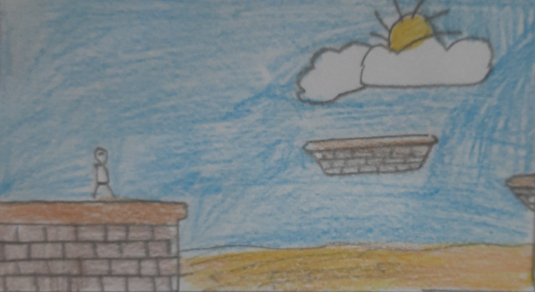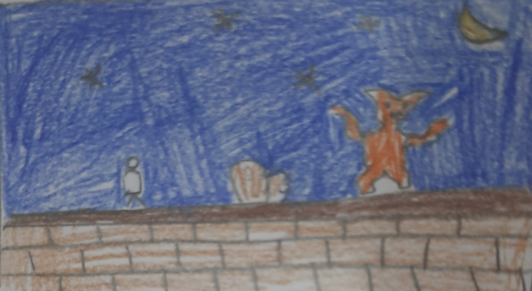

This is in day This is in night

****Monsters will come with obstacles every time (in day as well)****

How do you plan to make your game engaging?

We will add scores, sounds, feedback and a instructor which will tell the instruction in the form of small comments to make the game engaging.