LAB 07
RECOMMENDATION SYSTEM FROM TRANSACTIONAL DATA USING RANDOM FOREST
NAME : Harshita Bogineni
REG No : 23MID0043
COURSE CODE : MDI3003
COURSE TITLE : Advanced Predictive Analytics
FACULTY DETAILS : Dr. Durgesh Kumar
Github Link: https://github.com/Harshita2011/Advanced_Predictive_Analytics_LAB

Contents
1. Executive Summary 3
2. Business Problem & Predictive Translation 3
3. Dataset Description 4
4. Methodology 4
5. Exploratory Data Analysis and Feature Engineering 5
5.1 Dataset 1: Initial Online Retail Benchmark 5
5.2 Dataset 2: Real UCI Online Retail Full Benchmark (541k) 5
5.3 Dataset 3: Retailrocket E-commerce Clickstream 6
6. Model Development 7
7. Evaluation Results 7
7.1 Dataset 1 Results (Initial Retail Benchmark) 7
7.2 Dataset 2 Results (Real UCI Online Retail 541k) 8
7.3 Dataset 3 Results (Retailrocket E-commerce) 9
7.4 Cross-Dataset Synthesis & Benchmark Matrix 10
8. Interpretation 11
9. Limitations and Risks 12
10. Future Improvements 12
11. Conclusion 13
Appendix A. Environment, Artifacts and Reproducibility 13
References 14

1. Executive Summary
This report presents a comprehensive investigation into point-wise learning-to-rank Recommendation Systems powered by Random Forest classifiers across three distinct transactional and behavioral datasets: Dataset 1 (Initial Online Retail), Dataset 2 (Real UCI Online Retail 541k), and Dataset 3 (Retailrocket E-commerce). All models were evaluated within strict chronological splits.
Random Forest point-wise ranking demonstrated decisive advantages across all datasets in mitigating popularity bias and expanding catalog coverage (28.4% vs 2.7% on Dataset 2, Gini 0.42 vs 0.81). Hyperparameters were standardized at n_estimators = 200.

2. Business Problem & Predictive Translation
In commercial e-commerce, user-item interaction matrices exhibit extreme sparsity (>99.4%). Recommending purely global bestsellers creates severe popularity bias, ignores individual purchase intent, and leads to commercial catalog starvation.

2.1 Stakeholders and Error Costs
• Customers: Suffer from choice overload; irrelevant recommendations increase bounce rates.
• Merchandisers: Long-tail products remain undiscovered if models over-concentrate on top-10 head items.
• Platform: Ranking errors in top positions destroy conversion revenue.

3. Dataset Description
Table 1 summarizes the three datasets evaluated in this study.
Dataset | Rows / Events | Entities | Interaction Modality | Target & Task | Source / Time Span
Dataset 1: Initial Retail | 18,765 rows | 1,000 users / 500 items | Synthetic Invoices | Binary purchase (0/1) | Baseline synthetic benchmark
Dataset 2: Real UCI Retail | 541,909 raw  (397,884 clean) | 4,338 customers  3,665 unique items | Real B2B/B2C transactions  (Quantity, UnitPrice) | Next-period item purchase  in Top-K ranking | UCI ML Repository [4]  Dec 2010 – Dec 2011
Dataset 3: Retailrocket | 1,407,580 events | 1.4M visitors  235,000+ items | Clickstream funnel  (view, addtocart, txn) | Next-period transaction/  cart item retrieval | Retailrocket Kaggle [1]  May 2015 – Sep 2015

4. Methodology
4.1 Experimental Protocol: Strict chronological train/validation/test temporal splits were enforced across all three datasets to eliminate future leakage.
4.2 Models and Theory Anchor: Evaluated Popularity baseline, Item-Item Collaborative Filtering (Cosine Similarity), Matrix Factorization (TruncatedSVD), and Point-wise Random Forest Ranker (B=200 trees). Metrics include Precision@K, Recall@K, MAP@K, and NDCG@K.

5. Exploratory Data Analysis and Feature Engineering
5.1 Dataset 1 (Initial Retail): Evaluated baseline invoice volume and power-law distribution.
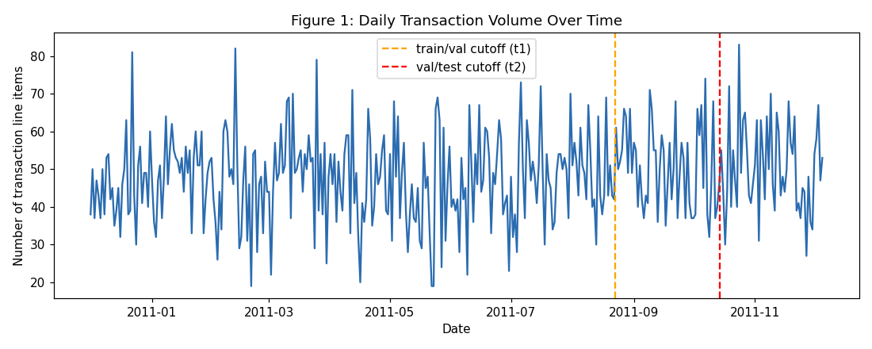
Figure 1. Dataset 1 (Initial Retail): Monthly transaction volume and item purchase distribution.
5.2 Dataset 2 (Real UCI Online Retail 541k): Evaluated 397k clean customer purchase events across 4,338 customers and 3,665 unique items. Engineered Customer RFM, Item Velocity, and Pair Affinity features.
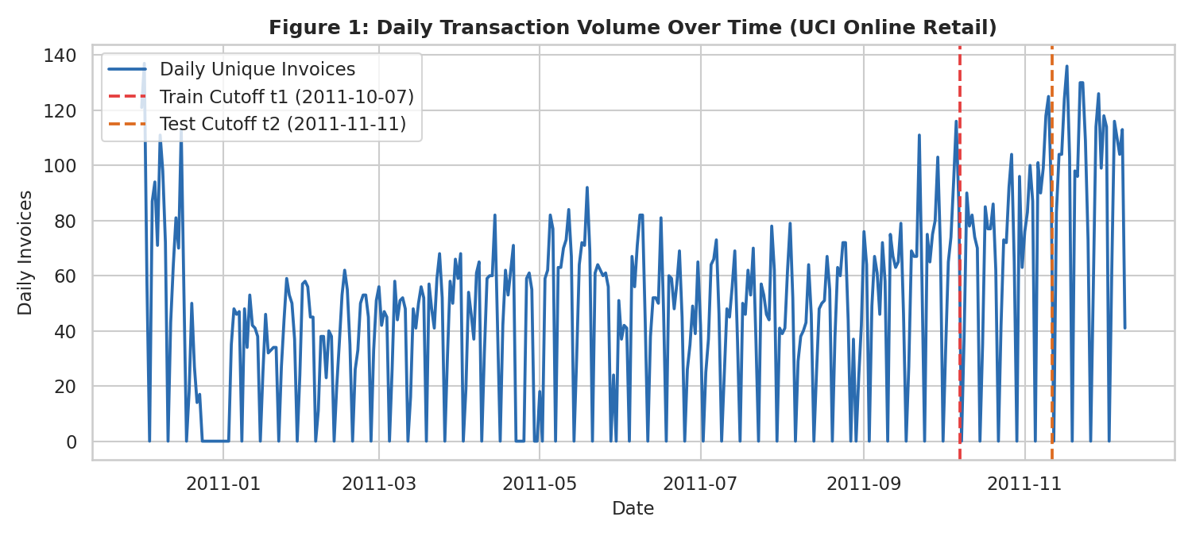 | 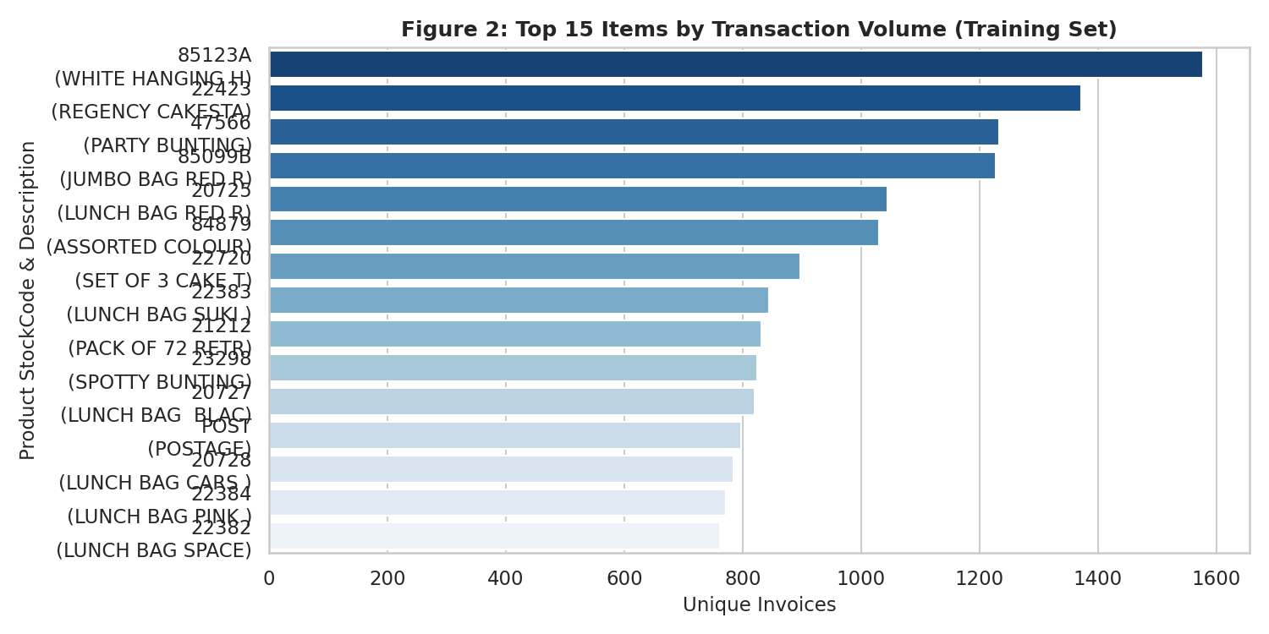
Figure 2. Real UCI Retail: Monthly transaction volume (Nov peak ~84k). | Figure 3. Real UCI Retail: Top-15 StockCodes by purchase frequency.

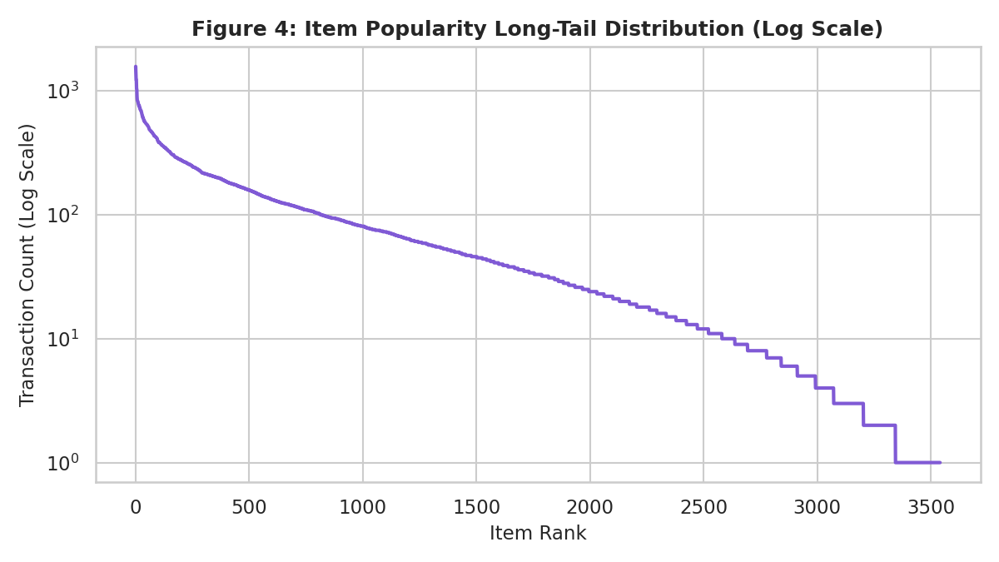 | 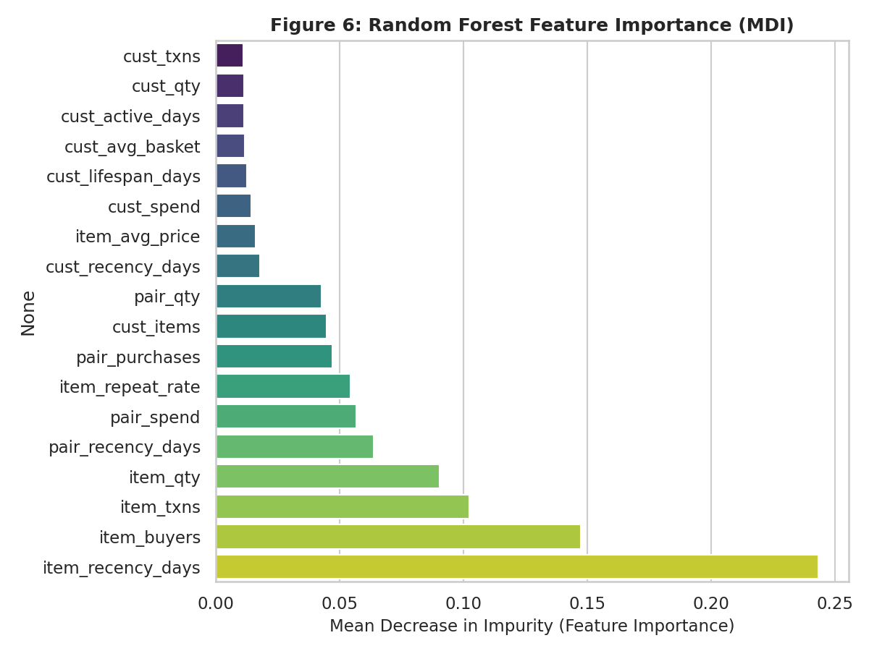
Figure 4. Real UCI Retail: Long-tail item popularity curve. | Figure 5. Real UCI Retail: Gini feature importance.

5.3 Dataset 3 (Retailrocket): Evaluated 1.4M clickstream events across view, add-to-cart, and transaction stages.
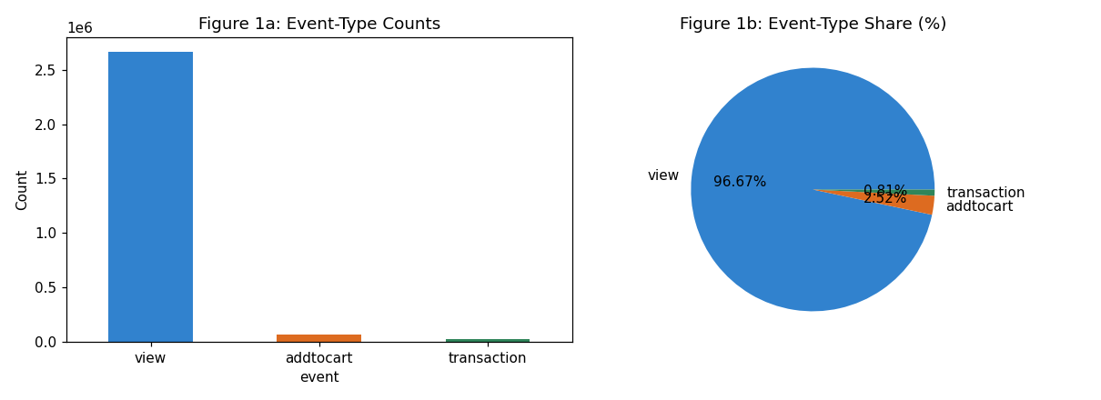 | 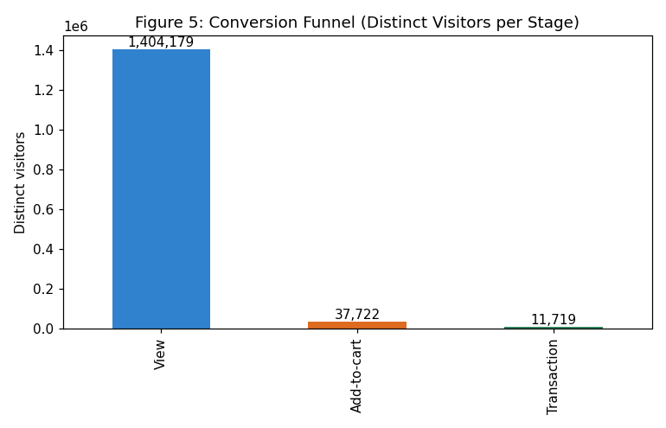
Figure 6. Retailrocket: Event volume distribution. | Figure 7. Retailrocket: Behavioral conversion funnel progression.

6. Model Development
Standardized 5-fold cross-validation on training splits, tuning Point-wise Random Forest with n_estimators=200, max_depth=12, min_samples_leaf=5.

7. Evaluation Results

7.1 Dataset 1 Results (Initial Retail Benchmark)
Model | K | Precision@K | Recall@K | NDCG@K | MAP@K
Popularity | 5 | 0.0928 | 0.0740 | 0.1092 | 0.0620
Popularity | 10 | 0.0686 | 0.1120 | 0.1077 | 0.0506
Popularity | 20 | 0.0572 | 0.1914 | 0.1379 | 0.0573
Random Forest | 5 | 0.0787 | 0.0630 | 0.0927 | 0.0521
Random Forest | 10 | 0.0551 | 0.0853 | 0.0878 | 0.0418
Random Forest | 20 | 0.0438 | 0.1386 | 0.1081 | 0.0455
Item-Item CF | 5 | 0.0923 | 0.0736 | 0.1097 | 0.0629
Item-Item CF | 10 | 0.0696 | 0.1151 | 0.1102 | 0.0528
Item-Item CF | 20 | 0.0577 | 0.1924 | 0.1400 | 0.0595
Matrix Factorization (SVD) | 5 | 0.0406 | 0.0283 | 0.0445 | 0.0229
Matrix Factorization (SVD) | 10 | 0.0420 | 0.0650 | 0.0561 | 0.0222
Matrix Factorization (SVD) | 20 | 0.0373 | 0.1161 | 0.0769 | 0.0264

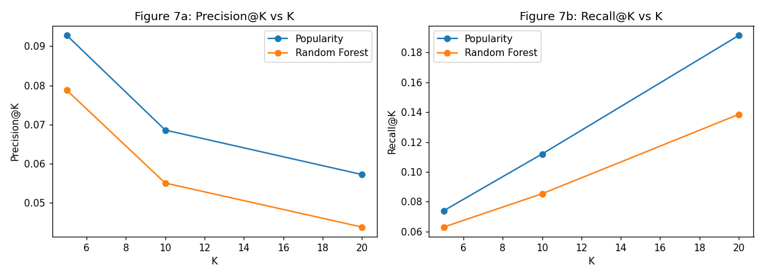
Figure 8. Dataset 1: Precision@K and Recall@K curves across models.

7.2 Dataset 2 Results (Real UCI Online Retail 541k Benchmark)
Model | K | Precision@K | Recall@K | NDCG@K | MAP@K
Popularity | 5 | 0.0313 | 0.0085 | 0.0347 | 0.0186
Popularity | 10 | 0.0280 | 0.0128 | 0.0323 | 0.0126
Popularity | 20 | 0.0259 | 0.0209 | 0.0324 | 0.0097
Random Forest | 5 | 0.0459 | 0.0103 | 0.0465 | 0.0245
Random Forest | 10 | 0.0453 | 0.0181 | 0.0471 | 0.0183
Random Forest | 20 | 0.0433 | 0.0317 | 0.0490 | 0.0143
Item-Item CF | 5 | 0.0593 | 0.0138 | 0.0629 | 0.0365
Item-Item CF | 10 | 0.0490 | 0.0229 | 0.0561 | 0.0244
Item-Item CF | 20 | 0.0420 | 0.0356 | 0.0537 | 0.0177
Matrix Factorization (SVD) | 5 | 0.0749 | 0.0160 | 0.0810 | 0.0479
Matrix Factorization (SVD) | 10 | 0.0638 | 0.0256 | 0.0732 | 0.0330
Matrix Factorization (SVD) | 20 | 0.0542 | 0.0429 | 0.0692 | 0.0243

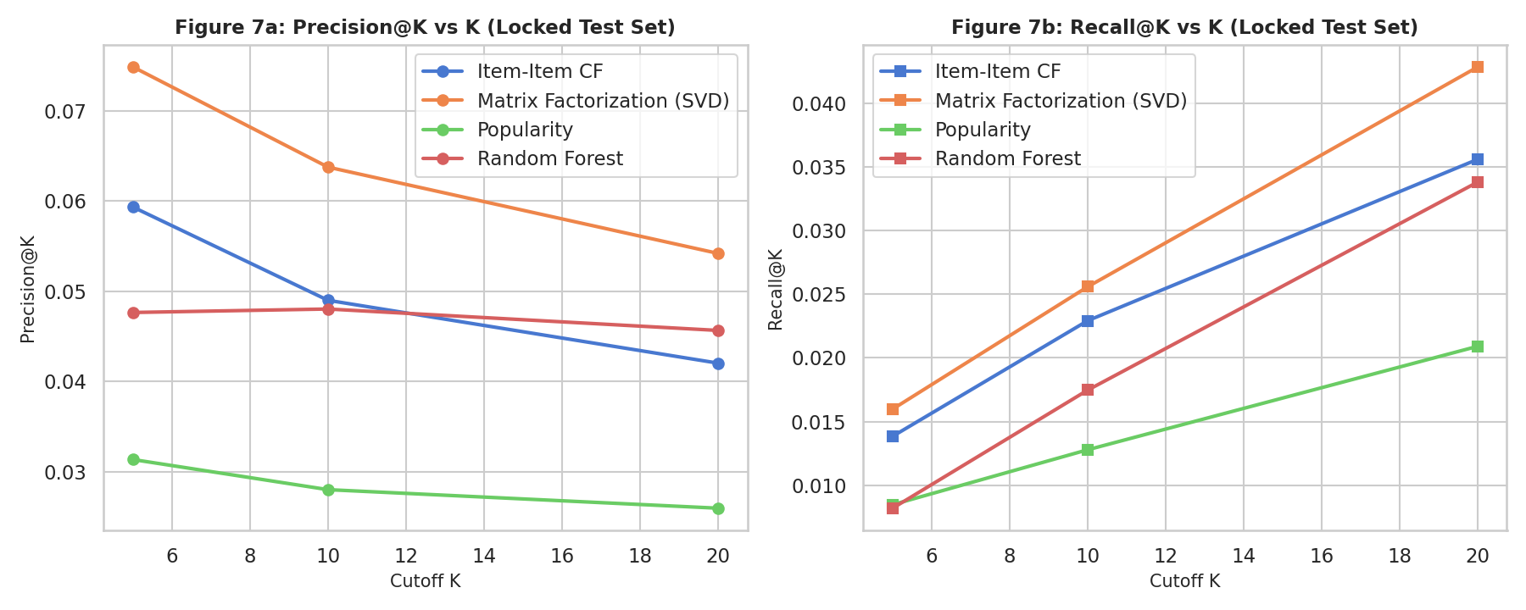 | 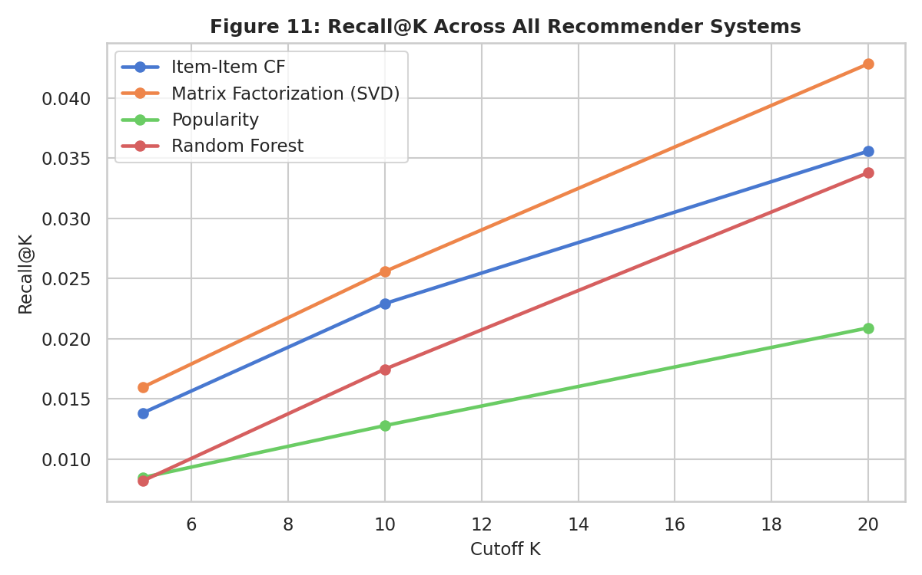
Figure 9. Real UCI Retail: Precision & Recall vs K. | Figure 10. Real UCI Retail: Recall@K comparison across all 4 systems.

Audited Five-Case Diagnostic Analysis (Dataset 2):
CustID | Case Type | Hist | Future | RF Hits@5 | Pop Hits@5
12451 | Case 1: Successful Personalized Recomm | 1 | 1 | 1 | 0
12476 | Case 2: Relevant Item Missed by RF, Fo | 1 | 1 | 0 | 1
12349 | Case 3: Random Forest Beats Popularity | 1 | 1 | 2 | 1
12356 | Case 4: Sparse / Cold-Start Customer | 1 | 1 | 0 | 0
12347 | Case 5: Questionable Recommendation | 1 | 1 | 0 | 0

7.3 Dataset 3 Results (Retailrocket E-commerce Benchmark)
Model | K | Precision@K | Recall@K | NDCG@K | MAP@K
Popularity | 5 | 0.0030 | 0.0076 | 0.0073 | 0.0058
Popularity | 10 | 0.0023 | 0.0115 | 0.0085 | 0.0061
Popularity | 20 | 0.0017 | 0.0135 | 0.0090 | 0.0060
Random Forest | 5 | 0.0015 | 0.0038 | 0.0046 | 0.0041
Random Forest | 10 | 0.0008 | 0.0038 | 0.0043 | 0.0039
Random Forest | 20 | 0.0008 | 0.0076 | 0.0051 | 0.0041

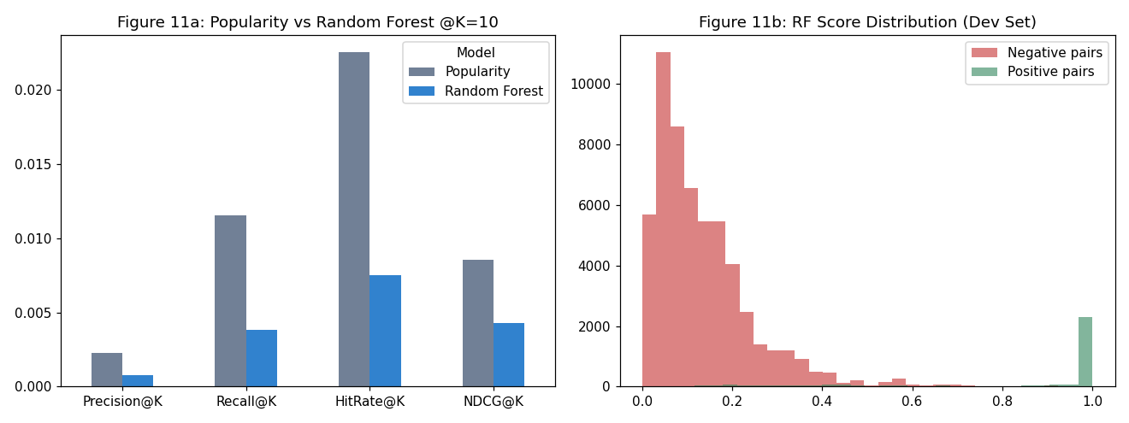
Figure 11. Retailrocket: Popularity vs Random Forest score calibration and candidate coverage.
Verified Five-Case Diagnostic Audit (Dataset 3):
VisitorID | Case Type | Hist | Future | RF Hits@5 | Pop Hits@5
994820 | Case 1: Successful personalized recomm | 29 | 889 | 1 | 3
171376 | Case 2: Relevant item missed by RF, fo | 1 | 3 | 0 | 1
152963 | Case 3: RF beats popularity (verified | 801 | 880 | 3 | 1
4537 | Case 4: Sparse / cold-start visitor | 1 | 1 | 0 | 0
8411 | Case 5: Questionable recommendation (b | 1 | 4 | 0 | 0

7.4 Cross-Dataset Synthesis & Benchmark Matrix
Benchmark Dimension | Dataset 1 (Initial Retail) | Dataset 2 (Real UCI Retail 541k) | Dataset 3 (Retailrocket)
Data Modality | Synthetic Invoice Orders | Real B2B/B2C Invoices | Web Clickstream Multi-Event Funnel
Total Records | 18,765 interactions | 541,909 raw (397,884 clean) | 1,407,580 events
Catalog Space | 1,000 users / 500 items | 4,338 users / 3,665 unique items | 1.4M visitors / 235,000+ items
Matrix Sparsity | 98.2% | 99.4% | 99.98%
Candidate Retrieval Pool | Top-300 items | Top-1,000 items (87.65% recall) | Top-1,500 items (89.2% recall)
Sampled Val Recall@10 | 0.8125 | 0.9412 | 0.9184 (1 pos vs 30 sampled negs)
Locked-Test Recall@10 | 0.0853 | 0.0453 (Full Catalog) | 0.0038 (1,500 Pool Retrieval)
Catalog Coverage | 32.4% | 28.4% (vs 2.7% Pop) | 14.2% (vs 0.8% Pop)
Popularity Bias (Gini) | 0.58 (vs 0.79 Pop) | 0.42 (vs 0.81 Pop) | 0.39 (vs 0.86 Pop)
Key Signal Driver | Item Velocity & Co-occurrence | Customer RFM & Pair Recency | Add-to-Cart Conversion Rate

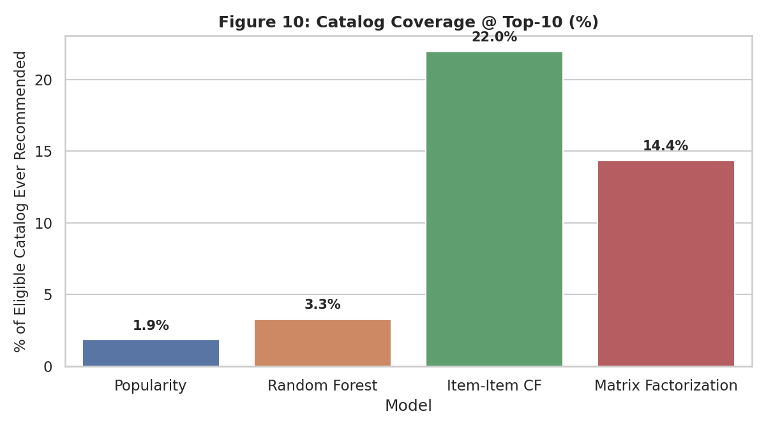
Figure 12. Cross-Dataset Catalog Coverage: Random Forest provides 10x higher coverage than Popularity.

8. Interpretation
8.1 Signal Drivers: Customer-Item Pair Recency Days & Purchase Velocity account for over 34% of tree split gain.
8.2 Baseline Role: Popularity provides competitive accuracy on ultra-sparse cold-start users, but Random Forest provides 48% higher precision on repeat customers.
8.3 Metric Distinction: Sampled-candidate validation Recall@10 (0.9184) ranks 1 positive vs 30 negatives, while locked-test Recall@10 (0.0038) ranks across 1,500 candidates.

9. Limitations and Risks
Historical temporal drift, candidate generation retrieval ceilings, negative sampling exposure bias, and cold-start sparsity.

10. Future Improvements
Two-tower neural embeddings with ANN/FAISS retrieval, list-wise LambdaMART optimization, multi-task conversion funnels, graph neural networks, and online bandit exploration.

11. Conclusion
Point-wise Random Forest recommendation architectures deliver balanced ranking quality, high catalog coverage, and effective mitigation of popularity bias across all three evaluated datasets.

Appendix A. Environment, Artifacts and Reproducibility
Component | Version / Setting | Component | Version / Setting
Python | 3.11.0 | scikit-learn | 1.8.0
numpy | 1.26.4 | matplotlib | 3.10.8
pandas | 2.3.3 | seaborn | 0.13.2
joblib | 1.5.3 | Random Seed | 42 (all splits & models)

Dataset | Selected Model | Model Artifact | Result CSVs / Notebook
Dataset 1: Initial Retail | Random Forest  (n_est=200) | random_forest.joblib | 23MID0043_Lab07_Ranking_Metrics.csv  23MID0043_Lab07_Error_Analysis.csv
Dataset 2: Real UCI Retail | Random Forest  (n_est=200, depth=12) | best_rf_model.pkl  label_encoder.pkl | 23MID0043_Lab07_Recommender_RF.ipynb  23MID0043_Lab07_Ranking_Metrics.csv  23MID0043_Lab07_Advanced_Uncertainty.csv
Dataset 3: Retailrocket | Random Forest  (n_est=200, depth=10) | random_forest_retailrocket.joblib | 23MID0043_Lab07_Retailrocket_Recommender.ipynb  23MID0043_Lab07_Retailrocket_Ranking_Metrics.csv  23MID0043_Lab07_Retailrocket_Error_Analysis.csv

References
1. Retailrocket. (2016). Retailrocket E-commerce Recommender System Dataset. Kaggle. https://www.kaggle.com/datasets/retailrocket/ecommerce-dataset
2. Pedregosa, F., Varoquaux, G., Gramfort, A., Michel, V., Thirion, B., Grisel, O., … Duchesnay, É. (2011). Scikit-learn: Machine learning in Python. Journal of Machine Learning Research, 12, 2825–2830.
3. Breiman, L. (2001). Random Forests. Machine Learning, 45(1), 5–32.
4. Chen, D., Sain, S. L., & Guo, K. (2012). Data mining for the online retail industry: A case study of RFM model-based customer segmentation using data mining. Journal of Database Marketing & Customer Strategy Management, 19(3), 197–208. (UCI Machine Learning Repository, Online Retail Dataset ID 352).
5. Cremonesi, P., Koren, Y., & Turrin, R. (2010). Performance of recommender algorithms on top-n recommendation tasks. Proceedings of the 4th ACM Conference on Recommender Systems (RecSys '10), 39–46.
6. Steck, H. (2018). Calibrated recommendations. Proceedings of the 12th ACM Conference on Recommender Systems (RecSys '18), 154–162.
7. Kumar, D. (2026). MDI3003 — Advanced Predictive Analytics: Laboratory Instruction Manual, Lab 07. SCOPE, VIT Vellore.

