EXPLORATORY DATA ANALYSIS
Optimising NYC Taxi Operations

Prepared by: Harshita Chandaiya
Assignment ID: EDA/02 | Total Marks: 200
MSc Data Science — IIIT Bangalore & Liverpool John Moores University

2023 NYC Yellow Taxi Trip Data Analysis

Executive Summary

The aim in this report is to conduct a thorough exploratory data analysis (EDA) of the 2023 NYC Yellow Taxi trip data to discover actionable insights that can be used to optimize taxi operations. This analysis reviews trends of demand, revenue, attributes of trips, and activity measured at the zone level, providing data-driven insights and recommendations that will support efficient operations, maximize revenue and passenger experience across NYC.
3.83M  Rows Collected | $107.6M  Annual Revenue (Sampled) | 79.6%  Credit Card Payments | 6 PM  Peak Demand Hour

1. Data Preparation

1.1 Loading the Dataset

This is a collection of 12 monthly parquet files containing the data for all taxi trips taking place in NYC in 2023. There are 19 columns that describe a trip, such as pick-up time and location, the components of the fare, tips, and payment types, in each file. Data was collected from technology providers by the NYC Taxi and Limousine Commission (TLC).

1.2 Sampling and Combining the Files
Each of the monthly files was sampled 10% and random_state=42 guarantees that each file generates the same sample. All 12 datasets that were sampled were combined.

Assumption: The 10% sample is used to make an assumption about the trends in the entire data set. The January file was re-downloaded, because of a corrupt upload, from the NYC TLC site.
Result: Prior to cleaning: Combined data set: 3,831,024 rows and 20 columns.

2.1 Fixing Columns

2.1.1 Fixing the Index

The dataset was merged and filtered, after which the index was reset with reset_index(drop=True) to ensure that the index is now sequentially numbered starting at 0.

2.1.2 Combining Airport Fee Columns

Airport_fee, airport_fee — this is because the airport fee column is duplicated due to the different naming convention used in monthly files. The Airport_fee column was reduced from 19 to 18 columns as the values of Airport_fee were filled in using fillna.

2.1.3 Fixing Datetime Columns and Filtering Year

Proper datetime format obtained for pick up and drop off datetime columns. 16 rows with dates outside 2023 (ranging from 2001 to 2024) were removed, leaving 3,831,008 rows.

2.2 Handling Missing Values
Five columns contained a total 130,737 missing entries, or 3.41% of the entries were missing. The rows in all five columns are consistently numbered; this indicates that they are in the same rows, mainly the vendor 2 rows (79,015 rows), then the rows in the Vendor 1 (50,854 rows) and Vendor 6 (868 rows).
Column | Missing Count | Missing % | Imputation Method | Reason
passenger_count | 130,737 | 3.41% | Median (1.0) | Skewed distribution
RatecodeID | 130,737 | 3.41% | Mode (1.0) | Categorical variable
store_and_fwd_flag | 130,737 | 3.41% | Mode (N) | Categorical variable
congestion_surcharge | 130,737 | 3.41% | Median (2.5) | Skewed distribution
Airport_fee | 130,737 | 3.41% | 0 | Most trips are non-airport

2.3 Handling Outliers and Standardising Values

This unit explores how to treat outliers and how to standardise values. The IQR method together with domain knowledge was used to determine outliers. Outliers are identified and reported but not removed from the data set as per the guidelines of the assignment.

2.3.1 Payment Type Outliers

From NYC TLC data dictionary 1-4 are valid payment types: There were 130,737 rows that contained the value 0, which is the same as the rows that were found to contain missing values above.

2.3.2 Trip Distance Outliers

77,271 rows with the trip distance of 0 or negative. The biggest distance travelled was 205,544 miles, which is obviously a data entry error and is much further than the distance that would be reasonable for traveling around NYC.

2.3.3 Tip Amount Outliers
One hundred ninety-two tips were negative, possibly due to refunds or data entry error and were considered an extreme outlier for the maximum tip, which was determined to be $700.

Column | Outlier Count | Percentage | Nature of Outlier
fare_amount | 419,124 | 10.94% | Negative fares and fares above $40.80
trip_distance | 506,306 | 13.22% | Max 205,544 miles is physically impossible
tip_amount | 294,300 | 7.68% | Negative tips and tips exceeding $9.53
total_amount | 478,485 | 12.49% | Negative totals indicate data entry errors
passenger_count | 916,341 | 23.92% | 0 passengers is invalid for a completed trip

3. Exploratory Data Analysis

3.1 General EDA: Finding Patterns and Trends

3.1.1 Classifying Variables

The variables were divided into three groups:

Categorical: These are types/groups that are stored as a number and are represented by their category definition: VendorID, store_and_fwd_flag, RatecodeID, PULocationID, DOLocationID, payment_type Measurable quantities are:

Numerical: passenger_count, trip_distance, fare_amount, extra, mta_tax, tip_amount, tolls_amount, improvement_surcharge, total_amount, congestion_surcharge, Airport_fee. Datetime: tpep_pickup_datetime, tpep_dropoff_datetime are time stamps

3.1.2 Distribution of Taxi Pickups by Hour, Day and Month
By Hour
Pickups are the lowest during the quietest hours of the city, from 3–5 AM. The activity builds up gradually from 6 am and is highest between 6-7 pm (evening rush hour). Late night hours (12–2 AM) have reasonable activity because of the nightlife.
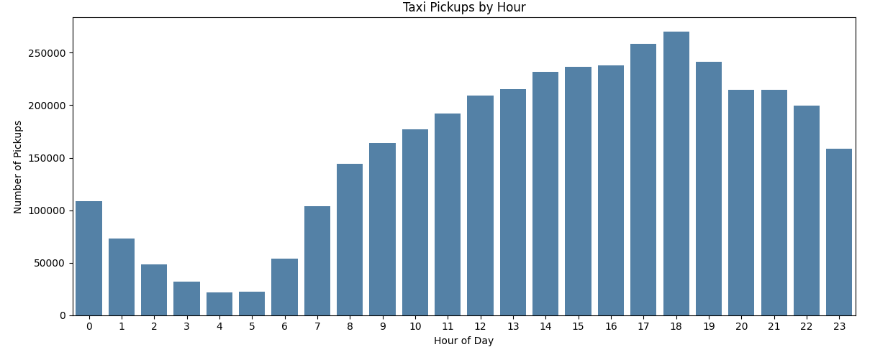
By Day of Week

Thursday is the hottest day and Wednesday comes in second. Demand is usually greater on weekdays than on weekends. The day with the least activity is Sunday.
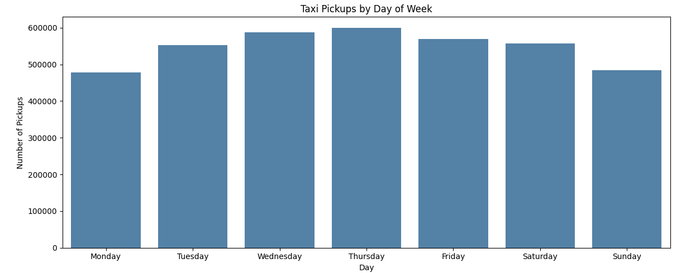
By Month
The busiest months are May and October ( ~350,000 pickups per month). The lowest months are August and September, with an average pickup of ~285,000. Peak time is Spring and Fall as Summer has a slight decrease which may be attributed to residents going on vacations.

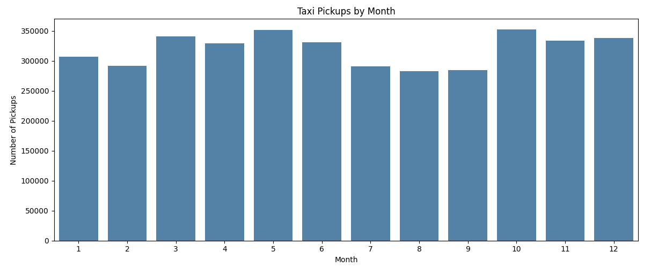

3.1.3 Filtering Zero/Negative Values

The data was cleaned by removing any rows with trips that had a fare_amount of 0 or negative, trips that had a trip_distance of 0 or negative, and trips that had a negative tip_amount, resulting in a new, clean dataset of 3,718,938 trips (~2.9% of all trips are removed).

3.1.4 Monthly Revenue Trends
May brings in the most revenue ($10.1M), followed by October ($10.0M). The low is in August at ~$8.0M. The combined annual revenue of all the samples is around $107.6M.
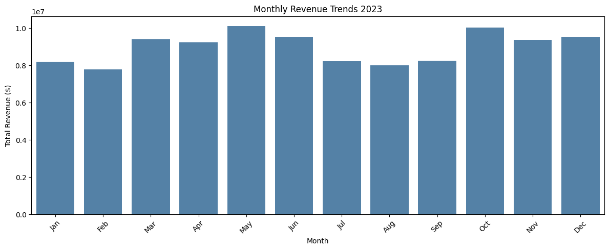

3.1.5 Quarterly Revenue Proportion

Quarter | Revenue Share | Insight
Q1 (Jan–Mar) | 23.6% | Winter slowdown
Q2 (Apr–Jun) | 26.8% | Spring peak season
Q3 (Jul–Sep) | 22.7% | Summer dip — lowest quarter
Q4 (Oct–Dec) | 26.9% | Fall peak season — highest quarter
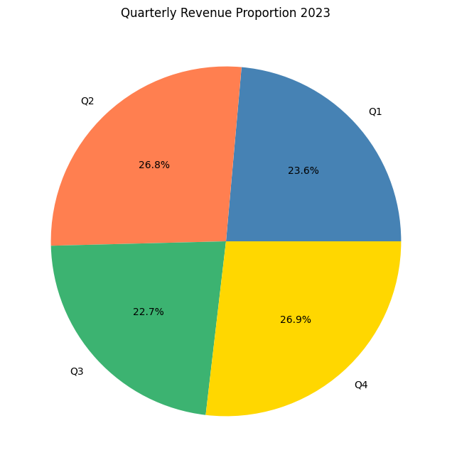

3.1.6 Relationship Between Distance and Fare Amount
The distance and the amount of fare can be used to identify the line number. The distance and the amount of fare can be used to determine the line number. The overall relationship between the trip distance and the fare was very weak (0.02) with the effect of some extreme outliers. The correlation increased to 0.95 after filtering to realistic ranges (less than 50 miles, less than $200) — which is a thumbs-up for NYC taxi pricing as being largely distance-based.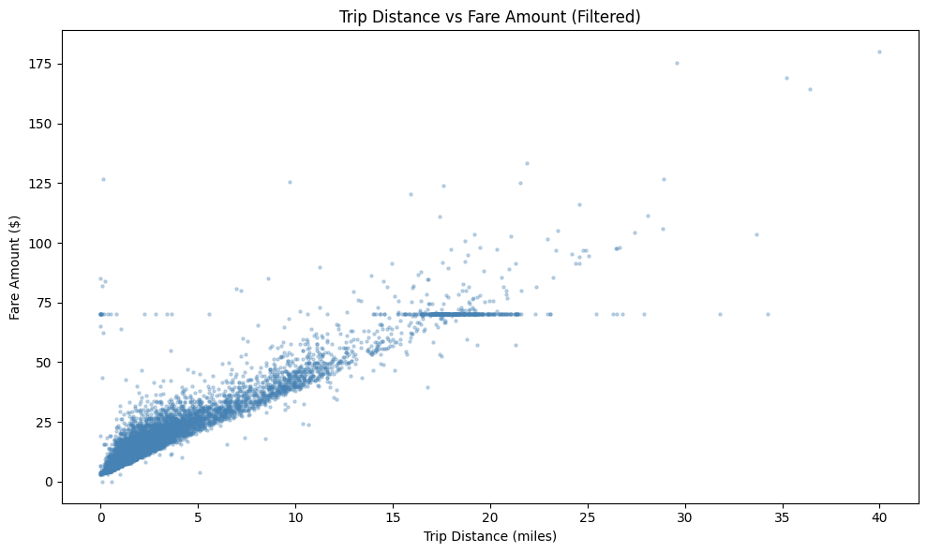

3.1.7 Relationship Between Fare/Tips and Trips/Passengers
The average fare is $18-22 for 1-6 passengers, with little difference in fare by group size. 7-9 passengers: $60-$90 (very few of these trips are available). More than three-quarters of passenger trips are single occupant.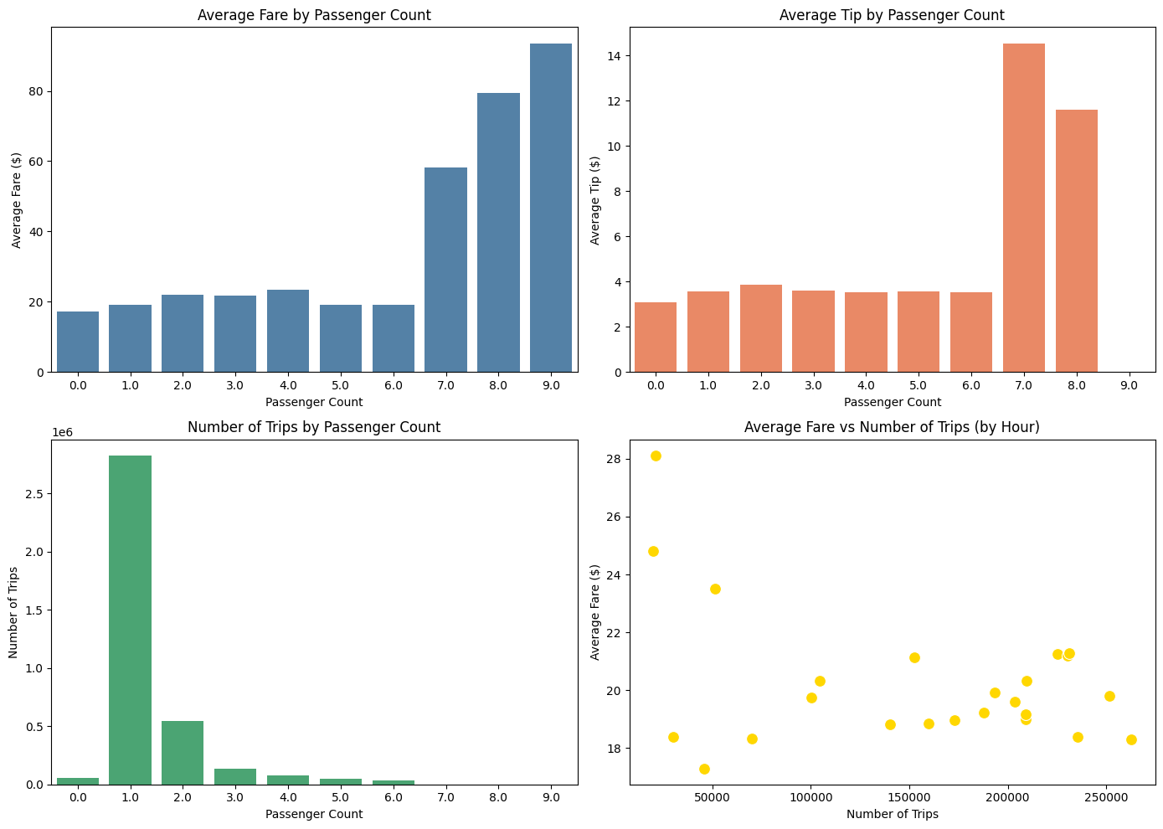

3.1.8 Distribution of Payment Types

Payment Type | Proportion
Credit Card | 79.61%
Cash | 16.66%
Unknown (Type 0) | 2.71%
Dispute | 0.66%
No Charge | 0.36%
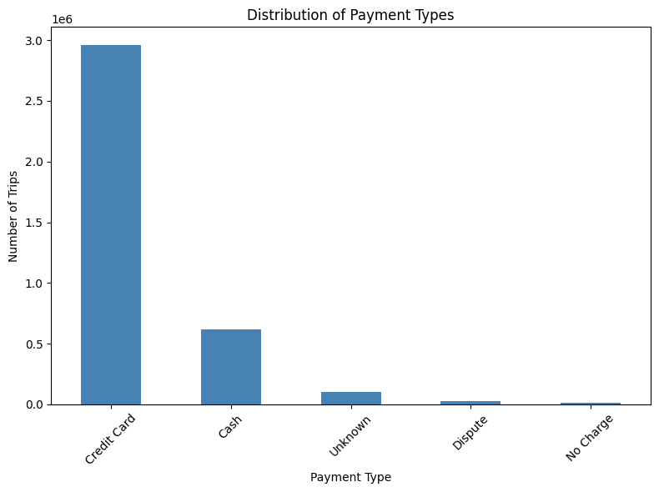

3.1.9 Taxi Zones Shapefile
The NYC taxi zones shapefile was loaded using GeoPandas, which contains information on the boundaries of 263 taxi zones in all five NYC boroughs.
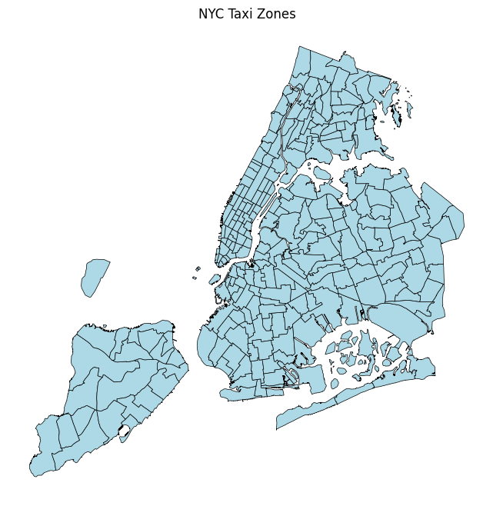

3.1.10 Merging Zone Data with Trip Data

A zone geoDataFrame was created by merging LocationID and the trip data, so that it is possible to analyse trip patterns at the zone level.

3.1.11–3.1.13 Trips per Zone and Map
Trip counts per pickup zone were joined into the zones GeoDataFrame and displayed as a choropleth map.
Zone | Number of Pickups
JFK Airport | 191,689
Upper East Side South | 176,488
Midtown Center | 173,331
Upper East Side North | 157,440
Midtown East | 133,040
LaGuardia Airport | 127,947
Penn Station/Madison Sq West | 127,879
Times Sq/Theatre District | 124,100
Lincoln Square East | 123,274
Murray Hill | 110,744
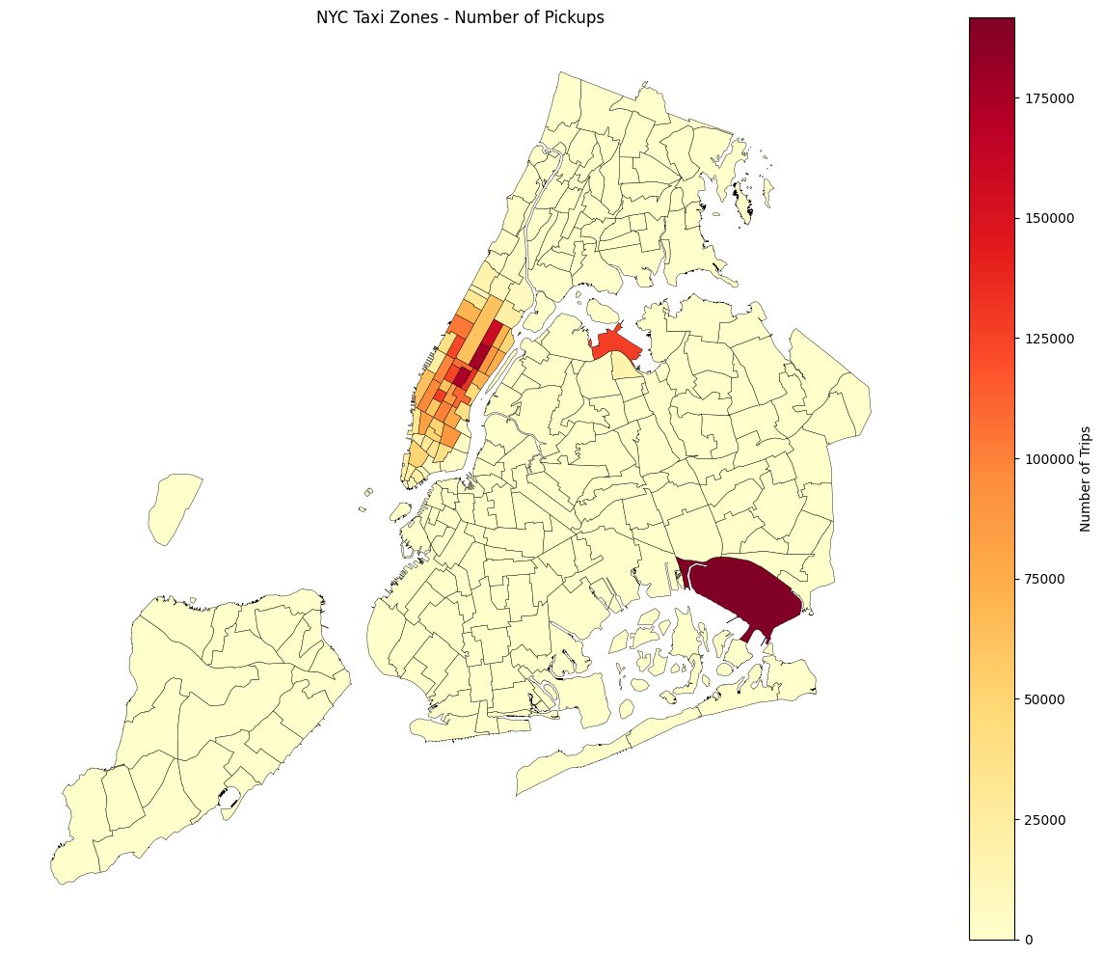

3.2 Detailed EDA: Insights and Strategies

3.2.1 Identifying Slow Routes
The amount of time it took for each trip and the average speed were determined. Routes were also limited to 0-80 mph and broken down into zones based on pickup/dropoff zone pairs that have 100 or more trips. The slowest routes are focused in Midtown Manhattan.
Pickup Zone | Dropoff Zone | Avg Speed (mph) | Trip Count
Midtown Center | Times Sq/Theatre District | 5.06 | 5,228
Penn Station/Madison Sq West | Garment District | 5.21 | 2,223
Midtown East | Times Sq/Theatre District | 5.26 | 4,234
Times Sq/Theatre District | Times Sq/Theatre District | 5.39 | 3,760
Midtown East | Midtown Center | 5.48 | 4,762

3.2.2 Hourly Number of Trips and Busy Hours
- Busiest hour: 6 PM (18:00) with 262,859 trips.
- Quietest period: 4–5 AM with ~20,000 trips.
- Very active from 11 AM to 10 PM.
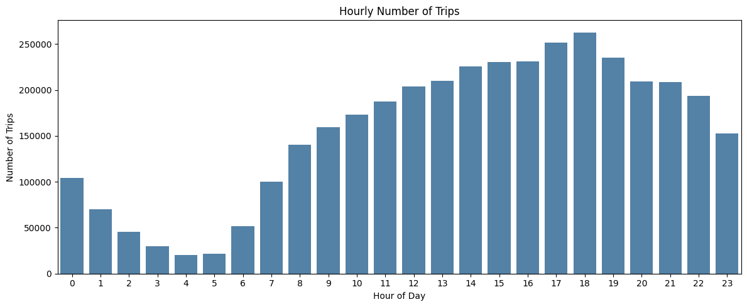

3.2.3 Scaling Up to Actual Trip Numbers
The estimated actual number of trips is based on multiplying the sampled number by 10 because only 10% was sampled. In 2023, there were an estimated 2,628,590 trips made city-wide for the estimated peak hour (6 PM).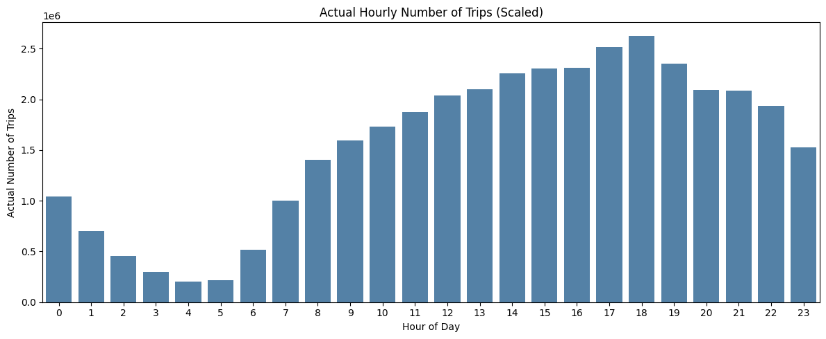

3.2.4 Hourly Traffic: Weekdays vs Weekends
Weekday peak: ~200,000 trips at 6 PM; weekend peak: ~65,000 trips. The ratio of the weekend to the weekday is higher for early morning in the weekend hours (12–2 AM) indicating nightlife activity. The peak demand on weekends is more gradual during the afternoon, whereas it is very sharp during the evening on weekdays.
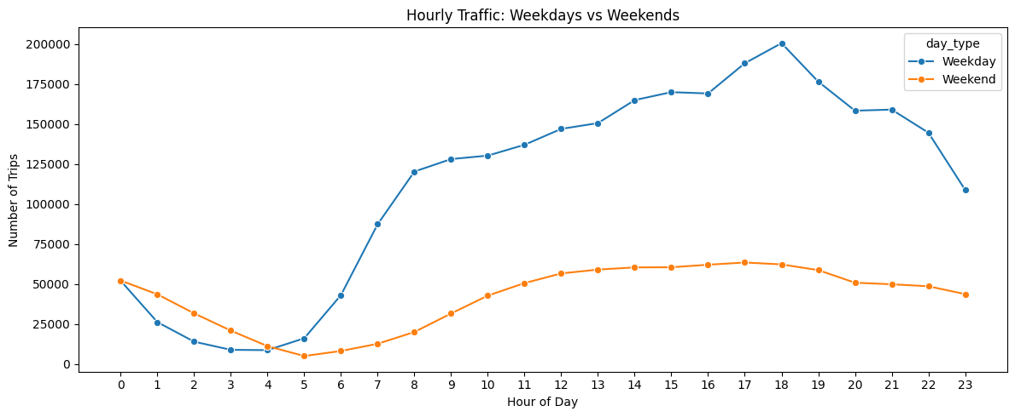

3.2.5 Top 10 Zones with High Hourly Pickups and Drops
. Pickups: JFK Airport leads; Dropoffs: Upper East Side North leads. High pickups and less dropoffs are observed in the airports, while residential areas have more dropoffs.
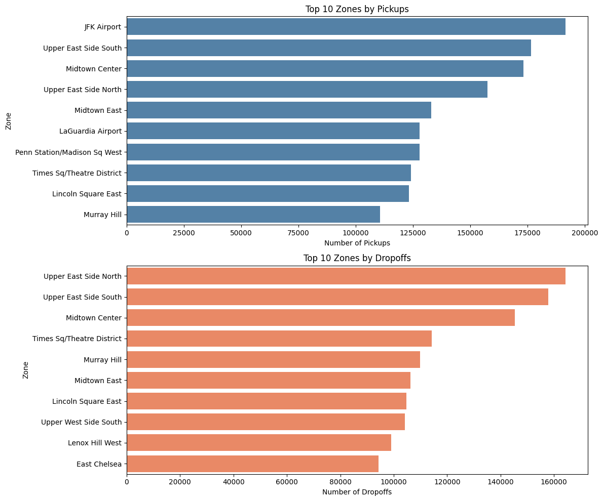

3.2.6 Pickup/Dropoff Ratio by Zone
Zones with a ratio of > 1 are net origin zones (cab deployments exceed dropoffs), and will need more cab deployments.
Zone | Pickup/Dropoff Ratio | Interpretation
East Elmhurst (near LGA) | 8.78 | Strong origin zone — cabs needed here
JFK Airport | 4.45 | Strong origin zone
LaGuardia Airport | 2.66 | Strong origin zone
Penn Station/Madison Sq West | 1.58 | Slight origin bias
Greenwich Village South | 1.41 | Balanced with slight origin bias

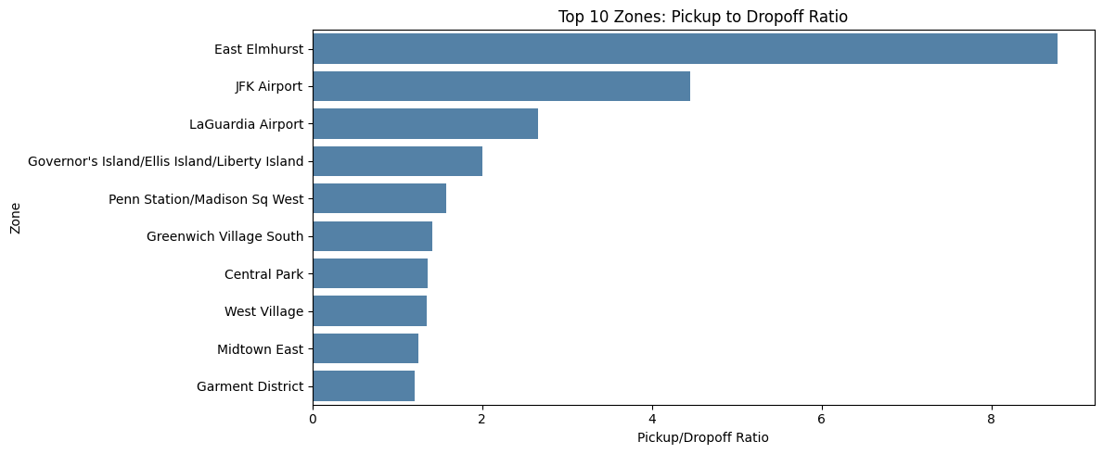

3.2.7 Top Zones with High Night Traffic
The night pick-up leader is JFK Airport (42,733), which is followed by East Village (39,504) and West Village (33,394), the latter two because of their nightlife activities and late night flights.

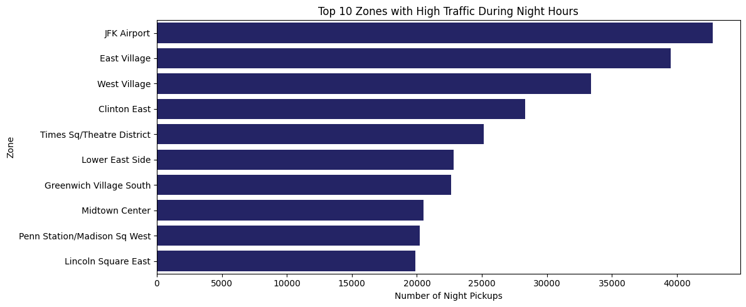

3.2.8 Revenue Share: Day vs Night
Daytime (6 AM–10 PM) accounts for 82.52% of revenue (~$88.8M), while nighttime accounts for 17.48% (~$18.8M). There are fewer night trips but they are longer and have a higher revenue per trip.
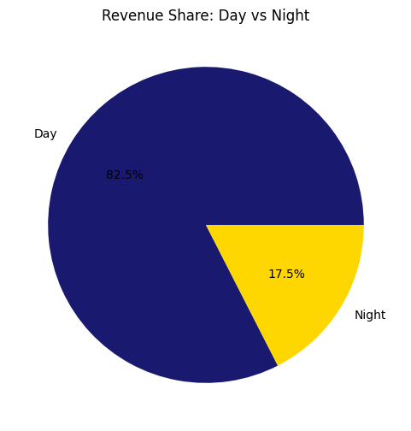

3.2.9 Average Fare per Mile per Passenger
The average fare with 1–6 passengers on board is very similar, proving the NYC taxi pricing model is distance and time-based, and not occupancy.
Passenger Count | Avg Fare per Mile ($)
1 | 7.86
2 | 7.68
3 | 7.82
4 | 7.80
5 | 7.65
6 | 7.82
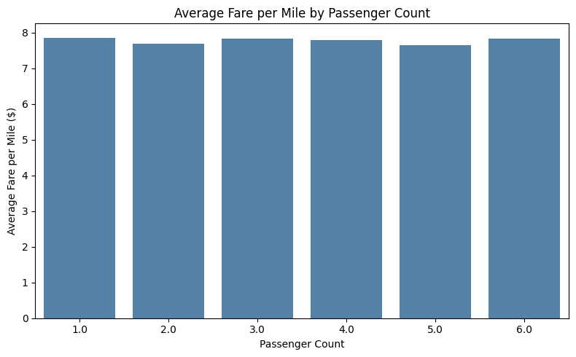

3.2.10 Average Fare per Mile by Hour and Day
By Hour:
- Peak times are from 11 AM to 1 PM (shorter, more congested trips) with the highest fare per mile at this time.
- Lowest cost per mile: ~$5.90 at 5 AM (longer airport runs result in lower per-mile costs).
By Day of Week:
- The highest fare per mile (~$8.10) is on Wednesdays and Thursdays when there are lots of business trips. The lowest (~$7.10) is on Sunday when weekend trips are longer.
- 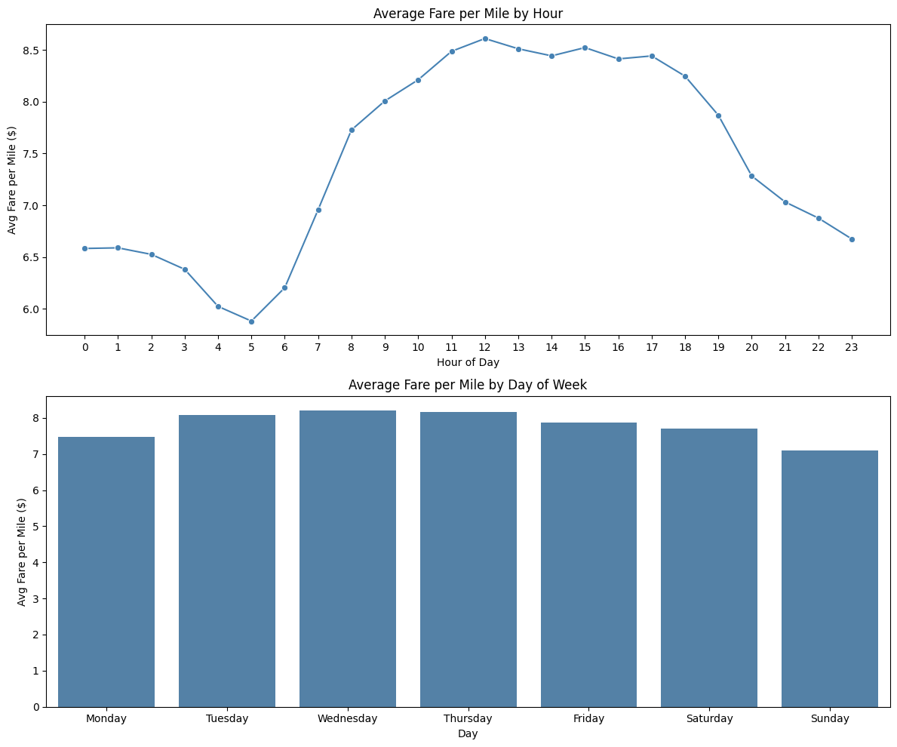

3.2.11 Average Fare per Mile by Vendor
Both Vendor 1 (Creative Mobile Technologies) and Vendor 2 (VeriFone) fall into the same pricing tier for NYC TLC, and have similar average fare per mile rates. The data provided by vendor 6 is limited and may not be representative.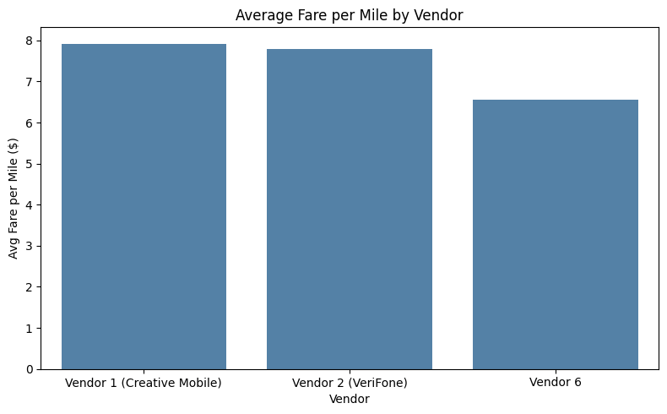

3.2.12 Vendor Fare Comparison by Distance Tier
Trips were sorted into five tiers: 0–2, 2–5, 5–10, 10–20, and 20–50 miles. The mileage charges are lower for both vendors for greater distances, reflecting the amortisation of base costs over longer trips.

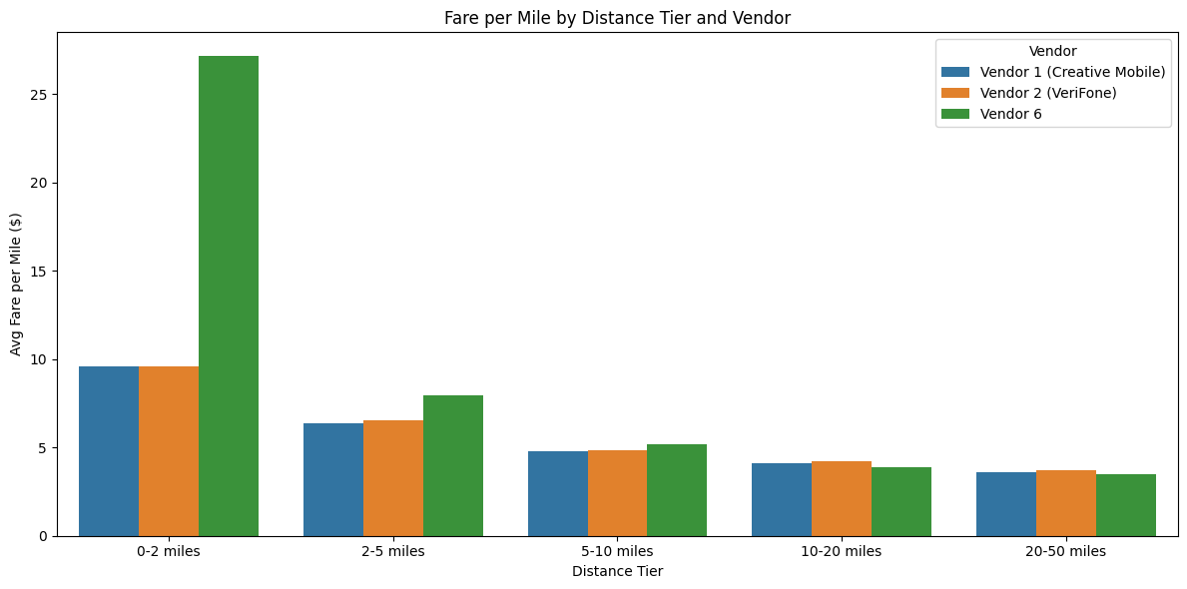

3.2.13 Tip Percentage Analysis
The average tip for those who pay with a credit card is 24.7%. Cashed tips are not counted and real tipping rates for cash transactions are thus underestimated to a large extent.
Payment Type | Average Tip Percentage
Credit Card | 24.7%
Unknown | 16.2%
Dispute | 0.03%
No Charge | 0.03%
Cash | ~0% (not recorded)
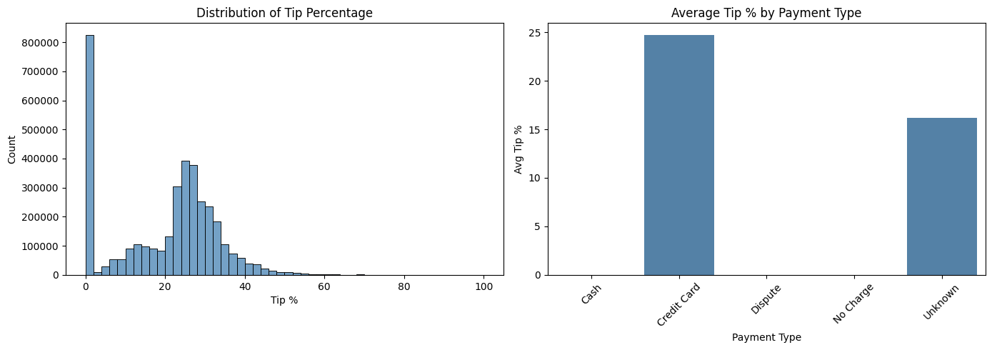

3.2.14 Passenger Count Trends
More than three-quarters of all trips are made by a single passenger. The average number of passengers per month remains at ~1.36. There are slightly more passengers on the weekend days, indicating that weekend traffic is used for groups and leisure travel.

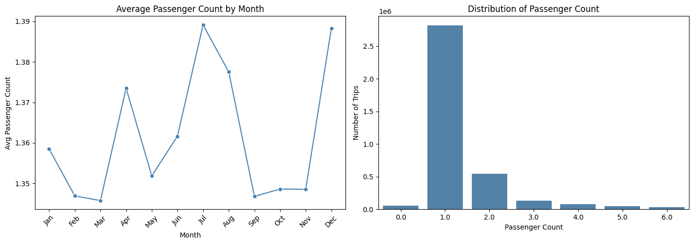

3.2.15 Passenger Count Variation Across Zones
Higher average numbers of passengers per trip are found in areas where they are entertained, such as tourist areas, or areas with airports, and lower average numbers of passengers per trip are found in residential areas (solo commuters).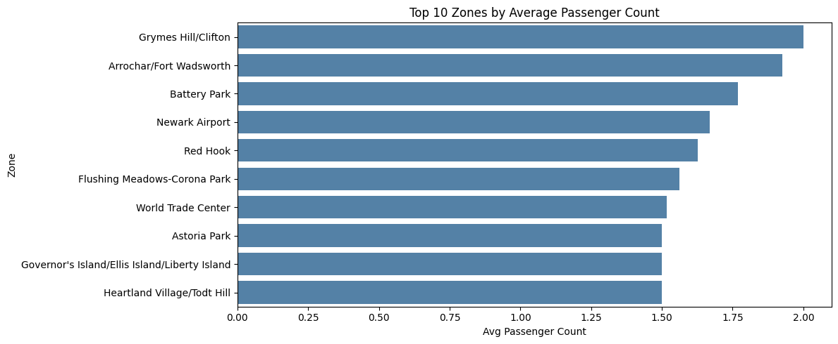

3.2.16 Extra Charges Analysis
Peak periods (4–8 PM and overnight (10 PM–6 AM)) are the most common times of extra charges, which coincide with NYC TLC surcharge policies. The highest surcharge rates are found in Airport zones as well as in Midtown areas. 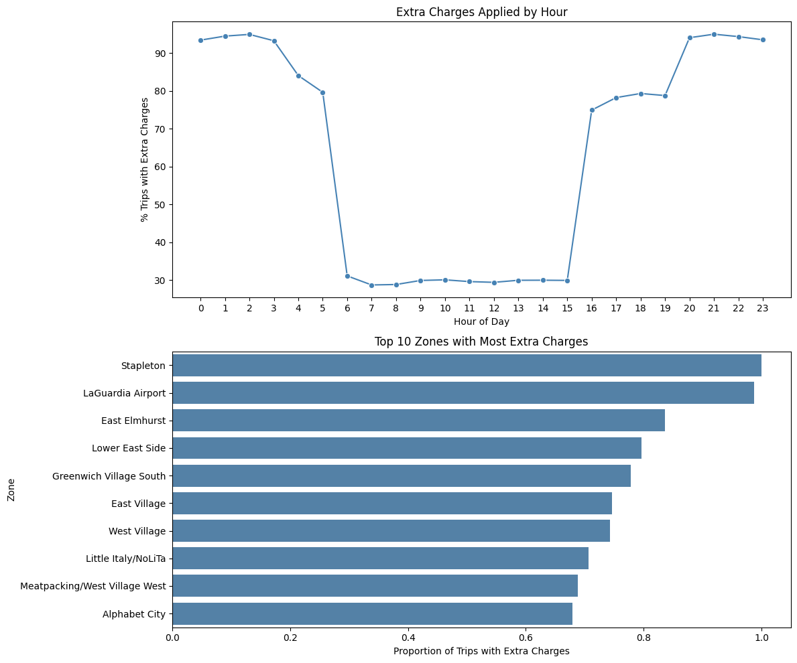

4. Conclusions & Recommendations

4.1 Recommendations to Optimise Routing and Dispatching
The recommendations to Optimise Routing and Dispatching are as follows:
- Based on Demand patterns & operational problems Analysis: Expand cab deployment during peak hours of the weekday (6–8 PM) when demand is at 262,859 trips/hour.
- Thursday is the busiest day of the week and should be prioritized for vehicle deployment.
- Don't have cabs park in Midtown Center and drive to Times Square during rush hour — the average speed drops to 5 mph.
- Avoid using roads that are less populated and heavily trafficked to minimize idling and maximize efficiency.
- Dynamic dispatching of cabs from low-traffic locations to high-traffic pickup points like JFK Airport (4.45:1) and East Elmhurst near LaGuardia (8.78:1).
- Reduce centre area coverage during early mornings (4am – 6am) and be more specific about airports and night-time areas.
- The dispatching of workforce should be distributed more evenly across the day on the weekends, instead of concentrated in the evening.

4.2 Strategic Cab Positioning Across Zones
- In terms of pickups and dropoffs, JFK Airport and LaGuardia Airport should have a continuous cab service (191,689 and 127,947 pickups respectively, with a high pickup-to-dropoff ratio).
- The Upper East Side (North and South) is a top-ranked pickup and dropoff area, and should be well covered as a key residential zone.
- Increase cabs in East Village and West Village (2nd and 3rd highest number of night time pickups after JFK) between 10 PM and 6 AM.
- During the quietest quarter of the year (Q3, July – September), bring in fewer cabs at 22.7% of total year revenue and more in areas of high need such as Midtown during other quarters.
- In May and October (high income months at ~$10.1M and ~$10.0M respectively) increase the number of cabs in all areas where the revenue is high.

4.3 Data-Driven Pricing Strategy Adjustments
- Incentivize credit card users, or offer a passenger discount for them — credit card users tip an average of 24.7%, compared to ~0% for cash, which will help increase recorded revenue and driver income.
- Analyze dynamic surge pricing in high-demand, midday areas, since the current flat-rate system may be leaving revenue on the table.
- Early morning pricing (4–6 AM) — fare per mile is less despite longer runs like airport runs (~$5.90).
- If a minimum fare or timebased surcharge is implemented this could affect revenue. Maintain the day-time fares already in place (11 AM to 2 PM) that are already the highest per mile (~$8.50).
- Enable shared ride pricing during peak travel times — 75% of trips are single ridership, passengers do not affect the cost of a ride, so shared rides could increase revenue per trip without increasing operating costs.
- Implement airport flat fare in addition to metered fare for waiting time and traffic congestion at the airport zones.

5. Assumptions
Assumption | Details
10% sampling | A 10% random sample is considered representative of full 2023 NYC Yellow Taxi data trends.
January data | The January 2023 parquet file was re-downloaded from the NYC TLC website due to a corrupted original.
Outlier policy | Outliers are identified and reported but not removed, as per assignment guidelines.
Night hours | Defined as 10 PM to 6 AM (hours 22, 23, 0, 1, 2, 3, 4, and 5).
Realistic distance | Set as 0–50 miles for correlation and speed analysis.
Realistic fares | Set as $0–$200 for correlation analysis.
Scale-up factor | Actual trip numbers estimated by multiplying sampled trips by 10 (inverse sampling fraction).
Cash tips | Cash tips recorded as $0 do not reflect actual amounts given, as the system does not track cash tip values.

