Regularised Regression Assignment: Used Car Price Prediction
Harshita Chandaiya

1. Problem Statement and Approach
Objective. This project aims at creating a regression model to estimate the price of used cars listed on AutoScout (German online car marketplace), using Ridge and Lasso regularisation to prevent overfitting, feature importance and to provide better basis for used-car pricing decision-making for a used-car reseller.
Business value. The accurate, interpretable pricing ability helps the reseller (a) price competently, (b) know which attributes of the car – mileage, age, fuel, power etc – are influencing the price and (c) not have speculative pricing mistakes because the pricing model won't generalise to the new inventory and the "unexpected" facts of that stock.
Approach. The data (15,915 listings, 23 columns) was cleaned, explored, and put in a modelling ready feature set. Three versions were constructed and compared (one of which was unregularised Linear Regression), with one using a coarse-then-fine grid of alpha values (regularisation strength) that were fine tuned by cross-validated MAE, and another being Ridge Regression, and the third being Lasso Regression. All work was done in the supplied starter notebook following the section layout and this report summarises the approach, key visuals, results in the same sequence as the pages of the notebook.

2. Data Understanding & Preliminary Analysis [13 Marks]
Missing values. Explicit NaN were not given in any column. 1,673 rows however did not contain any new information (because they were exact duplicates of other listings) so these have been dropped (10.5%). Duplicated listings would have been a silent threat to the model as the data it was based on would have been skewed towards the configuration that appeared most frequently in the scraped listings; this is why these duplicate listings have been dropped. The result was no need to handle any missing values other than these.
Numerical predictors identified: km, age, Previous_Owners, hp_kW, Gears, Displacement_cc, Weight_kg, cons_comb.
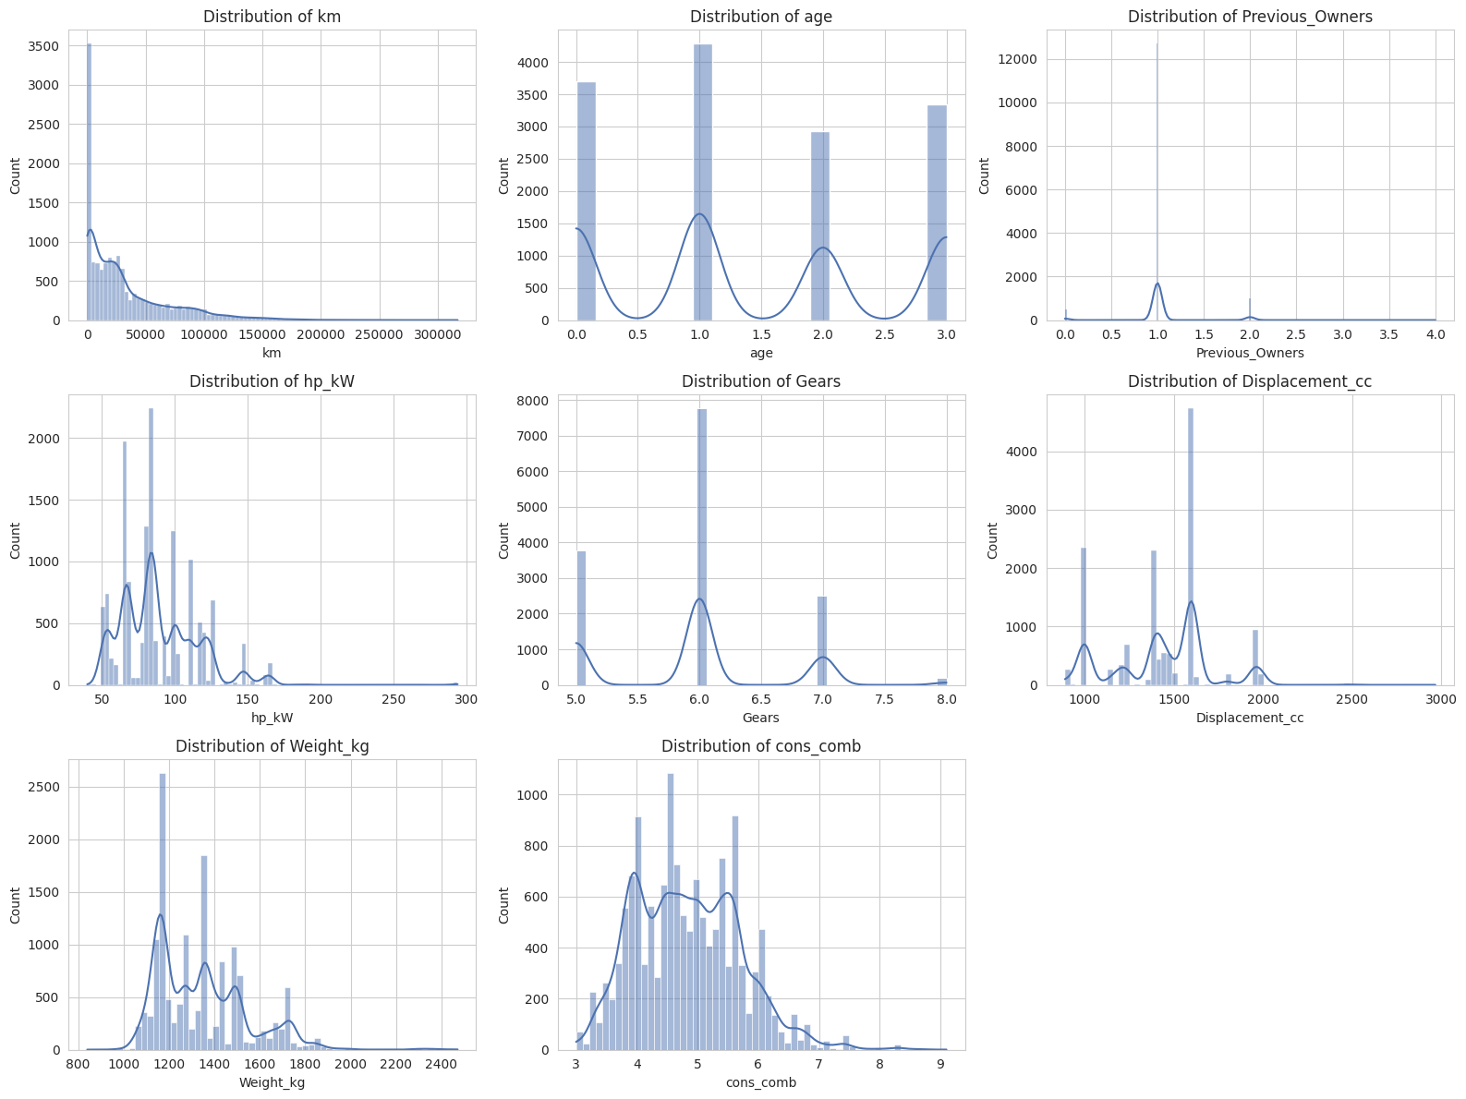
Numerical feature distributions
The majority of the numerical features are reasonably behaved; km and Previous_Owners has a long right tail (a few very high miles / multiple owners), on which is discussed further below under treatment for outliers.
Categorical predictors identified: make_model, body_type, vat, Type, Fuel, Inspection_new, Paint_Type, Upholstery_type, Gearing_Type, Drive_chain.
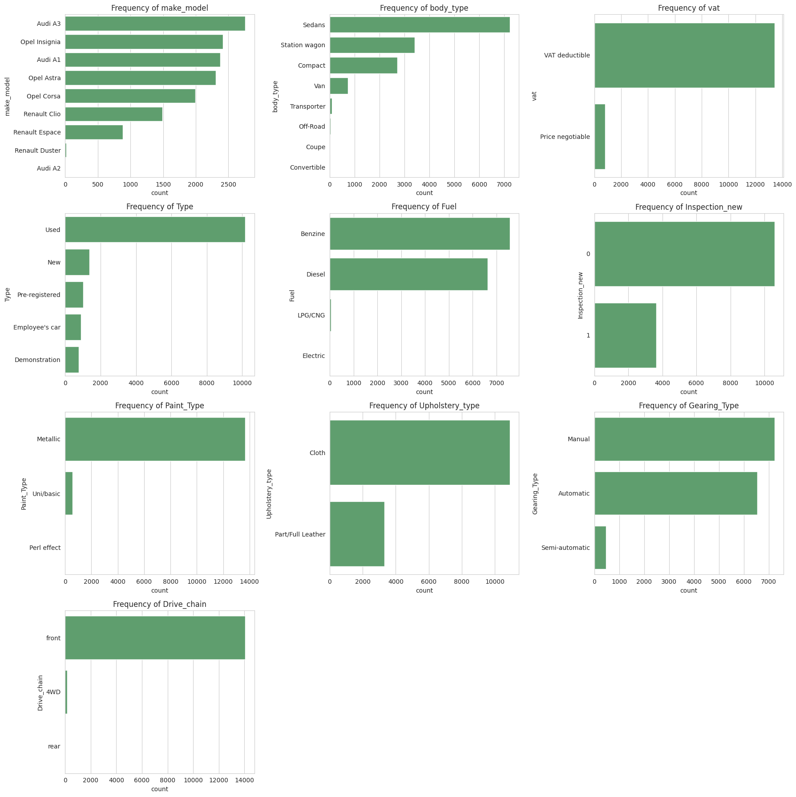
Categorical feature distributions
Fixing low-frequency values / class imbalance.
- Type: This condition is given as New, Pre-registered, Employee's car, and Demonstration—there were no data errors involved, all of these are reasonably sized groups (700+ per each condition) and reasonably meaningful, so left as-is.
- make_model, body_type, Fuel, Paint_Type, Drive_chain: Each data field had a few levels and a small number of rows (fewer than twenty) in them (i.e., one row for every Audi A2, 4 for every rear-drive car, 5 for every Electric car). Data elements that occurred less than 1% of the time were grouped in an Other node because a few examples don't allow a model to learn a stable effect and rare one hot columns introduce more of a risk of overfitting.

Target variable. price is right-skewed / heavy-tailed, (skewness ≈ 1.27), meaning that some very expensive cars are in the tail. This is because this assumption, i.e., linear-regression normally-distributed residuals, is violated, and the squared error loss is dominated by a few listings.
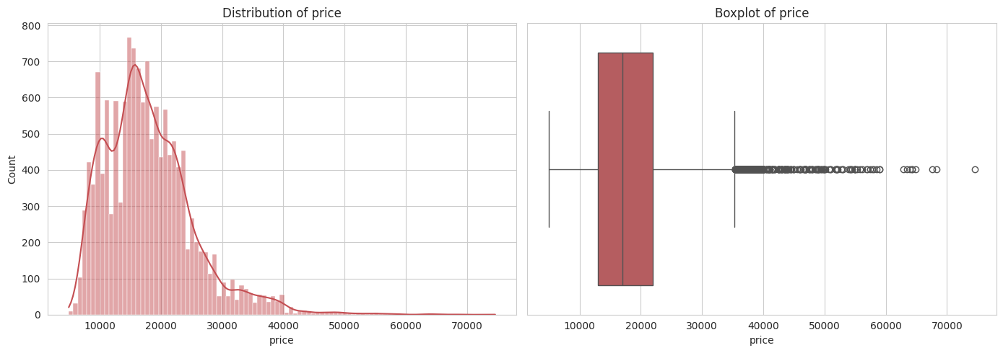
Distribution of price (raw, right-skewed)
We implemented a log(1+price) transform to reduce the impact of skewness to ≈ –0.04 (acting as a sort of standard normal distribution) which is the target used throughout all modelling work in this project; with log(price) being a standard normal distribution.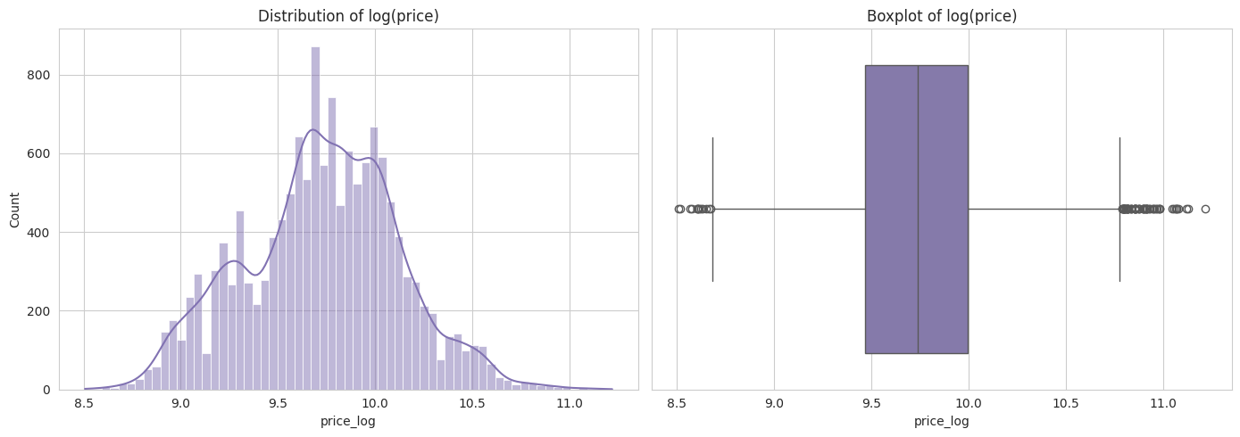
Distribution of log(price) after transform

3. Correlation Analysis [6 Marks]
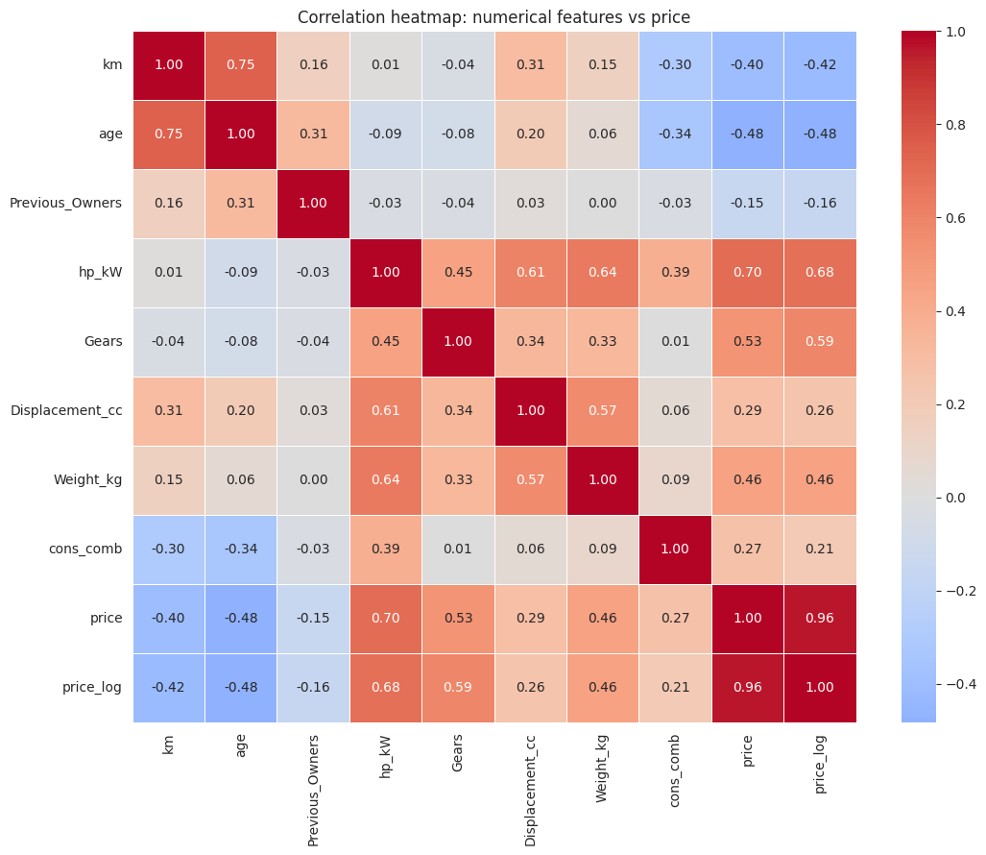
Correlation heatmap: numerical features vs price
As it should, hp_kW is most closely linked to price; age and km (unsurprisingly) are most closely linked to a loss of value; usage and time both predict loss of value, staying consistent with typical vehicle depreciation.
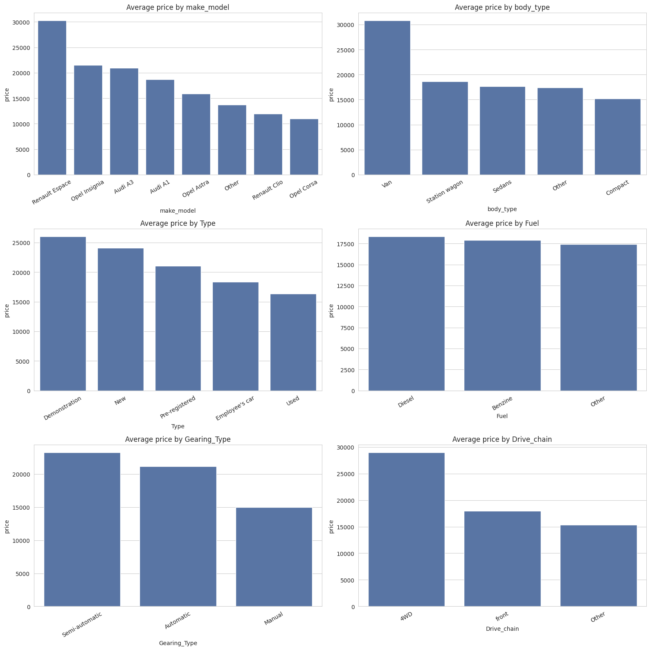

Average price by categorical feature
By far the largest spread in average price relates to the car identity (make_model) followed by body_type and Fuel. Type and Gearing_Type also provide obvious and sensible breaks (such as the differences in the price of Automatic/Semi-automatic vs. Manual and near-new “Type” categories vs. heavily-used listings).

4. Outlier Handling [5 Marks]
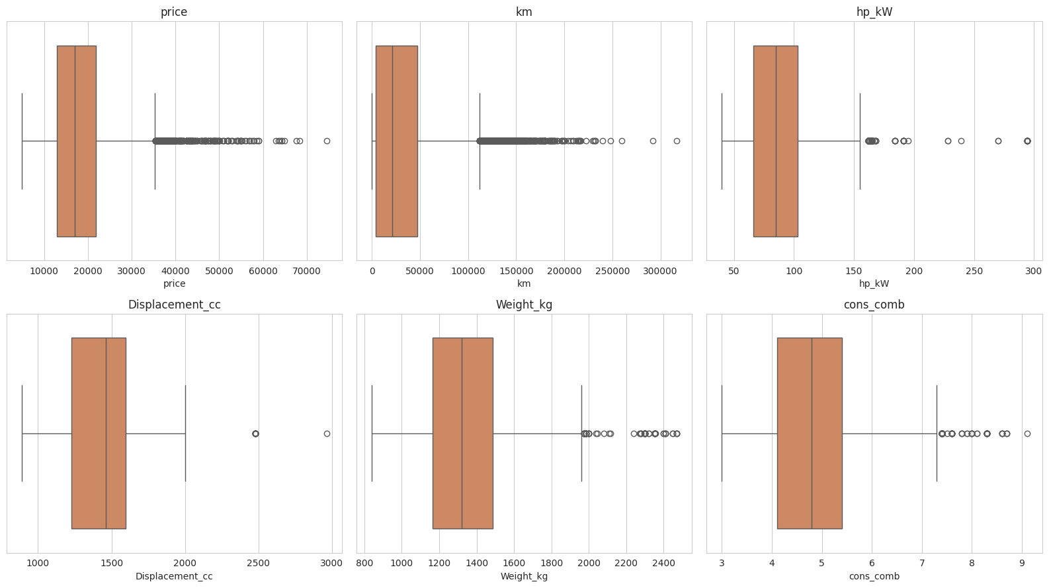
Boxplots of key numerical columns (before capping)
Using the 1.5×IQR rule:
Column | Outliers | % of data
price | 464 | 3.3%
km | 657 | 4.6%
hp_kW | 298 | 2.1%
Displacement_cc | 21 | 0.1%
Weight_kg | 73 | 0.5%
cons_comb | 111 | 0.8%
We capped (winsorised) km, hp_kW, Displacement_cc, Weight_kg, and cons_comb at their IQR bounds rather than deleting rows, because this limits the influence of extreme values while keeping every listing in the data. age and Previous_Owners were deliberately left out of this capping, since both are narrow, discrete counts where the IQR rule would incorrectly clip away genuinely valid values (most cars have exactly 1 owner). price itself was left untouched here, since its skew was already addressed separately via the log transform on the target.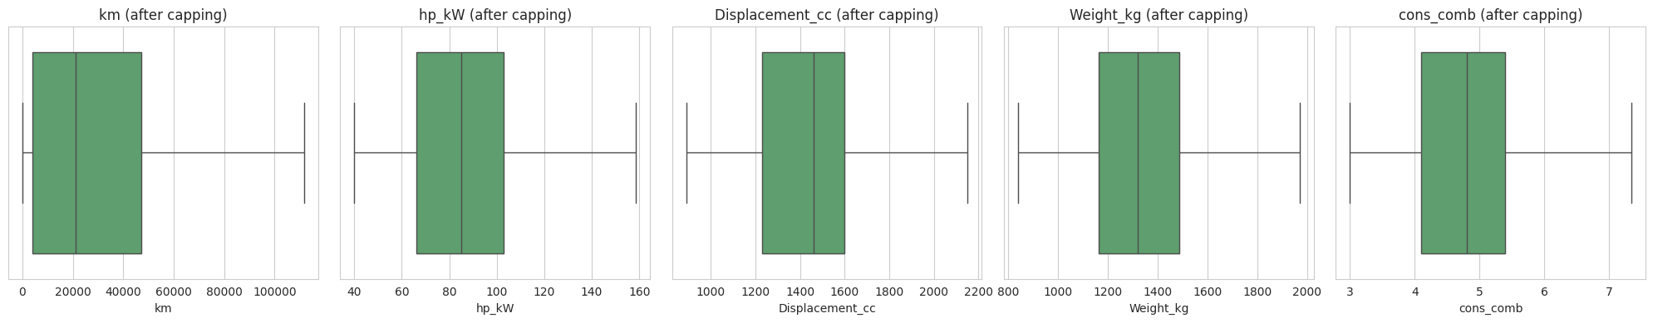
Capped distributions

5. Feature Engineering [11 Marks]
New / redundant columns.
- The exploratory reporting, make_model was converted to brand (e.g. Audi A1 → Audi) but make_model was preserved for modelling because, e.g. the price of Audi A1 and Audi A3 are not arbitrary.
The concept of a domain-informed performance metric was the basis behind the development of the power_to_weight (hp_kW / Weight_kg) parameter.
Bundled specification columns. These four categories (named Comfort_Convenience, Entertainment_Media, Extras, and Safety_Security) are all single lists of individual features (e.g. “Air conditioning, Armrest, Cruise control, …”) and represent four categories and should not be accessed as regular categorical columns. Only items which were found in 5% to 95% of listings were preserved, as they did not provide a great amount of discriminating information; items which were present in almost every car (e.g. ABS at 94%) or almost none (e.g. Night view assist at 0.5%) were dropped. This generated 71 highly informative binary flag columns in the four categories of specs (out of 94 columns of individual items).
Encoding. All other categorical columns were one-hot encoded: final output on these will be an array-like DataFrame containing binary values because of drop_first=True.With drop_first=True, all other categorical columns were one-hot encoded, to avoid ‘dummy variable trap' (0 or 1 for each category).Train/test split. 70/30 split, random_state=42.
Scaling. Features were standardised (StandardScaler) — to avoid data leakage features were fit on training set, and applied to test set. All features (numeric and binary flags) were scaled: Ridge and Lasso work by penalising the magnitude of the coefficient directly, which is why they both penalise unscaled features to the same extent based on the raw units used.

6. Baseline Linear Regression [10 Marks]
The full scaled feature set (105 features after encoding) was passed to a plain LinearRegression which was fitted.
Residual diagnostics:
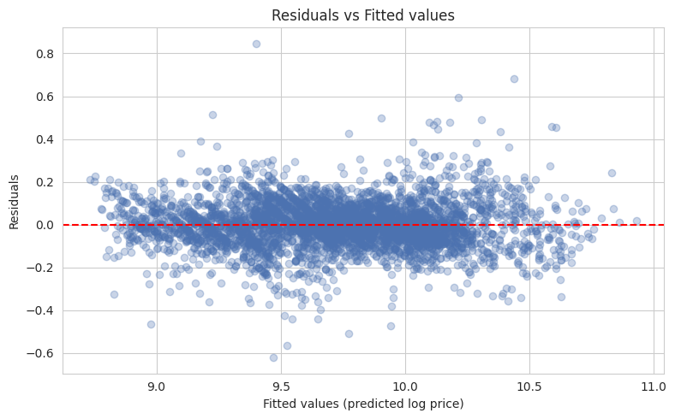
Residuals vs fitted values
The residuals have a fairly linear relationship to zero, with no obvious funnel or curved shape; and the assumption of homoscedasticity is satisfied reasonably well.
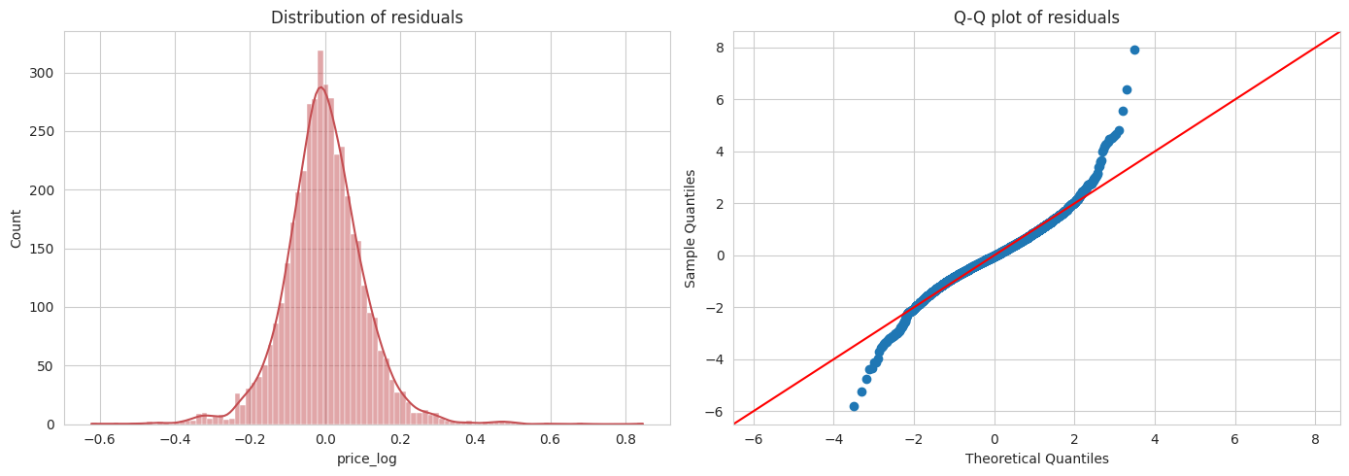
Residual distribution and Q-Q plot
Residuals tend to be normally distributed (with a more than acceptable deviation from the Q-Q bending reference line in the tails) and there is virtually no skewness (mean ≈ -0.001) in them — this is a very good characteristic for this 'little' linear model.
Multicollinearity (VIF). The first two VIF checks (power_to_weight, VIF ≈ 95; hp_kW, VIF ≈ 188) were highly collinear, which was to be expected as power_to_weight is indeed a direct calculation provided by hp_kW and Weight_kg, both of which were included in the model. Eliminated power_to_weight and retained two original features which would occur individually with more meaning. Once removed, there was one feature whose VIF remained higher than 10, and model performance was almost the same, solidifying the fact that indeed the dropped feature was not informative, but redundant instead..
Baseline performance (VIF-clean, 104 features):
 | Train R² | Test R² | Train RMSE | Test RMSE | Train MAE | Test MAE
Linear Regression | 0.9276 | 0.9276 | 0.1069 | 0.1076 | 0.0789 | 0.0791

Train and test scores are nearly equal — an early indicator that this is not a model that is meaningfully overfitting, as we will now see when Ridge and Lasso are tuned.

7. Ridge Regression [10 Marks]
A coarse grid [0.001, 0.01, 0.1, 1, 5, 10, 20, 50, 100, 200, 500, 1000] was tuned via 5-fold cross-validated negative MAE, followed by a finer grid centred on the coarse optimum.
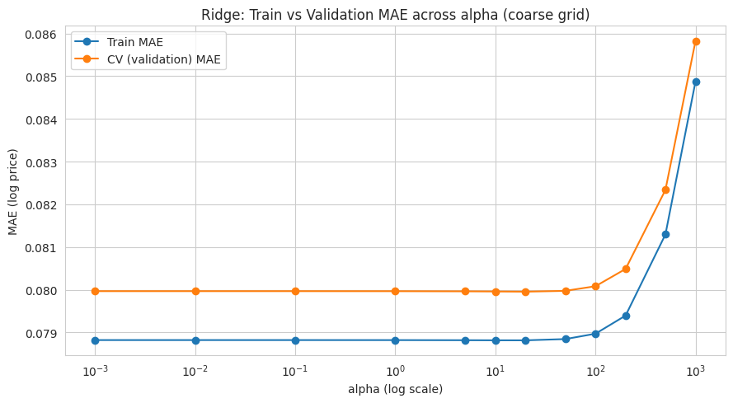
Ridge: train vs validation MAE across alpha
The coarse search resulted in alpha = 20, while doing the fine search (which was linearly spaced around this value) they narrowed it down to approximately alpha = 26.75.
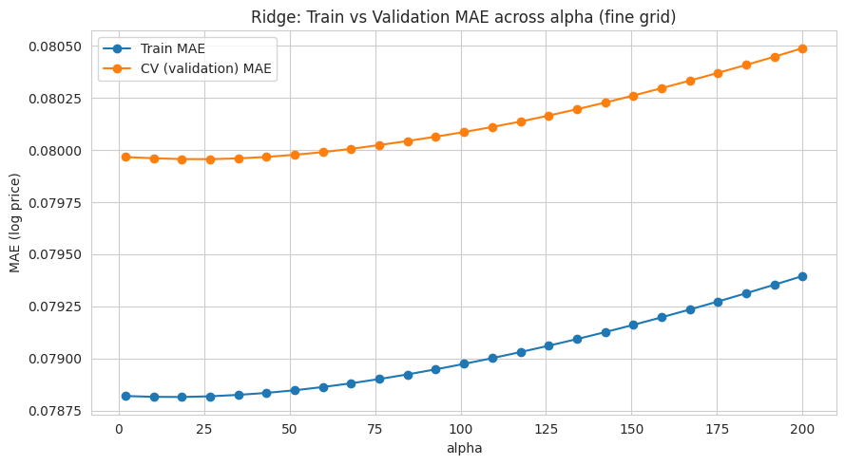
Ridge: train vs validation MAE, fine-tuned grid
The model was refit at the optimal alpha, and coefficients were extracted:
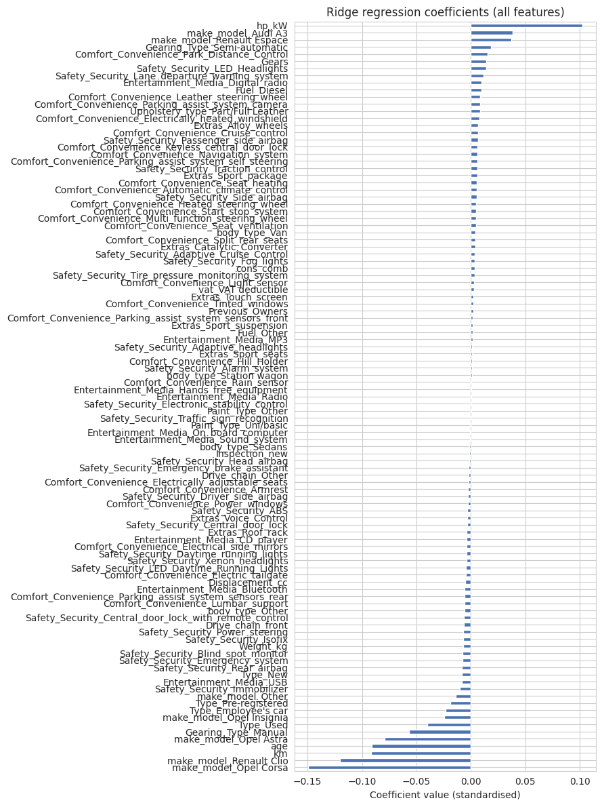
Ridge coefficients (all features)
Ridge test performance:
 | Train R² | Test R² | Train RMSE | Test RMSE | Train MAE | Test MAE
Ridge (α=26.75) | 0.9276 | 0.9275 | 0.1069 | 0.1076 | 0.0789 | 0.0791
It was again, almost the same as the unregularised baseline, as noted above.

8. Lasso Regression [10 Marks]

With Lasso, the same coarsely-refined tuning technique, which was done with four steps with coarse grid [0.0001 … 10] and fine grid around optimum, was applied.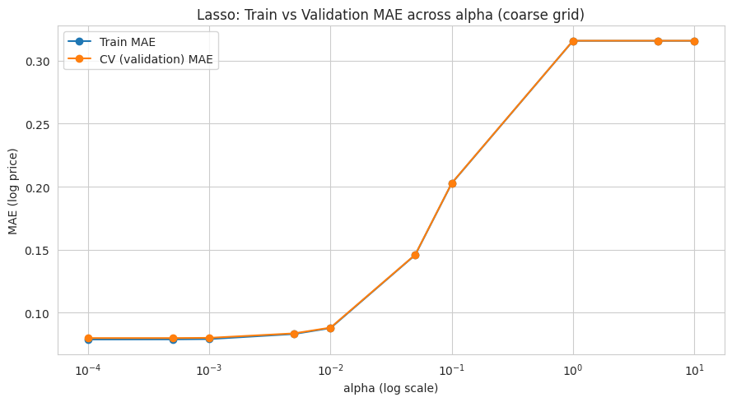
Lasso: train vs validation MAE, coarse then fine grid
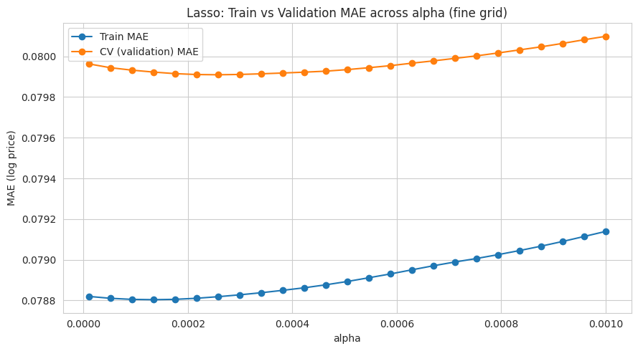
Lasso fine-tuned grid
Again, the optimal alpha best converged to a very small value (≈0.00026), thus favouring light regularisation; confirming the fact that the basic model was not significantly overfitted.

Once the model is refit, under the optimum alphas, the coefficients were extracted:
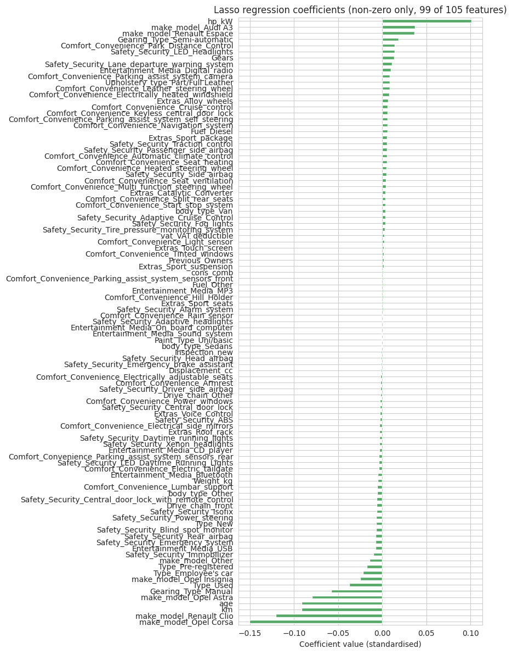
Lasso coefficients (non-zero only)
Lasso test performance:
 | Train R² | Test R² | Train RMSE | Test RMSE | Train MAE | Test MAE
Lasso (α=0.0003) | 0.9275 | 0.9274 | 0.1069 | 0.1077 | 0.0789 | 0.0792
Lasso zeroed out 6 of 105 features entirely: Entertainment_Media_Hands_free_equipment, Entertainment_Media_Radio, Safety_Security_Electronic_stability_control, Safety_Security_Traffic_sign_recognition, body_type_Station wagon, and Paint_Type_Other. These are largely near-universal comfort/safety items whose presence carries little pricing signal once other features are accounted for.

9. Regularisation Comparison & Analysis [5 Marks]
Model | Train R² | Test R² | Train RMSE | Test RMSE | Train MAE | Test MAE
Linear Regression | 0.9276 | 0.9276 | 0.1069 | 0.1076 | 0.0789 | 0.0791
Ridge (α=26.75) | 0.9276 | 0.9275 | 0.1069 | 0.1076 | 0.0789 | 0.0791
Lasso (α=0.0003) | 0.9275 | 0.9274 | 0.1069 | 0.1077 | 0.0789 | 0.0792
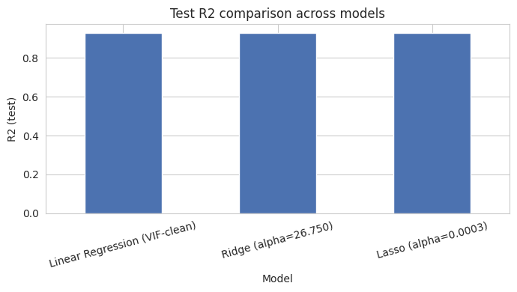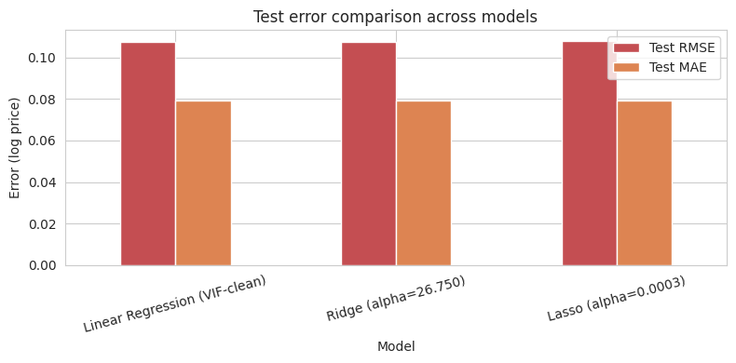
The three models are virtually indistinguishable. The most uniform and most powerful price influences in all three models were:
- hp_kW (positive) — more “powerful” cars fetch higher prices.
- make_model (most important overall) — e.g. Opel Corsa and Renault Clio are significantly more expensive or cheaper than Audi A1, while the Audi A3 and Renault Espace are significantly more expensive or cheaper than the Audi A1.
- km and age (both negative) — expected depreciation with usage and time
- Gearing_Type_Manual (negative) — for manual-transmission vehicles are lower than those assigned to an automatic transmission.
- 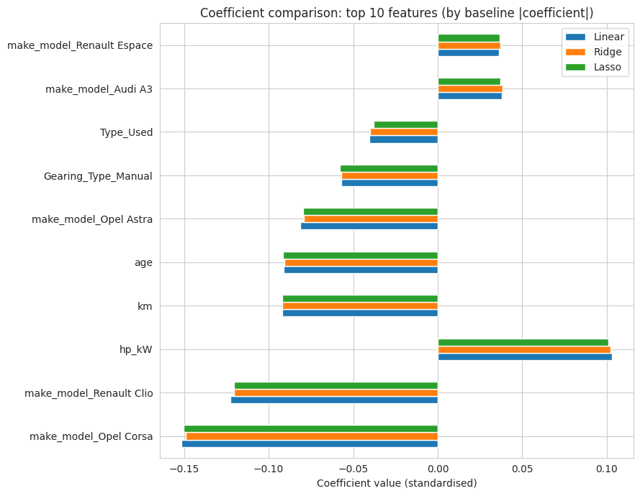
Coefficient comparison: top features and Lasso-eliminated features
To compare the coefficients, the features must be ordered in the same way as in the table above. Ridge does not change the sign of any of the coefficients, but reduces them slightly; Lasso is similar in that a few of the smallest coefficients are reduced to exactly 0. The coefficient values across the three models are almost the same for the top features and so the effects are likely real, rather than just caused by overfitting.

10. Conclusion & Key Takeaways [10 Marks]
Data quality. There were no explicit missing values in the raw dataset; however, ~10.5% of rows were exact duplicates and were dropped from the dataset. There were very few of some categorical variables that were too few to model with good confidence and were thus combined into Other. The bundled spec columns needed to be specially-parsed to get through to the flags, and only moderately common flags were kept.
Was there an improvement in performance with regularisation? Only slightly – the three models approach a virtually identical Test R² (~0.927- ~0.928) and test MAE (~0.079 (log scale)). The baseline train and test scores were almost the same so there was not much overfitting to correct for in regularisation. Indeed, the hyperparameters embedded in this are indicative that only mild regularisation weights were required for any of these models, in both cases (Ridge's alpha was ~27, Lasso's alpha was very small ~0.00026).
Could the data have been different? There are 14,242 listings that have been cleaned through this point, and the price variation is correlated to a factor of ~93% so it seems to be adequately linear at this degree of accuracy. Such a typical error, or Test MAE of ≈0.079 in log-price space, translates to approximately ±8% in the real price space, which is reasonable for a tool for resale pricing (used car sales also not necessarily result at one price level, but rather within a range).
Is a linear model sufficient? The R² is very good, while the residual pattern is reasonably linear, and the overall residuals (errors) are close to normal, so the linear/regularised-linear approach would suit this business use case and it is much more interpretable than a black-box solution — the coefficient 'b1' represents 'by how many dollars will a car cost more when its age increases from one year to the next?', which is useful when pricing and talking to stakeholders. We'd reasonably expect a further few percentage points of error to be achieved by a more flexible model (e.g. gradient boosting) at the price of interpretability, assuming it's worth sacrificing interpretability for the business and that the gain in accuracy is significant.
Recommendation. If you want price information for what you'd be likely to see in the day to day, you can choose one of two models: The Ridge model (or plain Linear Regression since the two models performed very similarly): keeps all features (which are helpful when the price depends on everything you listed) but yields better accuracy with more stable coefficients than Lasso. Lasso is more effective, when a lot of the car-specification columns are available as an option – for example, once per quarter, as a feature-audit tool to identify which of the multiple available columns can be left uncollected without price accuracy being significantly affected.

Assumptions made
- The duplication issues were deemed to be data issue (re-scraped car listing) and thus were deleted.
- Categorical frequencies <1% were considered too low to model and combined as Other.
- Outlier capping (winsorisation) was used for continuous features related to engineering/usage with the aim of maintaining sample size, while features such as length of time in car (age) and number of previous owners (Previous_Owners) were assumed to not require outlier capping as they were in a very narrow, discrete range.
- In principle, power_to_weight was believed to be also unlikely to cause problems, but it was dropped after VIF analysis indicated that it was near redundant with hp_kW and Weight_kg since they were already provided in the model.
- This leaves out spec items that are not found in less than 5% or more than 95% of all listings as they were considered to have little predictive value.

