**STEPS FOR INSTALLING THE CODE:**

1. Download the files ‘sorting.html’ and ‘Graph.html’
2. Select the file ‘sorting.html’ and open with google chrome.

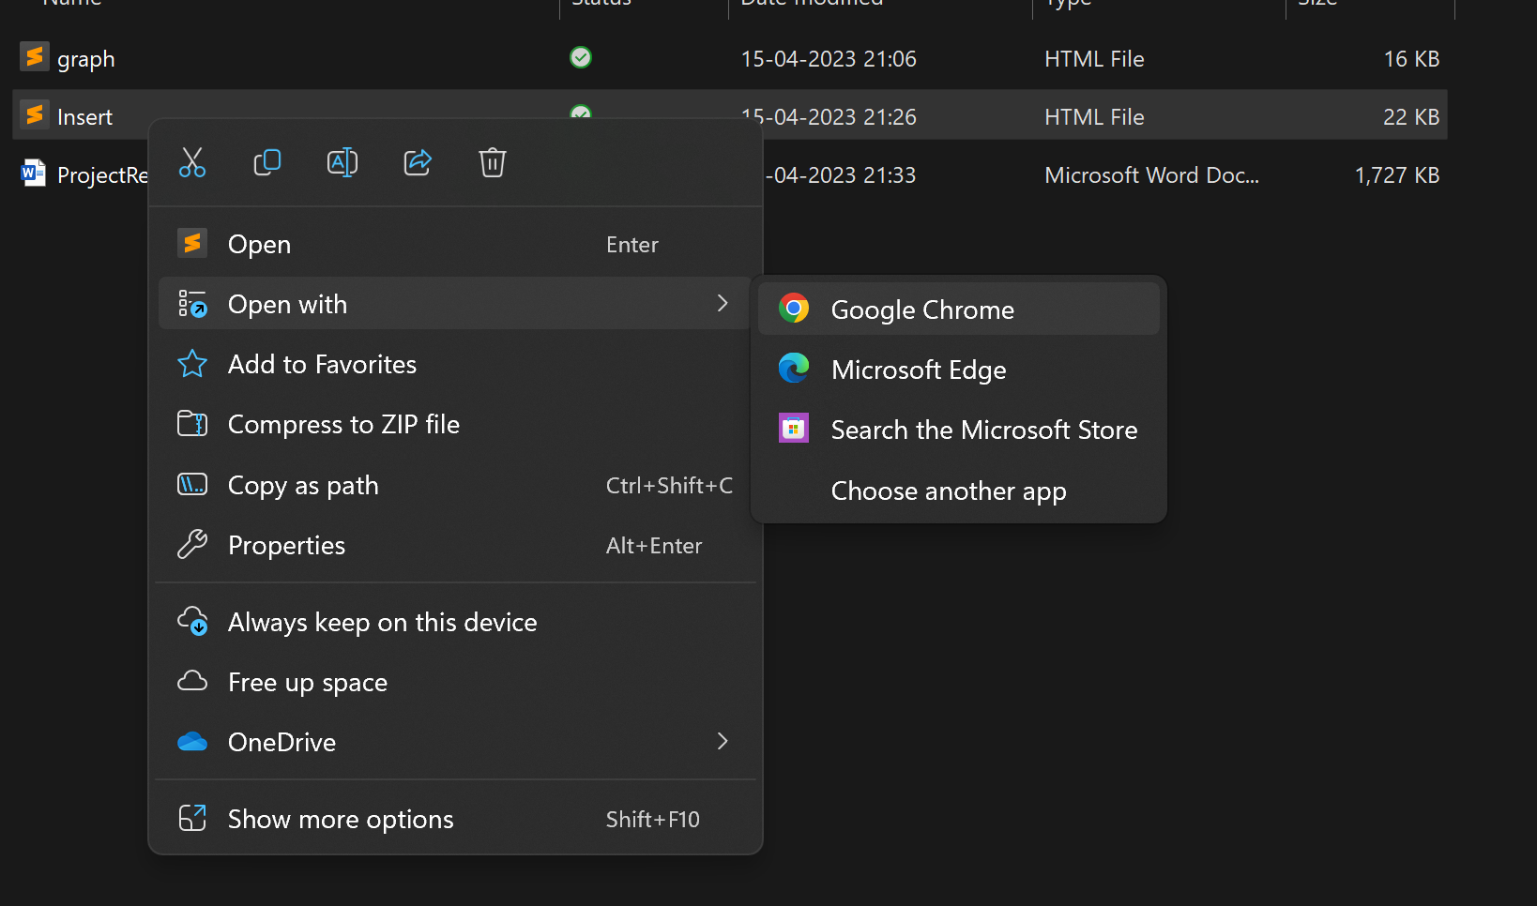

1. Go to website and give input a number. Note that the number should not be greater than 1000 and click on generate.
2. Now select the sorting technique by ticking on checkbox and click on answer. The sorted answers will be displayed at the bottom.
3. Click on graph button. It redirects to next page showing run time of each techniques.