Leetcode 9
https://leetcode.com/problems/palindrome-number/
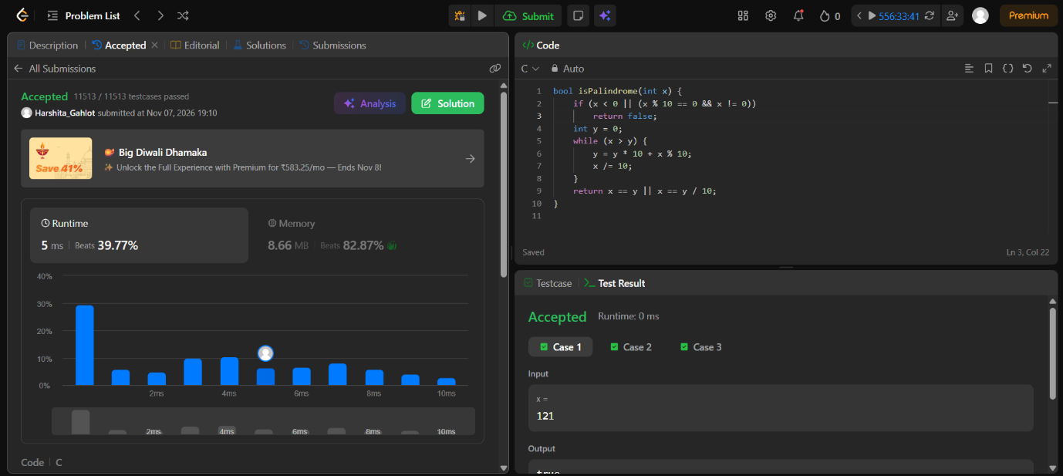

Code-
bool isPalindrome(int x) {
if (x < 0 || (x % 10 == 0 && x != 0))
return false;
int y = 0;
while (x > y) {
y = y * 10 + x % 10;
x /= 10;
}
return x == y || x == y / 10;
}

