Leetcode 2652
https://leetcode.com/problems/sum-multiples/
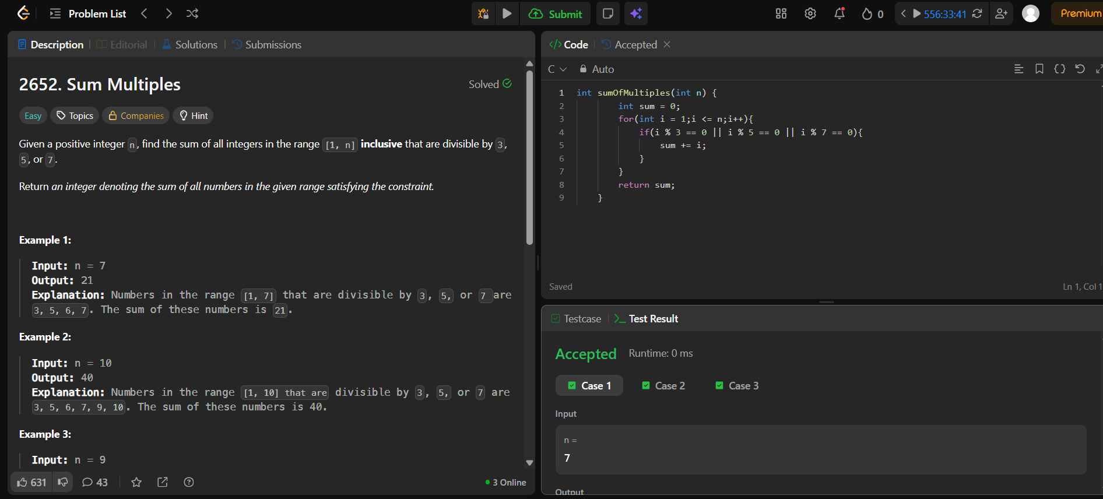

Code-
int sumOfMultiples(int n) {
int sum = 0;
for(int i = 1;i <= n;i++){
if(i % 3 == 0 || i % 5 == 0 || i % 7 == 0){
sum += i;
}
}
return sum;
}

