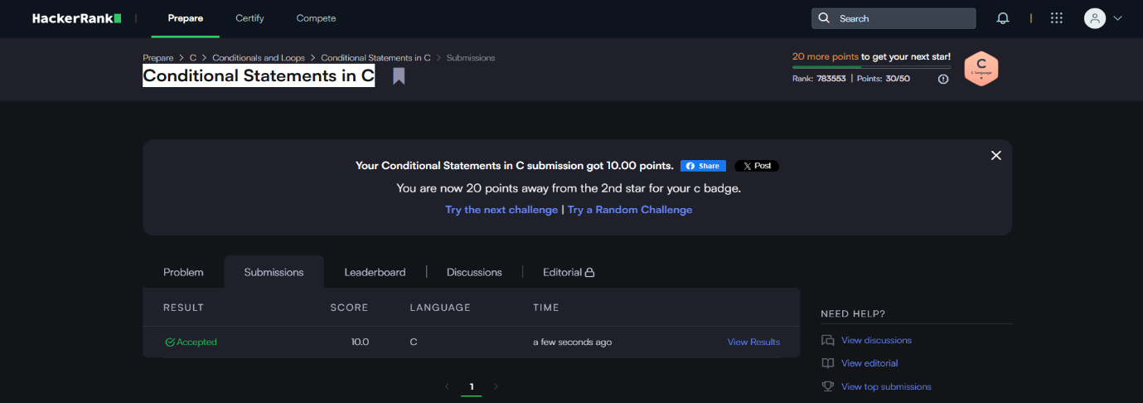
HackerRank – Conditional Statements in C
https://www.hackerrank.com/challenges/conditional-statements-in-c/problem

Code-
if (n == 1)
printf("one");
else if (n == 2)
printf("two");
else if (n == 3)
printf("three");
else if (n == 4)
printf("four");
else if (n == 5)
printf("five");
else if (n == 6)
printf("six");
else if (n == 7)
printf("seven");
else if (n == 8)
printf("eight");
else if (n == 9)
printf("nine");
else
printf("Greater than 9");
return 0;}

