HackerEarth – Roy and Profile Picture
https://www.hackerearth.com/practice/basic-programming/input-output/basics-of-input-output/practice-problems/algorithm/roy-and-profile-picture/

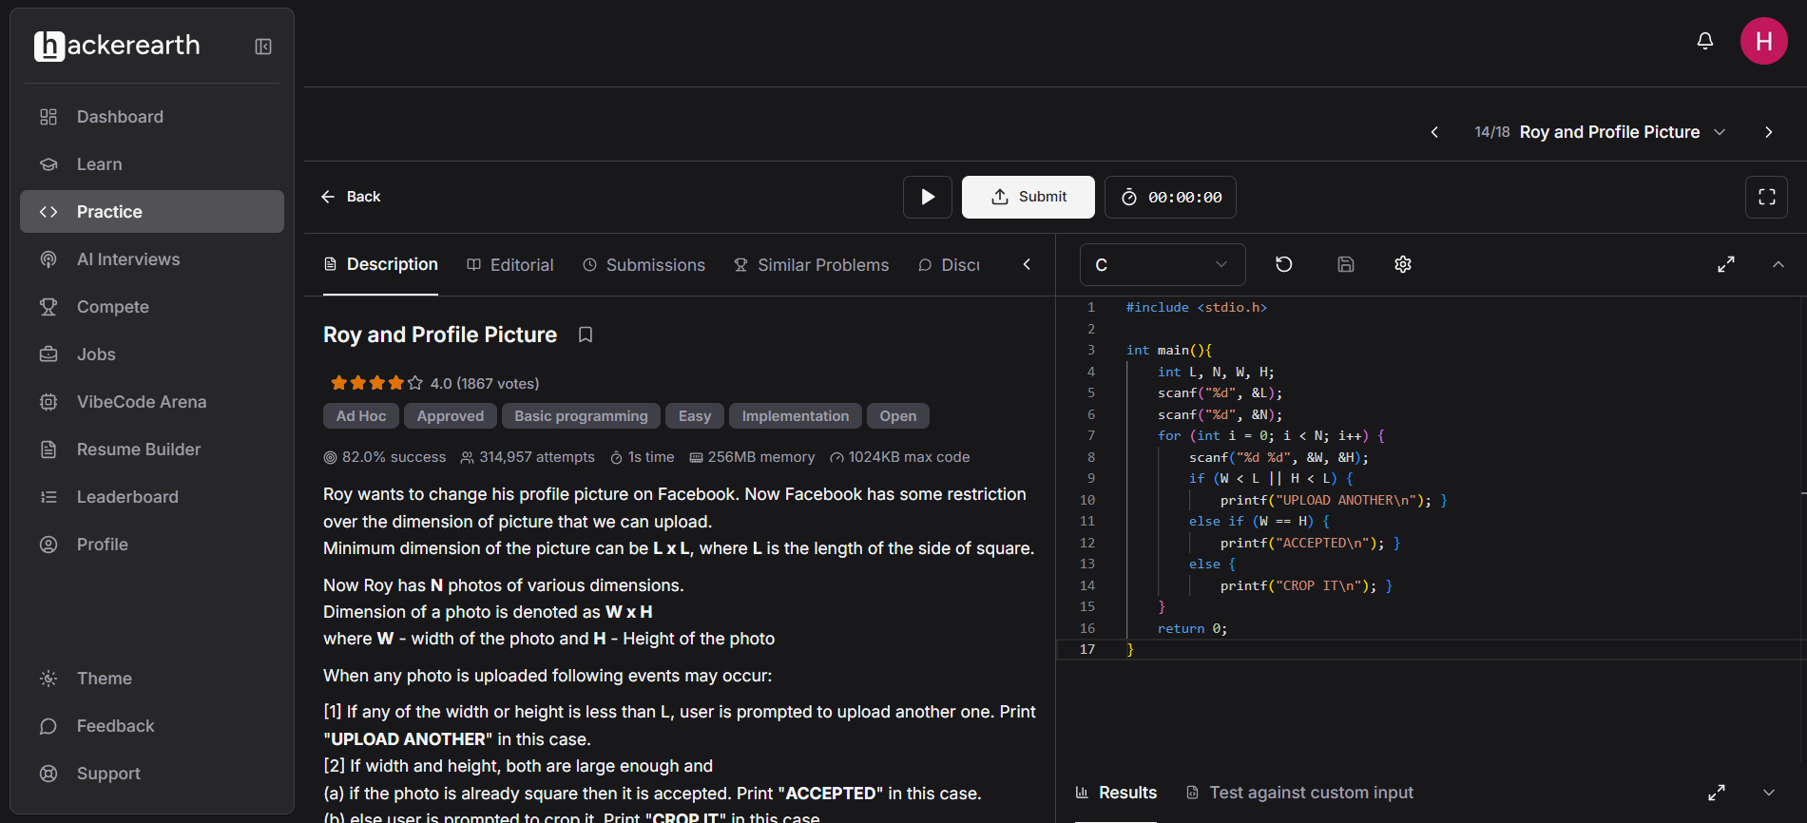
Code-
#include <stdio.h>

int main(){
int L, N, W, H;
scanf("%d", &L);
scanf("%d", &N);
for (int i = 0; i < N; i++) {
scanf("%d %d", &W, &H);
if (W < L || H < L) {
printf("UPLOAD ANOTHER\n"); }
else if (W == H) {
printf("ACCEPTED\n"); }
else {
printf("CROP IT\n"); }
}
return 0;

