Leetcode 2413
https://leetcode.com/problems/smallest-even-multiple/
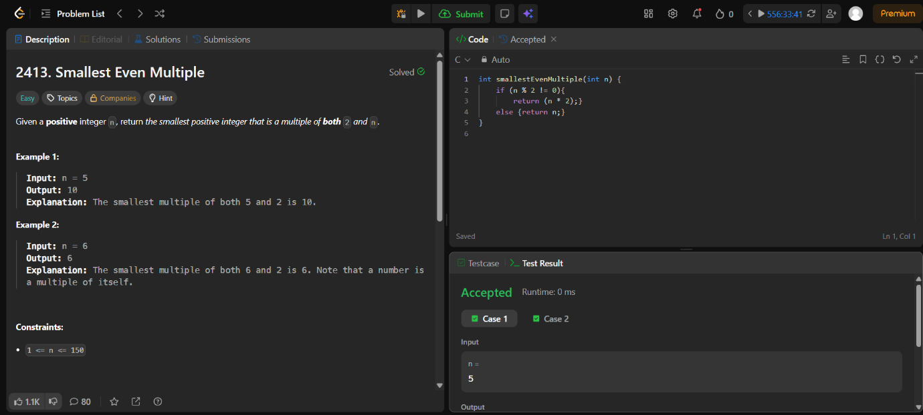

Code-
int smallestEvenMultiple(int n) {
if (n % 2 != 0){
return (n * 2);}
else {return n;}
}

