HackerEarth – A.Digit Sum
https://www.hackerearth.com/problem/algorithm/digit-sum-4/
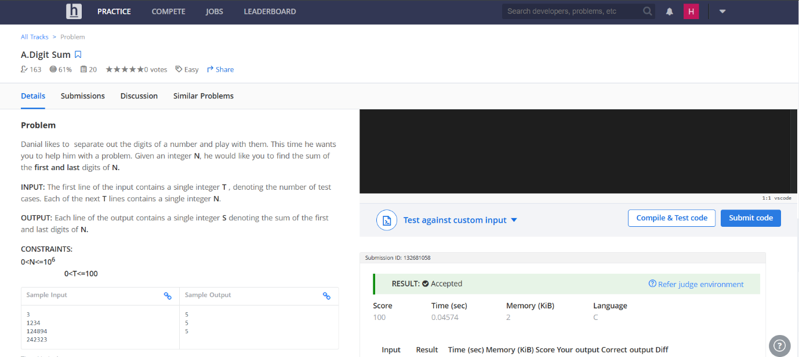

Code-
#include <stdio.h>

int main() {
int T, num, first, last;
scanf("%d", &T);
while (T--) {
scanf("%d", &num);
last = num % 10;
while (num >= 10) {
num = num / 10;
}
first = num;
printf("%d\n", first + last);
}
return 0;
}

